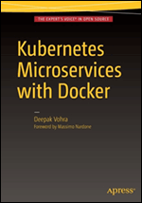

**Kubernetes Microservices with Docker**

**By:** Deepak Vohra

**Book:** 440 pages

**Publisher:** Apress © 2016

LAUNCHTOGGLE DROPDOWN

Recommends - Click to Unrecommend

 ([**2**](javascript:void(0);))Recommends - Click to view recommendationsRECOMMEND

**Kubernetes Microservices with Docker**

**Foreword**

Getting Started

**Chapter 1: Installing Kubernetes Using Docker**

**Chapter 2: Hello Kubernetes**

**Chapter 3: Using Custom Commands and Environment Variables**

Relational Databases

**Chapter 4: Using MySQL Database**

**Chapter 5: Using PostgreSQL Database**

**Chapter 6: Using Oracle Database**

NoSQL Database

**Chapter 7: Using MongoDB Database**

**Chapter 8: Using Apache Cassandra Database**

**Chapter 9: Using Couchbase**

Apache Hadoop Ecosystem

**Chapter 10: Using Apache Hadoop Ecosystem**

**Chapter 11: Using Apache Solr**

**Chapter 12: Using Apache Kafka**

Multi Containers and Nodes

**Chapter 13: Creating a Multi-Container Pod**

**Chapter 14: Installing Kubernetes on a Multi-Node Cluster**

**Index**

**List of Figures**

**List of Tables**

**Part I: Getting Started**

Chapter List

1. [Chapter 1:](http://viewer.books24x7.com/assetviewer.aspx?bkid=113388&destid=28#28) Installing Kubernetes Using Docker
2. [Chapter 2:](http://viewer.books24x7.com/assetviewer.aspx?bkid=113388&destid=128#128) Hello Kubernetes
3. [Chapter 3:](http://viewer.books24x7.com/assetviewer.aspx?bkid=113388&destid=244#244) Using Custom Commands and Environment Variables

# Kubernetes Microservices with Docker

Chapter 1 - Installing Kubernetes Using Docker

Apress © 2016

## Chapter 1: Installing Kubernetes Using Docker

**© Deepak Vohra 2016  
D. Vohra, *Kubernetes Microservices with Docker*, DOI 10.1007/978-1-4842-1907-2\_1**

### Overview

Kubernetes is software for managing a cluster of Docker containers. Kubernetes orchestration includes scheduling, distributing workload, and scaling. Kubernetes takes the software encapsulation provided by Docker further by introducing Pods. A Pod is a collection of one or more Docker containers with single interface features such as providing networking and filesystem at the Pod level rather than at the container level. Kubernetes also introduces "labels" using which services and replication controllers (replication controller is used to scale a cluster) identify or select the containers or pods they manage. Kubernetes is lightweight, portable (suited for the cloud architecture), and modular.

Kubernetes may be run on almost any platform. Local machine solutions include local Docker based, Vagrant, and no-VM local cluster. Hosted solutions include Google Container Engine. Some of the other platforms supported by Kubernetes are Fedora (Ansible and Manual), Amazon Web Services, Mesos, vSphere, and CoreOS. Kubernetes is an orchestration software for Docker containers; the recommended solution for installation is to use the Docker Engine. In this chapter we shall install Kubernetes on Docker, which runs on Ubuntu. We shall use an Amazon EC2 instance hosting Ubuntu as the operating system. In this chapter, a single node installation of Kubernetes is discussed. Multi-node installation of Kubernetes is discussed in [chapter 14](http://viewer.books24x7.com/assetviewer.aspx?bkid=113388&destid=1233#1233).

**Setting the Environment**

The following software is required for this chapter.

* - Docker Engine (latest version)
* - Kubernetes (version 1.01)

Linux is required to support 64-bit software. We have used an Amazon EC2 instance created from AMI Ubuntu Server 14.04 LTS (HVM), SSD Volume Type - ami-d05e75b8. An Amazon EC2 instance based on the Ubuntu AMI is shown in [Figure 1-1](https://viewer.books24x7.com/assetviewer.aspx?bookid=113388&chunkid=894575253&resumebookmarkid=24b8af05-b4be-e911-b9b2-00505695593a).

[Larger View](https://viewer.books24x7.com/assetviewer.aspx?bookid=113388&chunkid=894575253&resumebookmarkid=24b8af05-b4be-e911-b9b2-00505695593a)

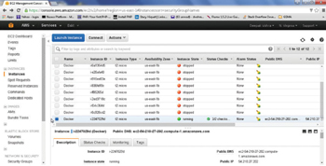

**Figure 1-1:**Amazon EC2 Instance Based on Ubuntu AMI

A different Ubuntu version may be used if the requirement of a 64-bit architecture is met. The minimum kernel version requirement is 3.10. The kernel version may be verified with the following command.

uname -r

The Public IP would be different for different users. Multiple Amazon EC2 instances and therefore multiple Public IP addresses have been used in the book as a different Public IP is assigned each time an Amazon EC2 instance is started. The Private IP Address of an Amazon EC2 instance is the same across restarts. SSH into an Ubuntu instance on Amazon EC2 (Public IP is 52.91.80.173 in following command).

ssh -i "docker.pem" ubuntu@52.91.80.173

The Amazon EC2 instance gets logged in as shown in [Figure 1-2](https://viewer.books24x7.com/assetviewer.aspx?bookid=113388&chunkid=894575253&resumebookmarkid=24b8af05-b4be-e911-b9b2-00505695593a). The command prompt becomes "ubuntu@ip-172-30-1-190" instead of root@localhost. Ip 172.30.1.190 is the Private IP of the Amazon EC2 instance and would also be different for different users.

[Larger View](https://viewer.books24x7.com/assetviewer.aspx?bookid=113388&chunkid=894575253&resumebookmarkid=24b8af05-b4be-e911-b9b2-00505695593a)

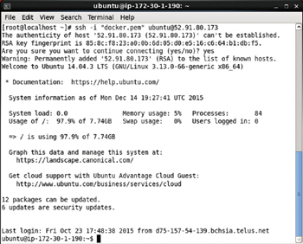

**Figure 1-2:**Loging into an Amazon EC2 instance

In the next section we shall install Docker on Ubuntu hosted on an Amazon EC2 instance.

**Installing Docker**

Ubuntu uses apt for package management; apt stores a list of repositories in the /etc/apt/sources.list list. Docker's apt repository is kept in the /etc/apt/sources.list.d/docker.list file. First, add the new repository key (gpg key) for the Docker repository with the following command.

sudo apt-key adv --keyserver hkp://pgp.mit.edu:80 --recv-keys

58118E89F3A912897C070ADBF76221572C52609D

The new gpg key gets added as shown in [Figure 1-3](https://viewer.books24x7.com/assetviewer.aspx?bookid=113388&chunkid=558391436&resumebookmarkid=24b8af05-b4be-e911-b9b2-00505695593a).

[Larger View](https://viewer.books24x7.com/assetviewer.aspx?bookid=113388&chunkid=558391436&resumebookmarkid=24b8af05-b4be-e911-b9b2-00505695593a)

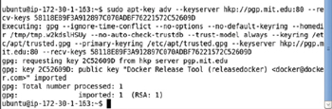

**Figure 1-3:**Adding a new gpg key

Next, update the apt sources for the Docker repository in the /etc/apt/sources.list.d/docker.list file based on the Ubuntu distribution, which may be found with the following command.

lsb\_release –a

For Ubuntu Trusty, add the following line to the /etc/apt/sources.list.d/docker.list file; the docker.list file may be opened with sudo vi /etc/apt/sources.list.d/docker.list.

deb https://apt.dockerproject.org/repo ubuntu-trusty main

Create the /etc/apt/sources.list.d/docker.list file if the file does not already exist. The updated file is shown in [Figure 1-4](https://viewer.books24x7.com/assetviewer.aspx?bookid=113388&chunkid=558391436&resumebookmarkid=24b8af05-b4be-e911-b9b2-00505695593a). Save the file with the :wq command if opened in the vi editor.

[Larger View](https://viewer.books24x7.com/assetviewer.aspx?bookid=113388&chunkid=558391436&resumebookmarkid=24b8af05-b4be-e911-b9b2-00505695593a)

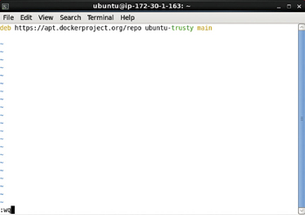

**Figure 1-4:**Creating the docker. list file

The entry to be added would be different for different Ubuntu distributions as listed in [Table 1-1](https://viewer.books24x7.com/assetviewer.aspx?bookid=113388&chunkid=558391436&resumebookmarkid=24b8af05-b4be-e911-b9b2-00505695593a).

**Table 1-1: The docker.list file Entry Based on Ubuntu Distribution**[[](https://viewer.books24x7.com/outputobject.aspx?bookid=113388&chunkid=558391436&objectid=ch1_tab1&objecttype=spreadsheet) Open table as spreadsheet](https://viewer.books24x7.com/outputobject.aspx?bookid=113388&chunkid=558391436&objectid=ch1_tab1&objecttype=spreadsheet)

| **Ubuntu Distribution** | **Entry** |
| --- | --- |
| Ubuntu Precise 12.04 (LTS) | deb <https://apt.dockerproject.org/repo> ubuntu-precise main |
| Ubuntu Trusty 14.04 (LTS) | deb <https://apt.dockerproject.org/repo> ubuntu-trusty main |
| Ubuntu Vivid 15.04 | deb <https://apt.dockerproject.org/repo> ubuntu-vivid main |

Run the following commands after updating the /etc/apt/sources.list.d/docker.list file to update the apt package index.

sudo apt-get update

Apt package index gets updated as shown in [Figure 1-5](https://viewer.books24x7.com/assetviewer.aspx?bookid=113388&chunkid=558391436&resumebookmarkid=24b8af05-b4be-e911-b9b2-00505695593a).

[Larger View](https://viewer.books24x7.com/assetviewer.aspx?bookid=113388&chunkid=558391436&resumebookmarkid=24b8af05-b4be-e911-b9b2-00505695593a)

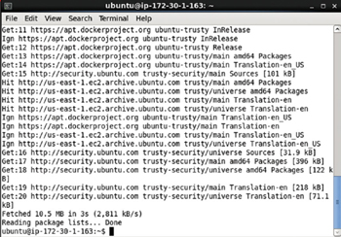

**Figure 1-5:**Updating Ubuntu Package List

Purge the old repository if it exists with the following command.

sudo apt-get purge lxc-docker\*

The output in [Figure 1-6](https://viewer.books24x7.com/assetviewer.aspx?bookid=113388&chunkid=558391436&resumebookmarkid=24b8af05-b4be-e911-b9b2-00505695593a) indicates that the old packages lxc-docker and lxc-docker-virtual-package are not installed and therefore not removed.

[Larger View](https://viewer.books24x7.com/assetviewer.aspx?bookid=113388&chunkid=558391436&resumebookmarkid=24b8af05-b4be-e911-b9b2-00505695593a)

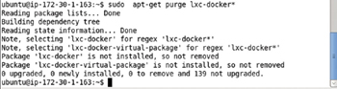

**Figure 1-6:**Purging the Old Repository

Run the following command to verify that apt is pulling from the updated repository for Docker.

sudo apt-cache policy docker-engine

The output in [Figure 1-7](https://viewer.books24x7.com/assetviewer.aspx?bookid=113388&chunkid=558391436&resumebookmarkid=24b8af05-b4be-e911-b9b2-00505695593a) indicates that the new repository ubuntu-trusty as specified in the /etc/apt/sources.list.d/docker.list is being used.

[Larger View](https://viewer.books24x7.com/assetviewer.aspx?bookid=113388&chunkid=558391436&resumebookmarkid=24b8af05-b4be-e911-b9b2-00505695593a)

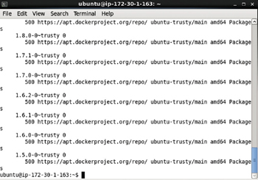

**Figure 1-7:**Using the Updated Repository verification

Next, install the prerequisites for Ubuntu, but first update the package manager with the following command.

sudo apt-get update

The package manager gets updated as shown in [Figure 1-8](https://viewer.books24x7.com/assetviewer.aspx?bookid=113388&chunkid=558391436&resumebookmarkid=24b8af05-b4be-e911-b9b2-00505695593a).

[Larger View](https://viewer.books24x7.com/assetviewer.aspx?bookid=113388&chunkid=558391436&resumebookmarkid=24b8af05-b4be-e911-b9b2-00505695593a)

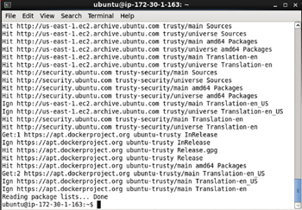

**Figure 1-8:**Updating the Package Manager

Install the prerequisite linux-image-extra package with the following command.

sudo apt-get install linux-image-generic-lts-trusty

When the preceding command is run, select Y if prompted with the following message.

* *After this operation, 281 MB of additional disk space will be used*.
* *Do you want to continue? [Y/n]*

The message prompt is shown in [Figure 1-9](https://viewer.books24x7.com/assetviewer.aspx?bookid=113388&chunkid=558391436&resumebookmarkid=24b8af05-b4be-e911-b9b2-00505695593a).

[Larger View](https://viewer.books24x7.com/assetviewer.aspx?bookid=113388&chunkid=558391436&resumebookmarkid=24b8af05-b4be-e911-b9b2-00505695593a)

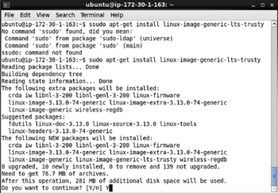

**Figure 1-9:**Message Prompt to Continue

Subsequently, before the command completes, a Package Configuration dialog might prompt with the following message:

*A new version of /boot/grub/menu.lst is available, but the version installed currently has been locally modified. What would you like to do about menu.lst?*

Select the default selection, which is "keep the local version currently installed" and click on Enter as shown in [Figure 1-10](https://viewer.books24x7.com/assetviewer.aspx?bookid=113388&chunkid=558391436&resumebookmarkid=24b8af05-b4be-e911-b9b2-00505695593a).

[Larger View](https://viewer.books24x7.com/assetviewer.aspx?bookid=113388&chunkid=558391436&resumebookmarkid=24b8af05-b4be-e911-b9b2-00505695593a)

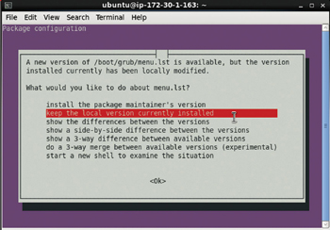

**Figure 1-10:**Selecting the Default Package Configuration

Reboot the system with the following command.

sudo reboot

When the sudo reboot command is run the AmazonEC2 instance is exited. Reconnect with the Amazon EC2 Ubuntu instance with the same ssh command as before.

ssh -i "docker.pem" ubuntu@52.91.80.173

After the host system reboots, update the package manager again with the following command.

sudo apt-get update

Package manager gets updated as shown in [Figure 1-11](https://viewer.books24x7.com/assetviewer.aspx?bookid=113388&chunkid=558391436&resumebookmarkid=24b8af05-b4be-e911-b9b2-00505695593a).

[Larger View](https://viewer.books24x7.com/assetviewer.aspx?bookid=113388&chunkid=558391436&resumebookmarkid=24b8af05-b4be-e911-b9b2-00505695593a)

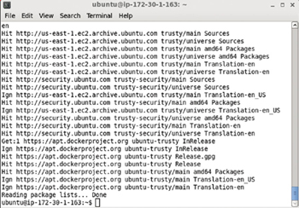

**Figure 1-11:**Updating Package Manager List after Reboot

Install Docker with the following command.

sudo apt-get install docker-engine

Select Y at the following prompt, if displayed, as shown in [Figure 1-12](https://viewer.books24x7.com/assetviewer.aspx?bookid=113388&chunkid=558391436&resumebookmarkid=24b8af05-b4be-e911-b9b2-00505695593a).

* *After this operation, 60.3 MB of additional disk space will be used*.
* *Do you want to continue? [Y/n]*

[Larger View](https://viewer.books24x7.com/assetviewer.aspx?bookid=113388&chunkid=558391436&resumebookmarkid=24b8af05-b4be-e911-b9b2-00505695593a)

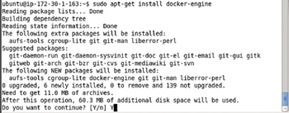

**Figure 1-12:**Message Prompt about the additional disk space being added

The Docker engine gets installed as shown in [Figure 1-13](https://viewer.books24x7.com/assetviewer.aspx?bookid=113388&chunkid=558391436&resumebookmarkid=24b8af05-b4be-e911-b9b2-00505695593a).

[Larger View](https://viewer.books24x7.com/assetviewer.aspx?bookid=113388&chunkid=558391436&resumebookmarkid=24b8af05-b4be-e911-b9b2-00505695593a)

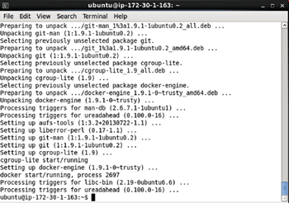

**Figure 1-13:**Installing the Docker Engine

Start the Docker service with the following command.

sudo service docker start

To verify the status of the Docker service, run the following command.

sudo service docker status

The output from the preceding commands is shown in [Figure 1-14](https://viewer.books24x7.com/assetviewer.aspx?bookid=113388&chunkid=558391436&resumebookmarkid=24b8af05-b4be-e911-b9b2-00505695593a). The docker engine is indicated as running as process 2697.

[Larger View](https://viewer.books24x7.com/assetviewer.aspx?bookid=113388&chunkid=558391436&resumebookmarkid=24b8af05-b4be-e911-b9b2-00505695593a)

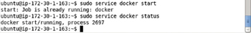

**Figure 1-14:**Starting Docker and verifying its Status

Having installed Docker, next we shall install Kubernetes.

**Installing Kubernetes**

Kubernetes is an open source container cluster manager. The main components of Kubernetes are the following:

1. etcd
2. Kubernetes master
3. Service proxy
4. kubelet

etcd is a simple, secure, fast and reliable distributed key-value store.

Kubernetes master exposes the Kubernetes API using which containers are run on nodes to handle tasks.

kubelet is an agent that runs on each node to monitor the containers running on the node, restarting them if required to keep the replication level.

A service proxy runs on each node to provide the Kubernetes service interface for clients. A service is an abstraction for the logical set of pods represented by the service, and a service selector is used to select the pods represented by the service. The service proxy routes the client traffic to a matching pod. Labels are used to match a service with a pod.

Optionally create a directory (/kubernetes) to install Kubernetes and set its permissions to global (777).

sudo mkdir /kubernetes

sudo chmod -R 777 /kubernetes

The output from the preceding commands is shown in [Figure 1-15](https://viewer.books24x7.com/assetviewer.aspx?bookid=113388&chunkid=266284266&resumebookmarkid=24b8af05-b4be-e911-b9b2-00505695593a).

[Larger View](https://viewer.books24x7.com/assetviewer.aspx?bookid=113388&chunkid=266284266&resumebookmarkid=24b8af05-b4be-e911-b9b2-00505695593a)



**Figure 1-15:**Creating a Directory to install Kubernetes

Change directory to the /kubernetes directory and start the Docker engine.

cd /kubernetes

sudo service docker start

If the Docker Engine is not running, it gets started. The Docker Engine is shown as already running in [Figure 1-16](https://viewer.books24x7.com/assetviewer.aspx?bookid=113388&chunkid=266284266&resumebookmarkid=24b8af05-b4be-e911-b9b2-00505695593a).

[Larger View](https://viewer.books24x7.com/assetviewer.aspx?bookid=113388&chunkid=266284266&resumebookmarkid=24b8af05-b4be-e911-b9b2-00505695593a)

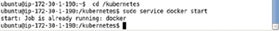

**Figure 1-16:**Starting Docker if not already running

As a prerequisite we need to set some Linux kernel parameters if not already set. Add support for memory and swap accounting. The following configs should be turned on in the kernel.

CONFIG\_RESOURCE\_COUNTERS=y

CONFIG\_MEMCG=y

CONFIG\_MEMCG\_SWAP=y

CONFIG\_MEMCG\_SWAP\_ENABLED=y

CONFIG\_MEMCG\_KMEM=y

The kernel configs are enabled when the Ubuntu system boots and the kernel configuration file is in the /boot directory. Change directory (cd) to the /boot directory and list the files/directories.

cd /boot

ls –l

The files in the /boot directory get listed as shown in [Figure 1-17](https://viewer.books24x7.com/assetviewer.aspx?bookid=113388&chunkid=266284266&resumebookmarkid=24b8af05-b4be-e911-b9b2-00505695593a). The kernel configs are configured in the config-3.13.0-48-generic file. The kernel version could be different for different users; for example, the kernel config file could /boot/config-3.13.0-66-generic.

[Larger View](https://viewer.books24x7.com/assetviewer.aspx?bookid=113388&chunkid=266284266&resumebookmarkid=24b8af05-b4be-e911-b9b2-00505695593a)

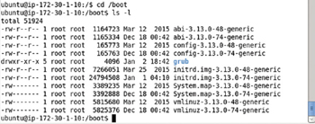

**Figure 1-17:**Listing the Files in the /boot Directory

Open the config-3.13.0-48-generic file in a vi editor.

sudo vi /boot/config-3.13.0-48-generic

The kernel configuration parameters get listed as shown in [Figure 1-18](https://viewer.books24x7.com/assetviewer.aspx?bookid=113388&chunkid=266284266&resumebookmarkid=24b8af05-b4be-e911-b9b2-00505695593a).

[Larger View](https://viewer.books24x7.com/assetviewer.aspx?bookid=113388&chunkid=266284266&resumebookmarkid=24b8af05-b4be-e911-b9b2-00505695593a)

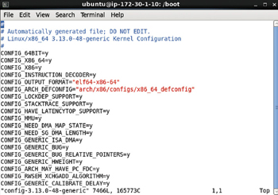

**Figure 1-18:**Kernel Configuration Parameter

Most of the configs listed earlier are already turned on as shown in [Figure 1-19](https://viewer.books24x7.com/assetviewer.aspx?bookid=113388&chunkid=266284266&resumebookmarkid=24b8af05-b4be-e911-b9b2-00505695593a). The CONFIG\_MEMCG\_SWAP\_ENABLED config is not set.

[Larger View](https://viewer.books24x7.com/assetviewer.aspx?bookid=113388&chunkid=266284266&resumebookmarkid=24b8af05-b4be-e911-b9b2-00505695593a)

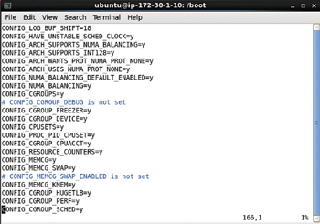

**Figure 1-19:**Most of the Required Kernel Parameters are already Set

Set CONFIG\_MEMCG\_SWAP\_ENABLED = y and save the kernel configuration file as shown in [Figure 1-20](https://viewer.books24x7.com/assetviewer.aspx?bookid=113388&chunkid=266284266&resumebookmarkid=24b8af05-b4be-e911-b9b2-00505695593a).

[Larger View](https://viewer.books24x7.com/assetviewer.aspx?bookid=113388&chunkid=266284266&resumebookmarkid=24b8af05-b4be-e911-b9b2-00505695593a)

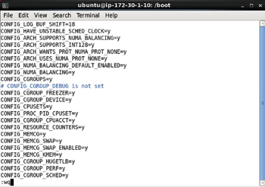

**Figure 1-20:**Setting the CONFIG\_MEMCG\_SWAP\_ENABLED Kernel Parameter

Next, we need to add support for memory and swap accounting to the kernel. The command-line parameters provided to the kernel may be listed with the following command.

cat /proc/cmdline

As shown in [Figure 1-21](https://viewer.books24x7.com/assetviewer.aspx?bookid=113388&chunkid=266284266&resumebookmarkid=24b8af05-b4be-e911-b9b2-00505695593a) memory and swap accounting are not turned on.

[Larger View](https://viewer.books24x7.com/assetviewer.aspx?bookid=113388&chunkid=266284266&resumebookmarkid=24b8af05-b4be-e911-b9b2-00505695593a)

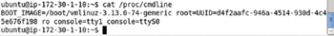

**Figure 1-21:**Listing the Command-Line Parameters

Grub 2 is the default boot loader for Ubuntu. To turn on memory and swap accounting, open the /etc/default/grub file in the vi editor. The GRUB\_CMDLINE\_LINUX is set to an empty string as shown in [Figure 1-22](https://viewer.books24x7.com/assetviewer.aspx?bookid=113388&chunkid=266284266&resumebookmarkid=24b8af05-b4be-e911-b9b2-00505695593a).

[Larger View](https://viewer.books24x7.com/assetviewer.aspx?bookid=113388&chunkid=266284266&resumebookmarkid=24b8af05-b4be-e911-b9b2-00505695593a)

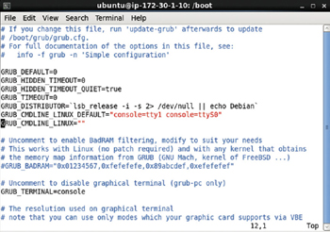

**Figure 1-22:**The /etc/default/grub file

Set the GRUB\_CMDLINE\_LINU as follows, which enables memory and swap accounting in the kernel at boot.

GRUB\_CMDLINE\_LINUX="cgroup\_enable=memory swapaccount=1"

The modified /etc/default/grub file is shown in [Figure 1-23](https://viewer.books24x7.com/assetviewer.aspx?bookid=113388&chunkid=266284266&resumebookmarkid=24b8af05-b4be-e911-b9b2-00505695593a). Save the file with the :wq command.

[Larger View](https://viewer.books24x7.com/assetviewer.aspx?bookid=113388&chunkid=266284266&resumebookmarkid=24b8af05-b4be-e911-b9b2-00505695593a)

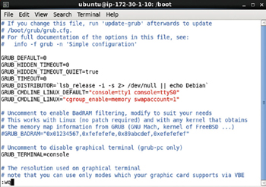

**Figure 1-23:**Modified /etc/default/grub file

Update the grub.cfg file with the following command.

sudo update-grub

The grub configuration file gets generated as shown in [Figure 1-24](https://viewer.books24x7.com/assetviewer.aspx?bookid=113388&chunkid=266284266&resumebookmarkid=24b8af05-b4be-e911-b9b2-00505695593a).

[Larger View](https://viewer.books24x7.com/assetviewer.aspx?bookid=113388&chunkid=266284266&resumebookmarkid=24b8af05-b4be-e911-b9b2-00505695593a)

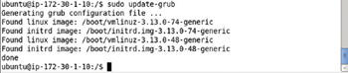

**Figure 1-24:**Generating an Updated Grub Configuration file

Reboot the system.

sudo reboot

Connection to the Ubuntu Amazon EC2 instance gets closed as shown in [Figure 1-25](https://viewer.books24x7.com/assetviewer.aspx?bookid=113388&chunkid=266284266&resumebookmarkid=24b8af05-b4be-e911-b9b2-00505695593a).

[Larger View](https://viewer.books24x7.com/assetviewer.aspx?bookid=113388&chunkid=266284266&resumebookmarkid=24b8af05-b4be-e911-b9b2-00505695593a)

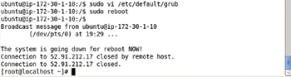

**Figure 1-25:**Rebooting Ubuntu Instance

SSH log in back into the Ubuntu instance. Rerun the command to list the command-line kernel parameters.

cat /proc/cmdline

The cgroup\_enable = memory swapaccount = 1 settings get output as shown in [Figure 1-26](https://viewer.books24x7.com/assetviewer.aspx?bookid=113388&chunkid=266284266&resumebookmarkid=24b8af05-b4be-e911-b9b2-00505695593a).

[Larger View](https://viewer.books24x7.com/assetviewer.aspx?bookid=113388&chunkid=266284266&resumebookmarkid=24b8af05-b4be-e911-b9b2-00505695593a)

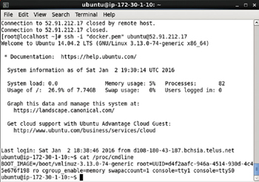

**Figure 1-26:**Updated Settings

Having set the prerequisite kernel parameters, next we shall start the Kubernetes components etcd, master, and service proxy.

**Starting etcd**

Run etcd with the following docker run command.

sudo docker run --net=host -d gcr.io/google\_containers/etcd:2.0.12 /usr/local/bin/etcd

--addr=127.0.0.1:4001 --bind-addr=0.0.0.0:4001 --data-dir=/var/etcd/data

The docker run command parameters are as follows ([Table 1-2](https://viewer.books24x7.com/assetviewer.aspx?bookid=113388&chunkid=914660864&resumebookmarkid=24b8af05-b4be-e911-b9b2-00505695593a)).

**Table 1-2: The docker run Command Parameters to start etcd**[[](https://viewer.books24x7.com/outputobject.aspx?bookid=113388&chunkid=914660864&objectid=ch1_tab2&objecttype=spreadsheet) Open table as spreadsheet](https://viewer.books24x7.com/outputobject.aspx?bookid=113388&chunkid=914660864&objectid=ch1_tab2&objecttype=spreadsheet)

| **Parameter** | **Description** |
| --- | --- |
| --net = host | Connects the Docker container to a network making use of the host container network inside the container |
| -d | Starts the container in the background |
| gcr.io/google\_containers/etcd: 2.0.12 | The container image |
| /usr/local/bin/etcd -- addr = 127.0.0. l: 4001  -bind-addr=0.0.0.0:4001 -- data-dir=/var/etcd/data | The command to run |

The output from the preceding command is shown in [Figure 1-27](https://viewer.books24x7.com/assetviewer.aspx?bookid=113388&chunkid=914660864&resumebookmarkid=24b8af05-b4be-e911-b9b2-00505695593a).

[Larger View](https://viewer.books24x7.com/assetviewer.aspx?bookid=113388&chunkid=914660864&resumebookmarkid=24b8af05-b4be-e911-b9b2-00505695593a)

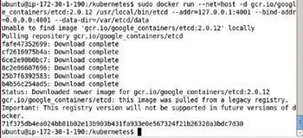

**Figure 1-27:**Starting etcd

The docker run command to start etcd is required to be run each time the Kubernetes cluster manager is to be started. Subsequent starts of etcd do not need to download the container image as shown in [Figure 1-28](https://viewer.books24x7.com/assetviewer.aspx?bookid=113388&chunkid=914660864&resumebookmarkid=24b8af05-b4be-e911-b9b2-00505695593a).

[Larger View](https://viewer.books24x7.com/assetviewer.aspx?bookid=113388&chunkid=914660864&resumebookmarkid=24b8af05-b4be-e911-b9b2-00505695593a)

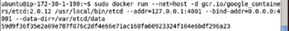

**Figure 1-28:**Subsequent Start of etcd does not need to download the container Image again

**Starting Kubernetes Master**

The Kubernetes master is started using the kubelet, which also starts the other Master components apiserver, scheduler, controller, and pause, which are discussed in [Table 1-3](https://viewer.books24x7.com/assetviewer.aspx?bookid=113388&chunkid=607929411&resumebookmarkid=24b8af05-b4be-e911-b9b2-00505695593a).

**Table 1-3: The docker run Command Parameters to start etcd**[[](https://viewer.books24x7.com/outputobject.aspx?bookid=113388&chunkid=607929411&objectid=ch1_tab3&objecttype=spreadsheet) Open table as spreadsheet](https://viewer.books24x7.com/outputobject.aspx?bookid=113388&chunkid=607929411&objectid=ch1_tab3&objecttype=spreadsheet)

| **Master Component** | **Description** |
| --- | --- |
| Apiserver | The apiserver takes API requests, processes them, and stores the result in etcd if required and returns the result. |
| Scheduler | The scheduler monitors the API for unscheduled pods and schedules them on a node to run and also notifies the about the same to the API. |
| Controller | The controller manages the replication level of the pods, starting new pods in a scale up event and stopping some of the pods in a scale down. |
| Pause | The pause keeps the port mappings of all the containers in the pod or the network endpoint of the pod. |

Run the Kubernetes master with the following command.

sudo docker run \

--volume=/:/rootfs:ro \

--volume=/sys:/sys:ro \

--volume=/dev:/dev \

--volume=/var/lib/docker/:/var/lib/docker:ro \

--volume=/var/lib/kubelet/:/var/lib/kubelet:rw \

--volume=/var/run:/var/run:rw \

--net=host \

--pid=host \

--privileged=true \

-d \

gcr.io/google\_containers/hyperkube:v1.0.1 \

/hyperkube kubelet --containerized --hostname-override="127.0.0.1"

--address="0.0.0.0" --api-

servers=http://localhost:8080 --config=/etc/kubernetes/manifests

The docker run command parameters are discussed in [Table 1-4](https://viewer.books24x7.com/assetviewer.aspx?bookid=113388&chunkid=607929411&resumebookmarkid=24b8af05-b4be-e911-b9b2-00505695593a).

**Table 1-4: The docker run Command Parameters to start etcd**[[](https://viewer.books24x7.com/outputobject.aspx?bookid=113388&chunkid=607929411&objectid=ch1_tab4&objecttype=spreadsheet) Open table as spreadsheet](https://viewer.books24x7.com/outputobject.aspx?bookid=113388&chunkid=607929411&objectid=ch1_tab4&objecttype=spreadsheet)

| **Parameter** | **Description** |
| --- | --- |
| --volume=/:/rootfs:ro \  --volume=/sys:/sys:ro \  --volume=/dev:/dev \  --volume=/var/lib/docker/:/var/lib/docker:ro \  --volume=/var/lib/kubelet/:/var/lib/kubelet:rw \  --volume=/var/run:/var/run:rw \ | The Docker volumes to use |
| --net=host | Connects the Docker container to a network making use of the host container network inside the container |
| --pid=host | Sets the pid namespace |
| --privileged = true | Provides access to most of the capabilities of the host machine in terms of kernel features and host access |
| -d | Starts the container in the background |
| gcr.io/google\_containers/hyperkube:v1.0.1 | The container image |
| hyperkube kubelet  --containerized  --hostname-override= "127.0.0.1"  --address="0.0.0.0"  --api-  servers=http://localhost:8080  --config=/etc/kubernetes/manifests | The command run |

The output from the docker run command to start the master is shown in [Figure 1-29](https://viewer.books24x7.com/assetviewer.aspx?bookid=113388&chunkid=607929411&resumebookmarkid=24b8af05-b4be-e911-b9b2-00505695593a).

[Larger View](https://viewer.books24x7.com/assetviewer.aspx?bookid=113388&chunkid=607929411&resumebookmarkid=24b8af05-b4be-e911-b9b2-00505695593a)

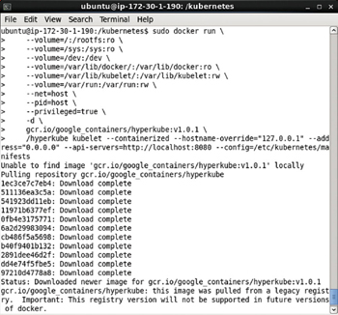

**Figure 1-29:**The docker run Command to start Kubernetes Master

The Master is required to be started each time the Kubernetes cluster manager is to be started. The container image is downloaded only the first time the command is run, and on subsequent runs the image is not downloaded as shown in [Figure 1-30](https://viewer.books24x7.com/assetviewer.aspx?bookid=113388&chunkid=607929411&resumebookmarkid=24b8af05-b4be-e911-b9b2-00505695593a).

[Larger View](https://viewer.books24x7.com/assetviewer.aspx?bookid=113388&chunkid=607929411&resumebookmarkid=24b8af05-b4be-e911-b9b2-00505695593a)

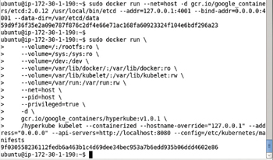

**Figure 1-30:**Subsequent starts of Kubernetes Master do not need to download Container image again

**Starting Service Proxy**

To start the service proxy, which is a proxy for the Kubernetes service providing a pod/s interface using a service selector with labels, start the service proxy by running the following docker run command.

sudo docker run -d --net=host --privileged gcr.io/google\_containers/hyperkube:v1.0.1

/hyperkube proxy -- master=http://127.0.0.1:8080 --v=2

The command parameters for the preceding command are discussed in [Table 1-5](https://viewer.books24x7.com/assetviewer.aspx?bookid=113388&chunkid=218695274&resumebookmarkid=24b8af05-b4be-e911-b9b2-00505695593a).

**Table 1-5: The docker run Command Parameters to start service proxy**[[](https://viewer.books24x7.com/outputobject.aspx?bookid=113388&chunkid=218695274&objectid=ch1_tab5&objecttype=spreadsheet) Open table as spreadsheet](https://viewer.books24x7.com/outputobject.aspx?bookid=113388&chunkid=218695274&objectid=ch1_tab5&objecttype=spreadsheet)

| **Parameter** | **Description** |
| --- | --- |
| -d | Runs the container in the background |
| --net=host | Sets the network for the container to the host's network |
| -- privileged | Provides access to most of the capabilities of the host machine in terms of kernel features and host access |
| gcr.io/google\_containers/hyperkube:v1.0.1 | The container image |
| hyperkube proxy -- master=  http://127.0.0.1:8080 --v=2 | The command to run. The master url is set to [http://127.0.0.1:8080](http://127.0.0.1:8080/). |

The output from the preceding docker run command is shown in [Figure 1-31](https://viewer.books24x7.com/assetviewer.aspx?bookid=113388&chunkid=218695274&resumebookmarkid=24b8af05-b4be-e911-b9b2-00505695593a).

[Larger View](https://viewer.books24x7.com/assetviewer.aspx?bookid=113388&chunkid=218695274&resumebookmarkid=24b8af05-b4be-e911-b9b2-00505695593a)

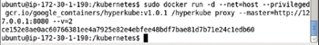

**Figure 1-31:**Starting the Service proxy

**Listing the Kubernetes Docker Containers**

The Docker containers started for a Kubernetes cluster manager may be listed with the following command.

sudo docker ps

The Docker containers listed include a container for the service proxy; a container for the kubelet; a container for etcd; and containers each for the master scheduler, controller, and apiserver, and pause as shown in [Figure 1-32](https://viewer.books24x7.com/assetviewer.aspx?bookid=113388&chunkid=943786928&resumebookmarkid=24b8af05-b4be-e911-b9b2-00505695593a).

[Larger View](https://viewer.books24x7.com/assetviewer.aspx?bookid=113388&chunkid=943786928&resumebookmarkid=24b8af05-b4be-e911-b9b2-00505695593a)

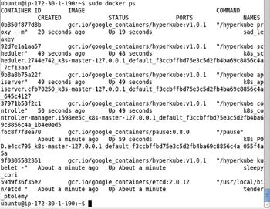

**Figure 1-32:**Listing the Docker Containers

The Docker container info may be found using the Docker container id. For example, obtain the container id for the Docker container running the controller as shown in [Figure 1-33](https://viewer.books24x7.com/assetviewer.aspx?bookid=113388&chunkid=943786928&resumebookmarkid=24b8af05-b4be-e911-b9b2-00505695593a).

[Larger View](https://viewer.books24x7.com/assetviewer.aspx?bookid=113388&chunkid=943786928&resumebookmarkid=24b8af05-b4be-e911-b9b2-00505695593a)

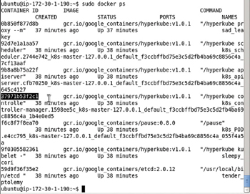

**Figure 1-33:**Obtaining the Docker Container Id

Run the following command to find the detail about the Docker container.

sudo docker inspect 37971b53f2c1

The detail such as the master ip and about the Docker container running the controller manager gets output as shown in [Figure 1-34](https://viewer.books24x7.com/assetviewer.aspx?bookid=113388&chunkid=943786928&resumebookmarkid=24b8af05-b4be-e911-b9b2-00505695593a).

[Larger View](https://viewer.books24x7.com/assetviewer.aspx?bookid=113388&chunkid=943786928&resumebookmarkid=24b8af05-b4be-e911-b9b2-00505695593a)

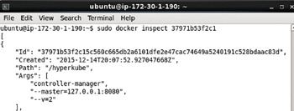

**Figure 1-34:**Listing Docker Container Information

**Installing kubectl**

The kubectl is used to control the Kubernetes cluster manager including running an image, getting the pods, getting the replication controller, making an application available as a service exposed at a specified port, and scaling the cluster. Download Kubectl binaries with the following command.

sudo wget https://storage.googleapis.com/kubernetes-release/release/v1.0.1/bin/linux/amd64/kubectl

The kubectl binaries get downloaded as shown in [Figure 1-35](https://viewer.books24x7.com/assetviewer.aspx?bookid=113388&chunkid=516995709&resumebookmarkid=24b8af05-b4be-e911-b9b2-00505695593a).

[Larger View](https://viewer.books24x7.com/assetviewer.aspx?bookid=113388&chunkid=516995709&resumebookmarkid=24b8af05-b4be-e911-b9b2-00505695593a)

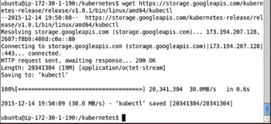

**Figure 1-35:**Installing Kubectl

Make the kubectl application executable by applying the + x permissions.

sudo chmod +x kubectl

Move the kubectl binaries to the /usr/local/bin/ directory.

sudo mv kubectl /usr/local/bin/

The output from the preceding commands is shown in [Figure 1-36](https://viewer.books24x7.com/assetviewer.aspx?bookid=113388&chunkid=516995709&resumebookmarkid=24b8af05-b4be-e911-b9b2-00505695593a).

[Larger View](https://viewer.books24x7.com/assetviewer.aspx?bookid=113388&chunkid=516995709&resumebookmarkid=24b8af05-b4be-e911-b9b2-00505695593a)



**Figure 1-36:**Moving and making kubectl Binaries executable

The kubectl command lists the usage as shown in [Figure 1-37](https://viewer.books24x7.com/assetviewer.aspx?bookid=113388&chunkid=516995709&resumebookmarkid=24b8af05-b4be-e911-b9b2-00505695593a).

[Larger View](https://viewer.books24x7.com/assetviewer.aspx?bookid=113388&chunkid=516995709&resumebookmarkid=24b8af05-b4be-e911-b9b2-00505695593a)

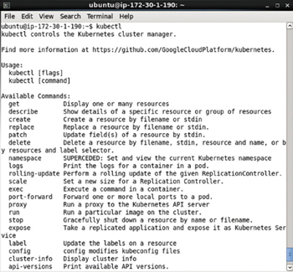

**Figure 1-37:**Kubectl Command Usage

The command parameters also get listed as shown in [Figure 1-38](https://viewer.books24x7.com/assetviewer.aspx?bookid=113388&chunkid=516995709&resumebookmarkid=24b8af05-b4be-e911-b9b2-00505695593a).

[Larger View](https://viewer.books24x7.com/assetviewer.aspx?bookid=113388&chunkid=516995709&resumebookmarkid=24b8af05-b4be-e911-b9b2-00505695593a)

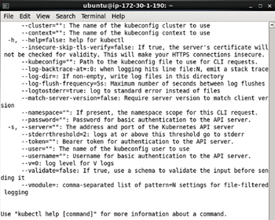

**Figure 1-38:**Command Parameters for Kubectl

**Listing Services**

The following command should list the Kubernetes service.

kubectl get services

The kubernetes service gets listed as shown in [Figure 1-39](https://viewer.books24x7.com/assetviewer.aspx?bookid=113388&chunkid=291480956&resumebookmarkid=24b8af05-b4be-e911-b9b2-00505695593a).

[Larger View](https://viewer.books24x7.com/assetviewer.aspx?bookid=113388&chunkid=291480956&resumebookmarkid=24b8af05-b4be-e911-b9b2-00505695593a)

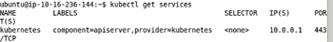

**Figure 1-39:**Listing the Kubernetes Service

**Listing Nodes**

The following command should list the Kubernetes node.

kubectl get nodes

The single node in the cluster gets listed as shown in [Figure 1-40](https://viewer.books24x7.com/assetviewer.aspx?bookid=113388&chunkid=323155872&resumebookmarkid=24b8af05-b4be-e911-b9b2-00505695593a).

[Larger View](https://viewer.books24x7.com/assetviewer.aspx?bookid=113388&chunkid=323155872&resumebookmarkid=24b8af05-b4be-e911-b9b2-00505695593a)

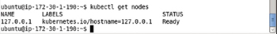

**Figure 1-40:**Listing the Nodes

**Testing the Kubernetes Installation**

To test the Kubernetes cluster manager, run the nginx application using the following command.

kubectl -s http://localhost:8080 run nginx --image=nginx --port=80

The output from the kubectl run command lists the replication controller, container/s, image/sm selector, and replicas as shown in [Figure 1-41](https://viewer.books24x7.com/assetviewer.aspx?bookid=113388&chunkid=558319350&resumebookmarkid=24b8af05-b4be-e911-b9b2-00505695593a).

[Larger View](https://viewer.books24x7.com/assetviewer.aspx?bookid=113388&chunkid=558319350&resumebookmarkid=24b8af05-b4be-e911-b9b2-00505695593a)

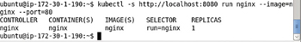

**Figure 1-41:**Running he nginx Application on Kubernetes Cluster

Expose the nginx application replication controller as a service with the kubectl expose command.

kubectl expose rc nginx --port=80

The nginx Kubernetes service gets created running on port 80 as shown in [Figure 1-42](https://viewer.books24x7.com/assetviewer.aspx?bookid=113388&chunkid=558319350&resumebookmarkid=24b8af05-b4be-e911-b9b2-00505695593a).

[Larger View](https://viewer.books24x7.com/assetviewer.aspx?bookid=113388&chunkid=558319350&resumebookmarkid=24b8af05-b4be-e911-b9b2-00505695593a)

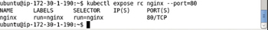

**Figure 1-42:**Creating a Kubernetes Service for nginx Application

List the detail about the nginx service with the kubectl get svc command.

kubectl get svc nginx

The nginx service detail gets listed as shown in [Figure 1-43](https://viewer.books24x7.com/assetviewer.aspx?bookid=113388&chunkid=558319350&resumebookmarkid=24b8af05-b4be-e911-b9b2-00505695593a).

[Larger View](https://viewer.books24x7.com/assetviewer.aspx?bookid=113388&chunkid=558319350&resumebookmarkid=24b8af05-b4be-e911-b9b2-00505695593a)

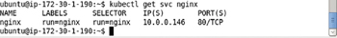

**Figure 1-43:**Listing the Kubernetes Service nginx

The cluster IP may be obtained with the following command.

kubectl get svc nginx --template={{.spec.clusterIP}}

The cluster ip is listed as 10.0.0.146 as shown in [Figure 1-44](https://viewer.books24x7.com/assetviewer.aspx?bookid=113388&chunkid=558319350&resumebookmarkid=24b8af05-b4be-e911-b9b2-00505695593a).

[Larger View](https://viewer.books24x7.com/assetviewer.aspx?bookid=113388&chunkid=558319350&resumebookmarkid=24b8af05-b4be-e911-b9b2-00505695593a)



**Figure 1-44:**Listing the Cluster IP

The web server may be called making use of the cluster ip with the following command.

curl 10.0.0.146

The html output as text gets output as shown in [Figure 1-45](https://viewer.books24x7.com/assetviewer.aspx?bookid=113388&chunkid=558319350&resumebookmarkid=24b8af05-b4be-e911-b9b2-00505695593a).

[Larger View](https://viewer.books24x7.com/assetviewer.aspx?bookid=113388&chunkid=558319350&resumebookmarkid=24b8af05-b4be-e911-b9b2-00505695593a)

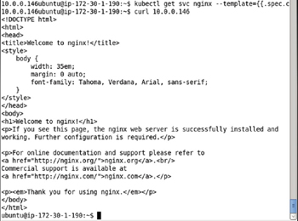

**Figure 1-45:**Using curl to invoke Application

### Summary

In this chapter we installed Kubernetes using Docker. An Amazon EC2 instance running Ubuntu is used to install Docker and Kubernetes. The nginx application is run only to test the installation of the Kubernetes cluster manager. The kubectl commands to create an application, replication controller, and service are discussed in more detail in the next chapter.

**Kubernetes Microservices with Docker**

Chapter 2 - Hello Kubernetes

Apress © 2016

**Chapter 2: Hello Kubernetes**

**© Deepak Vohra 2016  
D. Vohra, *Kubernetes Microservices with Docker*, DOI 10.1007/978-1-4842-1907-2\_2**

**Overview**

Kubernetes is a cluster manager for Linux containers. While Kubernetes supports other types of containers such as Rocket, and support for more types is to be added, we shall discuss Kubernetes in the context of Docker containers only. Docker is an open source container virtualization platform to build, package, and run distributed applications in containers that are lightweight snapshots of the underlying OS. A Docker image, which is application specific, encapsulates all the required software including dependencies for an application and is used to create Docker containers to run applications in the containers. The Docker containers are isolated from each other and have their own networking and filesystem and provide Container as a Service (CaaS). Docker is similar to virtual machines based on virtualization platforms such as Oracle VirtualBox and VMWare Player in that it is a virtualization over the underlying OS, but is different in that while a virtual machine makes use of an entire operating system, multiple Docker containers share the kernel and run in isolation on the host OS. Docker containers run on the Docker Engine, which runs on the underlying OS kernel.

In this chapter we shall introduce Kubernetes concepts using a Hello-World application.

Kubernetes concepts include Pod, Service, and Replication controller and are defined in the following subsections.

**What Is a Node?**

A *node* is a machine (physical or virtual) running Kubernetes onto which Pods may be scheduled. The node could be the *master node* or one of the *worker nodes*. In the preceding chapter on installing Kubernetes only a single node was used. In a later chapter, [Chapter 14](http://viewer.books24x7.com/assetviewer.aspx?bkid=113388&destid=1233#1233), we shall discuss creating a multi-node clusterwith a master and worker node/s.

**What Is a Cluster?**

A *cluster* is a collection of nodes including other resources such as storage to run Kubernetes applications. A cluster has a single Kubernetes master node and zero or more worker nodes. A highly available cluster consists of multiple masters or master nodes.

**What Is a Pod?**

*A Pod* is a collection of containers that are collocated and form an atomic unit. Multiple applications may be run within a Pod and though the different containers within a Pod could be for the same application, typically the different containers are for different applications. A Pod is a higher level abstraction for managing a group of containers with shared volumes and network namespace. All the applications (containers) in a Pod share the same filesystem and IP address with the port on which each application is exposed being different. Applications running in a Pod may access each other at "localhost" Scheduling and replication are performed at the Pod level rather than at the individual container level. For example if a Pod defines two containers for different applications and replication level is set at 1, a single replica of the Pod consists of two containers, one each for the two applications. Pods facilitate resource sharing and communication what would otherwise be implemented using --link in individually running Docker containers. A Pod consisting of multiple containers would typically be used for tightly coupled applications. For example, if an nginx application makes use of MySQL database, the two applications are able to interact by Kubernetes running containers for each in the same Pod.

**What Is a Service?**

A *Service* is the external interface for one or more Pods providing endpoint/s at which the application/s represented by the Service may be invoked. A Service is hosted at a single IP address but provides zero or more endpoints depending on the application/s interfaced by the Service. Services are connected to Pods using label selectors. Pods have label/s on them and a Service with a selector expression the same as a Pod label represents the Pod to an external client. An external client does not know or need to know about the Pods represented by a Service. An external client only needs to know the name of the Service and the port at which a particular application is exposed. The Service routes requests for an application based on a round-robin manner to one of the Pods selected using a label selector/. Thus, a Service is a high level abstraction for a collection of applications leaving the detail of which Pod to route a request to up to the Service. A Service could also be used for load balancing.

**What Is a Replication Controller?**

A *Replication Controller* manages the replication level of Pods as specified by the "replicas" setting in a Replication Controller definition or on the command line with the -replicasparameter. A Replication Controller ensures that the configured level of Pod replicas are running at any given time. If a replica fails or is stopped deliberately a new replica is started automatically. A Replication Controller is used for scaling the Pods within a cluster. A replica is defined at the Pod level implying that if a Pod consists of two containers a group of the two configured containers constitute a replica.

**What Is a Label?**

A *Label* is a key-value pair identifying a resource such as a Pod, Service, or Replication Controller: most commonly a Pod. Labels are used to identify a group or subset of resources for tasks such as assigning them to a Service. Services use label selectors to select the Pods they manage. For example, if a Pod is labeled "app = helloApp" and a Service "selector" is set as "app = helloApp" the Pod is represented by the Service. Service selectors are based on labels and not on the type of application they manage. For example, a Service could be representing a Pod running a hello-world application container with a specific label. Another Pod also running a hello-world container but with a label different than the Service selector expression would not be represented by the Service. And a third Pod running an application that is not a hello-world application but has the same label as the Service selector would also be represented by the same Service.

**What Is a Selector?**

A *selector* is a key-value expression to identify resources using matching labels. As discussed in the preceding subsection a Service selector expression "app = helloApp" would select all Pods with the label "app = helloApp". While typically a Service defines a selector to select Pods a Service could be defined to not include a selector and be defined to abstract other kinds of back ends. Two kinds of selectors are supported: equality-based and set-based. A selector could be made of multiple requirements implying that multiple expressions (equality-based or set-based) separated by ',' could be specified. All of the requirements must be met by a matching resource such as a Pod for the resource to be selected. A resource such as a Pod could have additional labels, but the ones in the selector must be specified for the resource to be selected. The equality-based selector, which is more commonly used and also the one used in the book, supports =,!=,== operators, the = being synonymous to ==.

**What Is a Name?**

A *name* is identifies a resource. A name is not the same as a label. For matching resources with a Service a label is used and not a name.

**What Is a Namespace?**

A *namespace* is a level above the name to demarcate a group of resources for a project or team to prevent name collisions. Resources within different namespaces could have the same name, but resources within a namespace have different names.

**What Is a Volume?**

A *volume* is a directory within the filesystem of a container. A volume could be used to store data. Kubernetes volumes evolve from Docker volumes.

**Why Kubernetes?**

Docker containers introduced a new level of modularity and fluidity for applications with the provision to package applications including dependencies, and transfer and run the applications across different environments. But with the use of Docker containers in production, practical problems became apparent such as which container to run on which node (scheduling), how to increase/decrease the number of running containers for an application (scaling), and how to communicate within containers. Kubernetes was designed to overcome all these and other practical issues of container cluster management. Kubernetes provides dynamic container cluster orchestration in real time. Kubernetes as a cluster manager provides the following benefits.

* -Microservices by breaking an application into smaller, manageable, scalable components that could be used by groups with different requirements.
* -Fault-tolerant cluster in which if a single Pod replica fails (due to node failure, for example), another is started automatically.
* -Horizontal scaling in which additional or fewer replicas of a Pod could be run by just modifying the "replicas" setting in the Replication Controller or using the -replicas parameter in the kubectl scale command.
* -Higher resource utilization and efficiency.
* -Separation of concerns. The Service development team does not need to interface with the cluster infrastructure team.

**Setting the Environment**

The following software is required for this chapter.

* -Docker Engine (latest version)
* -Kubernetes (version 1.01)
* -Kubectl (version 1.01)

We have used an Amazon EC2 Linux instance created from AMI Ubuntu Server 14.04 LTS (HVM), SSD Volume Type - ami-d05e75b8.

SSH Login to the Ubuntu interface (Public IP address would be different for different users and multiple IP Addresses may have been used in this chapter).

ssh -i "docker.pem" ubuntu@54.152.82.142

Install Docker as discussed in [Chapter 1](http://viewer.books24x7.com/assetviewer.aspx?bkid=113388&destid=28#28) and start the Docker Engine and verify its status using the following commands.

sudo service docker start

sudo service docker status

Install kubectl and start the Kubernetes cluster manager as discussed in [Chapter 1](http://viewer.books24x7.com/assetviewer.aspx?bkid=113388&destid=28#28). Output the Kubernetes cluster information using the following command.

kubectl cluster-info

The Kubernetes Master is shown running on [http://localhost:8080](http://localhost:8080/) in [Figure 2-1](https://viewer.books24x7.com/assetviewer.aspx?bookid=113388&chunkid=654452477&resumebookmarkid=24b8af05-b4be-e911-b9b2-00505695593a).

[Larger View](https://viewer.books24x7.com/assetviewer.aspx?bookid=113388&chunkid=654452477&resumebookmarkid=24b8af05-b4be-e911-b9b2-00505695593a)



**Figure 2-1:**Getting Cluster Info

In the following sections we shall run a hello-world application using the Kubernetes cluster manager. An application may be run imperatively using the kubectl tool on the command line or declaratively using definition files for a Pod, Replication Controller, and Service. We shall discuss each of these methods. The kubectl tool is used throughout this chapter and in subsequent chapters and a complete command reference is available at <https://cloud.google.com/container-engine/docs/kubectl/>.

**Creating an Application Imperatively**

With the Kubernetes master running on [http://localhost:8080](http://localhost:8080/), as obtained in the preceding section, run the following kubectl run command to run a hello-world application using the image tutum/hello-world. The –s option specifies the Kubernetes API server host and port. The –image command parameter specifies the Docker image to run as tutum/hello-world. The –replicas parameter specifies the number of replicas to create as 1. A Replication Controller is created even if the –replicas parameter is not specified. The default number of replicas is 1. The –port parameter specifies the container port the application is hosted at as 80.

kubectl -s http://localhost:8080 run hello-world --image=tutum/hello-world --replicas=1 --port=80

A new application container called hello-world gets created as shown in [Figure 2-2](https://viewer.books24x7.com/assetviewer.aspx?bookid=113388&chunkid=737027301&resumebookmarkid=24b8af05-b4be-e911-b9b2-00505695593a). A Replication Controller called "hello-world" also gets created. The Pod is created implicitly and label "run = hello-world" is added to the Pod. The number of replicas created is 1. The Replication Controller's selector field is also set to "run=hello-world" The Pods managed by a Replication Controller must specify a label that is the same as the selector specified at the Replication Controller level. By default a Replication Controller selector is set to the same expression as the Pod label.

[Larger View](https://viewer.books24x7.com/assetviewer.aspx?bookid=113388&chunkid=737027301&resumebookmarkid=24b8af05-b4be-e911-b9b2-00505695593a)

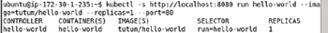

**Figure 2-2:**Creating an Application including a Replication Controller and Pod Replica/s

The Replication Controller created may be listed with the following command.

kubectl get rc

The hello-world Replication Controller gets listed as shown in [Figure 2-3](https://viewer.books24x7.com/assetviewer.aspx?bookid=113388&chunkid=737027301&resumebookmarkid=24b8af05-b4be-e911-b9b2-00505695593a).

[Larger View](https://viewer.books24x7.com/assetviewer.aspx?bookid=113388&chunkid=737027301&resumebookmarkid=24b8af05-b4be-e911-b9b2-00505695593a)



**Figure 2-3:**Listing the Replication Controllers

The Pods created and started are listed with the following command.

kubectl get pods

The single Pod created gets listed as shown in [Figure 2-4](https://viewer.books24x7.com/assetviewer.aspx?bookid=113388&chunkid=737027301&resumebookmarkid=24b8af05-b4be-e911-b9b2-00505695593a). A Pod name is assigned automatically. A Pod STATUS "Running" is listed, but the Pod may still not be ready and available. The READY column value of 0/1 indicates that 0 of 1 containers in the Pod are ready, which implies that the Pod has been created and is running but not yet ready. It could take a few seconds for a Pod to become Ready.

[Larger View](https://viewer.books24x7.com/assetviewer.aspx?bookid=113388&chunkid=737027301&resumebookmarkid=24b8af05-b4be-e911-b9b2-00505695593a)

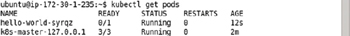

**Figure 2-4:**Listing the Pods

Run the same command again after a few seconds or a minute.

kubectl get pods

The Pod gets listed as ready as indicated by 1/1 in the READY column in [Figure 2-5](https://viewer.books24x7.com/assetviewer.aspx?bookid=113388&chunkid=737027301&resumebookmarkid=24b8af05-b4be-e911-b9b2-00505695593a). A value of 1/1 in the READY column indicates that 1 of 1 containers in the Pod are ready. The syntax for the READY column value is nReady/nTotal, which implies that nReady of the total nTotal containers in the Pod are ready. The Kubernetes Pod k8s-master-127.0.0.1, for example, has a READY column value of 3/3, which implies that 3 of 3 containers in the Kubernetes Pod are ready.

[Larger View](https://viewer.books24x7.com/assetviewer.aspx?bookid=113388&chunkid=737027301&resumebookmarkid=24b8af05-b4be-e911-b9b2-00505695593a)

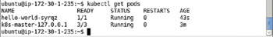

**Figure 2-5:**Listing a Pod as ready with all containers in the Pod as ready

Running a Pod and a Replication Controller does not implicitly create a Service. In the next subsection we shall create a Service for the hello-world application.

**Creating a Service**

Create a Kubernetes Service using the kubectl expose command, which creates a Service from a Pod, Replication Controller, or another Service. As we created a Replication Controller called hello-world, create a Service using the following command in which the port to expose the Service is set to 8080 and the Service type is LoadBalancer.

kubectl expose rc hello-world --port=8080 --type=LoadBalancer

A Kubernetes Service called hello-world gets created as shown in [Figure 2-6](https://viewer.books24x7.com/assetviewer.aspx?bookid=113388&chunkid=737027301&resumebookmarkid=24b8af05-b4be-e911-b9b2-00505695593a). The Service labels and selector also get set. The Service selector, listed in [Figure 2-6](https://viewer.books24x7.com/assetviewer.aspx?bookid=113388&chunkid=737027301&resumebookmarkid=24b8af05-b4be-e911-b9b2-00505695593a), is set to the same expression run=hello-world as the Replication Controller selector, which is shown in [Figure 2-3](https://viewer.books24x7.com/assetviewer.aspx?bookid=113388&chunkid=737027301&resumebookmarkid=24b8af05-b4be-e911-b9b2-00505695593a), which implies that the Service manages the Pods in the Replication Controller hello-world.

[Larger View](https://viewer.books24x7.com/assetviewer.aspx?bookid=113388&chunkid=737027301&resumebookmarkid=24b8af05-b4be-e911-b9b2-00505695593a)

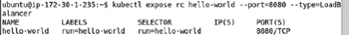

**Figure 2-6:**Creating a Kubernetes Service

The different types of Services are ClusterIp, NodePort, and LoadBalancer with the default being ClusterIP, as discussed in [Table 2-1](https://viewer.books24x7.com/assetviewer.aspx?bookid=113388&chunkid=737027301&resumebookmarkid=24b8af05-b4be-e911-b9b2-00505695593a).

**Table 2-1: Types of Services**[[](https://viewer.books24x7.com/outputobject.aspx?bookid=113388&chunkid=737027301&objectid=ch2_tab1&objecttype=spreadsheet) Open table as spreadsheet](https://viewer.books24x7.com/outputobject.aspx?bookid=113388&chunkid=737027301&objectid=ch2_tab1&objecttype=spreadsheet" \t "_blank)

| **Service Type** | **Description** |
| --- | --- |
| ClusterIp | Uses a cluster-internal IP only. |
| NodePort | In addition to a cluster IP exposes the Service on each node of the cluster. |
| LoadBalancer | In addition to exposing the Service on a cluster internal Ip and a port on each node on the cluster, requests the cloud provider to provide a load balancer for the Service. The load balancer balances the load between the Pods in the Service. |

List all the Kubernetes Services with the following command.

kubectl get services

In addition to the "kubernetes" Service for the Kubernetes cluster manager a "hello-world" Service gets created as shown in [Figure 2-7](https://viewer.books24x7.com/assetviewer.aspx?bookid=113388&chunkid=737027301&resumebookmarkid=24b8af05-b4be-e911-b9b2-00505695593a).

[Larger View](https://viewer.books24x7.com/assetviewer.aspx?bookid=113388&chunkid=737027301&resumebookmarkid=24b8af05-b4be-e911-b9b2-00505695593a)

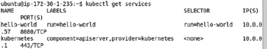

**Figure 2-7:**Listing the Services

**Describing a Pod**

Using the Pod name hello-world-syrqz obtained from the NAME column in the result for the kubectl get pods command use the kubectl describe pod command to list detailed information about the Pod.

kubectl describe pod hello-world-syrqz

Detailed information about the Pod including the IP address gets listed as shown in [Figure 2-8](https://viewer.books24x7.com/assetviewer.aspx?bookid=113388&chunkid=737027301&resumebookmarkid=24b8af05-b4be-e911-b9b2-00505695593a). The Pod has a Label run=hello-world, which is the same as the replication controller selector and also same as the service selector, which implies that the replication controller manages the Pod when scaling the cluster of Pods for example, and the service represents the Pod to external clients.

[Larger View](https://viewer.books24x7.com/assetviewer.aspx?bookid=113388&chunkid=737027301&resumebookmarkid=24b8af05-b4be-e911-b9b2-00505695593a)

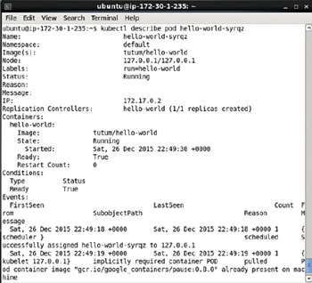

**Figure 2-8:**Describing a Pod

Next, we shall invoke the application using the IP Address 172.0.17.2 listed in the IP field.

**Invoking the Hello-World Application**

The hello-world application may be invoked using the IP for the application as listed in [Figure 2-8](https://viewer.books24x7.com/assetviewer.aspx?bookid=113388&chunkid=737027301&resumebookmarkid=24b8af05-b4be-e911-b9b2-00505695593a) with the following curl command.

curl 172.17.0.2

The HTML output from the application is shown in [Figure 2-9](https://viewer.books24x7.com/assetviewer.aspx?bookid=113388&chunkid=737027301&resumebookmarkid=24b8af05-b4be-e911-b9b2-00505695593a).

[Larger View](https://viewer.books24x7.com/assetviewer.aspx?bookid=113388&chunkid=737027301&resumebookmarkid=24b8af05-b4be-e911-b9b2-00505695593a)

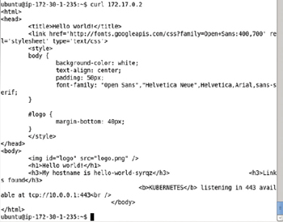

**Figure 2-9:**Invoking a Application using Pod IP with curl

To display the HTML output in a browser we need to invoke the application from a browser using URL 172.17.0.2:80. If a browser is not available on the Amazon EC2 Ubuntu instance, as it is not by default, we need to set up a SSH tunnel to the IP Address of the application using local port forwarding. Obtain the Public DNS for the Amazon EC2 instance ([ec2-52-91-200-41.compute-1.amazonaws.com](http://ec2-52-91-200-41.compute-1.amazonaws.com/) in the example) and run the following command to set up a SSH tunnel to the 172.17.0.2:80 host:port from a local machine. The –L indicates that local port forwarding is used to forward local port 80 to 172.17.0.2:80.

ssh -i "docker.pem" -f -nNT -L 80:172.17.0.2:80 ubuntu@ec2-52-91-200-41.compute-1.amazonaws.com

Invoke the URL [http://localhost](http://localhost/) in a browser on the local machine. The HTML output from the hello-world application gets displayed as shown in [Figure 2-10](https://viewer.books24x7.com/assetviewer.aspx?bookid=113388&chunkid=737027301&resumebookmarkid=24b8af05-b4be-e911-b9b2-00505695593a). The hostname is listed the same as the Pod name in [Figure 2-5](https://viewer.books24x7.com/assetviewer.aspx?bookid=113388&chunkid=737027301&resumebookmarkid=24b8af05-b4be-e911-b9b2-00505695593a).

[Larger View](https://viewer.books24x7.com/assetviewer.aspx?bookid=113388&chunkid=737027301&resumebookmarkid=24b8af05-b4be-e911-b9b2-00505695593a)

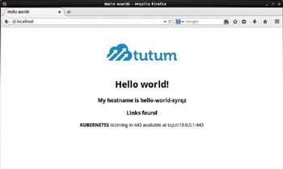

**Figure 2-10:**Invoking the Hello-World Application in a Browser

**Scaling the Application**

A Replication Controller was created by default when we created the hello-worldapplication with replicas set as 1. Next, we shall scale up the number of Pods to 4. The kubectl scale command is used to scale a Replication Controller. Run the following command to scale up the Replication Controller hello-world to 4.

kubectl scale rc hello-world --replicas=4

Subsequently, list the Pods using the following command.

kubectl get pods

The additional Pods get listed but some of the new Pods could be listed in various states such as running but not ready, or image ready and container creating as shown in [Figure 2-11](https://viewer.books24x7.com/assetviewer.aspx?bookid=113388&chunkid=737027301&resumebookmarkid=24b8af05-b4be-e911-b9b2-00505695593a).

[Larger View](https://viewer.books24x7.com/assetviewer.aspx?bookid=113388&chunkid=737027301&resumebookmarkid=24b8af05-b4be-e911-b9b2-00505695593a)

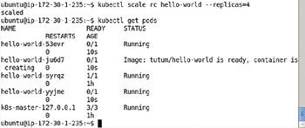

**Figure 2-11:**Scaling the Cluster of Pods with the Replication Controller

After a few seconds run the same command again to list the Pods.

kubectl get pods

If the Pods have started all the Pods are listed with STATUS- > Running and READY state 1/1 as shown in [Figure 2-12](https://viewer.books24x7.com/assetviewer.aspx?bookid=113388&chunkid=737027301&resumebookmarkid=24b8af05-b4be-e911-b9b2-00505695593a). Scaling to 4 replicas does not create 4 new Pods, but the total number of Pods is scaled to 4 and the single Pod created initially is included in the new scaled replicas of 4.

[Larger View](https://viewer.books24x7.com/assetviewer.aspx?bookid=113388&chunkid=737027301&resumebookmarkid=24b8af05-b4be-e911-b9b2-00505695593a)

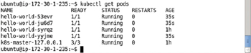

**Figure 2-12:**Listing all the Pods as Running and Ready

Describe the hello-world Service using the following command.

kubectl describe svc hello-world

The Service name, label/s, selector, type, IP, and Endpoints get listed as shown in [Figure 2-13](https://viewer.books24x7.com/assetviewer.aspx?bookid=113388&chunkid=737027301&resumebookmarkid=24b8af05-b4be-e911-b9b2-00505695593a). The Service may be invoked using the Endpoints for the various Pod replicas.

[Larger View](https://viewer.books24x7.com/assetviewer.aspx?bookid=113388&chunkid=737027301&resumebookmarkid=24b8af05-b4be-e911-b9b2-00505695593a)

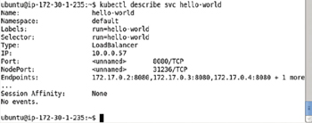

**Figure 2-13:**Describing the Service hello-world

As discussed previously, set up SSH tunneling with port forwarding for the newly added endpoints. The following command sets up a SSH tunnel with port forwarding from localhost port 8081 to 172.17.0.3:80 on the Amazon EC2 instance.

ssh -i "docker.pem" -f -nNT -L 8081:172.17.0.3:80 ubuntu@ec2-52-91-200-41.compute-1.

amazonaws.com

Subsequently invoke the hello-world application in a browser on a local machine with url [http://localhost:8081](http://localhost:8081/) to display the application output as shown in [Figure 2-14](https://viewer.books24x7.com/assetviewer.aspx?bookid=113388&chunkid=737027301&resumebookmarkid=24b8af05-b4be-e911-b9b2-00505695593a).

[Larger View](https://viewer.books24x7.com/assetviewer.aspx?bookid=113388&chunkid=737027301&resumebookmarkid=24b8af05-b4be-e911-b9b2-00505695593a)

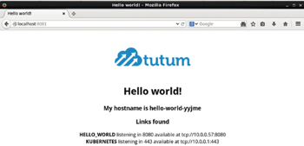

**Figure 2-14:**Invoking an Application in a Local Browser

Similarly the following command from a local machine sets up a SSH tunnel with port forwarding from localhost port 8082 to 172.17.0.4:80 on the Amazon EC2 instance.

ssh -i "docker.pem" -f -nNT -L 8082:172.17.0.4:80 ubuntu@ec2-52-91-200-41.compute-1.

amazonaws.com

Subsequently invoke the hello-world application using url [http://localhost:8082](http://localhost:8082/) to display the application output as shown in [Figure 2-15](https://viewer.books24x7.com/assetviewer.aspx?bookid=113388&chunkid=737027301&resumebookmarkid=24b8af05-b4be-e911-b9b2-00505695593a).

[Larger View](https://viewer.books24x7.com/assetviewer.aspx?bookid=113388&chunkid=737027301&resumebookmarkid=24b8af05-b4be-e911-b9b2-00505695593a)

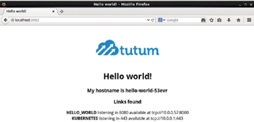

**Figure 2-15:**Invoking the second Service Endpoint in a Local Browser

**Deleting a Replication Controller**

The Replication Controller hello-world may be deleted with the following command.

kubectl delete rc hello-world

The Replication Controller gets deleted as shown in [Figure 2-16](https://viewer.books24x7.com/assetviewer.aspx?bookid=113388&chunkid=737027301&resumebookmarkid=24b8af05-b4be-e911-b9b2-00505695593a). Subsequently invoke the following command to list the Replication Controllers.

[Larger View](https://viewer.books24x7.com/assetviewer.aspx?bookid=113388&chunkid=737027301&resumebookmarkid=24b8af05-b4be-e911-b9b2-00505695593a)

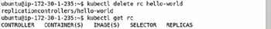

**Figure 2-16:**Deleting a Replication Controller

kubectl get rc

The hello-world Replication Controller does not get listed as shown in [Figure 2-16](https://viewer.books24x7.com/assetviewer.aspx?bookid=113388&chunkid=737027301&resumebookmarkid=24b8af05-b4be-e911-b9b2-00505695593a).

Deleting a Replication Controller deletes the Replication Controller and the Pods associated with the Replication Controller but does not delete the Service representing the Replication Controller. The kubectl get services command still lists the Service as shown in [Figure 2-17](https://viewer.books24x7.com/assetviewer.aspx?bookid=113388&chunkid=737027301&resumebookmarkid=24b8af05-b4be-e911-b9b2-00505695593a).

[Larger View](https://viewer.books24x7.com/assetviewer.aspx?bookid=113388&chunkid=737027301&resumebookmarkid=24b8af05-b4be-e911-b9b2-00505695593a)

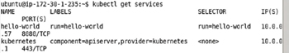

**Figure 2-17:**Deleting a Replication Controller does not delete the Service

**Deleting a Service**

To delete the Service hello-world run the following command.

kubectl delete svc hello-world

Subsequently invoke the following command to list the Services.

kubectl get services

The output from the preceding two commands is shown in [Figure 2-18](https://viewer.books24x7.com/assetviewer.aspx?bookid=113388&chunkid=737027301&resumebookmarkid=24b8af05-b4be-e911-b9b2-00505695593a) and does not list the hello-world Service.

[Larger View](https://viewer.books24x7.com/assetviewer.aspx?bookid=113388&chunkid=737027301&resumebookmarkid=24b8af05-b4be-e911-b9b2-00505695593a)

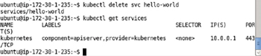

**Figure 2-18:**Deleting the hello-world Service

### Creating an Application Declaratively

Next, we shall create the same hello-world application declaratively using definition files for a Pod, Service, and Replication Controller. The definition files may be configured in YAML or JSON. We have used YAML initially and also discussed the JSON alternative later.

#### Creating a Pod Definition

Create a hello-world.yaml file and specify a definition for a Pod in the file. For the hello-world application the following definition is used in which the apiVersion mapping is for the API schema version (v1), kind mapping is the resource and set to Pod. The metadata mapping specifies the Pod's metadata and sets the name to hello-world (arbitrary). The spec mapping specifies the Pod behavior. The spec- > containers mapping specifies a collection of images to run. The hello-world.yaml specifies a single container for image tutum/hello-world. Container name is set to hello-world and container ports mapping is a list of ports with a single containerPort mapping for 8080 port.

apiVersion: v1

kind: Pod

metadata:

name: hello-world

spec:

containers:

-

image: tutum/hello-world

name: hello-world

ports:

-containerPort: 8080

The preceding is equivalent to the following command.

kubectl run hello-world --image=tutum/hello-world --port=8080

Only a few of the schema elements have been used in the hello-world.yaml. For the complete Pod schema refer <http://kubernetes.io/v1.1/docs/api-reference/v1/definitions.html#_v1_pod>.

Next, create the hello-world application using the hello-world.yaml definition file with the following kubectl create command. The –validate option validates the Pod definition file. A YAML lint validator (<http://www.yamllint.com/>) may be used to validate the YAML syntax in the hello-world.yaml. The syntax validation does not validate if the definition file conforms to the Pod schema.

kubectl create -f hello-world.yaml --validate

A Pod called hello-world gets created as shown in [Figure 2-19](https://viewer.books24x7.com/assetviewer.aspx?bookid=113388&chunkid=213865154&resumebookmarkid=24b8af05-b4be-e911-b9b2-00505695593a).

[Larger View](https://viewer.books24x7.com/assetviewer.aspx?bookid=113388&chunkid=213865154&resumebookmarkid=24b8af05-b4be-e911-b9b2-00505695593a)



**Figure 2-19:**Creating a Pod using a Definition File

List the Pods with the following command, which is the same regardless of how a Pod has been created.

kubectl get pods

The hello-world Pod gets listed as shown in [Figure 2-20](https://viewer.books24x7.com/assetviewer.aspx?bookid=113388&chunkid=213865154&resumebookmarkid=24b8af05-b4be-e911-b9b2-00505695593a). Initially, the Pod may not be READY-> 1/1. A READY column value of "0/1" implies that 0 of 1 containers in the Pod are ready.

[Larger View](https://viewer.books24x7.com/assetviewer.aspx?bookid=113388&chunkid=213865154&resumebookmarkid=24b8af05-b4be-e911-b9b2-00505695593a)

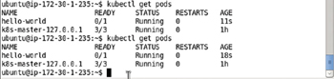

**Figure 2-20:**Listing the Pods soon after creating the Pods

Run the same command again after a few more seconds.

kubectl get pods

The hello-world Pod gets listed with STATUS as "Running" and READY state as "1/1," which implies that 1 of 1 containers in the Pod are ready, as shown in [Figure 2-21](https://viewer.books24x7.com/assetviewer.aspx?bookid=113388&chunkid=213865154&resumebookmarkid=24b8af05-b4be-e911-b9b2-00505695593a).

[Larger View](https://viewer.books24x7.com/assetviewer.aspx?bookid=113388&chunkid=213865154&resumebookmarkid=24b8af05-b4be-e911-b9b2-00505695593a)

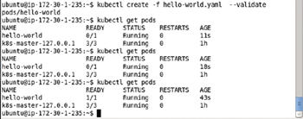

**Figure 2-21:**Listing the Pod as Ready and Running

Describe the hello-world Pod with the following command.

kubectl describe pod hello-world

The output from the preceding command is shown in [Figure 2-22](https://viewer.books24x7.com/assetviewer.aspx?bookid=113388&chunkid=213865154&resumebookmarkid=24b8af05-b4be-e911-b9b2-00505695593a).

[Larger View](https://viewer.books24x7.com/assetviewer.aspx?bookid=113388&chunkid=213865154&resumebookmarkid=24b8af05-b4be-e911-b9b2-00505695593a)

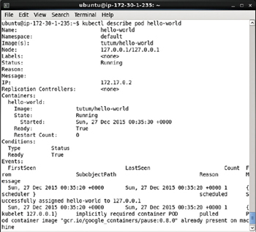

**Figure 2-22:**Describing the hello-world Pod

Invoke the hello-world Pod application using the IP 172.17.0.2.

curl 172.17.0.2

The HTML output from the hello-world application gets listed as shown in [Figure 2-23](https://viewer.books24x7.com/assetviewer.aspx?bookid=113388&chunkid=213865154&resumebookmarkid=24b8af05-b4be-e911-b9b2-00505695593a).

[Larger View](https://viewer.books24x7.com/assetviewer.aspx?bookid=113388&chunkid=213865154&resumebookmarkid=24b8af05-b4be-e911-b9b2-00505695593a)

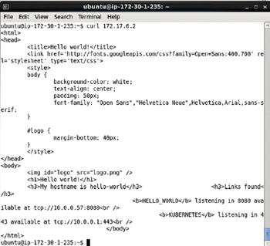

**Figure 2-23:**Invoking the hello-world Application with curl

Set up port forwarding from a local machine to the IP address of the hello-world Pod.

ssh -i "docker.pem" -f -nNT -L 80:172.17.0.2:80 ubuntu@ec2-52-91-200-41.compute-1.amazonaws.com

Subsequently invoke the url [http://localhost:80](http://localhost/) in a browser on a local machine to display the HTML output from the application as shown in [Figure 2-24](https://viewer.books24x7.com/assetviewer.aspx?bookid=113388&chunkid=213865154&resumebookmarkid=24b8af05-b4be-e911-b9b2-00505695593a). The default Hypertext transfer protocol port being 80, has been be omitted from the URL, as shown in [Figure 2-24](https://viewer.books24x7.com/assetviewer.aspx?bookid=113388&chunkid=213865154&resumebookmarkid=24b8af05-b4be-e911-b9b2-00505695593a).

[Larger View](https://viewer.books24x7.com/assetviewer.aspx?bookid=113388&chunkid=213865154&resumebookmarkid=24b8af05-b4be-e911-b9b2-00505695593a)

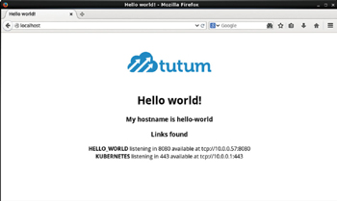

**Figure 2-24:**Invoking the hello-world Application in a Browser on a local machine

#### Creating a Service Definition

We created a Pod definition file and started a single Pod, but the Pod is not associated with any Service or Replication Controller. External clients have to access the Pod directly and are not able to scale the application with just a single unassociated Pod. Create a Service definition file hello-world-service.yaml as listed below. If copying and pasting YAML files listed in this chapter and other chapters it is recommended to use the YAML Lint (<http://www.yamllint.com/>) to format the files before using in an application.

apiVersion: v1

kind: Service

metadata:

labels:

app: hello-world

name: hello-world

spec:

ports:

-

name: http

port: 80

targetPort: http

selector:

app: hello-world

type: LoadBalancer

The main mappings of the Service definition file are kind, metadata, and spec. The kind is set to Service to indicate a Kubernetes Service. The label app and the name constitute the metadata. The spec mapping includes a ports mapping for port 80 with name http. Optionally a targetPort may be set, which defaults to the same value as port. The selector is the main mapping in the spec and specifies a mapping to be used for selecting the Pods to expose via the Service. The app:hello-world selector implies that all Pods with label app=hello-world are selected. The definition file may be created in the vi editor and saved with the :wq command as shown in [Figure 2-25](https://viewer.books24x7.com/assetviewer.aspx?bookid=113388&chunkid=213865154&resumebookmarkid=24b8af05-b4be-e911-b9b2-00505695593a).

[Larger View](https://viewer.books24x7.com/assetviewer.aspx?bookid=113388&chunkid=213865154&resumebookmarkid=24b8af05-b4be-e911-b9b2-00505695593a)

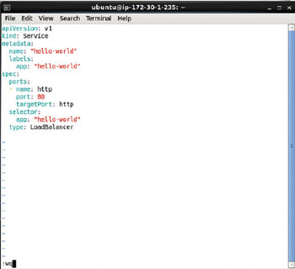

**Figure 2-25:**Service Definition File hello-world-service.yaml

A complete reference to the Kubernetes Service schema is available at <http://kubernetes.io/v1.1/docs/api-reference/v1/definitions.html#_v1_service>.

Create a Service using the definition file with the kubectl create command.

kubectl create -f hello-world-service.yaml

The hello-world Service gets created as shown in [Figure 2-26](https://viewer.books24x7.com/assetviewer.aspx?bookid=113388&chunkid=213865154&resumebookmarkid=24b8af05-b4be-e911-b9b2-00505695593a).

[Larger View](https://viewer.books24x7.com/assetviewer.aspx?bookid=113388&chunkid=213865154&resumebookmarkid=24b8af05-b4be-e911-b9b2-00505695593a)



**Figure 2-26:**Creating the hello-world Service using the Definition File

List the Services with the following command.

kubectl get services

The hello-world Service gets listed in addition to the kubernetes Service as shown in [Figure 2-27](https://viewer.books24x7.com/assetviewer.aspx?bookid=113388&chunkid=213865154&resumebookmarkid=24b8af05-b4be-e911-b9b2-00505695593a).

[Larger View](https://viewer.books24x7.com/assetviewer.aspx?bookid=113388&chunkid=213865154&resumebookmarkid=24b8af05-b4be-e911-b9b2-00505695593a)

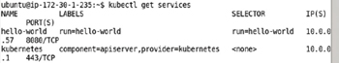

**Figure 2-27:**Listing the hello-world Service

Describe the hello-world Service with the following command.

kubectl describe svc hello-world

The Service name, namespace, labels, selector, type, Ip get listed as shown in [Figure 2-28](https://viewer.books24x7.com/assetviewer.aspx?bookid=113388&chunkid=213865154&resumebookmarkid=24b8af05-b4be-e911-b9b2-00505695593a). Because the hello-world Pod created using the Pod definition file does not include a label to match the Service selector, it is not managed by the Service. As the hello-world Service is not managing any Pods, no endpoint gets listed.

[Larger View](https://viewer.books24x7.com/assetviewer.aspx?bookid=113388&chunkid=213865154&resumebookmarkid=24b8af05-b4be-e911-b9b2-00505695593a)

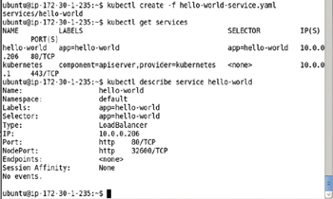

**Figure 2-28:**Describing the hello-world Service

#### Creating a Replication Controller Definition

Next, we shall create a Replication Controller and label the Replication Controller to match the selector of the Service created previously. Create a Service definition file hello-rc.yaml. The kind mapping of a Replication Controller is ReplicationController. The replicas' sub-mapping in the spec mapping is set to 2 to create two replicas from the Pod also specified in the spec. At least one of the labels in the template- > metadata- > labels must match the Service selector in the Service definition file for the Pod to be exposed by the Service. As the Service selector in the hello-world Service is app:hello-world add the app:hello-world label to the Replication Controller template. The app:hello-world setting in YAML translates to app=hello-world. The template may define one or more containers to be included in the Pod created from the Replication Controller. We have included container definition for only one container for image tutum/hello-world. The hello-rc.yaml is listed below. A YAML lint (<http://www.yamllint.com/>) may be used to validate the YAML syntax.

apiVersion: v1

kind: ReplicationController

metadata:

name: hello-world

spec:

replicas: 2

template:

metadata:

labels:

app: hello-world

spec:

containers:

-

image: tutum/hello-world

name: hello-world

ports:

-

containerPort: 8080

name: http

A complete schema for the Replication Controller is available at <http://kubernetes.io/v1.1/docs/api-reference/v1/definitions.html#_v1_replicationcontroller>.

Create the Replication Controller using the definition file with the kubectl createcommand, the same command that was used to create a Pod and a Service.

kubectl create -f hello-rc.yaml

Subsequently run the following command to list the Replication Controllers.

kubectl get rc

A hello-world Replication Controller gets created and gets listed as shown in [Figure 2-29](https://viewer.books24x7.com/assetviewer.aspx?bookid=113388&chunkid=213865154&resumebookmarkid=24b8af05-b4be-e911-b9b2-00505695593a). The number of replicas are listed as 2 as specified in the definition file.

[Larger View](https://viewer.books24x7.com/assetviewer.aspx?bookid=113388&chunkid=213865154&resumebookmarkid=24b8af05-b4be-e911-b9b2-00505695593a)

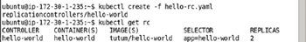

**Figure 2-29:**Creating a Replication Controller

List the Pods created with the Replication Controller with the following command.

kubectl get pods

The two Pods created from the definition file get listed as shown in [Figure 2-30](https://viewer.books24x7.com/assetviewer.aspx?bookid=113388&chunkid=213865154&resumebookmarkid=24b8af05-b4be-e911-b9b2-00505695593a). The Pod created the Pod definition file also gets listed but is not associated with the Replication Controller. Initially some or all of the new Pods may be listed as not ready as indicated by the 0/1 value in the READY column for one of the Pods in [Figure 2-30](https://viewer.books24x7.com/assetviewer.aspx?bookid=113388&chunkid=213865154&resumebookmarkid=24b8af05-b4be-e911-b9b2-00505695593a).

[Larger View](https://viewer.books24x7.com/assetviewer.aspx?bookid=113388&chunkid=213865154&resumebookmarkid=24b8af05-b4be-e911-b9b2-00505695593a)

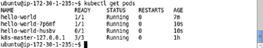

**Figure 2-30:**Listing the Pods soon after creating a Replication Controller

Invoke the same command again to list the Pods after a few more seconds.

kubectl get pods

All the Pods get listed as READY-> 1/1 and Running as shown in [Figure 2-31](https://viewer.books24x7.com/assetviewer.aspx?bookid=113388&chunkid=213865154&resumebookmarkid=24b8af05-b4be-e911-b9b2-00505695593a).

[Larger View](https://viewer.books24x7.com/assetviewer.aspx?bookid=113388&chunkid=213865154&resumebookmarkid=24b8af05-b4be-e911-b9b2-00505695593a)

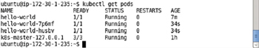

**Figure 2-31:**Listing all the Pods as Running and Ready

To describe the hello-world Service run the following command.

kubectl describe service hello-world

The Service detail including the Endpoints get listed as shown in [Figure 2-32](https://viewer.books24x7.com/assetviewer.aspx?bookid=113388&chunkid=213865154&resumebookmarkid=24b8af05-b4be-e911-b9b2-00505695593a). The service selector is app = hello-world and the service endpoints are 172.17.0.3:8080 and 172.17.0.4:8080.

[Larger View](https://viewer.books24x7.com/assetviewer.aspx?bookid=113388&chunkid=213865154&resumebookmarkid=24b8af05-b4be-e911-b9b2-00505695593a)

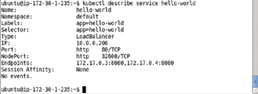

**Figure 2-32:**Describing the Service hello-world

All the preceding commands to create the hello-world Replication Controller, list its Pods and endpoints association with the hello-world Service shown in [Figure 2-33](https://viewer.books24x7.com/assetviewer.aspx?bookid=113388&chunkid=213865154&resumebookmarkid=24b8af05-b4be-e911-b9b2-00505695593a).

[Larger View](https://viewer.books24x7.com/assetviewer.aspx?bookid=113388&chunkid=213865154&resumebookmarkid=24b8af05-b4be-e911-b9b2-00505695593a)

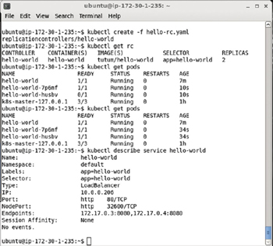

**Figure 2-33:**Summary of Commands to create a Replication Controller

#### Invoking the Hello-World Application

The Pods associated with the hello-world Replication Controller and Service by the same name may be invoked using the Service endpoints as listed in the Service description in [Figure 2-33](https://viewer.books24x7.com/assetviewer.aspx?bookid=113388&chunkid=213865154&resumebookmarkid=24b8af05-b4be-e911-b9b2-00505695593a). For example, invoke the 172.17.0.3 endpoint with the following curlcommand.

curl 172.17.0.3

The HTML output from the Pod gets output as shown in [Figure 2-34](https://viewer.books24x7.com/assetviewer.aspx?bookid=113388&chunkid=213865154&resumebookmarkid=24b8af05-b4be-e911-b9b2-00505695593a).

[Larger View](https://viewer.books24x7.com/assetviewer.aspx?bookid=113388&chunkid=213865154&resumebookmarkid=24b8af05-b4be-e911-b9b2-00505695593a)

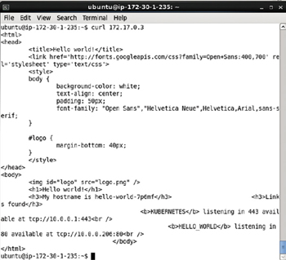

**Figure 2-34:**HTML Output from invoking the hello-world Application with curl

Similarly, invoke the 172.17.0.4 endpoint with the following curl command.

curl 172.17.0.4

The HTML output from the other Pod gets output as shown in [Figure 2-35](https://viewer.books24x7.com/assetviewer.aspx?bookid=113388&chunkid=213865154&resumebookmarkid=24b8af05-b4be-e911-b9b2-00505695593a).

[Larger View](https://viewer.books24x7.com/assetviewer.aspx?bookid=113388&chunkid=213865154&resumebookmarkid=24b8af05-b4be-e911-b9b2-00505695593a)

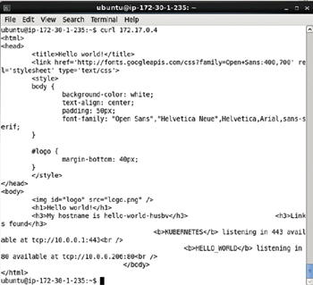

**Figure 2-35:**Invoking another Service Endpoint with curl

To invoke the Service endpoints in a browser on a local machine configure local port forwarding for the Service endpoints.

ssh -i "docker.pem" -f -nNT -L 8081:172.17.0.3:8080 ubuntu@ec2-52-91-200-41.compute-1.

amazonaws.com

ssh -i "docker.pem" -f -nNT -L 8082:172.17.0.4:8080 ubuntu@ec2-52-91-200-41.compute-1.

amazonaws.com

Subsequently invoke the localhost:8081 URL in a browser on a local machine as shown in [Figure 2-36](https://viewer.books24x7.com/assetviewer.aspx?bookid=113388&chunkid=213865154&resumebookmarkid=24b8af05-b4be-e911-b9b2-00505695593a) to display the HTML output from the Pod at endpoint 172.17.0.3:8080.

[Larger View](https://viewer.books24x7.com/assetviewer.aspx?bookid=113388&chunkid=213865154&resumebookmarkid=24b8af05-b4be-e911-b9b2-00505695593a)

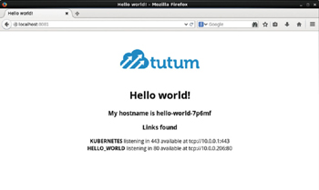

**Figure 2-36:**Invoking the hello-world Application in a Local machine Browser with its Service Endpoint

Similarly invoke the localhost:8082 URL in a browser on a local machine as shown in [Figure 2-37](https://viewer.books24x7.com/assetviewer.aspx?bookid=113388&chunkid=213865154&resumebookmarkid=24b8af05-b4be-e911-b9b2-00505695593a) to display the HTML output from the Pod at endpoint 172.17.0.4:8080.

[Larger View](https://viewer.books24x7.com/assetviewer.aspx?bookid=113388&chunkid=213865154&resumebookmarkid=24b8af05-b4be-e911-b9b2-00505695593a)

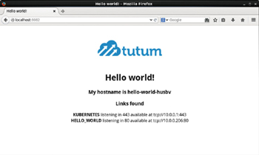

**Figure 2-37:**Invoking another Service Endpoint in a Browser

#### Scaling the Application

To scale the hello-world Replication Controller to 6 replicas, for example, run the following kubectl scale command.

kubectl scale rc hello-world --replicas=6

An output of "scaled" as shown in [Figure 2-38](https://viewer.books24x7.com/assetviewer.aspx?bookid=113388&chunkid=213865154&resumebookmarkid=24b8af05-b4be-e911-b9b2-00505695593a) indicates the Replication Controller has been scaled.

[Larger View](https://viewer.books24x7.com/assetviewer.aspx?bookid=113388&chunkid=213865154&resumebookmarkid=24b8af05-b4be-e911-b9b2-00505695593a)



**Figure 2-38:**Scaling an Application

The number of Pods for the hello-world Replication Controller increases when the Replication Controller is scaled up to 6. To list the Pods run the following command.

kubectl get pods

Six Pods get listed in addition to the hello-world Pod created initially using a Pod definition file as shown in [Figure 2-39](https://viewer.books24x7.com/assetviewer.aspx?bookid=113388&chunkid=213865154&resumebookmarkid=24b8af05-b4be-e911-b9b2-00505695593a). The preceding command may have to be run more than once to list all the Pods with STATUS as Running and READY state as 1/1. The hello-world Pod is not associated with the hello-world Replication Controller as it does not include a label that matches the selector label (same as template label) in the Replication Controller.

[Larger View](https://viewer.books24x7.com/assetviewer.aspx?bookid=113388&chunkid=213865154&resumebookmarkid=24b8af05-b4be-e911-b9b2-00505695593a)

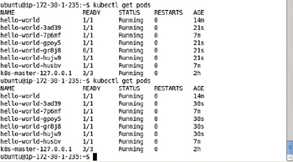

**Figure 2-39:**Listing Pods after Scaling

In the preceding example we scaled *up* the Replication Controller, but the kubectl scalecommand may also be used to scale *down* the Replication Controller. As an example, scale down the hello-world Replication Controller to 2 replicas.

kubectl scale rc hello-world --replicas=2

Subsequently list the Pods.

kubectl get pods

The number of replicas gets listed as 2 in addition to the hello-world Pod as shown in [Figure 2-40](https://viewer.books24x7.com/assetviewer.aspx?bookid=113388&chunkid=213865154&resumebookmarkid=24b8af05-b4be-e911-b9b2-00505695593a).

[Larger View](https://viewer.books24x7.com/assetviewer.aspx?bookid=113388&chunkid=213865154&resumebookmarkid=24b8af05-b4be-e911-b9b2-00505695593a)

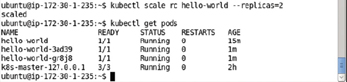

**Figure 2-40:**Scaling Down to 2 Replicas

**Using JSON for the Resource Definitions**

In the preceding section we used the YAML format to create the Pod, Service, and Replication Controller definition files. The definition files may be developed in JSON format instead. The YAMLToJSON utility (<http://yamltojson.com/>) may be used to convert from YAML to JSON and the JSON lint (<http://jsonlint.com/>) may be used to validate the JSON. A JSON to YAML utility is also available at <http://jsontoyaml.com/>. The JSON definition file hello-world-service.json for the hello-world Service is listed:

{

"apiVersion": "v1",

"kind": "Service",

"metadata": {

"name": "hello-world",

"labels": {

"app": "hello-world"

}

},

"spec": {

"ports": [

{

"name": "http",

"port": 80,

"targetPort": "http"

}

],

"selector": {

"app": "hello-world"

},

"type": "LoadBalancer"

}

}

Create a hello-world-service.json file using a vi editor and copy and paste the preceding listing to the file. Save the file using :wq as shown in [Figure 2-41](https://viewer.books24x7.com/assetviewer.aspx?bookid=113388&chunkid=609047849&resumebookmarkid=24b8af05-b4be-e911-b9b2-00505695593a).

[Larger View](https://viewer.books24x7.com/assetviewer.aspx?bookid=113388&chunkid=609047849&resumebookmarkid=24b8af05-b4be-e911-b9b2-00505695593a)

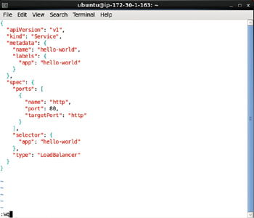

**Figure 2-41:**Service Definition File in JSON Format

Delete the hello-world Service and hello-world Replication Controller created previously. Run the following command to create a Service from the JSON format definition file.

kubectl create –f hello-world-service.json

The hello-world Service gets created as shown in [Figure 2-42](https://viewer.books24x7.com/assetviewer.aspx?bookid=113388&chunkid=609047849&resumebookmarkid=24b8af05-b4be-e911-b9b2-00505695593a).

[Larger View](https://viewer.books24x7.com/assetviewer.aspx?bookid=113388&chunkid=609047849&resumebookmarkid=24b8af05-b4be-e911-b9b2-00505695593a)



**Figure 2-42:**Creating a Service from the JSON Definition File

Subsequently list all the Kubernetes Services.

kubectl get services

The hello-world Service gets listed as shown in [Figure 2-43](https://viewer.books24x7.com/assetviewer.aspx?bookid=113388&chunkid=609047849&resumebookmarkid=24b8af05-b4be-e911-b9b2-00505695593a).

[Larger View](https://viewer.books24x7.com/assetviewer.aspx?bookid=113388&chunkid=609047849&resumebookmarkid=24b8af05-b4be-e911-b9b2-00505695593a)

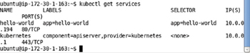

**Figure 2-43:**Listing the Services

The JSON format version of the Replication Controller definition file, hello-rc.json, is as follows.

{

"apiVersion": "v1",

"kind": "ReplicationController",

"metadata": {

"name": "hello-world"

},

"spec": {

"replicas": 2,

"template": {

"metadata": {

"labels": {

"app": "hello-world"

}

},

"spec": {

"containers": [

{

"image": "tutum/hello-world",

"name": "hello-world",

"ports": [

{

"containerPort": 8080,

"name": "http"

}

]

}

]

}

}

}

}

Create the hello-rc.json file inavieditor and save the filewith :wq as shown in [Figure 2-44](https://viewer.books24x7.com/assetviewer.aspx?bookid=113388&chunkid=609047849&resumebookmarkid=24b8af05-b4be-e911-b9b2-00505695593a).

[Larger View](https://viewer.books24x7.com/assetviewer.aspx?bookid=113388&chunkid=609047849&resumebookmarkid=24b8af05-b4be-e911-b9b2-00505695593a)

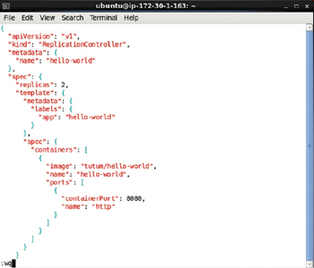

**Figure 2-44:**Creating the hello-rc.json File in vi Editor

Delete all previously created Pods and Replication Controllers. Run the following command to create the hello-world Replication Controller.

kubectl create –f hello-rc.json

The hello-world Replication Controller gets created as shown in [Figure 2-45](https://viewer.books24x7.com/assetviewer.aspx?bookid=113388&chunkid=609047849&resumebookmarkid=24b8af05-b4be-e911-b9b2-00505695593a). Subsequently run the following command to list the Replication Controllers.

kubectl get rc

The hello-world Replication Controller gets listed as shown in [Figure 2-45](https://viewer.books24x7.com/assetviewer.aspx?bookid=113388&chunkid=609047849&resumebookmarkid=24b8af05-b4be-e911-b9b2-00505695593a). List the Pods created by the Replication Controller using the following command.

kubectl get pods

Because replicas is set as 2 two Pods get listed as shown in [Figure 2-45](https://viewer.books24x7.com/assetviewer.aspx?bookid=113388&chunkid=609047849&resumebookmarkid=24b8af05-b4be-e911-b9b2-00505695593a).

[Larger View](https://viewer.books24x7.com/assetviewer.aspx?bookid=113388&chunkid=609047849&resumebookmarkid=24b8af05-b4be-e911-b9b2-00505695593a)

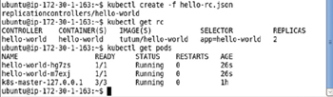

**Figure 2-45:**Creating a Replication Controller from the JSON format Definition File

Describe the hello-world Service with the following command.

kubectl describe svc hello-world

Because the label on the hello-world Replication Controller matches the Service selector, the two Pods created using the Replication Controller are represented by the Service and have endpoints in the Service as shown in [Figure 2-46](https://viewer.books24x7.com/assetviewer.aspx?bookid=113388&chunkid=609047849&resumebookmarkid=24b8af05-b4be-e911-b9b2-00505695593a).

[Larger View](https://viewer.books24x7.com/assetviewer.aspx?bookid=113388&chunkid=609047849&resumebookmarkid=24b8af05-b4be-e911-b9b2-00505695593a)

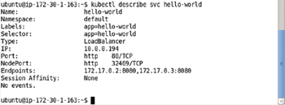

**Figure 2-46:**Describing the hello-world Service

Invoke a Service endpoint using a curl command as follows.

curl 172.17.0.2

The HTML output from the curl command gets output as shown in [Figure 2-47](https://viewer.books24x7.com/assetviewer.aspx?bookid=113388&chunkid=609047849&resumebookmarkid=24b8af05-b4be-e911-b9b2-00505695593a).

[Larger View](https://viewer.books24x7.com/assetviewer.aspx?bookid=113388&chunkid=609047849&resumebookmarkid=24b8af05-b4be-e911-b9b2-00505695593a)

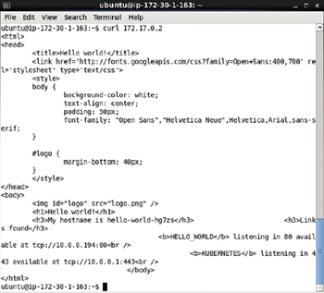

**Figure 2-47:**Invoking the hello-world Application with curl

Set up local port forwarding to a Service endpoint.

ssh -i "docker.pem" -f -nNT -L 80:172.17.0.2:8080 ubuntu@ec2-52-91-200-41.compute-1.

amazonaws.com

Subsequently invoke the Service endpoint in a browser in a local machine to display the HTML output as shown in [Figure 2-48](https://viewer.books24x7.com/assetviewer.aspx?bookid=113388&chunkid=609047849&resumebookmarkid=24b8af05-b4be-e911-b9b2-00505695593a).

[Larger View](https://viewer.books24x7.com/assetviewer.aspx?bookid=113388&chunkid=609047849&resumebookmarkid=24b8af05-b4be-e911-b9b2-00505695593a)

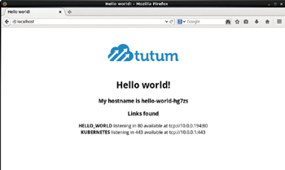

**Figure 2-48:**Displaying hello-world Application HTML in a Browser

### Summary

In this chapter we introduced the Kubernetes concepts such as Pod, Service, Replication Controller, Labels, and Selector. We also developed a hello-world application both imperatively on the command line, and declaratively using definition files. We discussed two different supported formats for the definition files: YAML and JSON. In the next chapter we shall discuss using environment variables in Pod definitions.

## Chapter 3: Using Custom Commands and Environment Variables

**© Deepak Vohra 2016  
D. Vohra, *Kubernetes Microservices with Docker*, DOI 10.1007/978-1-4842-1907-2\_3**

### Overview

## Chapter 3: Using Custom Commands and Environment Variables

**© Deepak Vohra 2016  
D. Vohra, *Kubernetes Microservices with Docker*, DOI 10.1007/978-1-4842-1907-2\_3**

### Overview

Kubernetes orchestrates Docker containers, and the instructions to run for a Docker image are specified in the Dockerfile. The ENTRYPOINT instruction specifies the command to run, and the CMD instruction specifies the default arguments for the ENTRYPOINT command. Kubernetes provides two fields, "Command" and "Args", to be specified for a container image in a Pod definition to override the default settings of ENTRYPOINT and CMD. We shall discuss these fields in this chapter. We shall also discuss using environment variables in a Pod definition's container mapping with the "env" field mapping.

**Setting the Environment**

The following software is used in this chapter.

* -Docker Engine (latest version)
* -Kubernetes (version 1.01)
* -Kubectl (version 1.01)

Install Docker engine, Kubernetes, and Kubectl as discussed in [chapter 1](http://viewer.books24x7.com/assetviewer.aspx?bkid=113388&destid=28#28). Start Docker Engine and verify its status with the following commands.

sudo service docker start

sudo service docker status

The output shown in [Figure 3-1](https://viewer.books24x7.com/assetviewer.aspx?bookid=113388&chunkid=196054495&resumebookmarkid=24b8af05-b4be-e911-b9b2-00505695593a) indicates that Docker is running.

[Larger View](https://viewer.books24x7.com/assetviewer.aspx?bookid=113388&chunkid=196054495&resumebookmarkid=24b8af05-b4be-e911-b9b2-00505695593a)

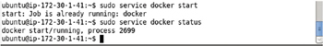

**Figure 3-1:**Starting Docker and Verifying Its Status

**The ENTRYPOINT and CMD Instructions**

The ENTRYPOINT in a Docker image's Dockerfile specifies the command to run when the image is run. The ENTRYPOINT has two forms discussed in [Table 3-1](https://viewer.books24x7.com/assetviewer.aspx?bookid=113388&chunkid=496937597&resumebookmarkid=24b8af05-b4be-e911-b9b2-00505695593a). A Dockerfile may have only one ENTRYPOINT. If multiple ENTRYPOINTs are specified, the last ENTRYPOINT entry is run.

**Table 3-1: ENTRYPOINT Forms**[[](https://viewer.books24x7.com/outputobject.aspx?bookid=113388&chunkid=496937597&objectid=ch3_tab1&objecttype=spreadsheet) Open table as spreadsheet](https://viewer.books24x7.com/outputobject.aspx?bookid=113388&chunkid=496937597&objectid=ch3_tab1&objecttype=spreadsheet" \t "_blank)

| **Form** | **Description** | **Format** |
| --- | --- | --- |
| Exec form | Runs an executable using the specified parameters. The exec form is the preferred form if environment variable substitution is not used. But if environment variable substitution is used the shell form must be used. The exec form does not perform any environment variable substitution. | ENTRYPOINT ["executable"", "param1", "param2"] |
| Shell form | Runs the command in a shell and prevents any CMD or run command-line arguments to be used in conjunction with ENTRYPOINT. The shell form starts a shell with /bin/sh -c even though a shell is not invoked explicitly. | ENTRYPOINT command param1 param2 |

The CMD instruction specifies the args for the ENTRYPOINT command in exec form. The CMDhas three forms as discussed in [Table 3-2](https://viewer.books24x7.com/assetviewer.aspx?bookid=113388&chunkid=496937597&resumebookmarkid=24b8af05-b4be-e911-b9b2-00505695593a). A Dockerfile may have only one CMD entry. If multiple CMDs are specified the last CMD entry is run. The CMD instruction may include an executable.

**Table 3-2: CMD Forms**[[](https://viewer.books24x7.com/outputobject.aspx?bookid=113388&chunkid=496937597&objectid=ch3_tab2&objecttype=spreadsheet) Open table as spreadsheet](https://viewer.books24x7.com/outputobject.aspx?bookid=113388&chunkid=496937597&objectid=ch3_tab2&objecttype=spreadsheet" \t "_blank)

| **Form** | **Description** | **Format** |
| --- | --- | --- |
| Exec form | The exec form specifies the command to invoke and the command parameters in JSON array format. The exec form does not perform environment variable substitution. If environment variable substitution is to be performed, use the shell form or invoke the shell explicitly in the exec form. In JSONs array format, double quotes "" must be used around names. | CMD ["executable", "param1", "param2"] |
| Default parameters to ENTRYPOINT | Specifies the default args to the ENTRYPOINT command. Both the ENTRYPOINT and CMD must be specified. Both the ENTRYPOINT and CMD must be specified using JSON array formats. In JSONs array format, double quotes "" must be used around names. | CMD ["param1", "param2" |
| Shell form | Invokes a shell to invoke the specified command using the parameters. The command is invoked as a sub-command of /bin/sh -c. | CMD command param1 param2 |

If command-line args are provided to the docker run command those override the default args in CMD instruction. The ENTRYPOINT instruction could also be used in combination with a helper script. Next, we shall discuss the two fields, "command" and "args" that could be used to override the ENTRYPOINT and CMD instructions in a Dockerfile respectively.

**The Command and Args Fields in a Pod Definition**

Kubernetes has the provision to override the ENTRYPOINT (command) and CMD (args) instructions specified in the Dockerfile. Two field mappings in a Pod's definition file could be used to override the ENTRYPOINT and CMD instructions. These fields are "Command" and "Args," and they override the Dockerfile "ENTRYPOINT "and "CMD" instructions respectively. The overriding applies based on which of these instructions and fields are specified. Some examples of overriding are discussed in [Table 3-3](https://viewer.books24x7.com/assetviewer.aspx?bookid=113388&chunkid=578195417&resumebookmarkid=24b8af05-b4be-e911-b9b2-00505695593a).

**Table 3-3: Examples of Overriding ENTRYPOINT and CMD with Command and Args**[[](https://viewer.books24x7.com/outputobject.aspx?bookid=113388&chunkid=578195417&objectid=ch3_tab3&objecttype=spreadsheet) Open table as spreadsheet](https://viewer.books24x7.com/outputobject.aspx?bookid=113388&chunkid=578195417&objectid=ch3_tab3&objecttype=spreadsheet" \t "_blank)

|  | **ENTRYPOINT** | **CMD** | **Command** | **Args** | **Used** |
| --- | --- | --- | --- | --- | --- |
| Example 1 | yes | yes | yes | yes | The Command and Args field mappings in the Pod definition file override the ENTRYPOINT and CMD instructions in Dockerfile. |
| Example 2 | yes | yes | no | no | The Dockerfile ENTRYPOINT command and CMD args are used. |
| Example 3 | yes | yes | yes | no | Only the command in the Command is used and Dockerfile ENTRYPOINT and CMD instructions are ignored. |
| Example 4 | yes | yes | no | yes | The Docker image's command as specified in the ENTRYPOINT is used with the args specified in the Pod definition's Args. The args from the Dockerfile's CMD are ignored. |
| Example 5 | no | yes | no | no | The command and parameters from the CMD instruction are run. |
| Example 6 | no | yes | yes | yes | The Command and Args field mappings in the Pod definition file are used. The CMD instruction in Dockerfile is overridden. |
| Example 7 | no | yes | no | yes | The Args field mapping in the Pod definition file is used. The CMD instruction in Dockerfile is overridden. |
| Example 8 | no | yes | yes | no | The command in the Command mapping is used, and Dockerfile CMD instruction is ignored. |

### Environment Variables

A Pod's schema has the provision to specify environment variables. The environment variables are specified as "name" and "value" field mappings as a collection within a container definition's "env" mapping. The format for specifying environment variables is as follows.

spec:

containers:

-

image: "image name"

name: "container name "

env:

-

name: "env variable 1"

value: " env variable 1 value"

-

name: "env variable 2"

value: " env variable 2 value"

The environment variables are added to the docker run command using -e when the Docker image is run by Kubernetes. The environment variables may also be used in "command" and "args" mappings using the environment variable substitution if a shell is used to run the Docker image command. A shell is invoked if one or more of the following is used:

* -The shell form of the ENTRYPOINT or CMD is used
* -The shell is invoked explicitly in the ENTRYPOINT or CMD instruction

In the following sections we shall use the "ubuntu" Docker image to demonstrate overriding the default ENTRYPOINT command and the default CMD args. We shall start with using the default ENTRYPOINT and CMD instructions.

**Using the Default ENTRYPOINT and CMD from a Docker Image**

The Dockerfile for the Ubuntu image does not provide an ENTRYPOINT instruction but the CMD instruction is set to CMD ["/bin/bash"]. In the example in this section we shall create a Pod definition that does not override the ENTRYPOINT or CMD instruction from the Docker image. Create a Pod definition file as follows with the image as "ubuntu" and some environment variables set.

apiVersion: v1

kind: Pod

metadata:

name: "hello-world"

labels:

app: "helloApp"

spec:

restartPolicy: Never

containers:

-

image: "ubuntu"

name: "hello"

ports:

containerPort: 8020

env:

-

name: "MESSAGE1"

value: "hello"

-

name: "MESSAGE2"

value: "kubernetes"

The env.yaml file may be created in a vi editor and saved with the :wq command as shown in [Figure 3-2](https://viewer.books24x7.com/assetviewer.aspx?bookid=113388&chunkid=267612317&resumebookmarkid=24b8af05-b4be-e911-b9b2-00505695593a).

[Larger View](https://viewer.books24x7.com/assetviewer.aspx?bookid=113388&chunkid=267612317&resumebookmarkid=24b8af05-b4be-e911-b9b2-00505695593a)

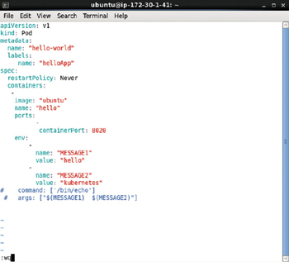

**Figure 3-2:**A Pod definition file env.yaml to demonstrate Environment Variables

Run the following command to create a Pod from the definition file env.yaml.

kubectl create –f env.yaml

The hello-world pod gets created as shown in [Figure 3-3](https://viewer.books24x7.com/assetviewer.aspx?bookid=113388&chunkid=267612317&resumebookmarkid=24b8af05-b4be-e911-b9b2-00505695593a). Run the following command to list the pods.

[Larger View](https://viewer.books24x7.com/assetviewer.aspx?bookid=113388&chunkid=267612317&resumebookmarkid=24b8af05-b4be-e911-b9b2-00505695593a)

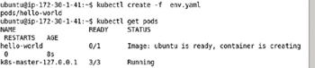

**Figure 3-3:**Creating and listing a Pod

kubectl get pods

The hello-world pod gets created but the Docker container created is listed as "creating" as shown in [Figure 3-3](https://viewer.books24x7.com/assetviewer.aspx?bookid=113388&chunkid=267612317&resumebookmarkid=24b8af05-b4be-e911-b9b2-00505695593a).

When the Docker container gets created the STATUS column value transitions to "Running" and the READY column value becomes 1/1, which indicates that 1 of 1 containers in the Pod are ready and which is not shown in [Figure 3-4](https://viewer.books24x7.com/assetviewer.aspx?bookid=113388&chunkid=267612317&resumebookmarkid=24b8af05-b4be-e911-b9b2-00505695593a) because the READY state transitions to 0/1 quickly thereafter. After the Pod command/args have run the Pod terminates and STATUSbecomes ExitCode:0 as shown in [Figure 3-4](https://viewer.books24x7.com/assetviewer.aspx?bookid=113388&chunkid=267612317&resumebookmarkid=24b8af05-b4be-e911-b9b2-00505695593a).

[Larger View](https://viewer.books24x7.com/assetviewer.aspx?bookid=113388&chunkid=267612317&resumebookmarkid=24b8af05-b4be-e911-b9b2-00505695593a)

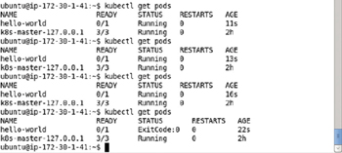

**Figure 3-4:**After the Command/Args have run, a Pod terminates and the Pod's Status becomes ExitCode:0

Run the following command to list the output from the Pod.

kubectl logs hello-world

As the default CMD ["/bin/bash"] in the "Ubuntu" Docker image is just the invocation of the bash shell using /bin/bash, no output is generated as shown in [Figure 3-5](https://viewer.books24x7.com/assetviewer.aspx?bookid=113388&chunkid=267612317&resumebookmarkid=24b8af05-b4be-e911-b9b2-00505695593a).

[Larger View](https://viewer.books24x7.com/assetviewer.aspx?bookid=113388&chunkid=267612317&resumebookmarkid=24b8af05-b4be-e911-b9b2-00505695593a)



**Figure 3-5:**No output generated with Default CMD ["/bin/bash"] in "ubuntu" Docker Image

### Overriding Both the ENTRYPOINT and CMD

In the second example we shall override both the ENTRYPOINT and CMD in a Dockerfileusing Command and Args mappings in the Pod definition file. Using in combination ENTRYPOINT and CMD will help us to specify the default executable for the image and also it will provide the default arguments to that executable. Environment variable substitution is used for the MESSAGE1 and MESSAGE2 environment variables with the $(VARIABLE\_NAME)syntax.

command: ["/bin/echo"]

args: [" $(MESSAGE1)", " $(MESSAGE2)"]

The env.yaml Pod definition file is listed:

apiVersion: v1

kind: Pod

metadata:

name: "hello-world"

labels:

app: "helloApp"

spec:

restartPolicy: Never

containers:

-

image: "ubuntu"

name: "hello"

ports:

-

containerPort: 8020

env:

-

name: "MESSAGE1"

value: "hello"

-

name: "MESSAGE2"

value: "kubernetes"

command: ["/bin/echo"]

args: [" $(MESSAGE1)", " $(MESSAGE2)"]

The env.yaml file may be opened and modified in the vi editor and saved using the :wq command as shown in [Figure 3-6](https://viewer.books24x7.com/assetviewer.aspx?bookid=113388&chunkid=303980594&resumebookmarkid=24b8af05-b4be-e911-b9b2-00505695593a).

[Larger View](https://viewer.books24x7.com/assetviewer.aspx?bookid=113388&chunkid=303980594&resumebookmarkid=24b8af05-b4be-e911-b9b2-00505695593a)

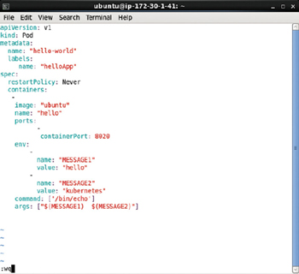

**Figure 3-6:**Modifying env.yaml in a vi Editor

First, we need to delete the hello-world pod created in the first example with the following command.

kubectl delete pod hello-world

The hello-world pod gets deleted as shown in [Figure 3-7](https://viewer.books24x7.com/assetviewer.aspx?bookid=113388&chunkid=303980594&resumebookmarkid=24b8af05-b4be-e911-b9b2-00505695593a).

[Larger View](https://viewer.books24x7.com/assetviewer.aspx?bookid=113388&chunkid=303980594&resumebookmarkid=24b8af05-b4be-e911-b9b2-00505695593a)



**Figure 3-7:**Deleting the hello-world Pod

Run the kubectl create command to create a Pod from the definition file env.yaml.

kubectl create –f env.yaml

The hello-world Pod gets created as shown in [Figure 3-8](https://viewer.books24x7.com/assetviewer.aspx?bookid=113388&chunkid=303980594&resumebookmarkid=24b8af05-b4be-e911-b9b2-00505695593a).

[Larger View](https://viewer.books24x7.com/assetviewer.aspx?bookid=113388&chunkid=303980594&resumebookmarkid=24b8af05-b4be-e911-b9b2-00505695593a)



**Figure 3-8:**Creating the hello-world Pod from definition file env.yaml

Run the kubectl get command to list the pods.

kubectl get pods

The hello-world pod gets listed as shown in [Figure 3-9](https://viewer.books24x7.com/assetviewer.aspx?bookid=113388&chunkid=303980594&resumebookmarkid=24b8af05-b4be-e911-b9b2-00505695593a). The Pod transitions quickly from the STATUS of "Running" to ExitCode:0 as shown in [Figure 3-9](https://viewer.books24x7.com/assetviewer.aspx?bookid=113388&chunkid=303980594&resumebookmarkid=24b8af05-b4be-e911-b9b2-00505695593a).

[Larger View](https://viewer.books24x7.com/assetviewer.aspx?bookid=113388&chunkid=303980594&resumebookmarkid=24b8af05-b4be-e911-b9b2-00505695593a)

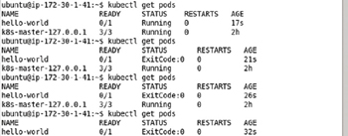

**Figure 3-9:**Listing the Pods with transitioning STATUS value

Run the following command to list the output from the Pod.

kubectl logs hello-world

The message created from environment variables MESSAGE1 and MESSAGE2 using substitution gets listed as shown in [Figure 3-10](https://viewer.books24x7.com/assetviewer.aspx?bookid=113388&chunkid=303980594&resumebookmarkid=24b8af05-b4be-e911-b9b2-00505695593a).

[Larger View](https://viewer.books24x7.com/assetviewer.aspx?bookid=113388&chunkid=303980594&resumebookmarkid=24b8af05-b4be-e911-b9b2-00505695593a)



**Figure 3-10:**Outputting Message Generated from Environment Variables using Value Substitution

**Specifying both the Executable and the Parameters in the Command Mapping**

In the third example, specify that both the executable and the parameters are specified in the Command mapping in the Pod definition file. Environment variable substitution is used for the MESSAGE1 and MESSAGE2 environment variables. The shell is not required to be invoked/started explicitly if the environment variable syntax $(VARIABLE\_NAME) is used, which is what we have used.

command: ["/bin/echo", " $(MESSAGE1)", " $(MESSAGE2)"]

The env.yaml Pod definition file is listed:

apiVersion: v1

kind: Pod

metadata:

name: "hello-world"

labels:

app: "helloApp"

spec:

restartPolicy: Never

containers:

-

image: "ubuntu"

name: "hello"

ports:

-

containerPort: 8020

env:

-

name: "MESSAGE1"

value: "hello"

-

name: "MESSAGE2"

value: "kubernetes"

command: ["/bin/echo", " $(MESSAGE1)", " $(MESSAGE2)"]

The env.yaml file may be opened and modified in the vi editor and saved using the :wq command as shown in [Figure 3-11](https://viewer.books24x7.com/assetviewer.aspx?bookid=113388&chunkid=589421483&resumebookmarkid=24b8af05-b4be-e911-b9b2-00505695593a).

[Larger View](https://viewer.books24x7.com/assetviewer.aspx?bookid=113388&chunkid=589421483&resumebookmarkid=24b8af05-b4be-e911-b9b2-00505695593a)

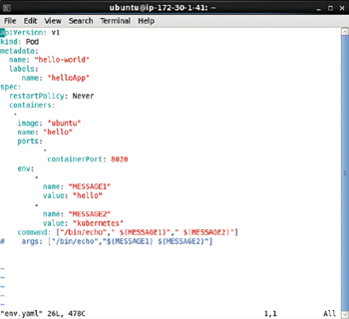

**Figure 3-11:**The Command mapping with both the Command Executable and the Parameters

Run the kubectl create command to create a Pod from the definition file env.yaml.

kubectl create –f env.yaml

The hello-world pod gets created as shown in [Figure 3-12](https://viewer.books24x7.com/assetviewer.aspx?bookid=113388&chunkid=589421483&resumebookmarkid=24b8af05-b4be-e911-b9b2-00505695593a). Run the kubectl getcommand to list the pods.

[Larger View](https://viewer.books24x7.com/assetviewer.aspx?bookid=113388&chunkid=589421483&resumebookmarkid=24b8af05-b4be-e911-b9b2-00505695593a)

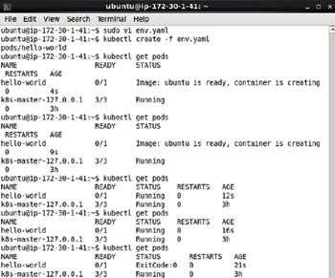

**Figure 3-12:**Creating and Listing the Pod with Definition file from [Figure 3-11](https://viewer.books24x7.com/assetviewer.aspx?bookid=113388&chunkid=589421483&resumebookmarkid=24b8af05-b4be-e911-b9b2-00505695593a)

kubectl get pods

The hello-world pod gets listed though initially the Pod STATUS is not listed as "Running" as shown in [Figure 3-12](https://viewer.books24x7.com/assetviewer.aspx?bookid=113388&chunkid=589421483&resumebookmarkid=24b8af05-b4be-e911-b9b2-00505695593a). The Pod transitions quickly to the READY value of 1/1 and subsequently 0/1. The 1/1 READY value is not shown in [Figure 3-12](https://viewer.books24x7.com/assetviewer.aspx?bookid=113388&chunkid=589421483&resumebookmarkid=24b8af05-b4be-e911-b9b2-00505695593a) as it transitions quickly to 0/1. After the command has run the Pod terminates and the STATUS becomes ExitCode:0as shown in [Figure 3-12](https://viewer.books24x7.com/assetviewer.aspx?bookid=113388&chunkid=589421483&resumebookmarkid=24b8af05-b4be-e911-b9b2-00505695593a).

Subsequently invoke the following command to list the output generated by the Pod.

kubectl get logs

The message created from environment variables MESSAGE1 and MESSAGE2 gets listed as shown in [Figure 3-13](https://viewer.books24x7.com/assetviewer.aspx?bookid=113388&chunkid=589421483&resumebookmarkid=24b8af05-b4be-e911-b9b2-00505695593a).

[Larger View](https://viewer.books24x7.com/assetviewer.aspx?bookid=113388&chunkid=589421483&resumebookmarkid=24b8af05-b4be-e911-b9b2-00505695593a)



**Figure 3-13:**Message output by Pod created in [Figure 3-12](https://viewer.books24x7.com/assetviewer.aspx?bookid=113388&chunkid=589421483&resumebookmarkid=24b8af05-b4be-e911-b9b2-00505695593a)

**Specifying Both the Executable and the Parameters in the Args Mapping**

In the fourth example, specify both the executable and the parameters in the Args mapping in the Pod definition file as a result overriding the CMD instruction in the Dockerfile. Environment variable substitution is used for the MESSAGE1 and MESSAGE2 environment variables with the environment variable syntax $(VARIABLE\_NAME).

args: ["/bin/echo", " $(MESSAGE1)", " $(MESSAGE2)"]

The env.yaml Pod definition file is listed:

apiVersion: v1

kind: Pod

metadata:

name: "hello-world"

labels:

app: "helloApp"

spec:

restartPolicy: Never

containers:

-

image: "ubuntu"

name: "hello"

ports:

-

containerPort: 8020

env:

-

name: "MESSAGE1"

value: "hello"

-

name: "MESSAGE2"

value: "kubernetes"

args: ["/bin/echo", " $(MESSAGE1)", " $(MESSAGE2)"]

The env.yaml file may be opened and modified in the vi editor and saved using the :wq command as shown in [Figure 3-14](https://viewer.books24x7.com/assetviewer.aspx?bookid=113388&chunkid=606631777).

[Larger View](https://viewer.books24x7.com/assetviewer.aspx?bookid=113388&chunkid=606631777)

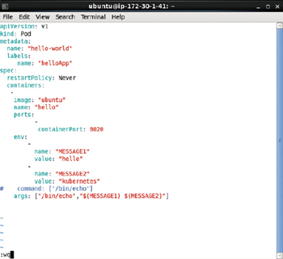

**Figure 3-14:**The args Mapping in the Pod definition file specifies both the Command Executable and the Parameters

The hello-world Pod created from the previous example must be deleted as otherwise the error shown in [Figure 3-15](https://viewer.books24x7.com/assetviewer.aspx?bookid=113388&chunkid=606631777) gets generated when the kubectl create command is run.

[Larger View](https://viewer.books24x7.com/assetviewer.aspx?bookid=113388&chunkid=606631777)

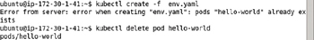

**Figure 3-15:**Error Generated if hello-world Pod already exists

Run the kubectl create command to create a Pod from the definition file env.yaml.

kubectl create –f env.yaml

The output from the command is shown in [Figure 3-16](https://viewer.books24x7.com/assetviewer.aspx?bookid=113388&chunkid=606631777).

[Larger View](https://viewer.books24x7.com/assetviewer.aspx?bookid=113388&chunkid=606631777)



**Figure 3-16:**Creating a Pod from definition file in [Figure 3-14](https://viewer.books24x7.com/assetviewer.aspx?bookid=113388&chunkid=606631777)

The hello-world pod gets created as shown in [Figure 3-17](https://viewer.books24x7.com/assetviewer.aspx?bookid=113388&chunkid=606631777). Run the kubectl getcommand to list the pods.

[Larger View](https://viewer.books24x7.com/assetviewer.aspx?bookid=113388&chunkid=606631777)

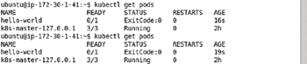

**Figure 3-17:**The Pod terminates and its Status transitions to ExitCode:0 after the command has run

kubectl get pods

The hello-world pod gets listed as shown in [Figure 3-17](https://viewer.books24x7.com/assetviewer.aspx?bookid=113388&chunkid=606631777). The Pod transitions quickly to the READY value of 1/1 and subsequently 0/1. The 1/1 READY value is not shown in [Figure 3-17](https://viewer.books24x7.com/assetviewer.aspx?bookid=113388&chunkid=606631777) as it transitions quickly to 0/1. After the command has run the Pod terminates and the STATUS becomes ExitCode:0 as shown in [Figure 3-17](https://viewer.books24x7.com/assetviewer.aspx?bookid=113388&chunkid=606631777).

Subsequently invoke the following command to list the output generated by the Pod.

kubectl get logs

The message created with environment variables substitution from MESSAGE1 and MESSAGE2gets listed as shown in [Figure 3-18](https://viewer.books24x7.com/assetviewer.aspx?bookid=113388&chunkid=606631777).

[Larger View](https://viewer.books24x7.com/assetviewer.aspx?bookid=113388&chunkid=606631777)



**Figure 3-18:**Outputting the Message Generated by Pod

### Summary

In this chapter we discussed the ENTRYPOINT and CMD instructions in a Docker image Dockerfile: instructions used to run the default command with the default parameters when the image is run in a Kubernetes Pod. We also discussed the Command and Argsmappings in a Pod definition file that could be used to override the ENTRYPOINT and CMDinstructions. We discussed various examples of overriding the default instructions for the "ubuntu" Docker image with "command" and "args" field mappings in a Pod definition file. We also demonstrated the use of environment variables in a Pod definition file. In the next chapter we shall discuss using MySQL Database with Kubernetes.

**Part II: Relational Databases**

Chapter List

1. [Chapter 4:](http://viewer.books24x7.com/assetviewer.aspx?bkid=113388&destid=297#297) Using MySQL Database
2. [Chapter 5:](http://viewer.books24x7.com/assetviewer.aspx?bkid=113388&destid=355#355) Using PostgreSQL Database
3. [Chapter 6:](http://viewer.books24x7.com/assetviewer.aspx?bkid=113388&destid=446#446) Using Oracle Database

## Chapter 4: Using MySQL Database

**© Deepak Vohra 2016  
D. Vohra, *Kubernetes Microservices with Docker*, DOI 10.1007/978-1-4842-1907-2\_4**

### Overview

MySQL database is the most commonly used open source database. The Docker image "mysql" could be used to create a Docker container running a MySQL database instance. Running Docker separately for a single MySQL instance or multiple instances lacks the features of scheduling multiple instances, scaling, and providing a service for external clients. In this chapter we shall discuss how the Kubernetes container cluster manager could be used to overcome all of those deficiencies.

**Setting the Environment**

The following software is required for this chapter.

* -Docker Engine (latest version)
* -Kubernetes Cluster Manager (version 1.01)
* -Kubectl (version 1.01)
* -Docker image "mysql" (latest version)

We have used an Amazon EC2 instance created from AMI Ubuntu Server 14-04 LTS (HVM), SSD Volume Type - ami-d05e75b8 to install the required software. The procedure to install Docker, Kubernetes, and Kubectl is discussed in [chapter 1](http://viewer.books24x7.com/assetviewer.aspx?bkid=113388&destid=28#28). Obtain the Public IP address of the Amazon EC2 instance as shown in [Figure 4-1](https://viewer.books24x7.com/assetviewer.aspx?bookid=113388&chunkid=208650597&resumebookmarkid=99efed37-cdbe-e911-b9b2-00505695593a).

[Larger View](https://viewer.books24x7.com/assetviewer.aspx?bookid=113388&chunkid=208650597&resumebookmarkid=99efed37-cdbe-e911-b9b2-00505695593a)

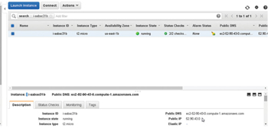

**Figure 4-1:**Obtaining the Public IP Address

SSH log in to the Ubuntu instance using the Public IP Address, which would be different for different users.

sh -i "docker.pem" ubuntu@52.90.43.0

Start the Docker engine and verify its status.

sudo service docker start

sudo service docker status

The Docker Engine should be listed as "running" as shown in [Figure 4-2](https://viewer.books24x7.com/assetviewer.aspx?bookid=113388&chunkid=208650597&resumebookmarkid=99efed37-cdbe-e911-b9b2-00505695593a).

[Larger View](https://viewer.books24x7.com/assetviewer.aspx?bookid=113388&chunkid=208650597&resumebookmarkid=99efed37-cdbe-e911-b9b2-00505695593a)

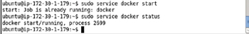

**Figure 4-2:**Starting Docker and Verifying Its Status

**Creating a Service**

In this section we shall create a Kubernetes service using a definition file. We have used the YAML format for definition files, but JSON could be used just as well. Create a service definition file called mysql-service.yaml and copy the following listing to the file. Within the spec field mapping for the service the "selector" expression is set to app: "mysql-app,"which translates to service selector app=mysql-app and which implies that the service routes traffic to Pods with the label app=mysql-app. If the selector expression is empty all Pods are selected. The port to expose the service is set to 3306 within the ports listing. And the service has a label app: "mysql-app". The kind field mapping must have value "Service."

apiVersion: v1

kind: Service

metadata:

name: "mysql"

labels:

app: "mysql-app"

spec:

ports:

# the port that this service should serve on

- port: 3306

# label keys and values that must match in order to receive traffic for this service

selector:

app: "mysql-app"

The service schema is available at <http://kubernetes.io/v1.1/docs/api-reference/v1/definitions.html#_v1_service>. Setting the selector field in the YAML definition file to app: "mysql-app" implies that all Pods with the YAML definition file label setting app: "mysql-app" are managed by the service. Create the service using the definition file with the kubectl create command.

kubectl create -f mysql-service.yaml

The mysql service gets created and the output is "services/mysql" as shown in [Figure 4-3](https://viewer.books24x7.com/assetviewer.aspx?bookid=113388&chunkid=995103093&resumebookmarkid=99efed37-cdbe-e911-b9b2-00505695593a).

[Larger View](https://viewer.books24x7.com/assetviewer.aspx?bookid=113388&chunkid=995103093&resumebookmarkid=99efed37-cdbe-e911-b9b2-00505695593a)



**Figure 4-3:**Creating a Service for MySQL Database

List the service using the following command.

kubectl get services

The mysql service gets listed as shown in [Figure 4-4](https://viewer.books24x7.com/assetviewer.aspx?bookid=113388&chunkid=995103093&resumebookmarkid=99efed37-cdbe-e911-b9b2-00505695593a).

[Larger View](https://viewer.books24x7.com/assetviewer.aspx?bookid=113388&chunkid=995103093&resumebookmarkid=99efed37-cdbe-e911-b9b2-00505695593a)

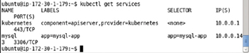

**Figure 4-4:**Listing the mysql Service

**Creating a Service**

In this section we shall create a Kubernetes service using a definition file. We have used the YAML format for definition files, but JSON could be used just as well. Create a service definition file called mysql-service.yaml and copy the following listing to the file. Within the spec field mapping for the service the "selector" expression is set to app: "mysql-app,"which translates to service selector app=mysql-app and which implies that the service routes traffic to Pods with the label app=mysql-app. If the selector expression is empty all Pods are selected. The port to expose the service is set to 3306 within the ports listing. And the service has a label app: "mysql-app". The kind field mapping must have value "Service."

apiVersion: v1

kind: Service

metadata:

name: "mysql"

labels:

app: "mysql-app"

spec:

ports:

# the port that this service should serve on

- port: 3306

# label keys and values that must match in order to receive traffic for this service

selector:

app: "mysql-app"

The service schema is available at <http://kubernetes.io/v1.1/docs/api-reference/v1/definitions.html#_v1_service>. Setting the selector field in the YAML definition file to app: "mysql-app" implies that all Pods with the YAML definition file label setting app: "mysql-app" are managed by the service. Create the service using the definition file with the kubectl create command.

kubectl create -f mysql-service.yaml

The mysql service gets created and the output is "services/mysql" as shown in [Figure 4-3](https://viewer.books24x7.com/assetviewer.aspx?bookid=113388&chunkid=995103093&resumebookmarkid=99efed37-cdbe-e911-b9b2-00505695593a).

[Larger View](https://viewer.books24x7.com/assetviewer.aspx?bookid=113388&chunkid=995103093&resumebookmarkid=99efed37-cdbe-e911-b9b2-00505695593a)



**Figure 4-3:**Creating a Service for MySQL Database

List the service using the following command.

kubectl get services

The mysql service gets listed as shown in [Figure 4-4](https://viewer.books24x7.com/assetviewer.aspx?bookid=113388&chunkid=995103093&resumebookmarkid=99efed37-cdbe-e911-b9b2-00505695593a).

[Larger View](https://viewer.books24x7.com/assetviewer.aspx?bookid=113388&chunkid=995103093&resumebookmarkid=99efed37-cdbe-e911-b9b2-00505695593a)



**Figure 4-4:**Listing the mysql Service

### Creating a Replication Controller

In this section we shall create a replication controller managed by the service created in the previous section. Create a replication controller definition file called mysql-rc.yaml and copy the following/next listing to the file. The kind field mapping must have value "ReplicationController." The replication controller has a label app: "mysql-app" in the metadata field mapping. If the labels are empty they are defaulted to the labels of the Pods the replication controller manages. The "spec" field mapping defines the replication controller and includes the "replicas" field mapping for the number of replicas to create. The replicas is set to 1 in the following/next listing. The default number of replicas is also 1. The spec includes a selector field mapping called app: "mysql-app," which selects all Pods with label app: "mysql-app" for the replication controller to manage and count toward the "replicas" setting. A Pod could have other labels in addition to the selector, but must include the selector expression/s of a replication controller to be managed by the replication controller. Similarly, a replication controller could be managing Pods not started with the replication controller definition file.

Labels and selector expression settings in YAML definition files are not used as such, but are translated to a label/selector by replacing the ':' with the '=' For example, service/replication controller selector setting app: "mysql-app" becomes selector app = mysql-app selector and label setting app: "mysql-app" becomes label app = mysql-app.

If a selector is not specified the labels on the template are used to match the Pods and count toward the "replicas" setting. The "template" field mapping defines a Pod managed by the replication controller. The spec field mapping within the template field specifies the behavior of the Pod. The "containers" field mapping within the "spec" field defines the collection/list of containers to create including the image, the environment variables if any, and the ports to use for each container.

We need to use an environment variable for the MySQL database replication controller. The Docker image "mysql" requires (is mandatory) the environment variable MYSQL\_ROOT\_PASSWORD to run a Docker container for MySQL database. The MYSQL\_ROOT\_PASSWORD variable sets the password for the root user. Environment variables are set with the "env" mapping within a containers field listing. An env mapping consists of a name mapping and a value mapping. The MYSQL\_ROOT\_PASSWORD environment variable is set as shown in the following listing. The "ports" field collection includes a containerPortmapping for port 3306. The indentations and hyphens in a YAML file must be well formatted and the following listing should be copied and syntax validated in the YAML Lint (<http://www.yamllint.com/>). The YAML lint only validates the syntax and does not validate if the Pod definition field conforms to the schema for a pod. The Pod schema is available at <http://kubernetes.io/v1.1/docs/api-reference/v1/definitions.html#_v1_podspec>.

---

apiVersion: v1

kind: ReplicationController

metadata:

labels:

app: "mysql-app"

spec:

replicas: 1

selector:

app: "mysql-app"

template:

metadata:

labels:

app: "mysql-app"

spec:

containers:

-

env:

-

name: "MYSQL\_ROOT\_PASSWORD"

value: "mysql"

image: "mysql"

name: "mysql"

ports:

-

containerPort: 3306

The mysql-rc.yaml definition file may be created in the vi editor and saved with the :wq command as shown in [Figure 4-5](https://viewer.books24x7.com/assetviewer.aspx?bookid=113388&chunkid=747499309&resumebookmarkid=99efed37-cdbe-e911-b9b2-00505695593a).

[Larger View](https://viewer.books24x7.com/assetviewer.aspx?bookid=113388&chunkid=747499309&resumebookmarkid=99efed37-cdbe-e911-b9b2-00505695593a)

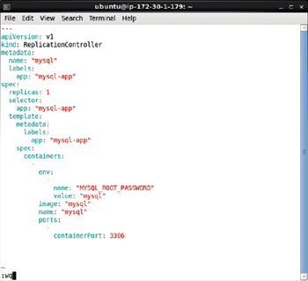

**Figure 4-5:**Definition File for Replication Controller

Create a replication controller from the service definition file with the kubectl createcommand.

kubectl create -f mysql-rc.yaml

As the output in [Figure 4-6](https://viewer.books24x7.com/assetviewer.aspx?bookid=113388&chunkid=747499309&resumebookmarkid=99efed37-cdbe-e911-b9b2-00505695593a) indicates, the mysql replication controller gets created.

[Larger View](https://viewer.books24x7.com/assetviewer.aspx?bookid=113388&chunkid=747499309&resumebookmarkid=99efed37-cdbe-e911-b9b2-00505695593a)



**Figure 4-6:**Creating a Replication Controller for MySQL Database

List the replication with the following command.

kubectl get rc

The mysql replication controller including the container name, image name, selector expression (app=mysql-app), and number of replicas get listed as shown in [Figure 4-7](https://viewer.books24x7.com/assetviewer.aspx?bookid=113388&chunkid=747499309&resumebookmarkid=99efed37-cdbe-e911-b9b2-00505695593a).

[Larger View](https://viewer.books24x7.com/assetviewer.aspx?bookid=113388&chunkid=747499309&resumebookmarkid=99efed37-cdbe-e911-b9b2-00505695593a)



**Figure 4-7:**Listing the MySQL Replication Controller

To describe the mysql replication controller run the following command.

kubectl describe rc mysql

The replication controller name, namespace, image, selector, labels, replicas, pod status, and events get listed as shown in [Figure 4-8](https://viewer.books24x7.com/assetviewer.aspx?bookid=113388&chunkid=747499309&resumebookmarkid=99efed37-cdbe-e911-b9b2-00505695593a).

[Larger View](https://viewer.books24x7.com/assetviewer.aspx?bookid=113388&chunkid=747499309&resumebookmarkid=99efed37-cdbe-e911-b9b2-00505695593a)

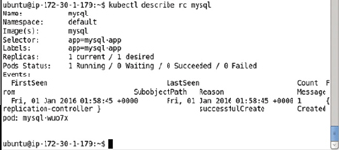

**Figure 4-8:**Describing the MySQL Replication Controller

**Listing the Pods**

The Pods created may be listed with the following command.

kubectl get pods

As shown in [Figure 4-9](https://viewer.books24x7.com/assetviewer.aspx?bookid=113388&chunkid=440173048&resumebookmarkid=99efed37-cdbe-e911-b9b2-00505695593a) the 2 replicas created by the replication controller get listed. Initially the Pods may not be listed as READY 1/1. Run the preceding command after a few seconds, multiple times if required, to list all the Pods as ready.

[Larger View](https://viewer.books24x7.com/assetviewer.aspx?bookid=113388&chunkid=440173048&resumebookmarkid=99efed37-cdbe-e911-b9b2-00505695593a)

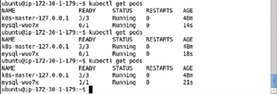

**Figure 4-9:**Listing the Pod/s for MySQL Database

**Listing Logs**

List the Pod logs for a pod: for example, the mysql-wuo7x pod, with the following command.

kubectl logs mysql-wuo7x

The Pod logs get listed as shown in [Figure 4-10](https://viewer.books24x7.com/assetviewer.aspx?bookid=113388&chunkid=240768265&resumebookmarkid=99efed37-cdbe-e911-b9b2-00505695593a).

[Larger View](https://viewer.books24x7.com/assetviewer.aspx?bookid=113388&chunkid=240768265&resumebookmarkid=99efed37-cdbe-e911-b9b2-00505695593a)

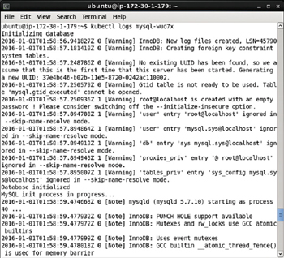

**Figure 4-10:**Listing the Logs generated by the Pod for MySQL Database

The MySQL Server is listed as started and "ready for connections" as shown in [Figure 4-11](https://viewer.books24x7.com/assetviewer.aspx?bookid=113388&chunkid=240768265&resumebookmarkid=99efed37-cdbe-e911-b9b2-00505695593a).

[Larger View](https://viewer.books24x7.com/assetviewer.aspx?bookid=113388&chunkid=240768265&resumebookmarkid=99efed37-cdbe-e911-b9b2-00505695593a)

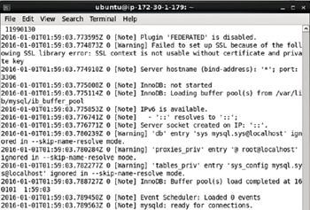

**Figure 4-11:**Listing mysqld as Ready for Connections

**Describing the Service**

To describe the mysql service run the following command.

kubectl describe svc mysql

The service name, namespace, labels, selector, type, Ip, port and endpoints get listed. Because the number of replicas is set to 1 only one endpoint is listed as shown in [Figure 4-12](https://viewer.books24x7.com/assetviewer.aspx?bookid=113388&chunkid=924920343&resumebookmarkid=99efed37-cdbe-e911-b9b2-00505695593a).

[Larger View](https://viewer.books24x7.com/assetviewer.aspx?bookid=113388&chunkid=924920343&resumebookmarkid=99efed37-cdbe-e911-b9b2-00505695593a)

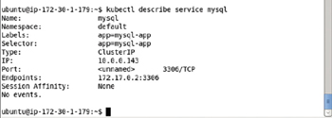

**Figure 4-12:**Describing the MySQL Service

### Starting an Interactive Shell

Bash is the free version of the Bourne shell distributed with Linux and GNU operating systems (OS). For Docker images that have a Linux OS image as the base image as specified in the FROM instruction in the Dockerfile, the software running in a Docker container may be accessed using the Bash shell. The "mysql" Docker image is based on the "debian" image and as a result supports access to software running in the Docker containers via a bash interactive shell.

Next, we shall start an interactive shell to start the MySQL CLI. But first we need to obtain the container id for one of the containers running MySQL. Run the following command to list the Docker containers.

sudo docker ps

The Docker container for the mysql image is shown listed in [Figure 4-13](https://viewer.books24x7.com/assetviewer.aspx?bookid=113388&chunkid=754786482&resumebookmarkid=99efed37-cdbe-e911-b9b2-00505695593a).

[Larger View](https://viewer.books24x7.com/assetviewer.aspx?bookid=113388&chunkid=754786482&resumebookmarkid=99efed37-cdbe-e911-b9b2-00505695593a)

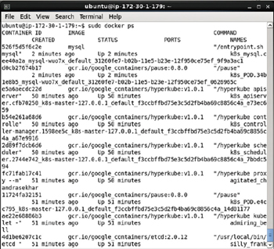

**Figure 4-13:**Listing the Docker Containers

Using the Docker container id from the output from the preceding command, start an interactive shell.

sudo docker exec -it 526f5d5f6c2e bash

An interactive shell or tty gets started as shown in [Figure 4-14](https://viewer.books24x7.com/assetviewer.aspx?bookid=113388&chunkid=754786482&resumebookmarkid=99efed37-cdbe-e911-b9b2-00505695593a).

[Larger View](https://viewer.books24x7.com/assetviewer.aspx?bookid=113388&chunkid=754786482&resumebookmarkid=99efed37-cdbe-e911-b9b2-00505695593a)



**Figure 4-14:**Starting the Interactive Terminal

**Starting the MySQL CLI**

Within the interactive shell run the following command to start the MySQL CLI as user root.

mysql –u root –p

When prompted with Password: set the password as the value of the environment variable MYSQL\_ROOT\_PASSWORD, which was set as "mysql" in the mysql-rc.yaml definition file. The MySQL CLI gets started as shown in [Figure 4-15](https://viewer.books24x7.com/assetviewer.aspx?bookid=113388&chunkid=218617204&resumebookmarkid=99efed37-cdbe-e911-b9b2-00505695593a).

[Larger View](https://viewer.books24x7.com/assetviewer.aspx?bookid=113388&chunkid=218617204&resumebookmarkid=99efed37-cdbe-e911-b9b2-00505695593a)

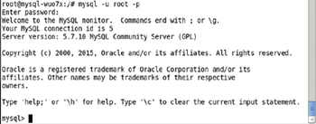

**Figure 4-15:**Starting the MySQL CLI Shell

List the databases with the following command.

show databases;

The default databases shown in [Figure 4-16](https://viewer.books24x7.com/assetviewer.aspx?bookid=113388&chunkid=218617204&resumebookmarkid=99efed37-cdbe-e911-b9b2-00505695593a) include the "mysql" database, which we shall use to create a database table. The other databases are system databases and should not be used for user tables.

[Larger View](https://viewer.books24x7.com/assetviewer.aspx?bookid=113388&chunkid=218617204&resumebookmarkid=99efed37-cdbe-e911-b9b2-00505695593a)

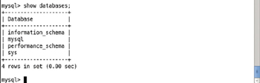

**Figure 4-16:**Listing the Databases

Set the database "mysql" as the current database with the following command.

use mysql

The database gets set as mysql as indicated by the "Database changed" output in [Figure 4-17](https://viewer.books24x7.com/assetviewer.aspx?bookid=113388&chunkid=218617204&resumebookmarkid=99efed37-cdbe-e911-b9b2-00505695593a).

[Larger View](https://viewer.books24x7.com/assetviewer.aspx?bookid=113388&chunkid=218617204&resumebookmarkid=99efed37-cdbe-e911-b9b2-00505695593a)

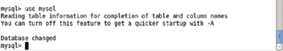

**Figure 4-17:**Setting the Database

**Creating a Database Table**

Next, create a database table called Catalog with the following SQL statement.

CREATE TABLE Catalog(CatalogId INTEGER PRIMARY KEY,Journal VARCHAR(25),

Publisher VARCHAR(25),Edition VARCHAR(25),Title VARCHAR(45),Author VARCHAR(25));

Add a row of data to the Catalog table with the following SQL statement.

INSERT INTO Catalog VALUES('1','Oracle Magazine','Oracle Publishing',

'November December 2013','Engineering as a Service','David A. Kelly');

The Catalog table gets created and a row of data gets added as shown in [Figure 4-18](https://viewer.books24x7.com/assetviewer.aspx?bookid=113388&chunkid=464547336&resumebookmarkid=99efed37-cdbe-e911-b9b2-00505695593a).

[Larger View](https://viewer.books24x7.com/assetviewer.aspx?bookid=113388&chunkid=464547336&resumebookmarkid=99efed37-cdbe-e911-b9b2-00505695593a)

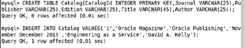

**Figure 4-18:**Creating a MySQL Database Table

Subsequently run the following SQL statement to query the database table Catalog.

SELECT \* FROM Catalog;

The single row of data added gets listed as shown in [Figure 4-19](https://viewer.books24x7.com/assetviewer.aspx?bookid=113388&chunkid=464547336&resumebookmarkid=99efed37-cdbe-e911-b9b2-00505695593a).

[Larger View](https://viewer.books24x7.com/assetviewer.aspx?bookid=113388&chunkid=464547336&resumebookmarkid=99efed37-cdbe-e911-b9b2-00505695593a)

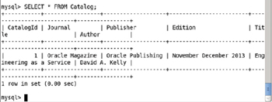

**Figure 4-19:**Querying the Database Table

**Exiting the MySQL CLI and Interactive Shell**

Exit the MySQL CLI with the "quit" command.

quit

Exit the interactive terminal with the "exit" command.

exit

The output from the preceding commands is shown in [Figure 4-20](https://viewer.books24x7.com/assetviewer.aspx?bookid=113388&chunkid=148847462&resumebookmarkid=99efed37-cdbe-e911-b9b2-00505695593a).

[Larger View](https://viewer.books24x7.com/assetviewer.aspx?bookid=113388&chunkid=148847462&resumebookmarkid=99efed37-cdbe-e911-b9b2-00505695593a)

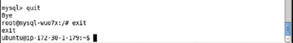

**Figure 4-20:**Exiting the MySQL CLI Shell and Docker Container Interactive Shell

### Scaling the Replicas

One of the main benefits of Kubernetes is to be able to scale the number of MySQL instances in the cluster. Run the following kubectl scale command to scale the replicas from 1 to 4.

kubectl scale rc mysql --replicas=4

Subsequently run the following command to list the Pods.

kubectl get pods

The number of Pods for the MySQL database gets increased to 4 as shown in [Figure 4-21](https://viewer.books24x7.com/assetviewer.aspx?bookid=113388&chunkid=265031878&resumebookmarkid=99efed37-cdbe-e911-b9b2-00505695593a). Some of the Pods may be listed as READY- > 0/1, which implies the Pod/s are not ready yet. When READY becomes 1/1 a Pod is ready to be accessed. The 0/1 value implies that 0 of the 1 Docker containers in the Pod are ready and similarly the 1/1 value implies that 1 of 1 containers is ready. The general syntax for the READY column value if all the n containers in the Pod are running is of the form n/n. The STATUS must be "Running" for a Pod to be considered available.

[Larger View](https://viewer.books24x7.com/assetviewer.aspx?bookid=113388&chunkid=265031878&resumebookmarkid=99efed37-cdbe-e911-b9b2-00505695593a)

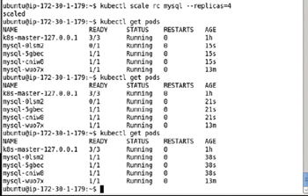

**Figure 4-21:**Scaling the Pod Replicas to Four

To describe the mysql service, run the following command.

kubectl describe svc mysql

The service description is the same as before except that the number of endpoints has increased to 4 as shown in [Figure 4-22](https://viewer.books24x7.com/assetviewer.aspx?bookid=113388&chunkid=265031878&resumebookmarkid=99efed37-cdbe-e911-b9b2-00505695593a).

[Larger View](https://viewer.books24x7.com/assetviewer.aspx?bookid=113388&chunkid=265031878&resumebookmarkid=99efed37-cdbe-e911-b9b2-00505695593a)

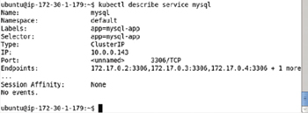

**Figure 4-22:**Describing the MySQL Service After Scaling the Pod Replicas

The command "scale" will also allow us to specify one or more preconditions for the scale actions needed. The following ([Table 4-1](https://viewer.books24x7.com/assetviewer.aspx?bookid=113388&chunkid=265031878&resumebookmarkid=99efed37-cdbe-e911-b9b2-00505695593a)) preconditions are supported.

**Table 4-1: Preconditions for the 'kubernetes scale' command**[[](https://viewer.books24x7.com/outputobject.aspx?bookid=113388&chunkid=265031878&objectid=ch4_tab1&objecttype=spreadsheet) Open table as spreadsheet](https://viewer.books24x7.com/outputobject.aspx?bookid=113388&chunkid=265031878&objectid=ch4_tab1&objecttype=spreadsheet" \t "_blank)

| **Precondition** | **Description** |
| --- | --- |
| --current-replicas | The current number of replicas for the scale to be performed. |
| --resource-version | The resource version to match for the scale to be performed. |

**Deleting the Replication Controller**

To delete the replication controller mysql, run the following command.

kubectl delete rc mysql

The replication controller gets deleted as shown in [Figure 4-23](https://viewer.books24x7.com/assetviewer.aspx?bookid=113388&chunkid=522094268&resumebookmarkid=99efed37-cdbe-e911-b9b2-00505695593a). Whenever a kubectlcommand output to create or delete an artifact (a Pod, service or replication controller) is of the form *artifact type/artifact name*, it implies that the command has succeeded to create/delete the pod/service/replication controller.

[Larger View](https://viewer.books24x7.com/assetviewer.aspx?bookid=113388&chunkid=522094268&resumebookmarkid=99efed37-cdbe-e911-b9b2-00505695593a)



**Figure 4-23:**Deleting the Replication Controller

Subsequently run the following command to get the replication controllers. The mysql rc does not get listed as shown in [Figure 4-24](https://viewer.books24x7.com/assetviewer.aspx?bookid=113388&chunkid=522094268&resumebookmarkid=99efed37-cdbe-e911-b9b2-00505695593a).

kubectl get rc

[Larger View](https://viewer.books24x7.com/assetviewer.aspx?bookid=113388&chunkid=522094268&resumebookmarkid=99efed37-cdbe-e911-b9b2-00505695593a)

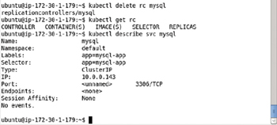

**Figure 4-24:**Describing the Service after Deleting the Replication Controllers

Describe the service mysql again with the following command.

kubectl describe svc mysql

No "Endpoints" get listed as shown in [Figure 4-24](https://viewer.books24x7.com/assetviewer.aspx?bookid=113388&chunkid=522094268&resumebookmarkid=99efed37-cdbe-e911-b9b2-00505695593a) because all the Pods get deleted when the replication controller managing them is deleted.

### Summary

In this chapter we discussed orchestrating the MySQL database cluster using the Kubernetes cluster manager. We created a Kubernetes service to represent a MySQL-based Pod. The "mysql" Docker image is used to create a Pod. We used a replication controller to create replicas for MySQL base Pods. Initially the number of replicas is set to 1. We used a Docker container running a MySQL instance to start the MySQL CLI and create a database table. Subsequently, we scaled the number of replicas to 4 using the replication controller. When scaled, the number of replicas and therefore the number of MySQL instances becomes 4. The replication controller maintains the replication level through replica failure or replica shut down by a user. This chapter also demonstrates the use of environment variables. The MYSQL\_ROOT\_PASSWORD environment variable is required to run a container for the Docker image "mysql" and we set the MYSQL\_ROOT\_PASSWORD environment variable in the Pod spec in the replication controller. In the next chapter we shall discuss using another open source database, the PostgreSQL database.

**Kubernetes Microservices with Docker**

Chapter 5 - Using PostgreSQL Database

Apress © 2016

## Chapter 5: Using PostgreSQL Database

**© Deepak Vohra 2016  
D. Vohra, *Kubernetes Microservices with Docker*, DOI 10.1007/978-1-4842-1907-2\_5**

### Overview

PostgreSQL is an open source object-relational database. PostgreSQL is scalable both in terms of the quantity of data and number of concurrent users. PostgreSQL is supported in several of Apache Hadoop ecosystem projects such as Apache Sqoop and may be used for Apache Hive Metastore. PostgreSQL 9.5 offers several new features such as support for UPSERT, BRIN indexing, faster sorts, and the TABLESAMPLE clause for getting a statistical sample of a large table. In this chapter we shall discuss creating a PostgreSQL 9.5 cluster using the Kubernetes cluster manager. We shall discuss both the imperative approach and the declarative approach for creating and scaling a PostgreSQL cluster.

**Setting the Environment**

We have used the same type of Amazon EC2 instance in this chapter as in other chapters, an instance based on Ubuntu Server 14.04 LTS (HVM), SSD Volume Type - ami-d05e75b8 AMI. The following software is required for this chapter.

* -Docker Engine (latest version)
* -Kubernetes Cluster Manager (version 1.01)
* -Kubectl (version 1.01)
* -Docker Image "postgres" (latest version)

The procedure to install the required software, start Docker engine and Kubernetes cluster manager, is discussed in [chapter 1](http://viewer.books24x7.com/assetviewer.aspx?bkid=113388&destid=28#28). To install the software first we need to log in to the Amazon EC2 instance. Obtain the Public IP Address of the Amazon EC2 instance as shown in [Figure 5-1](https://viewer.books24x7.com/assetviewer.aspx?bookid=113388&chunkid=369183413&resumebookmarkid=99efed37-cdbe-e911-b9b2-00505695593a).

[Larger View](https://viewer.books24x7.com/assetviewer.aspx?bookid=113388&chunkid=369183413&resumebookmarkid=99efed37-cdbe-e911-b9b2-00505695593a)

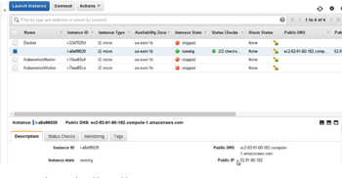

**Figure 5-1:**Obtaining the Public IP Address

SSH Login to the Ubuntu instance using the Public IP Address.

ssh -i "docker.pem" ubuntu@52.91.60.182

Start the Docker engine and verify its status.

sudo service docker start

sudo service docker status

Docker should be indicated as "running" as shown in [Figure 5-2](https://viewer.books24x7.com/assetviewer.aspx?bookid=113388&chunkid=369183413&resumebookmarkid=99efed37-cdbe-e911-b9b2-00505695593a).

[Larger View](https://viewer.books24x7.com/assetviewer.aspx?bookid=113388&chunkid=369183413&resumebookmarkid=99efed37-cdbe-e911-b9b2-00505695593a)

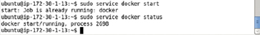

**Figure 5-2:**Starting Docker

List the services with the following command.

kubectl get services

The kubernetes service should get listed as shown in [Figure 5-3](https://viewer.books24x7.com/assetviewer.aspx?bookid=113388&chunkid=369183413&resumebookmarkid=99efed37-cdbe-e911-b9b2-00505695593a).

[Larger View](https://viewer.books24x7.com/assetviewer.aspx?bookid=113388&chunkid=369183413&resumebookmarkid=99efed37-cdbe-e911-b9b2-00505695593a)

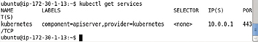

**Figure 5-3:**Listing the Kubernetes Services

### Creating a PostgreSQL Cluster Declaratively

In the following subsections we shall create and manage a PostgreSQL cluster declaratively, which implies we shall use definition files. The definition files could be based on the YAML format or the JSON format. We shall be using YAML format. It is recommended to create the service first so that any pods created subsequently have a service available to represent them. If the RC (replication controller) is created first, the pods are not usable until a service is created.

#### Creating a Service

Create a service definition file postgres-service.yaml and copy the following listing to the file. The "spec" field mapping for the service specifies the behavior of the service. The ports on which the service is exposed are defined in the "ports" field mapping. Only the port 5432 is exposed because PostgreSQL runs on port 5432. The selector expression is set to app: "postgres". All Pods with the label app=postgres are managed by the service.

apiVersion: v1

kind: Service

metadata:

name: "postgres"

labels:

app: "postgres"

spec:

ports:

- port: 5432

selector:

app: "postgres"

The postgres-service.yaml file may be created using the vi editor and saved with the :wq command as shown in [Figure 5-4](https://viewer.books24x7.com/assetviewer.aspx?bookid=113388&chunkid=252243619&resumebookmarkid=99efed37-cdbe-e911-b9b2-00505695593a).

[Larger View](https://viewer.books24x7.com/assetviewer.aspx?bookid=113388&chunkid=252243619&resumebookmarkid=99efed37-cdbe-e911-b9b2-00505695593a)

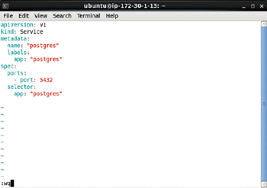

**Figure 5-4:**Service Definition File postgres-service.yaml

Create the service using the kubectl create command with the postgres-service.yamldefinition file.

kubectl create -f postgres-service.yaml

Subsequently list the services.

kubectl get services

Also list the Pods.

kubectl get pods

An output of services/postgres from the first command indicates that the service has been created. The second command lists the postgres service as running at port 5432 as shown in [Figure 5-5](https://viewer.books24x7.com/assetviewer.aspx?bookid=113388&chunkid=252243619&resumebookmarkid=99efed37-cdbe-e911-b9b2-00505695593a). The IP Address of the service is also listed. Creating a service by itself does not create a Pod by itself and only the Pod for the Kubernetes is listed. A service only manages or provides an interface for Pods with the label that matches the selectorexpression in the service.

[Larger View](https://viewer.books24x7.com/assetviewer.aspx?bookid=113388&chunkid=252243619&resumebookmarkid=99efed37-cdbe-e911-b9b2-00505695593a)

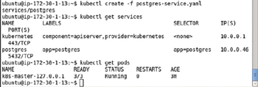

**Figure 5-5:**Creating a Service and listing the Service

Describe the service postgres with the following command.

kubectl describe svc postgres

The service name, namespace, labels, selector, type, IP address, Port exposed on, and Endpoints get listed. Because no Pods are initially associated with the service, no endpoints are listed as shown in [Figure 5-6](https://viewer.books24x7.com/assetviewer.aspx?bookid=113388&chunkid=252243619&resumebookmarkid=99efed37-cdbe-e911-b9b2-00505695593a).

[Larger View](https://viewer.books24x7.com/assetviewer.aspx?bookid=113388&chunkid=252243619&resumebookmarkid=99efed37-cdbe-e911-b9b2-00505695593a)

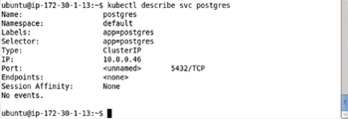

**Figure 5-6:**Describing the postgres Service

#### Creating a Replication Controller

In this section we shall create a definition file for a replication controller. Create a definition file called postgres-rc.yaml. The definition file has the field discussed in [Table 5-1](https://viewer.books24x7.com/assetviewer.aspx?bookid=113388&chunkid=252243619&resumebookmarkid=99efed37-cdbe-e911-b9b2-00505695593a).

**Table 5-1: Replication Controller Definition File postgres-rc.yaml**[[](https://viewer.books24x7.com/outputobject.aspx?bookid=113388&chunkid=252243619&objectid=ch5_tab1&objecttype=spreadsheet) Open table as spreadsheet](https://viewer.books24x7.com/outputobject.aspx?bookid=113388&chunkid=252243619&objectid=ch5_tab1&objecttype=spreadsheet" \t "_blank)

| **Field** | **Value** | **Description** |
| --- | --- | --- |
| apiVersion | v1 | The API version. |
| kind | ReplicationController | Defines the file to be a replication controller. |
| metadata |  | Metadata for the replication controller. |
| metadata -> name |  | The name of the replication controller. Either the name or the generateName field must be specified. The generateName field is the prefix to use in an automatically generated name. |
| spec |  | The specification for the replication controller. |
| spec-> replicas | 2 | The number of Pod replicas to create. |
| template |  | Specifies the template for the Pod that the replication controller manages. |
| template- > metadata |  | The metadata for the Pod including labels. The label is used to select the Pods managed by the replication controller and must manage the selector expression in the service definition file if the service is to represent the Pod. |
| template-> spec |  | Pod specification or configuration. |
| template- > spec- > containers |  | The containers in a Pod. Multiple containers could be specified but in this chapter only the container for PostgreSQL is specified. |
| template- > spec- > containers- > image |  | The Docker image to run in the container. |
| template- > spec- > containers- > name |  | For PostgreSQL the image is "postgres." The name field specifies the container name. |

Optionally the replication controller's selector field mapping may be specified. The key:value mapping in the selector must match a label in the template- > metadata field mapping for the replication controller to manage the Pod in the template. The selector field mapping if not specified defaults to the template- > metadata- > labels field mapping. In the following listing the selector is italicized and not included in the definition file used. The Pod's template- > metadata- > labels field mapping specifies an expression app: "postgres", which translates to Pod label app=postgres. The labels field expression must be the same as the "selector" field expression in the service definition file, which was discussed in the previous section, for the service to manage the Pod.

apiVersion: v1

kind: ReplicationController

metadata:

name: "postgres"

spec:

replicas: 2

*selector:*

*- app: "postgres"*

template:

metadata:

**labels:**

**app: "postgres"**

spec:

containers:

-

image: "postgres"

name: "postgres"

Copy the preceding listing to the postgres-rc.yaml file. The postgres-rc.yaml file may be opened in the vi editor and saved with :wq as shown in [Figure 5-7](https://viewer.books24x7.com/assetviewer.aspx?bookid=113388&chunkid=252243619&resumebookmarkid=99efed37-cdbe-e911-b9b2-00505695593a).

[Larger View](https://viewer.books24x7.com/assetviewer.aspx?bookid=113388&chunkid=252243619&resumebookmarkid=99efed37-cdbe-e911-b9b2-00505695593a)

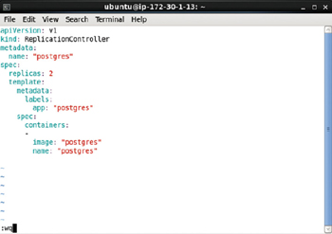

**Figure 5-7:**Replication Controller Definition File

Create a replication controller using the definition file postgres-rc.yaml.

kubectl create -f postgres-rc.yaml

Subsequently list the replication controllers.

kubectl get rc

An output of replicationcontrollers/postgres from the first command as shown in [Figure 5-8](https://viewer.books24x7.com/assetviewer.aspx?bookid=113388&chunkid=252243619&resumebookmarkid=99efed37-cdbe-e911-b9b2-00505695593a) indicates that the replication controller postgres has been created. The second command lists the postgres replication controller. As discussed before the Replication Controller SELECTOR column is set to the same value as the Pod label, app=postgres.

[Larger View](https://viewer.books24x7.com/assetviewer.aspx?bookid=113388&chunkid=252243619&resumebookmarkid=99efed37-cdbe-e911-b9b2-00505695593a)

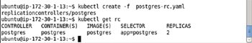

**Figure 5-8:**Creating and listing the Replication Controller for PostgreSQL Database

Describe the replication controller postgres with the following command.

kubectl describe rc postgres

The replication controller's name, namespace, image associated with the rc, selectors if any, labels, number of replicas, pod status, and events get listed as shown in [Figure 5-9](https://viewer.books24x7.com/assetviewer.aspx?bookid=113388&chunkid=252243619&resumebookmarkid=99efed37-cdbe-e911-b9b2-00505695593a).

[Larger View](https://viewer.books24x7.com/assetviewer.aspx?bookid=113388&chunkid=252243619&resumebookmarkid=99efed37-cdbe-e911-b9b2-00505695593a)

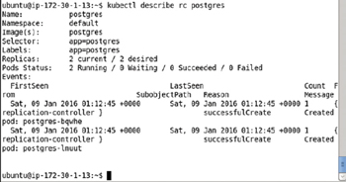

**Figure 5-9:**Describing the Replication Controller for PostgreSQL Database

#### Getting the Pods

To get and list the Pods run the following command.

kubectl get pods

The two Pods created by the replication controller get listed as shown in [Figure 5-10](https://viewer.books24x7.com/assetviewer.aspx?bookid=113388&chunkid=252243619&resumebookmarkid=99efed37-cdbe-e911-b9b2-00505695593a). The Pods should have the Running STATUS and have the READY column value as 1/1.

[Larger View](https://viewer.books24x7.com/assetviewer.aspx?bookid=113388&chunkid=252243619&resumebookmarkid=99efed37-cdbe-e911-b9b2-00505695593a)

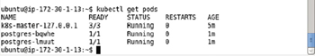

**Figure 5-10:**Listing the Pods for PostgreSQL Database

#### Starting an Interactive Command Shell

To be able to create a PostgreSQL table we need to start an interactive bash shell to access the PostgreSQL server running in a Docker container, and start the psql SQL shell for PostgreSQL. But, first we need to find the container id for a Docker container running the PostgreSQL database. Run the following command to list the Docker containers.

sudo docker ps

Two of the Docker containers are based on the "postgres" image as shown in [Figure 5-11](https://viewer.books24x7.com/assetviewer.aspx?bookid=113388&chunkid=252243619&resumebookmarkid=99efed37-cdbe-e911-b9b2-00505695593a). Copy the container id for the first Docker container for the postgres image from the CONTAINER ID column.

[Larger View](https://viewer.books24x7.com/assetviewer.aspx?bookid=113388&chunkid=252243619&resumebookmarkid=99efed37-cdbe-e911-b9b2-00505695593a)

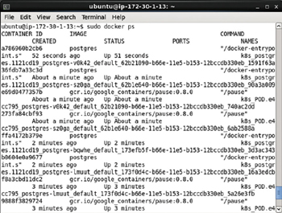

**Figure 5-11:**Listing the Docker Containers

Using the container id start the interactive shell.

sudo docker exec -it a786960b2cb6 bash

The interactive shell gets started as shown in [Figure 5-12](https://viewer.books24x7.com/assetviewer.aspx?bookid=113388&chunkid=252243619&resumebookmarkid=99efed37-cdbe-e911-b9b2-00505695593a).

[Larger View](https://viewer.books24x7.com/assetviewer.aspx?bookid=113388&chunkid=252243619&resumebookmarkid=99efed37-cdbe-e911-b9b2-00505695593a)



**Figure 5-12:**Starting an Interactive Shell

#### Starting the PostgreSQL SQL Terminal

Next, start the psql SQL shell for PostgreSQL. Set the user as postgres.

su –l postgres

Start the psql command line shell with the following command.

psql postgres

The psql shall get started as shown in [Figure 5-13](https://viewer.books24x7.com/assetviewer.aspx?bookid=113388&chunkid=252243619&resumebookmarkid=99efed37-cdbe-e911-b9b2-00505695593a).

[Larger View](https://viewer.books24x7.com/assetviewer.aspx?bookid=113388&chunkid=252243619&resumebookmarkid=99efed37-cdbe-e911-b9b2-00505695593a)

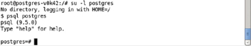

**Figure 5-13:**Starting the psql CLI Shell

For the general command syntax for the psql command refer <http://www.postgresql.org/docs/9.5/static/app-psql.html>.

#### Creating a Database Table

In the psql shell run the following SQL statements to create a database table called wlslogand add data to the table.

CREATE TABLE wlslog(time\_stamp VARCHAR(255) PRIMARY KEY,category VARCHAR(255),type

VARCHAR(255),servername VARCHAR(255),code VARCHAR(255),msg VARCHAR(255));

INSERT INTO wlslog(time\_stamp,category,type,servername,code,msg) VALUES('Apr-8-2014-7:

06:16-PM-PDT','Notice','WebLogicServer','AdminServer','BEA-000365','Server state changed

to STANDBY');

INSERT INTO wlslog(time\_stamp,category,type,servername,code,msg) VALUES('Apr-8-2014-7:

06:17-PM-PDT','Notice','WebLogicServer','AdminServer','BEA-000365','Server state changed

to STARTING');

INSERT INTO wlslog(time\_stamp,category,type,servername,code,msg) VALUES('Apr-8-2014-7:

06:18-PM-PDT','Notice','WebLogicServer','AdminServer','BEA-000360','Server started in

RUNNING mode');

Database table wlslog gets created and a row of data gets added as shown in [Figure 5-14](https://viewer.books24x7.com/assetviewer.aspx?bookid=113388&chunkid=252243619&resumebookmarkid=99efed37-cdbe-e911-b9b2-00505695593a).

[Larger View](https://viewer.books24x7.com/assetviewer.aspx?bookid=113388&chunkid=252243619&resumebookmarkid=99efed37-cdbe-e911-b9b2-00505695593a)

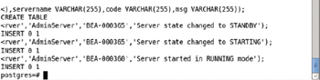

**Figure 5-14:**Creating a Database Table

Run the following SQL statement to query the database table wlslog.

SELECT \* FROM wlslog;

The 3 rows of data added get listed as shown in [Figure 5-15](https://viewer.books24x7.com/assetviewer.aspx?bookid=113388&chunkid=252243619&resumebookmarkid=99efed37-cdbe-e911-b9b2-00505695593a).

[Larger View](https://viewer.books24x7.com/assetviewer.aspx?bookid=113388&chunkid=252243619&resumebookmarkid=99efed37-cdbe-e911-b9b2-00505695593a)

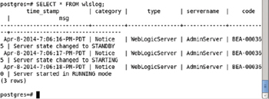

**Figure 5-15:**Querying the Database Table

#### Exiting the Interactive Command Shell

To exit the psql shell run the following command.

\q

To exit the interactive terminal run the following command.

exit

The psql shell and the interactive shell get exited as shown in [Figure 5-16](https://viewer.books24x7.com/assetviewer.aspx?bookid=113388&chunkid=252243619&resumebookmarkid=99efed37-cdbe-e911-b9b2-00505695593a).

[Larger View](https://viewer.books24x7.com/assetviewer.aspx?bookid=113388&chunkid=252243619&resumebookmarkid=99efed37-cdbe-e911-b9b2-00505695593a)

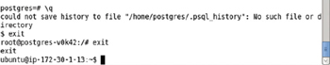

**Figure 5-16:**Exiting the psql Shell and Docker Container Interactive Shell

#### Scaling the PostgreSQL Cluster

One of the main benefits of the Kubernetes cluster manager is to be able to scale the cluster as required. Initially we created 2 replicas. For example, to scale up the number of PostgreSQL instances to 4 run the following command.

kubectl scale rc postgres --replicas=4

An output of "scaled" from the preceding command indicates that the cluster has been scaled as shown in [Figure 5-17](https://viewer.books24x7.com/assetviewer.aspx?bookid=113388&chunkid=252243619&resumebookmarkid=99efed37-cdbe-e911-b9b2-00505695593a).

[Larger View](https://viewer.books24x7.com/assetviewer.aspx?bookid=113388&chunkid=252243619&resumebookmarkid=99efed37-cdbe-e911-b9b2-00505695593a)



**Figure 5-17:**Scaling the number of Pod Replicas to 4

Subsequently list the pods with the following command.

kubectl get pods

The 4 Pods get listed as shown in [Figure 5-18](https://viewer.books24x7.com/assetviewer.aspx?bookid=113388&chunkid=252243619&resumebookmarkid=99efed37-cdbe-e911-b9b2-00505695593a). Initially some of the Pods could be listed as not "Running" and/or not in READY (1/1) state.

[Larger View](https://viewer.books24x7.com/assetviewer.aspx?bookid=113388&chunkid=252243619&resumebookmarkid=99efed37-cdbe-e911-b9b2-00505695593a)

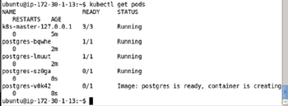

**Figure 5-18:**Listing the Pods after Scaling

Run the preceding command again after a few seconds.

kubectl get pods

The new Pods added to the cluster also get listed as "Running" and in READY state 1/1 as shown in [Figure 5-19](https://viewer.books24x7.com/assetviewer.aspx?bookid=113388&chunkid=252243619&resumebookmarkid=99efed37-cdbe-e911-b9b2-00505695593a).

[Larger View](https://viewer.books24x7.com/assetviewer.aspx?bookid=113388&chunkid=252243619&resumebookmarkid=99efed37-cdbe-e911-b9b2-00505695593a)

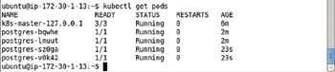

**Figure 5-19:**Listing all the Pods as running and ready

Describe the postgres service again.

kubectl describe svc postgres

Initially no Endpoint was listed as being associated with the service when the service was initially started. With 4 Pods running 4 Endpoints get listed as shown in [Figure 5-20](https://viewer.books24x7.com/assetviewer.aspx?bookid=113388&chunkid=252243619&resumebookmarkid=99efed37-cdbe-e911-b9b2-00505695593a).

[Larger View](https://viewer.books24x7.com/assetviewer.aspx?bookid=113388&chunkid=252243619&resumebookmarkid=99efed37-cdbe-e911-b9b2-00505695593a)

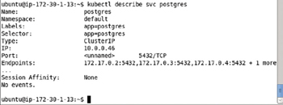

**Figure 5-20:**Describing the postgres Service

#### Listing the Logs

To list the logs data for a Pod, for example the postgres-v0k42 Pod, run the following command.

kubectl logs postgres-v0k42

The output in [Figure 5-21](https://viewer.books24x7.com/assetviewer.aspx?bookid=113388&chunkid=252243619&resumebookmarkid=99efed37-cdbe-e911-b9b2-00505695593a) lists the PostgreSQL starting.

[Larger View](https://viewer.books24x7.com/assetviewer.aspx?bookid=113388&chunkid=252243619&resumebookmarkid=99efed37-cdbe-e911-b9b2-00505695593a)

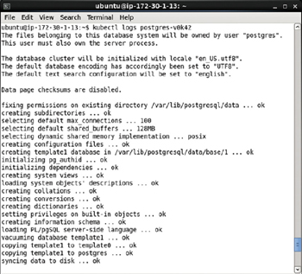

**Figure 5-21:**Listing the Logs for a Pod running PostgreSQL Database

When the PostgreSQL database gets started completely the message "database system is ready to accept connections" gets output as shown in [Figure 5-22](https://viewer.books24x7.com/assetviewer.aspx?bookid=113388&chunkid=252243619&resumebookmarkid=99efed37-cdbe-e911-b9b2-00505695593a).

[Larger View](https://viewer.books24x7.com/assetviewer.aspx?bookid=113388&chunkid=252243619&resumebookmarkid=99efed37-cdbe-e911-b9b2-00505695593a)

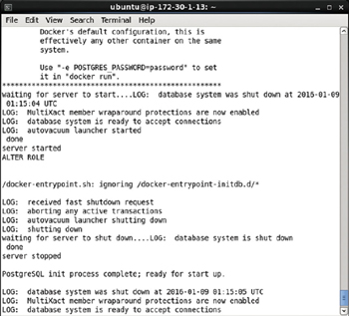

**Figure 5-22:**PostgreSQL Database listed as Started and subsequently Shutdown in the Logs

#### Deleting the Replication Controller

To delete the replication controller postgres and as a result delete all the Pods managed by the replication controller run the following command.

kubectl delete rc postgres

The postgres replication controller gets deleted as indicated by the replicationcontrollers/postgres output shown in [Figure 5-23](https://viewer.books24x7.com/assetviewer.aspx?bookid=113388&chunkid=252243619&resumebookmarkid=99efed37-cdbe-e911-b9b2-00505695593a). Subsequently, run the following command to list the replication controllers.

kubectl get rc

The postgres replication controller does not get listed as shown in [Figure 5-23](https://viewer.books24x7.com/assetviewer.aspx?bookid=113388&chunkid=252243619&resumebookmarkid=99efed37-cdbe-e911-b9b2-00505695593a). Deleting the replication controller does not delete the service managing the replication controller. To demonstrate list the services.

kubectl get services

The postgres service is still getting listed, as shown in [Figure 5-23](https://viewer.books24x7.com/assetviewer.aspx?bookid=113388&chunkid=252243619&resumebookmarkid=99efed37-cdbe-e911-b9b2-00505695593a).

[Larger View](https://viewer.books24x7.com/assetviewer.aspx?bookid=113388&chunkid=252243619&resumebookmarkid=99efed37-cdbe-e911-b9b2-00505695593a)

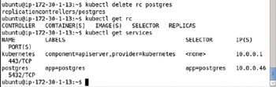

**Figure 5-23:**Deleting a Replication Controller

#### Stopping the Service

To stop the service postgres run the following command.

kubectl stop service postgres

Subsequently run the following command again.

kubectl get services

The postgres service does not get listed as shown in [Figure 5-24](https://viewer.books24x7.com/assetviewer.aspx?bookid=113388&chunkid=252243619&resumebookmarkid=99efed37-cdbe-e911-b9b2-00505695593a).

[Larger View](https://viewer.books24x7.com/assetviewer.aspx?bookid=113388&chunkid=252243619&resumebookmarkid=99efed37-cdbe-e911-b9b2-00505695593a)

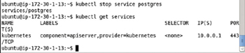

**Figure 5-24:**Stopping the postgres Service

**Creating a PostgreSQL Cluster Imperatively**

Using a declarative approach with definition files offers finer control over the service and replication controller. But a replication controller and service could also be created on the command line with kubectl commands. In the following subsections we shall create a replication controller and a service.

**Creating a Replication Controller**

To create a replication controller called postgres for image "postgres" with number of replicas as 2 and Post as 5432 run the following command.

kubectl run postgres --image=postgres --replicas=2 --port=5432

The postgres replication controller with 2 replicas of Pod with image postgres and selector expression run=postgres gets created as shown in [Figure 5-25](https://viewer.books24x7.com/assetviewer.aspx?bookid=113388&chunkid=172413504&resumebookmarkid=99efed37-cdbe-e911-b9b2-00505695593a).

[Larger View](https://viewer.books24x7.com/assetviewer.aspx?bookid=113388&chunkid=172413504&resumebookmarkid=99efed37-cdbe-e911-b9b2-00505695593a)

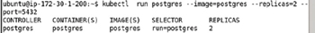

**Figure 5-25:**Creating a Replication Controller Imperatively

List the replication controllers with the following command.

kubectl get rc

The postgres replication controller gets listed as shown in [Figure 5-26](https://viewer.books24x7.com/assetviewer.aspx?bookid=113388&chunkid=172413504&resumebookmarkid=99efed37-cdbe-e911-b9b2-00505695593a).

[Larger View](https://viewer.books24x7.com/assetviewer.aspx?bookid=113388&chunkid=172413504&resumebookmarkid=99efed37-cdbe-e911-b9b2-00505695593a)



**Figure 5-26:**Listing the Replication Controllers

**Getting the Pods**

To list the Pods managed by the replication controller run the following command.

kubectl get pods

The two Pods get listed as shown in [Figure 5-27](https://viewer.books24x7.com/assetviewer.aspx?bookid=113388&chunkid=172413504&resumebookmarkid=99efed37-cdbe-e911-b9b2-00505695593a). Initially some of the Pods could be listed not Ready as indicated by the 0/1 READY column value. Run the preceding command again to list the Pods as ready with READY column value as 1/1.

[Larger View](https://viewer.books24x7.com/assetviewer.aspx?bookid=113388&chunkid=172413504&resumebookmarkid=99efed37-cdbe-e911-b9b2-00505695593a)

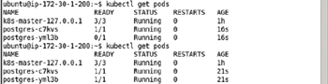

**Figure 5-27:**Listing the Pods

**Creating a Service**

To create a service we need to run the kubectl expose command. Initially only the kubernetes service is running. To demonstrate, run the following command.

kubectl get services

As shown in [Figure 5-28](https://viewer.books24x7.com/assetviewer.aspx?bookid=113388&chunkid=172413504&resumebookmarkid=99efed37-cdbe-e911-b9b2-00505695593a) only the kubernetes service is listed.

[Larger View](https://viewer.books24x7.com/assetviewer.aspx?bookid=113388&chunkid=172413504&resumebookmarkid=99efed37-cdbe-e911-b9b2-00505695593a)

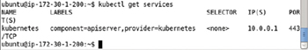

**Figure 5-28:**Listing the "kubernetes" Service

To create a service for the replication controller "postgres" run the following command in which the –port parameter specifies the port at which the service is exposed. The service type is set as LoadBalancer.

kubectl expose rc postgres --port=5432 --type=LoadBalancer

Subsequently list the services.

kubectl get services

The postgres service gets listed as shown in [Figure 5-29](https://viewer.books24x7.com/assetviewer.aspx?bookid=113388&chunkid=172413504&resumebookmarkid=99efed37-cdbe-e911-b9b2-00505695593a).

[Larger View](https://viewer.books24x7.com/assetviewer.aspx?bookid=113388&chunkid=172413504&resumebookmarkid=99efed37-cdbe-e911-b9b2-00505695593a)

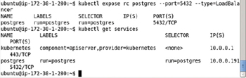

**Figure 5-29:**Creating a Service exposed at Port 5432

**Creating a Database Table**

The procedure to create a database table is the same as discussed previously for the declarative section and is discussed only briefly in this section. List the Docker containers with the following command.

sudo docker ps

Two of the Docker containers are listed with image as postgres in the IMAGE column as shown in [Figure 5-30](https://viewer.books24x7.com/assetviewer.aspx?bookid=113388&chunkid=172413504&resumebookmarkid=99efed37-cdbe-e911-b9b2-00505695593a). Copy the container id for one of these columns from the CONTAINER ID column.

[Larger View](https://viewer.books24x7.com/assetviewer.aspx?bookid=113388&chunkid=172413504&resumebookmarkid=99efed37-cdbe-e911-b9b2-00505695593a)

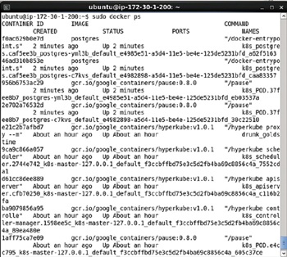

**Figure 5-30:**Listing the Docker Containers

Start the interactive shell with the following command.

sudo docker exec -it af0ac629b0e7d bash

The interactive terminal gets started as shown in [Figure 5-31](https://viewer.books24x7.com/assetviewer.aspx?bookid=113388&chunkid=172413504&resumebookmarkid=99efed37-cdbe-e911-b9b2-00505695593a).

[Larger View](https://viewer.books24x7.com/assetviewer.aspx?bookid=113388&chunkid=172413504&resumebookmarkid=99efed37-cdbe-e911-b9b2-00505695593a)



**Figure 5-31:**Starting the TTY

Set the user as postgres.

su –l postgres

Start the psql command line shell.

psql postgres

The psql shell is shown in [Figure 5-32](https://viewer.books24x7.com/assetviewer.aspx?bookid=113388&chunkid=172413504&resumebookmarkid=99efed37-cdbe-e911-b9b2-00505695593a).

[Larger View](https://viewer.books24x7.com/assetviewer.aspx?bookid=113388&chunkid=172413504&resumebookmarkid=99efed37-cdbe-e911-b9b2-00505695593a)

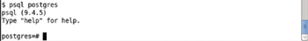

**Figure 5-32:**Starting the psql Shell

Run the following SQL statements to create a database table called wlslog and add data to the table.

CREATE TABLE wlslog(time\_stamp VARCHAR(255) PRIMARY KEY,category VARCHAR(255),type

VARCHAR(255),servername VARCHAR(255),code VARCHAR(255),msg VARCHAR(255));

INSERT INTO wlslog(time\_stamp,category,type,servername,code,msg) VALUES('Apr-8-2014-7:

06:16-PM-PDT','Notice','WebLogicServer','AdminServer','BEA-000365','Server state changed

to STANDBY');

INSERT INTO wlslog(time\_stamp,category,type,servername,code,msg) VALUES('Apr-8-2014-7:

06:17-PM-PDT','Notice','WebLogicServer','AdminServer','BEA-000365','Server state changed

to STARTING');

INSERT INTO wlslog(time\_stamp,category,type,servername,code,msg) VALUES('Apr-8-2014-7:

06:18-PM-PDT','Notice','WebLogicServer','AdminServer','BEA-000360','Server started in

RUNNING mode');

The database table wlslog gets created as shown in [Figure 5-33](https://viewer.books24x7.com/assetviewer.aspx?bookid=113388&chunkid=172413504&resumebookmarkid=99efed37-cdbe-e911-b9b2-00505695593a).

[Larger View](https://viewer.books24x7.com/assetviewer.aspx?bookid=113388&chunkid=172413504&resumebookmarkid=99efed37-cdbe-e911-b9b2-00505695593a)

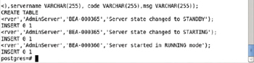

**Figure 5-33:**Creating a Database Table

Run the following SQL statement to query the wlslog table.

SELECT \* FROM wlslog;

The three rows of data added get listed as shown in [Figure 5-34](https://viewer.books24x7.com/assetviewer.aspx?bookid=113388&chunkid=172413504&resumebookmarkid=99efed37-cdbe-e911-b9b2-00505695593a).

[Larger View](https://viewer.books24x7.com/assetviewer.aspx?bookid=113388&chunkid=172413504&resumebookmarkid=99efed37-cdbe-e911-b9b2-00505695593a)

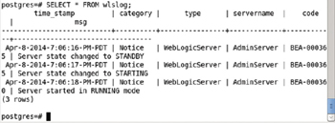

**Figure 5-34:**Querying the wlslog Database Table

To quit the psql shell and the interactive shell for the Docker container running PostgreSQL, run the following commands.

\q

**exit**

The psql shell and the tty get exited as shown in [Figure 5-35](https://viewer.books24x7.com/assetviewer.aspx?bookid=113388&chunkid=172413504&resumebookmarkid=99efed37-cdbe-e911-b9b2-00505695593a).

[Larger View](https://viewer.books24x7.com/assetviewer.aspx?bookid=113388&chunkid=172413504&resumebookmarkid=99efed37-cdbe-e911-b9b2-00505695593a)

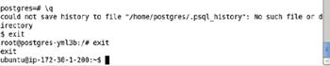

**Figure 5-35:**Exiting the Shells

**Scaling the PostgreSQL Cluster**

When we created the cluster initially we set the replicas to 2. List the pods as follows.

kubectl get pods

Only two Pods get listed as shown in [Figure 5-36](https://viewer.books24x7.com/assetviewer.aspx?bookid=113388&chunkid=172413504&resumebookmarkid=99efed37-cdbe-e911-b9b2-00505695593a).

[Larger View](https://viewer.books24x7.com/assetviewer.aspx?bookid=113388&chunkid=172413504&resumebookmarkid=99efed37-cdbe-e911-b9b2-00505695593a)

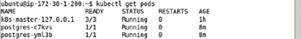

**Figure 5-36:**Listing the Pods

Scale the cluster to 4 replicas with the following command.

kubectl scale rc postgres --replicas=4

An output of "scaled" as shown in [Figure 5-37](https://viewer.books24x7.com/assetviewer.aspx?bookid=113388&chunkid=172413504&resumebookmarkid=99efed37-cdbe-e911-b9b2-00505695593a) indicates that the cluster has been scaled.

[Larger View](https://viewer.books24x7.com/assetviewer.aspx?bookid=113388&chunkid=172413504&resumebookmarkid=99efed37-cdbe-e911-b9b2-00505695593a)



**Figure 5-37:**Scaling the Pod Replicas to 4

Subsequently list the Pods.

kubectl get pods

The preceding command may have to be run multiple times to list all the Pods as "Running" and in READY state 1/1 as shown in [Figure 5-38](https://viewer.books24x7.com/assetviewer.aspx?bookid=113388&chunkid=172413504&resumebookmarkid=99efed37-cdbe-e911-b9b2-00505695593a).

[Larger View](https://viewer.books24x7.com/assetviewer.aspx?bookid=113388&chunkid=172413504&resumebookmarkid=99efed37-cdbe-e911-b9b2-00505695593a)

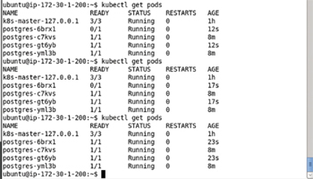

**Figure 5-38:**Listing the Pods in various states of starting

**Deleting the Replication Controller**

To delete the replication controller run the following command.

kubectl delete rc postgres

List the Pods subsequent to deleting the rc.

kubectl get pods

List the services.

kubectl get services

The postgres replication controller gets deleted and does not get listed subsequently as shown in [Figure 5-39](https://viewer.books24x7.com/assetviewer.aspx?bookid=113388&chunkid=172413504&resumebookmarkid=99efed37-cdbe-e911-b9b2-00505695593a). The postgres service still gets listed also shown in [Figure 5-39](https://viewer.books24x7.com/assetviewer.aspx?bookid=113388&chunkid=172413504&resumebookmarkid=99efed37-cdbe-e911-b9b2-00505695593a).

[Larger View](https://viewer.books24x7.com/assetviewer.aspx?bookid=113388&chunkid=172413504&resumebookmarkid=99efed37-cdbe-e911-b9b2-00505695593a)

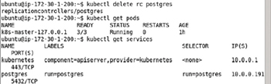

**Figure 5-39:**Deleting the Replication Controller

**Stopping the Service**

To stop the service run the following command.

kubectl stop service postgres

The postgres service gets stopped as shown in [Figure 5-40](https://viewer.books24x7.com/assetviewer.aspx?bookid=113388&chunkid=172413504&resumebookmarkid=99efed37-cdbe-e911-b9b2-00505695593a). Subsequently run the following command.

kubectl get services

The postgres service does not get listed as shown in [Figure 5-40](https://viewer.books24x7.com/assetviewer.aspx?bookid=113388&chunkid=172413504&resumebookmarkid=99efed37-cdbe-e911-b9b2-00505695593a) also.

[Larger View](https://viewer.books24x7.com/assetviewer.aspx?bookid=113388&chunkid=172413504&resumebookmarkid=99efed37-cdbe-e911-b9b2-00505695593a)

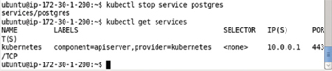

**Figure 5-40:**Stopping the Service

### Summary

In this chapter we used the Kubernetes cluster manager to start and manage a PostgreSQL server cluster. We demonstrated creating a cluster both imperatively on the command line and declaratively using definition files. We scaled the cluster using a replication controller and exposed a service for the cluster using a Kubernetes service. In the next chapter we shall discuss creating and managing an Oracle Database cluster.

**Kubernetes Microservices with Docker**

Chapter 6 - Using Oracle Database

Apress © 2016

## Chapter 6: Using Oracle Database

**© Deepak Vohra 2016  
D. Vohra, *Kubernetes Microservices with Docker*, DOI 10.1007/978-1-4842-1907-2\_6**

### Overview

Oracle Database is the most commonly used relational database (RDBMS). Installing and configuring Oracle Database would usually involve downloading the software, setting the kernel parameters, installing and configuring the software, all of which is quite involved. Using Docker containers coordinated with Kubernetes makes the task of installing, configuring, and orchestrating a Oracle Database cluster much easier. Oracle Database cluster consisting of multiple instances could benefit from the schedulability, scalability, distributedness, and failover features of the Kubernetes container cluster manager. In this chapter we shall install Oracle Database using a Docker image for the database. We shall create multiple replicas of the database Pod using a replication controller and expose the database as a service.

**Setting the Environment**

The following software is required for this chapter.

* -Docker Engine (latest version)
* -Kubernetes (version 1.01)
* -Kubectl (version 1.01)
* -Docker Image for Oracle Database (Oracle Database XE 11g)

If not already installed, install Docker Engine, Kubernetes, and Kubectl as discussed in [Chapter 1](http://viewer.books24x7.com/assetviewer.aspx?bkid=113388&destid=28#28). SSH login to the Ubuntu instance on Amazon EC2 using the Public IP Address of the EC2 instance.

ssh -i "docker.pem" ubuntu@52.90.115.30

Start the Docker instance and verify its status with the following commands.

sudo service docker start

sudo service docker status

Docker is indicated as running in [Figure 6-1](https://viewer.books24x7.com/assetviewer.aspx?bookid=113388&chunkid=922075234&resumebookmarkid=99efed37-cdbe-e911-b9b2-00505695593a).

[Larger View](https://viewer.books24x7.com/assetviewer.aspx?bookid=113388&chunkid=922075234&resumebookmarkid=99efed37-cdbe-e911-b9b2-00505695593a)

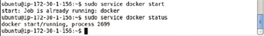

**Figure 6-1:**Starting Docker and verifying its Status

List the services running.

kubectl get services

Only the kubernetes service is listed as running in [Figure 6-2](https://viewer.books24x7.com/assetviewer.aspx?bookid=113388&chunkid=922075234&resumebookmarkid=99efed37-cdbe-e911-b9b2-00505695593a).

[Larger View](https://viewer.books24x7.com/assetviewer.aspx?bookid=113388&chunkid=922075234&resumebookmarkid=99efed37-cdbe-e911-b9b2-00505695593a)

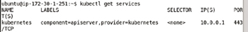

**Figure 6-2:**Listing the Kubernetes Service

**Creating an Oracle Database Instance Imperatively**

In this section we shall create an Oracle Database cluster using kubectl on the command line. Several Docker images are available for Oracle Database and we shall be using the sath89/oracle-xe-11g image (<https://hub.docker.com/r/sath89/oracle-xe-11g/>). Run the following kubectl command to create an Oracle Database cluster consisting of 2 replicas with port set as 1521.

kubectl run oradb --image=sath89/oracle-xe-11g --replicas=2 --port=1521

The output from the command in [Figure 6-3](https://viewer.books24x7.com/assetviewer.aspx?bookid=113388&chunkid=266285931&resumebookmarkid=99efed37-cdbe-e911-b9b2-00505695593a) lists a replication controller called oradb, a Docker container called oradb, a selector (run=oradb) to select Pods that comprise the replication controller replicas, and the number of replicas (2). The Pod label is also set to run=oradb.

[Larger View](https://viewer.books24x7.com/assetviewer.aspx?bookid=113388&chunkid=266285931&resumebookmarkid=99efed37-cdbe-e911-b9b2-00505695593a)

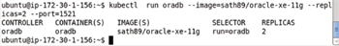

**Figure 6-3:**Creating a Replication Controller and Pod Replicas for Oracle Database

List the replication controller with the following command.

kubectl get rc

The oradb replication controller shown in [Figure 6-4](https://viewer.books24x7.com/assetviewer.aspx?bookid=113388&chunkid=266285931&resumebookmarkid=99efed37-cdbe-e911-b9b2-00505695593a) gets listed.

[Larger View](https://viewer.books24x7.com/assetviewer.aspx?bookid=113388&chunkid=266285931&resumebookmarkid=99efed37-cdbe-e911-b9b2-00505695593a)

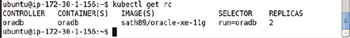

**Figure 6-4:**Listing the Replication Controllers

List the Pods using the following command.

kubectl get pods

In addition to the Kubernetes Pod k8s-master-127.0.0.1 two other pods get listed for Oracle Database as shown in [Figure 6-5](https://viewer.books24x7.com/assetviewer.aspx?bookid=113388&chunkid=266285931&resumebookmarkid=99efed37-cdbe-e911-b9b2-00505695593a). Initially the Pods could be listed as "not ready" as shown in [Figure 6-5](https://viewer.books24x7.com/assetviewer.aspx?bookid=113388&chunkid=266285931&resumebookmarkid=99efed37-cdbe-e911-b9b2-00505695593a) also. Run the preceding command after a duration of a few seconds, multiple times if required, to list the two Pods are Running and READY (1/1).

[Larger View](https://viewer.books24x7.com/assetviewer.aspx?bookid=113388&chunkid=266285931&resumebookmarkid=99efed37-cdbe-e911-b9b2-00505695593a)

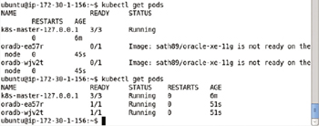

**Figure 6-5:**Listing the Pods in various stages of running

Get the nodes with the following command.

kubectl get nodes

And get the Kubernetes services with the following command.

kubectl get services

Only the kubernetes service gets listed as shown in [Figure 6-6](https://viewer.books24x7.com/assetviewer.aspx?bookid=113388&chunkid=266285931&resumebookmarkid=99efed37-cdbe-e911-b9b2-00505695593a) because we have not yet created a service for Oracle Database.

[Larger View](https://viewer.books24x7.com/assetviewer.aspx?bookid=113388&chunkid=266285931&resumebookmarkid=99efed37-cdbe-e911-b9b2-00505695593a)

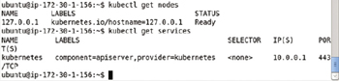

**Figure 6-6:**Creating a Replication Controller does not create a Service

**Listing Logs**

List the logs for one of the Pods using the following command.

kubectl logs oradb-ea57r

The logs generated by a started Oracle Database instance get output as shown in [Figure 6-7](https://viewer.books24x7.com/assetviewer.aspx?bookid=113388&chunkid=266285931&resumebookmarkid=99efed37-cdbe-e911-b9b2-00505695593a). Oracle Net Listener is indicated as having been started.

[Larger View](https://viewer.books24x7.com/assetviewer.aspx?bookid=113388&chunkid=266285931&resumebookmarkid=99efed37-cdbe-e911-b9b2-00505695593a)

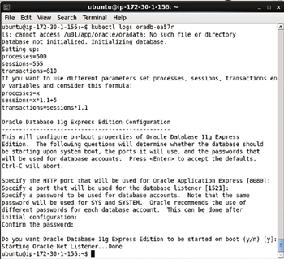

**Figure 6-7:**Listing Logs for a Pod

**Creating a Service**

Next, expose the replication controller oradb as a Kubernetes service on port 1521. Subsequently list the Kubernetes services.

kubectl expose rc oradb --port=1521 --type=LoadBalancer

kubectl get services

The first of the two preceding commands starts the oradb service. Subsequently the service gets listed as shown in [Figure 6-8](https://viewer.books24x7.com/assetviewer.aspx?bookid=113388&chunkid=266285931&resumebookmarkid=99efed37-cdbe-e911-b9b2-00505695593a). The service selector is run=oradb, which is the same as the replication controller selector.

[Larger View](https://viewer.books24x7.com/assetviewer.aspx?bookid=113388&chunkid=266285931&resumebookmarkid=99efed37-cdbe-e911-b9b2-00505695593a)

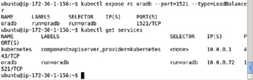

**Figure 6-8:**Creating a Service Imperatively

Describe the service with the following command.

kubectl describe svc oradb

The service name, namespace, labels, selector, type, IP, Port, NodePort, and endpoints get listed as shown in [Figure 6-9](https://viewer.books24x7.com/assetviewer.aspx?bookid=113388&chunkid=266285931&resumebookmarkid=99efed37-cdbe-e911-b9b2-00505695593a).

[Larger View](https://viewer.books24x7.com/assetviewer.aspx?bookid=113388&chunkid=266285931&resumebookmarkid=99efed37-cdbe-e911-b9b2-00505695593a)

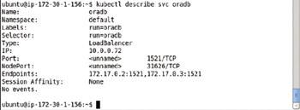

**Figure 6-9:**Describing the oradb Service

**Scaling the Database**

Run the kubectl scale command to scale the replicas. For example, reduce the number of replicas to 1.

kubectl scale rc oradb --replicas=1

An output of "scaled" indicates that the replicas have been scaled as shown in [Figure 6-10](https://viewer.books24x7.com/assetviewer.aspx?bookid=113388&chunkid=266285931&resumebookmarkid=99efed37-cdbe-e911-b9b2-00505695593a).

[Larger View](https://viewer.books24x7.com/assetviewer.aspx?bookid=113388&chunkid=266285931&resumebookmarkid=99efed37-cdbe-e911-b9b2-00505695593a)



**Figure 6-10:**Scaling the Replicas to 1

Subsequently list the running Pods.

kubectl get pods

Only one Oracle Database Pod gets listed as the other has been stopped to reduce the replication level to one as shown in [Figure 6-11](https://viewer.books24x7.com/assetviewer.aspx?bookid=113388&chunkid=266285931&resumebookmarkid=99efed37-cdbe-e911-b9b2-00505695593a). Subsequently, describe the service.

[Larger View](https://viewer.books24x7.com/assetviewer.aspx?bookid=113388&chunkid=266285931&resumebookmarkid=99efed37-cdbe-e911-b9b2-00505695593a)

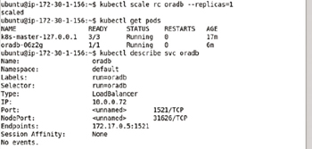

**Figure 6-11:**Listing and Describing the Single Pod

kubectl describe svc oradb

Because the cluster has been scaled down to one replica the number of endpoints also gets reduced to one as shown in [Figure 6-11](https://viewer.books24x7.com/assetviewer.aspx?bookid=113388&chunkid=266285931&resumebookmarkid=99efed37-cdbe-e911-b9b2-00505695593a).

**Deleting the Replication Controller and Service**

In subsequent sections we shall be creating a cluster of Oracle Database instances declaratively using definition files. As we shall be using the same configuration parameters, delete the "oradb" replication controller and the "oradb" service with the following commands.

kubectl delete rc oradb

kubectl delete svc oradb

Both the replication controller and the service get deleted as shown in [Figure 6-12](https://viewer.books24x7.com/assetviewer.aspx?bookid=113388&chunkid=266285931&resumebookmarkid=99efed37-cdbe-e911-b9b2-00505695593a).

[Larger View](https://viewer.books24x7.com/assetviewer.aspx?bookid=113388&chunkid=266285931&resumebookmarkid=99efed37-cdbe-e911-b9b2-00505695593a)

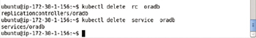

**Figure 6-12:**Deleting the Replication Controller and Service

### Creating an Oracle Database Instance Declaratively

In this section we shall create Oracle Database cluster declaratively using definition files for a Pod, replication controller, and service. We have used the YAML format in the definition files but the JSON format may be used instead.

#### Creating a Pod

Create a definition file for a Pod called oradb.yaml. Copy the following listing, which defines a Pod named "oradb" with a label setting name: "oradb", which translates to Pod label name=oradb. The container image is set as "sath89/oracle-xe-11g" and the container port is set as 1521.

apiVersion: v1

kind: Pod

metadata:

name: "oradb"

labels:

name: "oradb"

spec:

containers:

-

image: "sath89/oracle-xe-11g"

name: "oradb"

ports:

-

containerPort: 1521

restartPolicy: Always

The oradb.yaml file may be created in the vi editor and saved with the :wq command as shown in [Figure 6-13](https://viewer.books24x7.com/assetviewer.aspx?bookid=113388&chunkid=165639436&resumebookmarkid=99efed37-cdbe-e911-b9b2-00505695593a).

[Larger View](https://viewer.books24x7.com/assetviewer.aspx?bookid=113388&chunkid=165639436&resumebookmarkid=99efed37-cdbe-e911-b9b2-00505695593a)

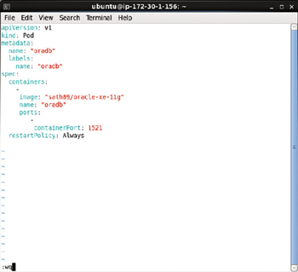

**Figure 6-13:**Pod Definition File

Create a Pod using the definition file oradb.yaml with the kubectl create command.

kubectl create -f oradb.yaml --validate

An output of "pods/oradb" in [Figure 6-14](https://viewer.books24x7.com/assetviewer.aspx?bookid=113388&chunkid=165639436&resumebookmarkid=99efed37-cdbe-e911-b9b2-00505695593a) indicates that the oradb Pod has been created.

[Larger View](https://viewer.books24x7.com/assetviewer.aspx?bookid=113388&chunkid=165639436&resumebookmarkid=99efed37-cdbe-e911-b9b2-00505695593a)



**Figure 6-14:**Creating a Pod from a Definition File

Subsequently list the running Pods with the following command.

kubectl get pods

The single Pod oradb gets listed as shown in [Figure 6-15](https://viewer.books24x7.com/assetviewer.aspx?bookid=113388&chunkid=165639436&resumebookmarkid=99efed37-cdbe-e911-b9b2-00505695593a). Initially, the oradb Pod could be listed in various phases of starting such as Image "is ready, container is creating" or the READY value could be 0/1 indicating that the Pod is not ready yet. When the STATUS column becomes "Running" and the READY column becomes 1/1 the Pod is started and ready. The preceding command may have to be run multiple times to list the Pod as Running and Ready.

[Larger View](https://viewer.books24x7.com/assetviewer.aspx?bookid=113388&chunkid=165639436&resumebookmarkid=99efed37-cdbe-e911-b9b2-00505695593a)

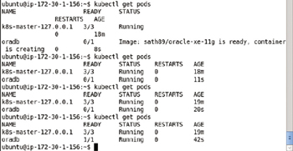

**Figure 6-15:**Listing the Pod/s, which could initially be not Running and not Ready

#### Creating a Service

Next, create a service for an Oracle Database cluster. The service does not specify how many instances (replicas) of the Oracle Database image are running or should be running. The replicas are controlled by the replication controller. The service only defines a port to expose the service at, a label for the service and a selector to match the Pods to be managed by the service. The selector setting is app: "oradb" which translates to service selector app=oradb. Create a service definition file oradb-service.yaml and copy the following listing to the definition file.

apiVersion: v1

kind: Service

metadata:

name: "oradb"

labels:

app: "oradb"

spec:

ports:

-

port: 1521

selector:

app: "oradb"

The oradb-service.yaml definition file may be created in the vi editor and saved with :wq as shown in [Figure 6-16](https://viewer.books24x7.com/assetviewer.aspx?bookid=113388&chunkid=165639436&resumebookmarkid=99efed37-cdbe-e911-b9b2-00505695593a).

[Larger View](https://viewer.books24x7.com/assetviewer.aspx?bookid=113388&chunkid=165639436&resumebookmarkid=99efed37-cdbe-e911-b9b2-00505695593a)

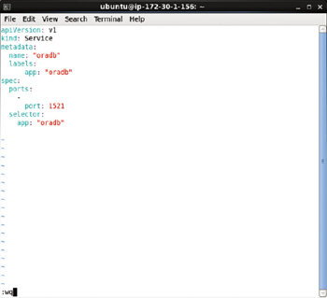

**Figure 6-16:**Service Definition File

Run the following command to create a service from the service definition file.

kubectl create -f oradb-service.yaml

The oradb service gets created as indicated by the "services/oradb" output in [Figure 6-17](https://viewer.books24x7.com/assetviewer.aspx?bookid=113388&chunkid=165639436&resumebookmarkid=99efed37-cdbe-e911-b9b2-00505695593a). Subsequently list the services.

kubectl get services

The oradb service gets listed as shown in [Figure 6-17](https://viewer.books24x7.com/assetviewer.aspx?bookid=113388&chunkid=165639436&resumebookmarkid=99efed37-cdbe-e911-b9b2-00505695593a).

[Larger View](https://viewer.books24x7.com/assetviewer.aspx?bookid=113388&chunkid=165639436&resumebookmarkid=99efed37-cdbe-e911-b9b2-00505695593a)

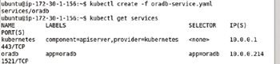

**Figure 6-17:**Creating a Service from a Service Definition File

Describe the oradb service with the following command.

kubectl describe svc oradb

No service endpoint gets listed as shown in [Figure 6-18](https://viewer.books24x7.com/assetviewer.aspx?bookid=113388&chunkid=165639436&resumebookmarkid=99efed37-cdbe-e911-b9b2-00505695593a) because the service selector does not match the label on the Pod already running. The service selector app=oradb has to match a Pod label for the service to be able to manage the Pod. In the next section we shall create a replication controller with a matching label.

[Larger View](https://viewer.books24x7.com/assetviewer.aspx?bookid=113388&chunkid=165639436&resumebookmarkid=99efed37-cdbe-e911-b9b2-00505695593a)

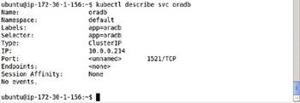

**Figure 6-18:**Describing a Service for Oracle Database

#### Creating a Replication Controller

Create a replication controller definition file called oradb-rc.yaml and copy the following listing, which defines a replication controller, to the definition file. For the replication controller to manage the Pods defined in the spec field the key:value expression of the selector in the replication controller has to match a label in the Pod template mapping. The selector is omitted in the oradb-rc.yaml but the spec- > template- > metadata- > labels must be specified. The selector defaults to the same setting as the spec->template->metadata->labels. The template- > spec- > containers mapping defines the containers in the Pod. Only the Oracle Database container "sath89/oracle-xe-11g" is defined.

apiVersion: v1

kind: ReplicationController

metadata:

name: "oradb"

labels:

app: "oradb"

spec:

replicas: 2

template:

metadata:

labels:

app: "oradb"

spec:

containers:

-

image: "sath89/oracle-xe-11g"

name: "oradb"

The oradb-rc.yaml file may be edited in the vi editor and saved with the :wq command as shown in [Figure 6-19](https://viewer.books24x7.com/assetviewer.aspx?bookid=113388&chunkid=165639436&resumebookmarkid=99efed37-cdbe-e911-b9b2-00505695593a).

[Larger View](https://viewer.books24x7.com/assetviewer.aspx?bookid=113388&chunkid=165639436&resumebookmarkid=99efed37-cdbe-e911-b9b2-00505695593a)

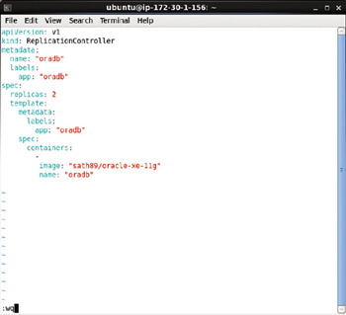

**Figure 6-19:**Replication Controller Definition File

Next, run the following command to create a replication controller from the definition file oradb-rc.yaml.

kubectl create -f oradb-rc.yaml

The replication controller gets created as shown in [Figure 6-20](https://viewer.books24x7.com/assetviewer.aspx?bookid=113388&chunkid=165639436&resumebookmarkid=99efed37-cdbe-e911-b9b2-00505695593a). List the replication controller with the following command.

kubectl get rc

The oradb replication controller gets created as shown in [Figure 6-20](https://viewer.books24x7.com/assetviewer.aspx?bookid=113388&chunkid=165639436&resumebookmarkid=99efed37-cdbe-e911-b9b2-00505695593a).

[Larger View](https://viewer.books24x7.com/assetviewer.aspx?bookid=113388&chunkid=165639436&resumebookmarkid=99efed37-cdbe-e911-b9b2-00505695593a)

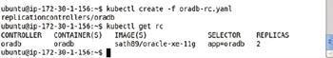

**Figure 6-20:**Creating and listing a Replication Controller from a Definition File

The Pods created by the replication controller are listed with the following command.

kubectl get pods

Three Oracle Database Pods get listed as shown in [Figure 6-21](https://viewer.books24x7.com/assetviewer.aspx?bookid=113388&chunkid=165639436&resumebookmarkid=99efed37-cdbe-e911-b9b2-00505695593a). Why do three Pods get listed even though the replication controller replicas are set to 2? Because the Pod started using the Pod definition file oradb.yaml does not include a label that matches the selector in the replication controller. The replication controller selector is app: "oradb" while the label on the Pod is name: "oradb". Two replicas are started by the replication controller and one Pod was started earlier by the pod definition file.

[Larger View](https://viewer.books24x7.com/assetviewer.aspx?bookid=113388&chunkid=165639436&resumebookmarkid=99efed37-cdbe-e911-b9b2-00505695593a)

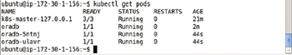

**Figure 6-21:**Listing the Pod Replicas

Describe the service oradb with the following command.

kubectl describe svc oradb

The service endpoints get listed as shown in [Figure 6-22](https://viewer.books24x7.com/assetviewer.aspx?bookid=113388&chunkid=165639436&resumebookmarkid=99efed37-cdbe-e911-b9b2-00505695593a). Only two endpoints get listed because the service selector app: "oradb" matches the Pod label in the replication controller with two replicas. The Pod created earlier does not include a label that matches the selector expression.

[Larger View](https://viewer.books24x7.com/assetviewer.aspx?bookid=113388&chunkid=165639436&resumebookmarkid=99efed37-cdbe-e911-b9b2-00505695593a)

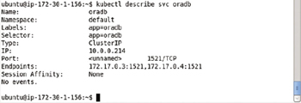

**Figure 6-22:**Describing the Service after creating the Replication Controller

#### Keeping the Replication Level

The task of the replication controller is to maintain the replication level of the Pods. Because the replicas field mapping in the replication controller spec is 2, two replicas of the Pod configured in the Pod spec must be running at all time while the replication controller is running. To demonstrate that the replication level is kept, delete a Pod.

kubectl delete pod oradb-5ntnj

Subsequently list the running Pods.

kubectl get pods

One of the two replicas got deleted with the kubectl delete pod command but another replica is listed as getting started in [Figure 6-23](https://viewer.books24x7.com/assetviewer.aspx?bookid=113388&chunkid=165639436&resumebookmarkid=99efed37-cdbe-e911-b9b2-00505695593a). It may take a few seconds for the replicas to reach the replication level. Run the preceding command multiple times to list the replicas as running. The number of replicas gets back to 2.

[Larger View](https://viewer.books24x7.com/assetviewer.aspx?bookid=113388&chunkid=165639436&resumebookmarkid=99efed37-cdbe-e911-b9b2-00505695593a)

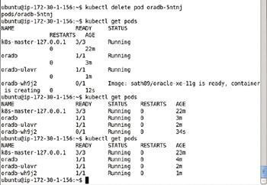

**Figure 6-23:**Maintaining the Replication Level

The "oradb" Pod is not associated with the replication controller and therefore it is not counted as one of the replicas managed by the replication controller. The oradb Pod is not managed by the replication controller because, as discussed earlier, the label on the oradbPod does not match the label on the replication controller. To demonstrate that the oradbpod is not managed by the replication controller delete the Pod.

kubectl delete pod oradb

Subsequently list the running Pods.

kubectl get pods

The oradb Pod gets deleted and a replacement Pod does not get started and does not get listed in the running Pods as shown in [Figure 6-24](https://viewer.books24x7.com/assetviewer.aspx?bookid=113388&chunkid=165639436&resumebookmarkid=99efed37-cdbe-e911-b9b2-00505695593a).

[Larger View](https://viewer.books24x7.com/assetviewer.aspx?bookid=113388&chunkid=165639436&resumebookmarkid=99efed37-cdbe-e911-b9b2-00505695593a)

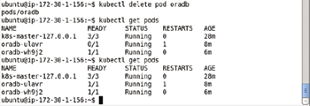

**Figure 6-24:**The oradb Pod is not managed by the Replication Controller

#### Scaling the Database

The replication controller may be used to scale the number of Pods running for Oracle Database. As an example scale up the number of Pod replicas to 3 from 2.

kubectl scale rc oradb --replicas=3

The "scaled" output indicates that the replicas have been scaled. Subsequently run the following command, multiple times if required, to list the new Pod replica as running and ready.

kubectl get pods

Three replicas of the Pod get listed as shown in [Figure 6-25](https://viewer.books24x7.com/assetviewer.aspx?bookid=113388&chunkid=165639436&resumebookmarkid=99efed37-cdbe-e911-b9b2-00505695593a).

[Larger View](https://viewer.books24x7.com/assetviewer.aspx?bookid=113388&chunkid=165639436&resumebookmarkid=99efed37-cdbe-e911-b9b2-00505695593a)

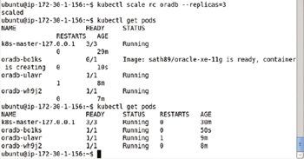

**Figure 6-25:**Scaling the Cluster to 3 Replicas

Describe the service again.

kubectl describe svc oradb

Three endpoints get listed instead of two as shown in [Figure 6-26](https://viewer.books24x7.com/assetviewer.aspx?bookid=113388&chunkid=165639436&resumebookmarkid=99efed37-cdbe-e911-b9b2-00505695593a). The service has a single IP address.

[Larger View](https://viewer.books24x7.com/assetviewer.aspx?bookid=113388&chunkid=165639436&resumebookmarkid=99efed37-cdbe-e911-b9b2-00505695593a)

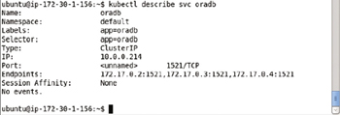

**Figure 6-26:**Listing the 3 Endpoints in the Service

#### Starting the Interactive Shell

In this section we shall start an interactive tty (shell) to connect to the software, which is Oracle Database, running in a Docker container started with and managed by Kubernetes. First, list the Docker containers with the following command.

sudo docker ps

Copy the container id for one of the Docker containers for the sath89/oracle-xe-11g image as shown in [Figure 6-27](https://viewer.books24x7.com/assetviewer.aspx?bookid=113388&chunkid=165639436&resumebookmarkid=99efed37-cdbe-e911-b9b2-00505695593a).

[Larger View](https://viewer.books24x7.com/assetviewer.aspx?bookid=113388&chunkid=165639436&resumebookmarkid=99efed37-cdbe-e911-b9b2-00505695593a)

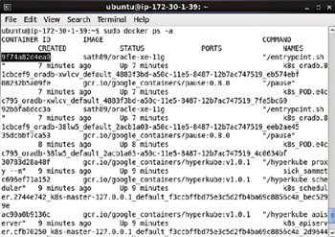

**Figure 6-27:**Copying the Container Id for a Docker Container

Using the container id start an interactive shell with the following command.

sudo docker exec -it 9f74a82d4ea0 bash

The interactive shell gets started as shown in [Figure 6-28](https://viewer.books24x7.com/assetviewer.aspx?bookid=113388&chunkid=165639436&resumebookmarkid=99efed37-cdbe-e911-b9b2-00505695593a).

[Larger View](https://viewer.books24x7.com/assetviewer.aspx?bookid=113388&chunkid=165639436&resumebookmarkid=99efed37-cdbe-e911-b9b2-00505695593a)



**Figure 6-28:**Starting an Interactive Shell

#### Connecting to Database

In the interactive tty change the user to "oracle."

su -l oracle

The difference between su oracle and su - oracle is that the latter logs in with the environment variables of oracle user and also sets the current directory to oracle home directory while the former logs in as oracle but the environment variables and current directory remain unchanged.

Subsequently start the SQL\*Plus. Using the /nolog option does not establish an initial connection with the database.

sqlplus /nolog

Run the following command to connect SYS as SYSDBA.

CONNECT SYS AS SYSDBA

Specify the Password as "oracle" when prompted. The output from the preceding commands to start SQL\*Plus and connect SYS are shown in [Figure 6-29](https://viewer.books24x7.com/assetviewer.aspx?bookid=113388&chunkid=165639436&resumebookmarkid=99efed37-cdbe-e911-b9b2-00505695593a). A connection gets established.

[Larger View](https://viewer.books24x7.com/assetviewer.aspx?bookid=113388&chunkid=165639436&resumebookmarkid=99efed37-cdbe-e911-b9b2-00505695593a)

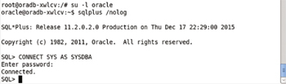

**Figure 6-29:**Starting SQL\*Plus

#### Creating a User

To create a user called OE and grant CONNECT and RESOURCE roles to the user, run the following commands.

CREATE USER OE QUOTA UNLIMITED ON SYSTEM IDENTIFIED BY OE;

GRANT CONNECT, RESOURCE TO OE;

The OE user gets created and the roles get granted as shown in [Figure 6-30](https://viewer.books24x7.com/assetviewer.aspx?bookid=113388&chunkid=165639436&resumebookmarkid=99efed37-cdbe-e911-b9b2-00505695593a).

[Larger View](https://viewer.books24x7.com/assetviewer.aspx?bookid=113388&chunkid=165639436&resumebookmarkid=99efed37-cdbe-e911-b9b2-00505695593a)

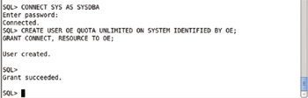

**Figure 6-30:**Connecting as SYSDBA and creating a User

#### Creating a Database Table

Create a database table called OE.Catalog with the following SQL statement.

CREATE TABLE OE.Catalog(CatalogId INTEGER PRIMARY KEY,Journal VARCHAR2(25),Publisher

VARCHAR2(25),Edition VARCHAR2(25),Title VARCHAR2(45),Author VARCHAR2(25));

Add a row of data to the OE.Catalog table with the following SQL statement.

INSERT INTO OE.Catalog VALUES('1','Oracle Magazine','Oracle Publishing',

'November December 2013','Engineering as a Service','David A. Kelly');

The OE.Catalog table gets created and a row of data gets added as shown in [Figure 6-31](https://viewer.books24x7.com/assetviewer.aspx?bookid=113388&chunkid=165639436&resumebookmarkid=99efed37-cdbe-e911-b9b2-00505695593a).

[Larger View](https://viewer.books24x7.com/assetviewer.aspx?bookid=113388&chunkid=165639436&resumebookmarkid=99efed37-cdbe-e911-b9b2-00505695593a)

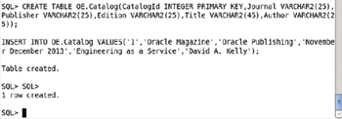

**Figure 6-31:**Creating a Database Table

Run the following SQL statement to query the OE.CATALOG table.

SELECT \* FROM OE.CATALOG;

The single row of data added gets listed as shown in [Figure 6-32](https://viewer.books24x7.com/assetviewer.aspx?bookid=113388&chunkid=165639436&resumebookmarkid=99efed37-cdbe-e911-b9b2-00505695593a).

[Larger View](https://viewer.books24x7.com/assetviewer.aspx?bookid=113388&chunkid=165639436&resumebookmarkid=99efed37-cdbe-e911-b9b2-00505695593a)

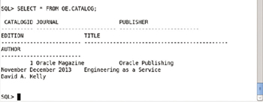

**Figure 6-32:**Querying the Database Table

#### Exiting the Interactive Shell

Logout from SQL\*Plus command with the "exit" command and exit the "oracle" user with the "exit" command and exit the interactive terminal with the "exit" command also as shown in [Figure 6-33](https://viewer.books24x7.com/assetviewer.aspx?bookid=113388&chunkid=165639436&resumebookmarkid=99efed37-cdbe-e911-b9b2-00505695593a).

[Larger View](https://viewer.books24x7.com/assetviewer.aspx?bookid=113388&chunkid=165639436&resumebookmarkid=99efed37-cdbe-e911-b9b2-00505695593a)

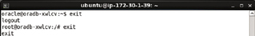

**Figure 6-33:**Exiting the Interactive Shell

### Summary

In this chapter we used Kubernetes to create and orchestrate an Oracle Database cluster. We discussed both the imperative and declarative approaches to creating and managing a cluster. Using the imperative method, the kubectl commands may be used directly without a definition file to create a replication controller and a service. With the declarative method definition files for a Pod, replication controller and service have to be used. We demonstrated scaling a cluster. We also used a Docker container to log in to SQL\*Plus and create a database table. In the next chapter we shall discuss using MongoDB with Kubernetes.

**Part III: NoSQL Database**

Chapter List

1. [Chapter 7:](http://viewer.books24x7.com/assetviewer.aspx?bkid=113388&destid=526#526) Using MongoDB Database
2. [Chapter 8:](http://viewer.books24x7.com/assetviewer.aspx?bkid=113388&destid=640#640) Using Apache Cassandra Database
3. [Chapter 9:](http://viewer.books24x7.com/assetviewer.aspx?bkid=113388&destid=740#740) Using Couchbase

**Kubernetes Microservices with Docker**

Chapter 7 - Using MongoDB Database

Apress © 2016

## Chapter 7: Using MongoDB Database

**© Deepak Vohra 2016  
D. Vohra, *Kubernetes Microservices with Docker*, DOI 10.1007/978-1-4842-1907-2\_7**

### Overview

MongoDB is a flexible schema model NoSQL data store, the most commonly used NoSQL data store. MongoDB is based on the BSON (binary JSON) storage model. Documents are stored in collections. Being a schema-free data store, no two documents need to be alike in terms of the fields in a BSON document. In a large scale cluster several instances of MongoDB could be running and several issues could arise.

* -MongoDB instances scheduling
* -Scaling the MongoDB Cluster
* -Load Balancing
* -Providing MongoDB as a Service

While Docker has made it feasible to provide Container as a Service (CaaS) it does not provide by itself any of the features listed previously. In this chapter we discuss using Kubernetes container cluster manager to manage and orchestrate a cluster of Docker containers running MongoDB.

**Setting the Environment**

The following software is required for this chapter.

* -Docker Engine (latest version)
* -Kubernetes (version 1.01)
* -Kubectl (version 1.01)
* -Docker image for MongoDB (latest version)

Install the required software on an Amazon EC2 instance running Ubuntu 14; the same AMI is used as in the other chapters. SSH Login to the Ubuntu instance using the Public IP Address, which would be different for different users.

ssh -i "docker.pem" ubuntu@52.91.190.195

The Ubuntu instance gets logged into as shown in [Figure 7-1](https://viewer.books24x7.com/assetviewer.aspx?bookid=113388&chunkid=886065819&resumebookmarkid=99efed37-cdbe-e911-b9b2-00505695593a).

[Larger View](https://viewer.books24x7.com/assetviewer.aspx?bookid=113388&chunkid=886065819&resumebookmarkid=99efed37-cdbe-e911-b9b2-00505695593a)

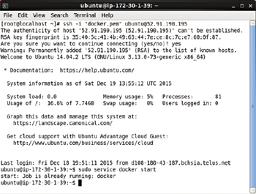

**Figure 7-1:**Logging into Ubuntu Instance on Amazon EC2

The procedure to install is discussed in [chapter 1](http://viewer.books24x7.com/assetviewer.aspx?bkid=113388&destid=28#28). To verify that Docker is running run the following command.

sudo service docker start

Docker should be listed as running as shown in [Figure 7-2](https://viewer.books24x7.com/assetviewer.aspx?bookid=113388&chunkid=886065819&resumebookmarkid=99efed37-cdbe-e911-b9b2-00505695593a).

[Larger View](https://viewer.books24x7.com/assetviewer.aspx?bookid=113388&chunkid=886065819&resumebookmarkid=99efed37-cdbe-e911-b9b2-00505695593a)



**Figure 7-2:**Starting Docker

List the Pods with the following command.

kubectl get pods

And list the nodes with the following command.

kubectl get nodes

The Kubernetes Pod gets listed and the node also gets listed as shown in [Figure 7-3](https://viewer.books24x7.com/assetviewer.aspx?bookid=113388&chunkid=886065819&resumebookmarkid=99efed37-cdbe-e911-b9b2-00505695593a).

[Larger View](https://viewer.books24x7.com/assetviewer.aspx?bookid=113388&chunkid=886065819&resumebookmarkid=99efed37-cdbe-e911-b9b2-00505695593a)

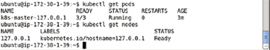

**Figure 7-3:**Listing Kubernetes Pod and the single Node

To list the services run the following command.

kubectl get services

The "kubernetes" service gets listed as shown in [Figure 7-4](https://viewer.books24x7.com/assetviewer.aspx?bookid=113388&chunkid=886065819&resumebookmarkid=99efed37-cdbe-e911-b9b2-00505695593a).

[Larger View](https://viewer.books24x7.com/assetviewer.aspx?bookid=113388&chunkid=886065819&resumebookmarkid=99efed37-cdbe-e911-b9b2-00505695593a)

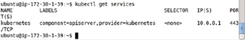

**Figure 7-4:**Listing the Kubernetes Service

**Creating a MongoDB Cluster Declaratively**

In the following subsections we shall create a Kubernetes service and replication controller for a MongoDB cluster. We shall scale the cluster and also demonstrate features such as using a volume and a host port. We shall create a MongoDB collection and add documents to the collection in a Mongo shell running in a Docker container tty (interactive terminal or shell).

**Creating a Service**

Create a service definition file mongo-service-yaml. Add the following ([Table 7-1](https://viewer.books24x7.com/assetviewer.aspx?bookid=113388&chunkid=336195868)) field mappings in the definition file.

**Table 7-1: Service Definition File mongo-service-yaml File Fields**[[](https://viewer.books24x7.com/outputobject.aspx?bookid=113388&chunkid=336195868&objectid=ch7_tab1&objecttype=spreadsheet) Open table as spreadsheet](https://viewer.books24x7.com/outputobject.aspx?bookid=113388&chunkid=336195868&objectid=ch7_tab1&objecttype=spreadsheet" \t "_blank)

| **Field** | **Value** | **Description** |
| --- | --- | --- |
| apiVersion | v1 | The API version. |
| kind | Service | Specifies the definition file to be a service. |
| metadata |  | The service metadata. |
| metadata- > labels | name: mongo |  |
| metadata- > name | mongo | A label mapping. A label may be added multiple times and does not generate an error and has no additional significance. |
| spec |  | The service specification. |
| spec- > ports |  | The port/s on which the service is exposed. |
| spec- > ports-> port | 27017 | The port on which the service is hosted. |
| spec- > ports-> targetPort | 27017 | The port that an incoming port is mapped to. The targetPort field is optional and defaults to the same value as the port field. The targetPort could be useful if the service is to evolve without breaking clients' settings. For example, the targetPort could be set to a string port name of a back-end Pod, which stays fixed. And the actual port number the back-end Pod exposes could be varied without affecting the clients' settings. |
| selector | name: mongo | The service selector used to select Pods. Pods with label expression the same as the selector are managed by the service. |

Copy the following listing to the mongo-service.yaml.

apiVersion: v1

kind: Service

metadata:

labels:

name: mongo

name: mongo

spec:

ports:

- port: 27017

targetPort: 27017

selector:

name: mongo

The vi editor could be used to create the mongo-service.yaml file and saved using the :wq command as shown in [Figure 7-5](https://viewer.books24x7.com/assetviewer.aspx?bookid=113388&chunkid=336195868).

[Larger View](https://viewer.books24x7.com/assetviewer.aspx?bookid=113388&chunkid=336195868)

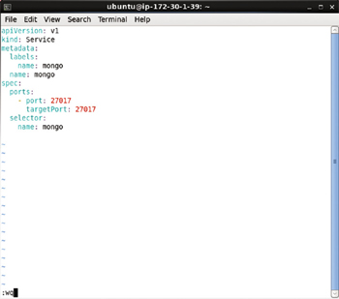

**Figure 7-5:**Service Definition File in vi Editor

The default service type is ClusterIp, which uses a cluster-internal IP only. The type could be set to LoadBalancer as shown in [Figure 7-6](https://viewer.books24x7.com/assetviewer.aspx?bookid=113388&chunkid=336195868) to also expose the service on each of the nodes in the cluster and also requests the cloud provider to provision a load balancer.

[Larger View](https://viewer.books24x7.com/assetviewer.aspx?bookid=113388&chunkid=336195868)

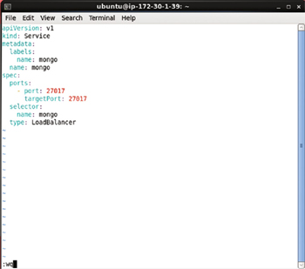

**Figure 7-6:**Setting the Service Type

To create the service from the definition file run the following command.

kubectl create -f mongo-service.yaml

List the services with the following command.

kubectl get services

The mongo service gets listed as shown in [Figure 7-7](https://viewer.books24x7.com/assetviewer.aspx?bookid=113388&chunkid=336195868).

[Larger View](https://viewer.books24x7.com/assetviewer.aspx?bookid=113388&chunkid=336195868)

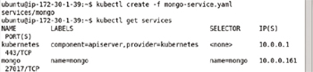

**Figure 7-7:**Creating the Service from the Definition File

**Creating a Replication Controller**

In this section we shall create a replication controller. Create a definition file mongo-rc.yaml. Add the following ([Table 7-2](https://viewer.books24x7.com/assetviewer.aspx?bookid=113388&chunkid=336195868)) field mappings to the definition file.

**Table 7-2: Replication Controller Definition File Fields**[[](https://viewer.books24x7.com/outputobject.aspx?bookid=113388&chunkid=336195868&objectid=ch7_tab2&objecttype=spreadsheet) Open table as spreadsheet](https://viewer.books24x7.com/outputobject.aspx?bookid=113388&chunkid=336195868&objectid=ch7_tab2&objecttype=spreadsheet" \t "_blank)

| **Field** | **Value** | **Description** |
| --- | --- | --- |
| apiVersion | v1 | The API version. |
| kind | ReplicationController | Specifies the definition file to be for a replication controller. |
| metadata |  | Specifies the metadata for the replication controller. |
| metadata - > labels | name: mongo | The labels mapping for the replication controller. |
| metadata - > name | mongo-rc | The replication controller name. |
| spec |  | The replication controller specification. |
| spec- > replicas | 2 | The number of replicas to keep at all times. |
| spec- > template |  | The template for a Pod. |
| spec- > template- > metadata |  | The metadata for the Pod. |
| spec- > template- > metadata- > labels |  | The Pod labels. The labels are used by the replication controller and service to select Pods to manage. The selector in a replication controller and a service must match a Pod label for the replication controller and Service to managed the Pod. |
| spec- > template- > metadata- > labels- > name | mongo | A Pod label. |
| spec- > template- > spec |  | The specification for the Pod. |
| spec- > template- > spec- > containers |  | The containers in a Pod. Multiple containers could be specified but we have configured only one container. |
| spec- > template- > spec- > containers - > image | mongo | The container for "mongo" Docker image. |
| spec- > template- > spec- > containers - > name | mongo | The container name. |
| spec- > template- > spec- > containers - > ports |  | The container ports to reserve. |
| spec- > template- > spec- > containers - > ports- > name | mongo | The port name. |
| spec- > template- > spec- > containers - > ports - > containerPort | 27017 | The container port number. |

Each of the Pod, Service, and Replication Controllers are defined in a separate YAML mapping file. The mongo-rc.yaml is listed.

apiVersion: v1

kind: ReplicationController

metadata:

labels:

name: mongo

name: mongo-rc

spec:

replicas: 2

template:

metadata:

labels:

name: mongo

spec:

containers:

-

image: mongo

name: mongo

ports:

-

containerPort: 27017

name: mongo

The mongo-rc.yaml file may be edited in a vi editor and saved with :wq as shown in [Figure 7-8](https://viewer.books24x7.com/assetviewer.aspx?bookid=113388&chunkid=336195868).

[Larger View](https://viewer.books24x7.com/assetviewer.aspx?bookid=113388&chunkid=336195868)

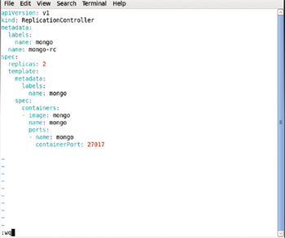

**Figure 7-8:**Replication Controller Definition File

To create a replication controller from the definition file, run the following command.

kubectl create -f mongo-rc.yaml

The mongo-rc replication controller gets created as shown in [Figure 7-9](https://viewer.books24x7.com/assetviewer.aspx?bookid=113388&chunkid=336195868).

[Larger View](https://viewer.books24x7.com/assetviewer.aspx?bookid=113388&chunkid=336195868)



**Figure 7-9:**Creating the Replication Controller

Run the following command to list the replication containers.

kubectl get rc

[Larger View](https://viewer.books24x7.com/assetviewer.aspx?bookid=113388&chunkid=336195868)

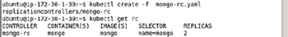

**Figure 7-10:**Creating and istingReplication Controllers

**Creating a Volume**

Kubernetes supports volumes. A *volume* is a directory in a Pod that is accessible to containers in the Pod that provide a volume mount for the volume. Volumes persist as long as the Pod containing the volumes exists. Volumes are useful for the following purposes.

* -Persist data across container crash. When a container that mounts a volume crashes, the data in the volume is not deleted as the volume is not on the container but is on the Pod.
* -Data in a volume may be shared by multiple containers that mount the volume.

A volume in a Pod is specified with the spec- > volume field. A container mounts a volume with the spec.containers.volumeMounts field. Several types of volumes are supported, some of which are discussed in [Table 7-3](https://viewer.books24x7.com/assetviewer.aspx?bookid=113388&chunkid=336195868).

**Table 7-3: Types of Volumes**[[](https://viewer.books24x7.com/outputobject.aspx?bookid=113388&chunkid=336195868&objectid=ch7_tab3&objecttype=spreadsheet) Open table as spreadsheet](https://viewer.books24x7.com/outputobject.aspx?bookid=113388&chunkid=336195868&objectid=ch7_tab3&objecttype=spreadsheet" \t "_blank)

| **Volume Type** | **Description** |
| --- | --- |
| emptyDir | An empty directory in the Pod that could be used to keep some files used by one or more containers. An empty directory could also be used for checkpointing. |
| hostPath | Mountsa directory from the host node into the Pod. |
| gcePersistentDisk | Mountsa Google Compute Engine Persistent disk into a Pod. |
| awsElasticBlockStore | Mountsan Amazon Web Services EBS volume into a Pod. |
| gitRepo | Mountsa git repo into the pod. |
| flocker | Mountsa Flocker dataset into a pod. |
| nfs | Mountsa Network File System into a Pod. |

Next, we shall add a volume of type emptyDir to the replication controller definition file mongo-rc.yaml. A modified version of mongo-rc.yaml is listed.

apiVersion: v1

kind: ReplicationController

metadata:

labels:

name: mongo

name: mongo-rc

spec:

replicas: 2

template:

metadata:

labels:

name: mongo

spec:

containers:

-

image: mongo

name: mongo

ports:

-

containerPort: 27017

name: mongo

volumeMounts:

-

mountPath: /mongo/data/db

name: mongo-storage

volumes:

-

emptyDir: {}

name: mongo-storage

The preceding definition file includes the following volume configuration for a volume named mongo-storage of type emptyDir.

volumes:

-

emptyDir: {}

name: mongo-storage

The volume exists in the Pod and individual containers in the Pod may mount the volume using field spec->containers->volumeMounts. The modified mongo-rc.yaml includes the following volume mount for the mongo container.

volumeMounts:

-

mountPath: /mongo/data/db

name: mongo-storage

The preceding configuration adds a volume mount for the mongo-storage volume at mount path or directory path /mongo/data/db in the container. Within a container the volume may be accessed at /mongo/data/db. For example, in an interactive terminal for a container change directory (cd) to the /mongo/data/db directory.

cd /mongo/data/db

List the files and directories in the in the /mongo/data/db directory.

ls -l

The directory is empty as it is supposed to be initially as shown in [Figure 7-11](https://viewer.books24x7.com/assetviewer.aspx?bookid=113388&chunkid=336195868).

[Larger View](https://viewer.books24x7.com/assetviewer.aspx?bookid=113388&chunkid=336195868)



**Figure 7-11:**Empty Directory

The volume should not be confused with the data directory for the MongoDB server. The data directory is created at /data/db by default and is created in each Docker container running a MongoDB server instance. The /mongo/data/db is common to all Docker containers while the /data/db exists in each Docker container.

**Listing the Logs**

After having started a replication controller, list the Pods with the following command.

kubectl get pods

The two Pods get listed as shown in [Figure 7-12](https://viewer.books24x7.com/assetviewer.aspx?bookid=113388&chunkid=336195868).

[Larger View](https://viewer.books24x7.com/assetviewer.aspx?bookid=113388&chunkid=336195868)

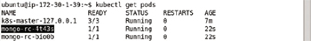

**Figure 7-12:**Listing the Pods

The logs for a Pod, for example, the mongo-rc-4t43s Pod, may be listed with the following command.

kubectl logs mongo-rc-4t43s

The Pod logs show the MongoDB server starting as shown in [Figure 7-13](https://viewer.books24x7.com/assetviewer.aspx?bookid=113388&chunkid=336195868).

[Larger View](https://viewer.books24x7.com/assetviewer.aspx?bookid=113388&chunkid=336195868)

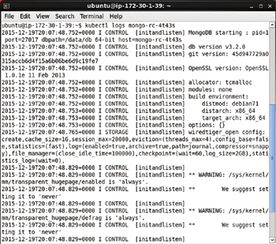

**Figure 7-13:**Listing the Pod Logs

When the MongoDB server gets started, the message "waiting for connections on port 27017" gets output as shown in [Figure 7-14](https://viewer.books24x7.com/assetviewer.aspx?bookid=113388&chunkid=336195868).

[Larger View](https://viewer.books24x7.com/assetviewer.aspx?bookid=113388&chunkid=336195868)

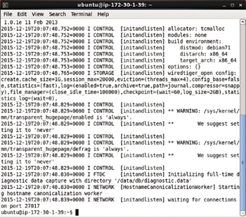

**Figure 7-14:**MongoDB Running on Port 27017

**Starting the Interactive Shell for Docker Container**

In this section we shall start an interactive terminal or bash shell for MongoDB server for which we need the container id of a Docker container running a MongoDB server. List the Docker containers.

sudo docker ps

Copy the container id for a container with image as "mongo" as shown in [Figure 7-15](https://viewer.books24x7.com/assetviewer.aspx?bookid=113388&chunkid=336195868).

[Larger View](https://viewer.books24x7.com/assetviewer.aspx?bookid=113388&chunkid=336195868)

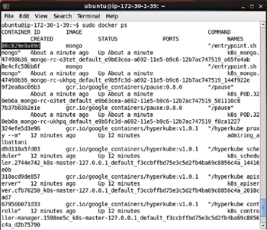

**Figure 7-15:**Copying Docker Container ID

Because the "mongo" Docker image is based on the "debian" Docker image as speciifed in the FROM instruction, we are able to start a bash shell to interact with the MongoDB server running in a Docker container based on the "mongo" image. Start an interactive bash shell using the following command.

sudo docker exec -it 00c829e0a89d bash

An interactive shell gets started as shown in [Figure 7-16](https://viewer.books24x7.com/assetviewer.aspx?bookid=113388&chunkid=336195868).

[Larger View](https://viewer.books24x7.com/assetviewer.aspx?bookid=113388&chunkid=336195868)



**Figure 7-16:**Starting an Interactive Shell

**Starting a Mongo Shell**

Start the Mongo shell with the following command.

mongo

Mongo shell gets started as shown in [Figure 7-17](https://viewer.books24x7.com/assetviewer.aspx?bookid=113388&chunkid=336195868).

[Larger View](https://viewer.books24x7.com/assetviewer.aspx?bookid=113388&chunkid=336195868)

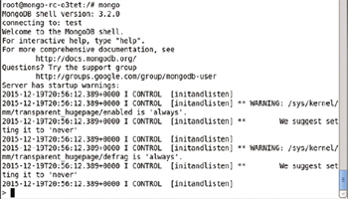

**Figure 7-17:**Mongo Shell

**Creating a Database**

List the databases with the following command from the Mongo shell.

show dbs

A database gets created implicitly when a database is used or set. For example, set the database to use as mongodb, which is not listed with show dbs and does not exist yet.

use mongodb

But, setting the database to use as mongodb does not create the database mongodb till the database is used. Run the following command to list the databases.

show dbs

The mongodb database does not get listed as shown in [Figure 7-19](https://viewer.books24x7.com/assetviewer.aspx?bookid=113388&chunkid=336195868). To create the mongodbdatabase, invoke some operation on the database such as create a collection called catalog with the following command.

db.createCollection("catalog")

Subsequently list the databases again.

show dbs

The mongodb database gets listed as shown in [Figure 7-18](https://viewer.books24x7.com/assetviewer.aspx?bookid=113388&chunkid=336195868). To list the collections run the following command.

show collections

The catalog collection gets listed.

[Larger View](https://viewer.books24x7.com/assetviewer.aspx?bookid=113388&chunkid=336195868)

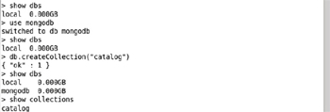

**Figure 7-18:**Creating and Listing a MongoDB Database

**Creating a Collection**

The catalog collection was created using the db.createCollection methodin the previous section. As another example, create a capped collection called catalog\_capped using the following command: a capped collection is a fixed size collection that supports high throughput operations to add and get documents based on insertion order.

db.createCollection("catalog\_capped", {capped: true, autoIndexId: true, size: 64 \* 1024,

max: 1000} )

A capped collection gets added as shown in [Figure 7-19](https://viewer.books24x7.com/assetviewer.aspx?bookid=113388&chunkid=336195868). Initially the collection is empty. Get the documents in the catalog collection with the following command.

db.catalog.count()

The document count is listed as 0 as we have not yet added any documents.

[Larger View](https://viewer.books24x7.com/assetviewer.aspx?bookid=113388&chunkid=336195868)

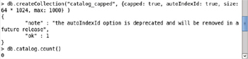

**Figure 7-19:**Creating a Capped Collection

**Adding Documents**

In this section we shall add documents to the catalog collection. Specify the JSON for the documents to be added. The \_id field is required in each document stored in MongoDB. The \_id field may be added explicitly as in the doc2 document. If not provided in the document JSON the \_id is generated automatically.

doc1 = {"catalogId" : "catalog1", "journal" : 'Oracle Magazine', "publisher" :

'Oracle Publishing', "edition" : 'November December 2013',"title" : 'Engineering as a

Service',"author" : 'David A. Kelly'}

doc2 = {"\_id": ObjectId("507f191e810c19729de860ea"), "catalogId" : "catalog1", "journal"

: 'Oracle Magazine', "publisher" : 'Oracle Publishing', "edition" : 'November December

2013',"title" : 'Engineering as a Service',"author" : 'David A. Kelly'};

The doc1 and doc2 are shown in [Figure 7-20](https://viewer.books24x7.com/assetviewer.aspx?bookid=113388&chunkid=336195868).

[Larger View](https://viewer.books24x7.com/assetviewer.aspx?bookid=113388&chunkid=336195868)

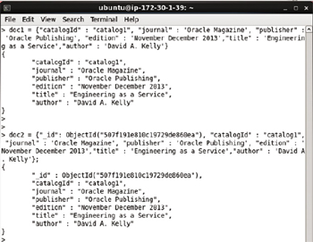

**Figure 7-20:**Documents doc1 and doc2

To add the documents to the catalog collection run the following command.

db.catalog.insert([doc1, doc2], { writeConcern: { w: "majority", wtimeout: 5000 },

ordered:true })

As indicated by the nInserted field in the JSON result in [Figure 7-21](https://viewer.books24x7.com/assetviewer.aspx?bookid=113388&chunkid=336195868) documents get added.

[Larger View](https://viewer.books24x7.com/assetviewer.aspx?bookid=113388&chunkid=336195868)

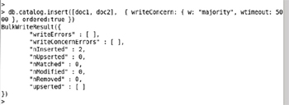

**Figure 7-21:**Adding Documents

**Finding Documents**

To query the catalog invoke the find() method. To list all documents in the catalogcollection run the following command.

db.catalog.find()

The two documents added get listed as shown in [Figure 7-22](https://viewer.books24x7.com/assetviewer.aspx?bookid=113388&chunkid=336195868). For one of the documents the \_id field is generated automatically.

[Larger View](https://viewer.books24x7.com/assetviewer.aspx?bookid=113388&chunkid=336195868)

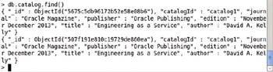

**Figure 7-22:**Finding Documents

**Finding a Single Document**

To find a single document from the catalog collection run the following command to invoke the findOne() method.

db.catalog.findOne()

A single document gets listed as shown in [Figure 7-23](https://viewer.books24x7.com/assetviewer.aspx?bookid=113388&chunkid=336195868).

[Larger View](https://viewer.books24x7.com/assetviewer.aspx?bookid=113388&chunkid=336195868)

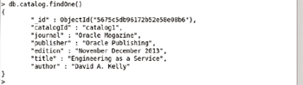

**Figure 7-23:**Finding a Single Document

**Finding Specific Fields in a Single Document**

To get only specific fields, edition, title, and author, for example, from a single document run the following command.

db.catalog.findOne(

{ },

{ edition: 1, title: 1, author: 1 }

)

Only the specific fields in a single document get listed as shown in [Figure 7-24](https://viewer.books24x7.com/assetviewer.aspx?bookid=113388&chunkid=336195868). The \_id field always gets listed.

[Larger View](https://viewer.books24x7.com/assetviewer.aspx?bookid=113388&chunkid=336195868)

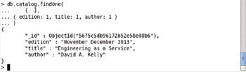

**Figure 7-24:**Finding Selected Fields in a Document

**Dropping a Collection**

To drop the catalog collection run the following command.

db.catalog.drop()

Subsequently list the collections with the following command.

show collections

The catalog collection does not get listed and only the catalog\_capped collection gets listed as shown in [Figure 7-25](https://viewer.books24x7.com/assetviewer.aspx?bookid=113388&chunkid=336195868).

[Larger View](https://viewer.books24x7.com/assetviewer.aspx?bookid=113388&chunkid=336195868)

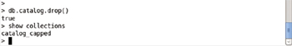

**Figure 7-25:**Dropping the catalog Collection

**Exiting Mongo Shell and Interactive Shell**

To exit the Mongo shell run the following command.

exit

To exit the interactive terminal run the following command.

exit

The Mongo shell and the interactive terminal get exited as shown in [Figure 7-26](https://viewer.books24x7.com/assetviewer.aspx?bookid=113388&chunkid=336195868).

[Larger View](https://viewer.books24x7.com/assetviewer.aspx?bookid=113388&chunkid=336195868)

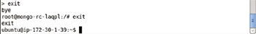

**Figure 7-26:**Exiting the Shells

**Scaling the Cluster**

To scale the Mongo cluster run the kubectl scale command. For example, the following command scales the cluster to 4 replicas.

kubectl scale rc mongo --replicas=4

An output of "scaled" as shown in [Figure 7-27](https://viewer.books24x7.com/assetviewer.aspx?bookid=113388&chunkid=336195868) scales the cluster to 4 replicas.

[Larger View](https://viewer.books24x7.com/assetviewer.aspx?bookid=113388&chunkid=336195868)



**Figure 7-27:**Scaling a Replication Controller

List the Pods after scaling.

kubectl get pods

The four Pods get listed. Initially some of the Pods could be listed as not in READY (1/1) state. Run the preceding command multiple times to list all pods running and ready as shown in [Figure 7-28](https://viewer.books24x7.com/assetviewer.aspx?bookid=113388&chunkid=336195868).

[Larger View](https://viewer.books24x7.com/assetviewer.aspx?bookid=113388&chunkid=336195868)

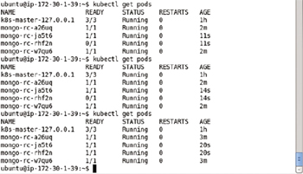

**Figure 7-28:**Listing the Pods after Scaling

**Deleting the Replication Controller**

To delete a replication controller mongo-rc run the following command.

kubectl delete replicationcontroller mongo-rc

All the Pods managed by the replication controller also get deleted. Subsequently run the following command to list the Pods.

kubectl get pods

The mongo Pods do not get listed as shown in [Figure 7-29](https://viewer.books24x7.com/assetviewer.aspx?bookid=113388&chunkid=336195868).

[Larger View](https://viewer.books24x7.com/assetviewer.aspx?bookid=113388&chunkid=336195868)

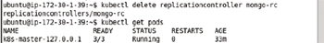

**Figure 7-29:**Deleting a Replication Controller

**Deleting the Service**

To delete the service called mongo run the following command.

kubectl delete service mongo

The mongo service does not get listed as shown in [Figure 7-30](https://viewer.books24x7.com/assetviewer.aspx?bookid=113388&chunkid=336195868).

[Larger View](https://viewer.books24x7.com/assetviewer.aspx?bookid=113388&chunkid=336195868)

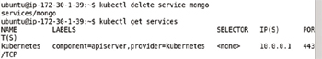

**Figure 7-30:**Deleting the mongo Service

**Using a Host Port**

The container specification within a Pod has the provision to configure a host port. A host port is a container port mapping to the host implying that the specified host port gets reserved for a single container The hostPort field should be used for a single machine container. Multiple containers of the type in which the hostPort is specified cannot be started because the host port can be reserved only by a single container. Other Pods that do not specify a hostPort field could be run, however, on the same machine on which a container with hostPort field mapping is running. As a variation of the replication controller we used earlier add a hostPort field in the spec- > containers- > ports field. The modified mongo-rc.yaml is listed.

apiVersion: v1

kind: ReplicationController

metadata:

labels:

name: mongo

name: mongo-rc

spec:

replicas: 2

template:

metadata:

labels:

name: mongo

spec:

containers:

-

image: mongo

name: mongo

ports:

-

containerPort: 27017

hostPort: 27017

name: mongo

Run the following command to create a replication controller.

kubectl create -f mongo-rc.yaml

List the replication controllers with the following command.

kubectl get rc

The mongo-rc replication controller gets created and listed as shown in [Figure 7-31](https://viewer.books24x7.com/assetviewer.aspx?bookid=113388&chunkid=336195868).

[Larger View](https://viewer.books24x7.com/assetviewer.aspx?bookid=113388&chunkid=336195868)

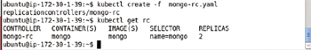

**Figure 7-31:**Creating a Replication Controller from a Definition File

List the Pods with the following command.

kubectl get pods

Only one of the two replicas is listed as Running and READY (1/1). Even if the preceding command is run multiple times, only one replica is listed as running as shown in [Figure 7-32](https://viewer.books24x7.com/assetviewer.aspx?bookid=113388&chunkid=336195868).

[Larger View](https://viewer.books24x7.com/assetviewer.aspx?bookid=113388&chunkid=336195868)

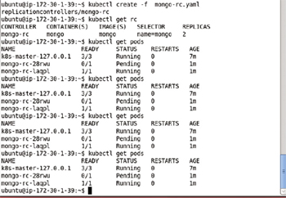

**Figure 7-32:**Listing the Pods after creating a Replication Controller

Scale the MongoDB cluster to 4 replicas with the following command.

kubectl scale rc mongo --replicas=4

Though the output from the command is "Scaled" and 4 Pods get created but only one Pod is in READY (1/1) state at any particular time as shown in [Figure 7-33](https://viewer.books24x7.com/assetviewer.aspx?bookid=113388&chunkid=336195868).

[Larger View](https://viewer.books24x7.com/assetviewer.aspx?bookid=113388&chunkid=336195868)

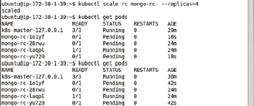

**Figure 7-33:**Scaling the Replication Controller to 4 Replicas

Even if the single running Pod is stopped only one new Pod gets started. To demonstrate, stop the single running Pod.

kubectl stop pod mongo-rc-laqpl

The Pod gets removed but a replacement Pod gets created to maintain the replication level of 1 as shown in [Figure 7-34](https://viewer.books24x7.com/assetviewer.aspx?bookid=113388&chunkid=336195868).

[Larger View](https://viewer.books24x7.com/assetviewer.aspx?bookid=113388&chunkid=336195868)

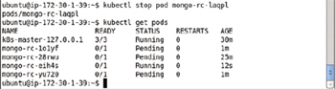

**Figure 7-34:**Another Pod gets created when the single running Pod is stopped

List the Pods again after a few seconds and only one Pod gets listed as shown in [Figure 7-35](https://viewer.books24x7.com/assetviewer.aspx?bookid=113388&chunkid=336195868).

[Larger View](https://viewer.books24x7.com/assetviewer.aspx?bookid=113388&chunkid=336195868)

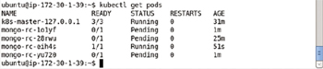

**Figure 7-35:**Only a single Pod is Running and Ready

Using the hostPort field is not recommended unless a single container machine is to be used or only a single container is required to be mapped to the host port.

**Creating a MongoDB Cluster Imperatively**

In the following subsections we shall create a Kubernetes replication controller and service for a MongoDB cluster on the command line using kubectl.

**Creating a Replication Controller**

To create a replication controller for the Docker image "mongo" with 2 replicas and port 27017 run the following command.

kubectl run mongo --image=mongo --replicas=2 --port=27017

The replication controller gets created as shown in [Figure 7-36](https://viewer.books24x7.com/assetviewer.aspx?bookid=113388&chunkid=369528024&resumebookmarkid=a546b65e-d1be-e911-b9b2-00505695593a).

[Larger View](https://viewer.books24x7.com/assetviewer.aspx?bookid=113388&chunkid=369528024&resumebookmarkid=a546b65e-d1be-e911-b9b2-00505695593a)

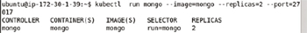

**Figure 7-36:**Creating a Replication Controller Imperatively

List the Pods with the following command.

kubectl get rc

The mongo-rc gets listed as shown in [Figure 7-37](https://viewer.books24x7.com/assetviewer.aspx?bookid=113388&chunkid=369528024&resumebookmarkid=a546b65e-d1be-e911-b9b2-00505695593a).

[Larger View](https://viewer.books24x7.com/assetviewer.aspx?bookid=113388&chunkid=369528024&resumebookmarkid=a546b65e-d1be-e911-b9b2-00505695593a)

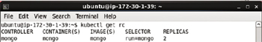

**Figure 7-37:**Listing the Replication Controllers

**Listing the Pods**

List the Pods with the following command.

kubectl get pods

The two Pods started for MongoDB get listed as shown in [Figure 7-38](https://viewer.books24x7.com/assetviewer.aspx?bookid=113388&chunkid=369528024&resumebookmarkid=a546b65e-d1be-e911-b9b2-00505695593a). Initially the Pods could be listed as not running.

[Larger View](https://viewer.books24x7.com/assetviewer.aspx?bookid=113388&chunkid=369528024&resumebookmarkid=a546b65e-d1be-e911-b9b2-00505695593a)

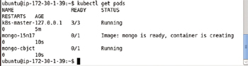

**Figure 7-38:**Listing the Pods with some of the pods not Running yet

Run the following preceding multiple times if required to list the Pods as running as shown in [Figure 7-39](https://viewer.books24x7.com/assetviewer.aspx?bookid=113388&chunkid=369528024&resumebookmarkid=a546b65e-d1be-e911-b9b2-00505695593a).

[Larger View](https://viewer.books24x7.com/assetviewer.aspx?bookid=113388&chunkid=369528024&resumebookmarkid=a546b65e-d1be-e911-b9b2-00505695593a)

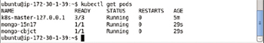

**Figure 7-39:**Listing all the Pods as Running

**Listing the Logs**

List the logs for a Pod with the following command. The mongo-56850 is the Pod name.

kubectl logs mongo-56850

The Pod logs get listed as shown in [Figure 7-40](https://viewer.books24x7.com/assetviewer.aspx?bookid=113388&chunkid=369528024&resumebookmarkid=a546b65e-d1be-e911-b9b2-00505695593a).

[Larger View](https://viewer.books24x7.com/assetviewer.aspx?bookid=113388&chunkid=369528024&resumebookmarkid=a546b65e-d1be-e911-b9b2-00505695593a)

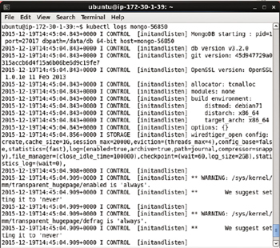

**Figure 7-40:**Listing Pod Logs

MongoDB is listed as started as shown in [Figure 7-41](https://viewer.books24x7.com/assetviewer.aspx?bookid=113388&chunkid=369528024&resumebookmarkid=a546b65e-d1be-e911-b9b2-00505695593a). Output on commands run on the server also get output.

[Larger View](https://viewer.books24x7.com/assetviewer.aspx?bookid=113388&chunkid=369528024&resumebookmarkid=a546b65e-d1be-e911-b9b2-00505695593a)

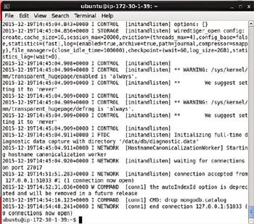

**Figure 7-41:**Listing MongoDB Server as running and waiting for connections on port 27017

**Creating a Service**

To create a service for the mongo replication controller run the following command to expose a service on port 27017 of type LoadBalancer, which was discussed earlier.

kubectl expose rc mongo --port=27017 --type=LoadBalancer

The mongo service gets created as shown in [Figure 7-42](https://viewer.books24x7.com/assetviewer.aspx?bookid=113388&chunkid=369528024&resumebookmarkid=a546b65e-d1be-e911-b9b2-00505695593a).

[Larger View](https://viewer.books24x7.com/assetviewer.aspx?bookid=113388&chunkid=369528024&resumebookmarkid=a546b65e-d1be-e911-b9b2-00505695593a)

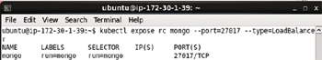

**Figure 7-42:**Creating a Service Imperatively

List the services with the following command.

kubectl get services

The mongo service is listed as running in [Figure 7-43](https://viewer.books24x7.com/assetviewer.aspx?bookid=113388&chunkid=369528024&resumebookmarkid=a546b65e-d1be-e911-b9b2-00505695593a).

[Larger View](https://viewer.books24x7.com/assetviewer.aspx?bookid=113388&chunkid=369528024&resumebookmarkid=a546b65e-d1be-e911-b9b2-00505695593a)

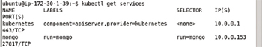

**Figure 7-43:**Listing the Services including the mongo Service

An interactive terminal and a Mongo shell may get started to create a MongoDB database and collection to add and query documents in the collection as discussed when creating a MongoDB cluster declaratively.

**Scaling the Cluster**

To scale the cluster to 4 replicas, for example, run the following command.

kubectl scale rc mongo --replicas=4

An output of "scaled" indicates that the cluster has been scaled as shown in [Figure 7-44](https://viewer.books24x7.com/assetviewer.aspx?bookid=113388&chunkid=369528024&resumebookmarkid=a546b65e-d1be-e911-b9b2-00505695593a).

[Larger View](https://viewer.books24x7.com/assetviewer.aspx?bookid=113388&chunkid=369528024&resumebookmarkid=a546b65e-d1be-e911-b9b2-00505695593a)



**Figure 7-44:**Scaling the Cluster created Imperatively

Subsequently get the Pods.

kubectl get pods

Four pods get listed as shown in [Figure 7-45](https://viewer.books24x7.com/assetviewer.aspx?bookid=113388&chunkid=369528024&resumebookmarkid=a546b65e-d1be-e911-b9b2-00505695593a). Initially some of the Pods could be shown as not running

[Larger View](https://viewer.books24x7.com/assetviewer.aspx?bookid=113388&chunkid=369528024&resumebookmarkid=a546b65e-d1be-e911-b9b2-00505695593a)

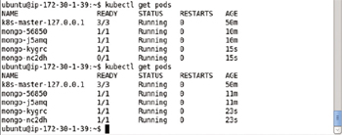

**Figure 7-45:**Listing Pods after Scaling

To describe the mongo service run the following command.

kubectl describe svc mongo

The service description includes the service label, selector in addition to the service endpoints, one for each of the four pods as shown in [Figure 7-46](https://viewer.books24x7.com/assetviewer.aspx?bookid=113388&chunkid=369528024&resumebookmarkid=a546b65e-d1be-e911-b9b2-00505695593a).

[Larger View](https://viewer.books24x7.com/assetviewer.aspx?bookid=113388&chunkid=369528024&resumebookmarkid=a546b65e-d1be-e911-b9b2-00505695593a)

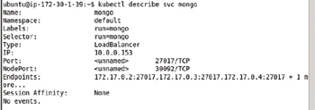

**Figure 7-46:**Describing the Service mongo after Scaling

**Deleting the Service and Replication Controller**

The mongo service and the mongo replication controller may be deleted with the following commands.

kubectl delete service mongo

kubectl delete rc mongo

The "mongo" service and the "mongo" replication controller get deleted as shown in [Figure 7-47](https://viewer.books24x7.com/assetviewer.aspx?bookid=113388&chunkid=369528024&resumebookmarkid=a546b65e-d1be-e911-b9b2-00505695593a). Deleting one does not delete the other; the decoupling of the replication controller from the service is a feature suitable to evolve one without having to modify the other.

[Larger View](https://viewer.books24x7.com/assetviewer.aspx?bookid=113388&chunkid=369528024&resumebookmarkid=a546b65e-d1be-e911-b9b2-00505695593a)

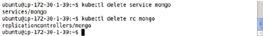

**Figure 7-47:**Deleting the Service and the Replication Controller

### Summary

In this chapter we used the Kubernetes cluster manager to create and orchestrate a MongoDB cluster. We created a replication controller and a service both imperatively and declaratively. We also demonstrated scaling a cluster. We introduced two other features of Kubernetes replication controllers: volumes and host port. This chapter is about using Kubernetes with MongoDB and the emphasis is less on MongoDB; but if MongoDB is to be explored in more detail, refer to the Apress book *Pro MongoDB Development*(<http://www.apress.com/9781484215999?gtmf=s>). In the next chapter we shall discuss another NoSQL database, Apache Cassandra.

**Kubernetes Microservices with Docker**

Chapter 8 - Using Apache Cassandra Database

Apress © 2016

## Chapter 8: Using Apache Cassandra Database

**© Deepak Vohra 2016  
D. Vohra, *Kubernetes Microservices with Docker*, DOI 10.1007/978-1-4842-1907-2\_8**

### Overview

Apache Cassandra is an open source wide column data store. Cassandra is a scalable, reliable, fault-tolerant, and highly available NoSQL database. Cassandra is based on a flexible schema data model in which data is stored in rows in a table (also called column family) with a primary key identifying a row. The primary key could be a single column or multiple column (compound) row key. A relational database also stores data in table rows, but what makes Cassandra different is that the table rows do not have to follow a fixed schema. Each row in a table could have different columns or some of the columns could be the same as other rows. Each row does not have to include all the columns or any column data at all. In this regard Cassandra provides a dynamic column specification. A keyspace is a namespace container for the data stored in Cassandra. In this chapter we shall discuss using Kubernetes cluster manager with Apache Cassandra.

**Setting the Environment**

The following software is required for this chapter.

* -Docker Engine (latest version)
* -Kubernetes (version 1.01)
* -Kubectl (version 1.01)
* -Docker image for Apache Cassandra (latest version)

Install the software on an Amazon EC2 instance created from Ubuntu Server 14.04 LTS (HVM), SSD Volume Type - ami-d05e75b8 AMI as explained in [chapter 1](http://viewer.books24x7.com/assetviewer.aspx?bkid=113388&destid=28#28). SSH Login to the Ubuntu instance using the Public IP Address of the Amazon EC2 instance.

ssh -i "docker.pem" ubuntu@52.23.l60.7

Start the Docker engine and verify its status.

sudo service docker start

sudo service docker status

The Docker engine should be running as shown in [Figure 8-1](https://viewer.books24x7.com/assetviewer.aspx?bookid=113388&chunkid=382594296&resumebookmarkid=a546b65e-d1be-e911-b9b2-00505695593a).

[Larger View](https://viewer.books24x7.com/assetviewer.aspx?bookid=113388&chunkid=382594296&resumebookmarkid=a546b65e-d1be-e911-b9b2-00505695593a)

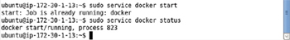

**Figure 8-1:**Starting Docker

List the services.

kubectl get services

The "kubernetes" service should be listed as shown in [Figure 8-2](https://viewer.books24x7.com/assetviewer.aspx?bookid=113388&chunkid=382594296&resumebookmarkid=a546b65e-d1be-e911-b9b2-00505695593a).

[Larger View](https://viewer.books24x7.com/assetviewer.aspx?bookid=113388&chunkid=382594296&resumebookmarkid=a546b65e-d1be-e911-b9b2-00505695593a)

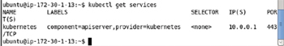

**Figure 8-2:**Listing the "kubernetes" Service

List the Pods and the nodes with the following commands.

kubectl get pods

kubectl get nodes

Initially the only pod running is the Kubernetes pod as shown in [Figure 8-3](https://viewer.books24x7.com/assetviewer.aspx?bookid=113388&chunkid=382594296&resumebookmarkid=a546b65e-d1be-e911-b9b2-00505695593a).

[Larger View](https://viewer.books24x7.com/assetviewer.aspx?bookid=113388&chunkid=382594296&resumebookmarkid=a546b65e-d1be-e911-b9b2-00505695593a)

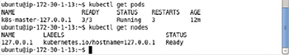

**Figure 8-3:**Listing the Pod and Node for Kubernetes

A Cassandra cluster may be created and managed both declaratively and imperatively, and we shall discuss both the options.

**Creating a Cassandra Cluster Declaratively**

In the following subsections we have discussed creating a Cassandra cluster using definition files based on the YAML format. First, create a service to represent a Cassandra cluster. A service is the external interface for a cluster of Pods, Apache Cassandra pods in the context of this chapter.

**Creating a Service**

Create a service definition file called cassandra-service.yaml. Add the fields discussed in [Table 8-1](https://viewer.books24x7.com/assetviewer.aspx?bookid=113388&chunkid=175284627&resumebookmarkid=a546b65e-d1be-e911-b9b2-00505695593a).

**Table 8-1: Fields in the Service Definition File**[[](https://viewer.books24x7.com/outputobject.aspx?bookid=113388&chunkid=175284627&objectid=ch8_tab1&objecttype=spreadsheet) Open table as spreadsheet](https://viewer.books24x7.com/outputobject.aspx?bookid=113388&chunkid=175284627&objectid=ch8_tab1&objecttype=spreadsheet" \t "_blank)

| **Field** | **Description** | **Value** |
| --- | --- | --- |
| apiVersion | API Version. | v1 |
| kind | Kind of the definition file. | Service |
| metadata | Metadata of the service. |  |
| metadata - > name | Service name. Required field. | cassandra |
| metadata - > labels | Service labels. A label could be any key- > value pair. A service label is set as app:cassandra. | app:cassandra |
| spec | The service specification. |  |
| spec - > labels | The spec labels. A label could be any key- > value pair. The service label is set as app:Cassandra. | app:cassandra |
| spec - > selector | Service selector. Used to select Pods to manage. Pods with a label the same as the selector expression are selected or managed by the service. The selector expression could be any key:value pair.  Or, multiple requirements or expressions could be specified using a ','. The app:cassandra setting translates to service selector app = cassandra. | app:cassandra |
| spec - > ports | The service ports. The ports field is required. |  |
| spec - > ports - > port | A single service port at which the service is exposed for access by external clients. | 9042 |
| spec - > type | The service type. | LoadBalancer |

The cassandra-service.yaml is listed below. Use the YAML Lint (<http://www.yamllint.com/>) to validate the syntax.

apiVersion: v1

kind: Service

metadata:

name: cassandra

labels:

app: cassandra

spec:

labels:

app: cassandra

selector:

app: cassandra

ports:

-

port: 9042

type: LoadBalancer

The cassandra-service.yaml file may be created in a vi editor and saved using the :wq command as shown in [Figure 8-4](https://viewer.books24x7.com/assetviewer.aspx?bookid=113388&chunkid=175284627&resumebookmarkid=a546b65e-d1be-e911-b9b2-00505695593a).

[Larger View](https://viewer.books24x7.com/assetviewer.aspx?bookid=113388&chunkid=175284627&resumebookmarkid=a546b65e-d1be-e911-b9b2-00505695593a)

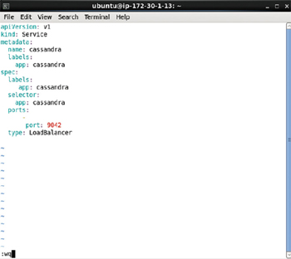

**Figure 8-4:**Service Definition File in vi Editor

To create a service run the following command.

kubectl create -f cassandra-service.yaml

Subsequently list the services.

kubectl get services

The cassandra service gets listed as shown in [Figure 8-5](https://viewer.books24x7.com/assetviewer.aspx?bookid=113388&chunkid=175284627&resumebookmarkid=a546b65e-d1be-e911-b9b2-00505695593a).

[Larger View](https://viewer.books24x7.com/assetviewer.aspx?bookid=113388&chunkid=175284627&resumebookmarkid=a546b65e-d1be-e911-b9b2-00505695593a)

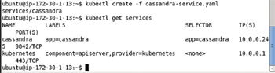

**Figure 8-5:**Creating and listing a Service for Apache Cassandra

Describe the cassandra service with the following command.

kubectl describe svc cassandra

The service name, namespace, labels, selector, type, IP, Port, NodePort and endpoints get listed as shown in [Figure 8-6](https://viewer.books24x7.com/assetviewer.aspx?bookid=113388&chunkid=175284627&resumebookmarkid=a546b65e-d1be-e911-b9b2-00505695593a). No service endpoint is listed initially because a Pod has not been created yet.

[Larger View](https://viewer.books24x7.com/assetviewer.aspx?bookid=113388&chunkid=175284627&resumebookmarkid=a546b65e-d1be-e911-b9b2-00505695593a)

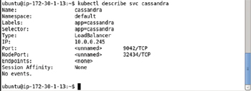

**Figure 8-6:**Describing the Service for Apache Cassandra

**Creating a Replication Controller**

Next, we shall create a replication controller for Cassandra. A replication controller defines the configuration for the containers and their respective Docker images in the Pod. Create a definition file cassandra-rc.yaml and add the following ([Table 8-2](https://viewer.books24x7.com/assetviewer.aspx?bookid=113388&chunkid=175284627&resumebookmarkid=a546b65e-d1be-e911-b9b2-00505695593a)) fields.

**Table 8-2: Fields in the Replication Controller Definition File**[[](https://viewer.books24x7.com/outputobject.aspx?bookid=113388&chunkid=175284627&objectid=ch8_tab2&objecttype=spreadsheet) Open table as spreadsheet](https://viewer.books24x7.com/outputobject.aspx?bookid=113388&chunkid=175284627&objectid=ch8_tab2&objecttype=spreadsheet" \t "_blank)

| **Field** | **Description** | **Value** |
| --- | --- | --- |
| apiVersion | The API Version. | v1 |
| kind | Kind of definition file. | ReplicationController |
| metadata | Replication controller metadata. |  |
| metadata - > labels | Replication controller labels. The key:value pair app:cassandra is set as a label on the replication controller. | app:cassandra |
| spec | The replication controller specification. |  |
| spec - > replicas | The number of replicas. | 1 |
| spec- > selector | The selector expression for the replication controller.  Must be the same as one of the labels in the spec - > template - > metadata - > labels field. Required field but not required to be set explicitly and defaults to the labels in spec - > template - > metadata - > labels field. If multiple requirements are set in the selector multiple labels in the Pod template labels must match. For example if the selector is app=cassandra, name=cassandra the Pod template labels spec - > template - > metadata - > labels must include both of these labels. |  |
| spec - > template | The Pod template. Required field. |  |
| spec - > template - > metadata | Template metadata. |  |
| spec - > template - > metadata - > labels | Template labels. The key:value pair app:cassandra is set as a label on the Pod. A label must be set on the template. The label setting translates to Pod label app=cassandra. | app:cassandra |
| spec - > template - > spec | The container specification. |  |
| spec - > template - > spec - > containers | The containers in the Pod. |  |
| spec - > template - > spec - > containers - > image | The Docker image for a container. | cassandra |
| spec - > template - > spec - > containers - > name | The container name. | cassandra |
| spec - > template - > spec - > containers - > ports | The container ports. |  |
| spec - > template - > spec - > containers - > ports - > containerPort | The container port for CQL command shell. | 9042 |
| spec - > template - > spec - > containers - > ports - > name | The port name. | cql |
| spec - > template - > spec - > containers - > ports - > containerPort | The container port for thrift clients. | 9160 |
| spec - > template - > spec - > containers - > ports - > name | The port name. | thrift |

The cassandra-rc.yaml is listed.

apiVersion: v1

kind: ReplicationController

metadata:

name: cassandra-rc

labels:

app: cassandra

spec:

replicas: 1

template:

metadata:

labels:

app: cassandra

spec:

containers:

-

image: cassandra

name: cassandra

ports:

-

containerPort: 9042

name: cql

-

containerPort: 9160

name: thrift

The cassandra-rc.yaml field may be created in a vi editor and saved with the :wq command as shown in [Figure 8-7](https://viewer.books24x7.com/assetviewer.aspx?bookid=113388&chunkid=175284627&resumebookmarkid=a546b65e-d1be-e911-b9b2-00505695593a).

[Larger View](https://viewer.books24x7.com/assetviewer.aspx?bookid=113388&chunkid=175284627&resumebookmarkid=a546b65e-d1be-e911-b9b2-00505695593a)

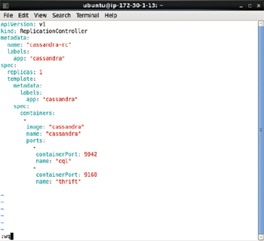

**Figure 8-7:**Replication Controller Definition File in vi Editor

Create a replication controller with the following command.

kubectl create -f cassandra-rc.yaml

Subsequently list the replication controllers.

kubectl get rc

The cassandra-rc replication controller gets created and listed as shown in [Figure 8-8](https://viewer.books24x7.com/assetviewer.aspx?bookid=113388&chunkid=175284627&resumebookmarkid=a546b65e-d1be-e911-b9b2-00505695593a).

[Larger View](https://viewer.books24x7.com/assetviewer.aspx?bookid=113388&chunkid=175284627&resumebookmarkid=a546b65e-d1be-e911-b9b2-00505695593a)

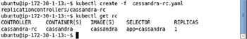

**Figure 8-8:**Creating a Replication Controller from Definition File

List the Pods created by the replication controller.

kubectl get pods

As the number of replicas is set to 1 in the replication controller definition file, one Pod gets created and is listed in [Figure 8-9](https://viewer.books24x7.com/assetviewer.aspx?bookid=113388&chunkid=175284627&resumebookmarkid=a546b65e-d1be-e911-b9b2-00505695593a). The preceding command may have to be run multiple times to list the Pod as running and ready. Alternatively run the command for the first time after a few seconds of having created the replication controller; by a minute all Pods should have started.

[Larger View](https://viewer.books24x7.com/assetviewer.aspx?bookid=113388&chunkid=175284627&resumebookmarkid=a546b65e-d1be-e911-b9b2-00505695593a)

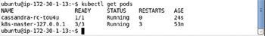

**Figure 8-9:**Listing Pod/s for Apache Cassandra

Describe the Cassandra service.

kubectl describe svc cassandra

An endpoint gets listed for the Pod as shown in [Figure 8-10](https://viewer.books24x7.com/assetviewer.aspx?bookid=113388&chunkid=175284627&resumebookmarkid=a546b65e-d1be-e911-b9b2-00505695593a). When the service description was listed before creating a replication controller, no endpoint got listed.

[Larger View](https://viewer.books24x7.com/assetviewer.aspx?bookid=113388&chunkid=175284627&resumebookmarkid=a546b65e-d1be-e911-b9b2-00505695593a)

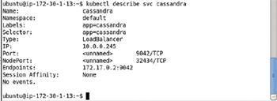

**Figure 8-10:**Describing the Service after creating the Replication Controller

In the preceding example we created a replication controller with the number of replicas set as 1. The replication controller does not have to create a replica to start with. To demonstrate we shall create the replication controller again, but with a different replicas setting. Delete the replication controller previously created.

kubectl delete rc cassandra-rc

Modify the cassandra-rc.yaml to set replicas field to 0 as shown in [Figure 8-11](https://viewer.books24x7.com/assetviewer.aspx?bookid=113388&chunkid=175284627&resumebookmarkid=a546b65e-d1be-e911-b9b2-00505695593a).

[Larger View](https://viewer.books24x7.com/assetviewer.aspx?bookid=113388&chunkid=175284627&resumebookmarkid=a546b65e-d1be-e911-b9b2-00505695593a)

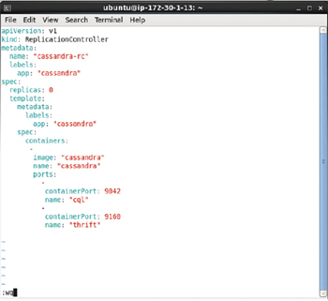

**Figure 8-11:**Setting Replicas to 0

Create the replication controller again with the modified definition file.

kubectl create -f cassandra-rc.yaml

Subsequently list the replicas.

kubectl get rc

The cassandra-rc replication controller gets created and gets listed as shown in [Figure 8-12](https://viewer.books24x7.com/assetviewer.aspx?bookid=113388&chunkid=175284627&resumebookmarkid=a546b65e-d1be-e911-b9b2-00505695593a).

[Larger View](https://viewer.books24x7.com/assetviewer.aspx?bookid=113388&chunkid=175284627&resumebookmarkid=a546b65e-d1be-e911-b9b2-00505695593a)

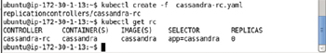

**Figure 8-12:**Creating the Replication Controller with Modified Definition File

List the Pods.

kubectl get pods

Because the replicas field is set to 0 the REPLICAS get listed as 0 as shown in [Figure 8-13](https://viewer.books24x7.com/assetviewer.aspx?bookid=113388&chunkid=175284627&resumebookmarkid=a546b65e-d1be-e911-b9b2-00505695593a).

[Larger View](https://viewer.books24x7.com/assetviewer.aspx?bookid=113388&chunkid=175284627&resumebookmarkid=a546b65e-d1be-e911-b9b2-00505695593a)

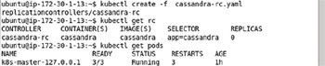

**Figure 8-13:**With Replicas as 0 no Pod gets created

**Scaling the Database**

Starting with the replication controller with 0 replicas created we shall scale up the cluster to a single replica. Run the following command to scale the Pod cluster to 1 replica.

kubectl scale rc cassandra-rc --replicas=1

Subsequently list the Pods.

kubectl get pods

The output from the preceding commands is shown in [Figure 8-14](https://viewer.books24x7.com/assetviewer.aspx?bookid=113388&chunkid=175284627&resumebookmarkid=a546b65e-d1be-e911-b9b2-00505695593a). A "scaled" output indicates that the cluster has been scaled. The single Pod could take a while (a few seconds) to get started and become ready.

[Larger View](https://viewer.books24x7.com/assetviewer.aspx?bookid=113388&chunkid=175284627&resumebookmarkid=a546b65e-d1be-e911-b9b2-00505695593a)

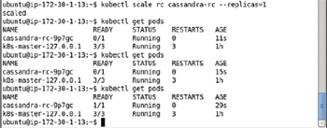

**Figure 8-14:**Scaling the Replication Controller to 1 Pod

Describe the cassandra service again.

kubectl describe svc cassandra

A single endpoint should get listed for the Pod added as shown in [Figure 8-15](https://viewer.books24x7.com/assetviewer.aspx?bookid=113388&chunkid=175284627&resumebookmarkid=a546b65e-d1be-e911-b9b2-00505695593a).

[Larger View](https://viewer.books24x7.com/assetviewer.aspx?bookid=113388&chunkid=175284627&resumebookmarkid=a546b65e-d1be-e911-b9b2-00505695593a)

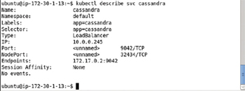

**Figure 8-15:**Describing the Service after Scaling the Cluster

**Describing the Pod**

To describe the Pod run the following command.

kubectl describe pod cassandra-rc-tou4u

Detailed information about the Pod such as name, namespace, image, node, labels, status, IP address, and events gets output as shown in [Figure 8-16](https://viewer.books24x7.com/assetviewer.aspx?bookid=113388&chunkid=175284627&resumebookmarkid=a546b65e-d1be-e911-b9b2-00505695593a). The Pod label is app=cassandra as specified in the replication controller definition file.

[Larger View](https://viewer.books24x7.com/assetviewer.aspx?bookid=113388&chunkid=175284627&resumebookmarkid=a546b65e-d1be-e911-b9b2-00505695593a)

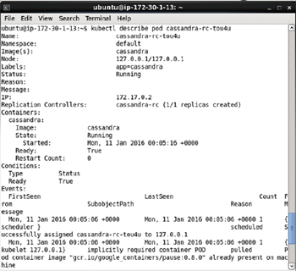

**Figure 8-16:**Describing the single Pod

**Starting an Interactive Shell**

As the "cassandra" Docker image inherits from the "debian" Docker image an interactive bash shell may be used to access a Docker container based on the cassandra image. To start an interactive bash shell to access the Cassandra server running in a Docker container, we need to obtain the container id. List the running containers.

sudo docker ps

All the running containers get listed as shown in [Figure 8-17](https://viewer.books24x7.com/assetviewer.aspx?bookid=113388&chunkid=175284627&resumebookmarkid=a546b65e-d1be-e911-b9b2-00505695593a). Copy the container id for the container for the cassandra image.

[Larger View](https://viewer.books24x7.com/assetviewer.aspx?bookid=113388&chunkid=175284627&resumebookmarkid=a546b65e-d1be-e911-b9b2-00505695593a)

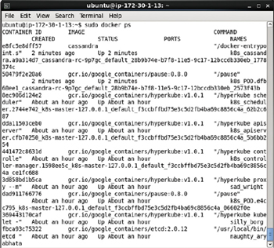

**Figure 8-17:**Listing the Docker Containers

Using the container id start an interactive bash shell.

sudo docker exec -it e8fc5e8ddff57 bash

An interactive shell gets started as shown in [Figure 8-18](https://viewer.books24x7.com/assetviewer.aspx?bookid=113388&chunkid=175284627&resumebookmarkid=a546b65e-d1be-e911-b9b2-00505695593a).

[Larger View](https://viewer.books24x7.com/assetviewer.aspx?bookid=113388&chunkid=175284627&resumebookmarkid=a546b65e-d1be-e911-b9b2-00505695593a)



**Figure 8-18:**Starting the Interactive Shell

**Starting the CQL Shell**

Cassandra Query Language (CQL) is the query language for Apache Cassandra. In the following sections we shall run CQL commands to create a keyspace and a table. Start the CQL Shell with the following command.

cqlsh

CQL Shell 5.0.1 gets started as shown in [Figure 8-19](https://viewer.books24x7.com/assetviewer.aspx?bookid=113388&chunkid=175284627&resumebookmarkid=a546b65e-d1be-e911-b9b2-00505695593a).

[Larger View](https://viewer.books24x7.com/assetviewer.aspx?bookid=113388&chunkid=175284627&resumebookmarkid=a546b65e-d1be-e911-b9b2-00505695593a)

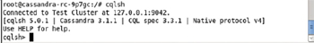

**Figure 8-19:**Starting the cqlsh Shell

**Creating a Keyspace**

Next, create a keyspace called CatalogKeyspace using the replication class as SimpleStrategy and replication factor as 3.

CREATE KEYSPACE CatalogKeyspace

WITH replication = {'class': 'SimpleStrategy', 'replication\_factor' : 3};

A keyspace gets created as shown in [Figure 8-20](https://viewer.books24x7.com/assetviewer.aspx?bookid=113388&chunkid=175284627&resumebookmarkid=a546b65e-d1be-e911-b9b2-00505695593a).

[Larger View](https://viewer.books24x7.com/assetviewer.aspx?bookid=113388&chunkid=175284627&resumebookmarkid=a546b65e-d1be-e911-b9b2-00505695593a)



**Figure 8-20:**Creating a Keyspace

**Altering a Keyspace**

A keyspace may be altered with the ALTER KEYSPACE command. Run the following command to alter the keyspace setting replication factor to 1.

ALTER KEYSPACE CatalogKeyspace

WITH replication = {'class': 'SimpleStrategy', 'replication\_factor' : 1};

Keyspace gets altered as shown in [Figure 8-21](https://viewer.books24x7.com/assetviewer.aspx?bookid=113388&chunkid=175284627&resumebookmarkid=a546b65e-d1be-e911-b9b2-00505695593a).

[Larger View](https://viewer.books24x7.com/assetviewer.aspx?bookid=113388&chunkid=175284627&resumebookmarkid=a546b65e-d1be-e911-b9b2-00505695593a)



**Figure 8-21:**Altering a Keyspace

**Using a Keyspace**

To use the CatalogKeyspace keyspace run the following command.

use CatalogKeyspace;

Keyspace CatalogKeyspace gets set as shown in [Figure 8-22](https://viewer.books24x7.com/assetviewer.aspx?bookid=113388&chunkid=175284627&resumebookmarkid=a546b65e-d1be-e911-b9b2-00505695593a).

[Larger View](https://viewer.books24x7.com/assetviewer.aspx?bookid=113388&chunkid=175284627&resumebookmarkid=a546b65e-d1be-e911-b9b2-00505695593a)



**Figure 8-22:**Setting a Keyspace to be used

**Creating a Table**

A table is also called a column family. Both CREATE TABLE and CREATE COLUMN FAMILYclauses may be used to create a table (column family). Create a table called catalog using the following CQL statement.

CREATE TABLE catalog(catalog\_id text,journal text,publisher text,edition text,title

text,author text,PRIMARY KEY (catalog\_id)) WITH compaction = { 'class' :

'LeveledCompactionStrategy' };

Add two rows of data to the table using the following CQL statements.

INSERT INTO catalog (catalog\_id, journal, publisher, edition,title,author) VALUES

('catalog1','Oracle Magazine', 'Oracle Publishing', 'November-December 2013', 'Engineering

as a Service','David A. Kelly') IF NOT EXISTS;

INSERT INTO catalog (catalog\_id, journal, publisher, edition,title,author) VALUES

('catalog2','Oracle Magazine', 'Oracle Publishing', 'November-December 2013',

'Quintessential and Collaborative','Tom Haunert') IF NOT EXISTS;

Output from the preceding commands is shown in [Figure 8-23](https://viewer.books24x7.com/assetviewer.aspx?bookid=113388&chunkid=175284627&resumebookmarkid=a546b65e-d1be-e911-b9b2-00505695593a). A Cassandra table gets created and two rows of data get added.

[Larger View](https://viewer.books24x7.com/assetviewer.aspx?bookid=113388&chunkid=175284627&resumebookmarkid=a546b65e-d1be-e911-b9b2-00505695593a)

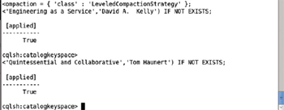

**Figure 8-23:**Creating an Apache Cassandra Table

Run the following CQL query statement to select data from the catalog table.

SELECT \* FROM catalog;

The two rows of data added gets listed as shown in [Figure 8-24](https://viewer.books24x7.com/assetviewer.aspx?bookid=113388&chunkid=175284627&resumebookmarkid=a546b65e-d1be-e911-b9b2-00505695593a).

[Larger View](https://viewer.books24x7.com/assetviewer.aspx?bookid=113388&chunkid=175284627&resumebookmarkid=a546b65e-d1be-e911-b9b2-00505695593a)

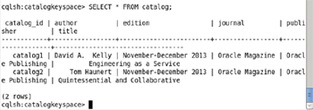

**Figure 8-24:**Querying an Apache Cassandra Table

**Deleting from a Table**

To delete row/s of data run a DELETE CQL statement. The primary key column value cannot be deleted with DELETE. Delete the other column values for the row with catalog\_id as 'catalog' with the following CQL statement.

DELETE journal, publisher, edition, title, author from catalog WHERE catalog\_id='catalog1';

Subsequently run the following CQL query to select data from the catalog table.

SELECT \* FROM catalog;

As shown in [Figure 8-25](https://viewer.books24x7.com/assetviewer.aspx?bookid=113388&chunkid=175284627&resumebookmarkid=a546b65e-d1be-e911-b9b2-00505695593a) only one complete row of data gets output. The other row lists only the catalog\_id column value, and all the other column values are null.

[Larger View](https://viewer.books24x7.com/assetviewer.aspx?bookid=113388&chunkid=175284627&resumebookmarkid=a546b65e-d1be-e911-b9b2-00505695593a)

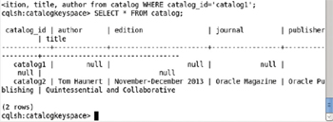

**Figure 8-25:**Querying Table after deleting Data from a Row

**Truncating a Table**

Truncating a table implies removing all table data including primary key column values. Run the following TRUNCATE CQL statement to remove all rows.

TRUNCATE catalog;

Subsequently run the CQL query statement again.

SELECT \* from catalog;

No rows get listed as shown in [Figure 8-26](https://viewer.books24x7.com/assetviewer.aspx?bookid=113388&chunkid=175284627&resumebookmarkid=a546b65e-d1be-e911-b9b2-00505695593a); not even null values are listed after running a TRUNCATE statement.

[Larger View](https://viewer.books24x7.com/assetviewer.aspx?bookid=113388&chunkid=175284627&resumebookmarkid=a546b65e-d1be-e911-b9b2-00505695593a)

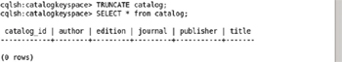

**Figure 8-26:**Querying a Table after Truncating a Table

**Dropping a Table and Keyspace**

To drop a table run the CQL statement with the DROP TABLE clause. The IF EXISTS clause drops the table if it exists but does not return an error if the table does not exist.

DROP TABLE IF EXISTS catalog;

Drop the CatalogKeyspace keyspace using the DROP KEYSPACE clause statement. The IF EXISTS clause drops the keyspace if it exists but does not return an error if the keyspace does not exist.

DROP KEYSPACE IF EXISTS CatalogKeyspace;

To verify that the keyspace CatalogKeyspace has been removed, run the following statement.

use CatalogKeyspace;

As the CatalogKeyspace keyspace does not exist an error gets generated as shown in [Figure 8-27](https://viewer.books24x7.com/assetviewer.aspx?bookid=113388&chunkid=175284627&resumebookmarkid=a546b65e-d1be-e911-b9b2-00505695593a).

[Larger View](https://viewer.books24x7.com/assetviewer.aspx?bookid=113388&chunkid=175284627&resumebookmarkid=a546b65e-d1be-e911-b9b2-00505695593a)

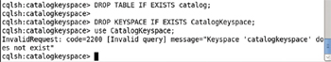

**Figure 8-27:**Dropping a Table

**Creating a Volume**

In [chapter 7](http://viewer.books24x7.com/assetviewer.aspx?bkid=113388&destid=526#526) we introduced volumes, how they are mounted into a Pod using volume mounts, and how they are accessed within a container. We introduced various types of volumes and demonstrated the emptyDir type of volume. In this section we shall use another type of volume, the hostPath volume. The hostPath volume mounts a directory from the host into the Pod. All containers in the Pod and all Pods based on a Pod template using a hostPath type of volume may access the directory on the host. As a modification of the replication controller used earlier, we shall add a volume of type hostPath to the cassandra-rc.yaml file. For example, if the host directory /cassandra/data is to be mounted in a Pod add the following volume in the spec- > template field.

volumes:

-

hostPath:

path: /cassandra/data

name: cassandra-storage

The volume is mounted in the Pod using the same fields as a emptyDir volume. The modified cassandra-rc.yaml is listed.

apiVersion: v1

kind: ReplicationController

metadata:

name: cassandra-rc

labels:

app: cassandra

spec:

replicas: 1

template:

metadata:

labels:

app: cassandra

spec:

containers:

-

image: cassandra

name: cassandra

ports:

-

containerPort: 9042

name: cql

-

containerPort: 9160

name: thrift

volumeMounts:

-

mountPath: /cassandra/data

name: cassandra-storage

volumes:

-

hostPath:

path: /cassandra/data

name: cassandra-storage

The cassandra-rc.yaml definition file maybe edited invi editor and savedwith the :wq command as shown in [Figure 8-28](https://viewer.books24x7.com/assetviewer.aspx?bookid=113388&chunkid=175284627&resumebookmarkid=a546b65e-d1be-e911-b9b2-00505695593a). It is recommended to add quotes in field values.

[Larger View](https://viewer.books24x7.com/assetviewer.aspx?bookid=113388&chunkid=175284627&resumebookmarkid=a546b65e-d1be-e911-b9b2-00505695593a)

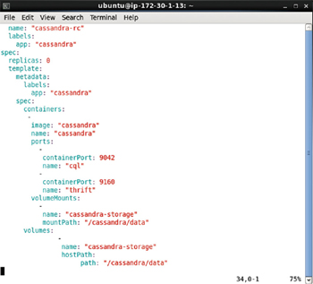

**Figure 8-28:**Replication Controller Definition File with a Volume of type hostPath

The host directory that is mounted into a Pod has to pre-exist. Create the /cassandra/datadirectory and set its permissions to global (777).

sudo mkdir –p /cassandra/data

sudo chmod –R 777 /cassandra/data

The output from the preceding commands is shown in [Figure 8-29](https://viewer.books24x7.com/assetviewer.aspx?bookid=113388&chunkid=175284627&resumebookmarkid=a546b65e-d1be-e911-b9b2-00505695593a). The /cassandra/datadirectory gets created.

[Larger View](https://viewer.books24x7.com/assetviewer.aspx?bookid=113388&chunkid=175284627&resumebookmarkid=a546b65e-d1be-e911-b9b2-00505695593a)



**Figure 8-29:**Creating the Directory for the Volume

Change directory (cd) to the /cassandra/data directory on the host.

cd /cassandra/data

List the files and directories in the /cassandra/data directory.

ls –l

Initially the /cassandra/data is empty as shown in [Figure 8-30](https://viewer.books24x7.com/assetviewer.aspx?bookid=113388&chunkid=175284627&resumebookmarkid=a546b65e-d1be-e911-b9b2-00505695593a). Add a sample file, cassandra.txt, to the directory with the vi editor. Subsequently list the directory files and directories again.

vi cassandra.txt

ls –l

As shown in [Figure 8-30](https://viewer.books24x7.com/assetviewer.aspx?bookid=113388&chunkid=175284627&resumebookmarkid=a546b65e-d1be-e911-b9b2-00505695593a) the cassandra.txt file gets listed. What the hostPath volume does is to make the /cassandra/data directory available to all containers in the Pod.

[Larger View](https://viewer.books24x7.com/assetviewer.aspx?bookid=113388&chunkid=175284627&resumebookmarkid=a546b65e-d1be-e911-b9b2-00505695593a)

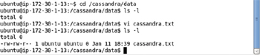

**Figure 8-30:**Adding a file in the hostPath Volume Directory

Create a replication controller as discussed for the definition file used previously. One Pod should get created. List the Docker containers.

sudo docker ps

Copy the container id for the Docker container for image "cassandra" as shown in [Figure 8-31](https://viewer.books24x7.com/assetviewer.aspx?bookid=113388&chunkid=175284627&resumebookmarkid=a546b65e-d1be-e911-b9b2-00505695593a).

[Larger View](https://viewer.books24x7.com/assetviewer.aspx?bookid=113388&chunkid=175284627&resumebookmarkid=a546b65e-d1be-e911-b9b2-00505695593a)

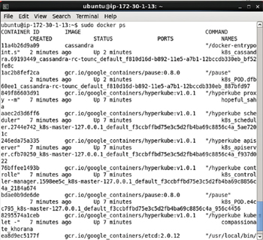

**Figure 8-31:**Listing the Docker Containers

Using the container id start an interactive shell.

sudo docker exec -it 11a4b26d9a09 bash

The interactive shell gets started as shown in [Figure 8-32](https://viewer.books24x7.com/assetviewer.aspx?bookid=113388&chunkid=175284627&resumebookmarkid=a546b65e-d1be-e911-b9b2-00505695593a).

[Larger View](https://viewer.books24x7.com/assetviewer.aspx?bookid=113388&chunkid=175284627&resumebookmarkid=a546b65e-d1be-e911-b9b2-00505695593a)



**Figure 8-32:**Starting an Interactive Shell

Change directory (cd) to the /cassandra/data directory and list the files in the directory.

cd /cassandra/data

ls –l

As shown in [Figure 8-33](https://viewer.books24x7.com/assetviewer.aspx?bookid=113388&chunkid=175284627&resumebookmarkid=a546b65e-d1be-e911-b9b2-00505695593a) the cassandra.txt file gets listed. The /cassandra/data directory exists on the host but is accessible from a container.

[Larger View](https://viewer.books24x7.com/assetviewer.aspx?bookid=113388&chunkid=175284627&resumebookmarkid=a546b65e-d1be-e911-b9b2-00505695593a)

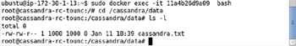

**Figure 8-33:**Accessing the Volume in a Docker Container

Similarly volumes of other types could be created. Following is the volumeMounts and volumes fields settings for a AWS Volume. The volumeID field has the format aws://zone/volume id.

volumeMounts:

-

mountPath: /aws-ebs

name: aws-volume

volumes:

-

name: aws-volume

awsElasticBlockStore:

volumeID: aws://us-east-ib/vol-428ba3ae

fsType: ext4

A more complete cassandra-rc.yaml file is shown in [Figure 8-34](https://viewer.books24x7.com/assetviewer.aspx?bookid=113388&chunkid=175284627&resumebookmarkid=a546b65e-d1be-e911-b9b2-00505695593a).

[Larger View](https://viewer.books24x7.com/assetviewer.aspx?bookid=113388&chunkid=175284627&resumebookmarkid=a546b65e-d1be-e911-b9b2-00505695593a)

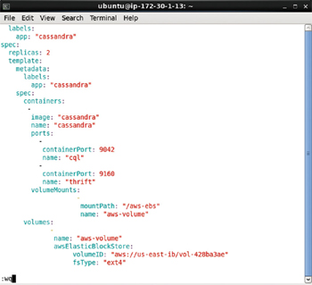

**Figure 8-34:**Volume of type awsElasticBlockStore in a Replication Controller Definition File

**Creating a Cassandra Cluster Imperatively**

If the default settings for most of the fields are to be used, creating a replication controller imperatively is the better option.

**Creating a Replication Controller**

To create a replication controller on the command line use the kubectl run command. For a replication controller based on the Docker image "cassandra" run the following command in which replication controller name is "cassandra" and port is 9042. The replicas is set to 1, also the default value.

kubectl run cassandra --image=cassandra --replicas=1 --port=9042

Subsequently list the replication controllers.

kubectl get rc

The "cassandra" replication controller gets created and get listed as shown in [Figure 8-35](https://viewer.books24x7.com/assetviewer.aspx?bookid=113388&chunkid=722450438&resumebookmarkid=a546b65e-d1be-e911-b9b2-00505695593a).

[Larger View](https://viewer.books24x7.com/assetviewer.aspx?bookid=113388&chunkid=722450438&resumebookmarkid=a546b65e-d1be-e911-b9b2-00505695593a)

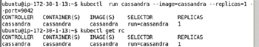

**Figure 8-35:**Creating a Replication Controller Imperatively

To list the Pods run the following command.

kubectl get pods

The single Pod created gets listed as shown in [Figure 8-36](https://viewer.books24x7.com/assetviewer.aspx?bookid=113388&chunkid=722450438&resumebookmarkid=a546b65e-d1be-e911-b9b2-00505695593a).

[Larger View](https://viewer.books24x7.com/assetviewer.aspx?bookid=113388&chunkid=722450438&resumebookmarkid=a546b65e-d1be-e911-b9b2-00505695593a)

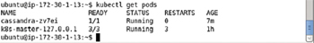

**Figure 8-36:**Listing the single Pod

To describe the replication controller run the following command.

kubectl describe rc cassandra

The replication controller's name, namespace, image, selector, labels, replicas, pod status, and events get listed as shown in [Figure 8-37](https://viewer.books24x7.com/assetviewer.aspx?bookid=113388&chunkid=722450438&resumebookmarkid=a546b65e-d1be-e911-b9b2-00505695593a). The selector defaults to "run=cassandra" for the cassandra replication controller.

[Larger View](https://viewer.books24x7.com/assetviewer.aspx?bookid=113388&chunkid=722450438&resumebookmarkid=a546b65e-d1be-e911-b9b2-00505695593a)

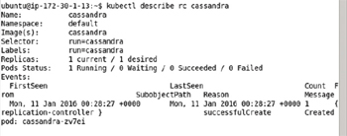

**Figure 8-37:**Describing the Replication Controller

**Creating a Service**

To expose the replication controller cassandra as a service, run the kubectl exposecommand. The port is required to be specified and is set to 9042 for the service.

kubectl expose rc cassandra --port=9042 --type=LoadBalancer

The cassandra service gets created as shown in [Figure 8-38](https://viewer.books24x7.com/assetviewer.aspx?bookid=113388&chunkid=722450438&resumebookmarkid=a546b65e-d1be-e911-b9b2-00505695593a).

[Larger View](https://viewer.books24x7.com/assetviewer.aspx?bookid=113388&chunkid=722450438&resumebookmarkid=a546b65e-d1be-e911-b9b2-00505695593a)

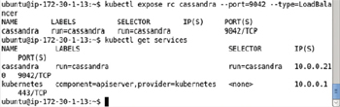

**Figure 8-38:**Creating a Service for Apache Cassandra Imperatively

Describe the service with the following command.

kubectl describe service cassandra

As shown in [Figure 8-39](https://viewer.books24x7.com/assetviewer.aspx?bookid=113388&chunkid=722450438&resumebookmarkid=a546b65e-d1be-e911-b9b2-00505695593a) the service name, namespace, labels, selector, type, IP, Port, NodePort, and Endpoint get listed. The service selector run=cassandra must be the same as the label on the Pod to manage.

[Larger View](https://viewer.books24x7.com/assetviewer.aspx?bookid=113388&chunkid=722450438&resumebookmarkid=a546b65e-d1be-e911-b9b2-00505695593a)

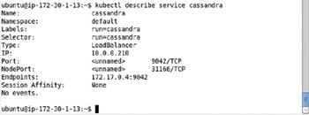

**Figure 8-39:**Describing the Service

**Scaling the Database**

To scale the cluster, run the kubectl scale command. An important reason, to scale the Cassandra replication controller is to run more Cassandra nodes and have them join the cluster, and we demonstrated scaling up a cluster. But it is not always necessary to scale up a cluster. A cluster may also be scaled down. To scale down the cluster to 0 replicas run the following command.

kubectl scale rc cassandra --replicas=0

A output of "scaled" in [Figure 8-40](https://viewer.books24x7.com/assetviewer.aspx?bookid=113388&chunkid=722450438&resumebookmarkid=a546b65e-d1be-e911-b9b2-00505695593a) indicates that the cluster has been scaled down.

[Larger View](https://viewer.books24x7.com/assetviewer.aspx?bookid=113388&chunkid=722450438&resumebookmarkid=a546b65e-d1be-e911-b9b2-00505695593a)



**Figure 8-40:**Scaling Down the Database Cluster to 0 Replicas

List the Pods.

kubectl get pods

No pod gets listed as shown in [Figure 8-41](https://viewer.books24x7.com/assetviewer.aspx?bookid=113388&chunkid=722450438&resumebookmarkid=a546b65e-d1be-e911-b9b2-00505695593a).

[Larger View](https://viewer.books24x7.com/assetviewer.aspx?bookid=113388&chunkid=722450438&resumebookmarkid=a546b65e-d1be-e911-b9b2-00505695593a)

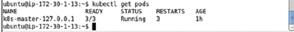

**Figure 8-41:**Listing the Pods after Scaling Down

List the services with the following command.

kubectl get services

Scaling the cluster to 0 replicas would leave no Pod for the service to manage but the service is still running as shown in [Figure 8-42](https://viewer.books24x7.com/assetviewer.aspx?bookid=113388&chunkid=722450438&resumebookmarkid=a546b65e-d1be-e911-b9b2-00505695593a).

[Larger View](https://viewer.books24x7.com/assetviewer.aspx?bookid=113388&chunkid=722450438&resumebookmarkid=a546b65e-d1be-e911-b9b2-00505695593a)

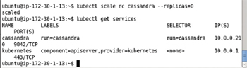

**Figure 8-42:**Listing the Services after Scaling Down

But the service does not have any endpoint associated with it as shown with the kubectl describe command in [Figure 8-43](https://viewer.books24x7.com/assetviewer.aspx?bookid=113388&chunkid=722450438&resumebookmarkid=a546b65e-d1be-e911-b9b2-00505695593a).

[Larger View](https://viewer.books24x7.com/assetviewer.aspx?bookid=113388&chunkid=722450438&resumebookmarkid=a546b65e-d1be-e911-b9b2-00505695593a)

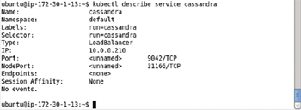

**Figure 8-43:**Describing the Service after Scaling Down

**Deleting the Replication Controller and Service**

To delete the replication controller "cassandra" run the following command.

kubectl delete rc cassandra

Subsequently list the replication controllers.

kubectl get rc

To delete the service "cassandra" run the following command.

kubectl delete service cassandra

Subsequently list the services.

kubectl get services

The output from the preceding commands is shown in [Figure 8-44](https://viewer.books24x7.com/assetviewer.aspx?bookid=113388&chunkid=722450438&resumebookmarkid=a546b65e-d1be-e911-b9b2-00505695593a). The replication controller and service get deleted and do not get listed.

[Larger View](https://viewer.books24x7.com/assetviewer.aspx?bookid=113388&chunkid=722450438&resumebookmarkid=a546b65e-d1be-e911-b9b2-00505695593a)

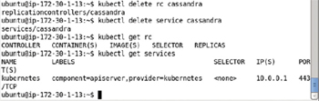

**Figure 8-44:**Deleting the Replication Controller and the Service

### Summary

In this chapter we used Kubernetes to create an Apache Cassandra cluster. We used both the declarative and imperative approaches. We introduced the volumes in the previous chapter and in this chapter we discussed using two other types of volumes: hostPath and AWS Volume. We scaled the cluster not only up but also down. We demonstrated that a replication controller does not require a Pod to be running and could specify 0 replicas. In the next chapter we shall discuss using Kubernetes cluster manager with another NoSQL database, Couchbase.

**Kubernetes Microservices with Docker**

Chapter 9 - Using Couchbase

Apress © 2016

## Chapter 9: Using Couchbase

**© Deepak Vohra 2016  
D. Vohra, *Kubernetes Microservices with Docker*, DOI 10.1007/978-1-4842-1907-2\_9**

### Overview

Couchbase is a distributed NoSQL database based on the JSON data model. Couchbase is faster than MongoDB and Apache Cassandra. Couchbase offers some features not available in MongoDB and Cassandra such as a Graphical User Interface (GUI), the Couchbase Web Console. Couchbase also provides command-line tools such as couchbase-cli, cbbackup, cbrestore, and cbtransfer. Couchbase, being a distributed database, could benefit from the cluster management provided by Kubernetes cluster manager, which is what we shall discuss in this chapter.

**Setting the Environment**

We have used an Ubuntu instance on Amazon EC2 created using the same AMI as used in the other chapters, the Ubuntu Server 14.04 LTS (HVM), SSD Volume Type - ami-d05e75b8. If an instance created from the AMI already exists the same may be used. The following software is required for this chapter.

* -Docker Engine (latest version)
* -Kubernetes (version 1.01)
* -Kubectl (version 1.01)
* -Docker image for Couchbase (latest version)

First, we need to log in to the Ubuntu instance. Obtain the Public IP Address of the Ubuntu instance from the Amazon EC2 instance console as shown in [Figure 9-1](https://viewer.books24x7.com/assetviewer.aspx?bookid=113388&chunkid=865224196&resumebookmarkid=a546b65e-d1be-e911-b9b2-00505695593a).

[Larger View](https://viewer.books24x7.com/assetviewer.aspx?bookid=113388&chunkid=865224196&resumebookmarkid=a546b65e-d1be-e911-b9b2-00505695593a)

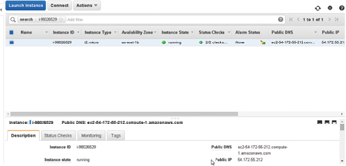

**Figure 9-1:**Getting Public IP Address

Use the Public IP Address log in to the Ubuntu instance.

ssh -i "docker.pem" ubuntu@54.172.55.212

The Ubuntu instance gets logged into as shown in [Figure 9-2](https://viewer.books24x7.com/assetviewer.aspx?bookid=113388&chunkid=865224196&resumebookmarkid=a546b65e-d1be-e911-b9b2-00505695593a).

[Larger View](https://viewer.books24x7.com/assetviewer.aspx?bookid=113388&chunkid=865224196&resumebookmarkid=a546b65e-d1be-e911-b9b2-00505695593a)

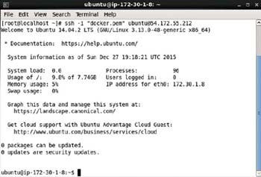

**Figure 9-2:**Logging into Ubuntu Instance on Amazon EC2

Start the Docker Engine and verify its status.

sudo service docker start

sudo service docker status

Docker engine should be listed as running as shown in [Figure 9-3](https://viewer.books24x7.com/assetviewer.aspx?bookid=113388&chunkid=865224196&resumebookmarkid=a546b65e-d1be-e911-b9b2-00505695593a).

[Larger View](https://viewer.books24x7.com/assetviewer.aspx?bookid=113388&chunkid=865224196&resumebookmarkid=a546b65e-d1be-e911-b9b2-00505695593a)

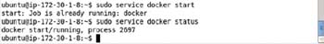

**Figure 9-3:**Starting Docker Engine

List the running services.

kubectl get services

The kubernetes service should be listed as running as shown in [Figure 9-4](https://viewer.books24x7.com/assetviewer.aspx?bookid=113388&chunkid=865224196&resumebookmarkid=a546b65e-d1be-e911-b9b2-00505695593a).

[Larger View](https://viewer.books24x7.com/assetviewer.aspx?bookid=113388&chunkid=865224196&resumebookmarkid=a546b65e-d1be-e911-b9b2-00505695593a)

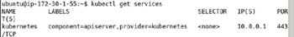

**Figure 9-4:**Listing the "kubernetes" Service

List the nodes.

kubectl get nodes

The node should be listed with STATUS "Ready" as shown in [Figure 9-5](https://viewer.books24x7.com/assetviewer.aspx?bookid=113388&chunkid=865224196&resumebookmarkid=a546b65e-d1be-e911-b9b2-00505695593a).

[Larger View](https://viewer.books24x7.com/assetviewer.aspx?bookid=113388&chunkid=865224196&resumebookmarkid=a546b65e-d1be-e911-b9b2-00505695593a)



**Figure 9-5:**Listing the Single Node

**Creating a Couchbase Cluster Declaratively**

In the following subsections we shall create a Couchbase Pod, a replication controller, and a service all using definition files.

**Creating a Pod**

A Pod definition file is used to create a single Pod. A Pod could have 0 or more container configurations. Create a definition file couchbase.yaml. Add the following ([Table 9-1](https://viewer.books24x7.com/assetviewer.aspx?bookid=113388&chunkid=568365072&resumebookmarkid=a546b65e-d1be-e911-b9b2-00505695593a)) fields to the definition file.

**Table 9-1: Pod Definition File Fields**[[](https://viewer.books24x7.com/outputobject.aspx?bookid=113388&chunkid=568365072&objectid=ch9_tab1&objecttype=spreadsheet) Open table as spreadsheet](https://viewer.books24x7.com/outputobject.aspx?bookid=113388&chunkid=568365072&objectid=ch9_tab1&objecttype=spreadsheet" \t "_blank)

| **Field** | **Description** | **Value** |
| --- | --- | --- |
| apiVersion |  | v1 |
| kind | The kind of definition file. | Pod |
| metadata | The Pod metadata. |  |
| metadata - > labels | The Pod labels. A service selector makes use of the labels to select the Pods to manage. | app: couchbaseApp |
| metadata - > name | The Pod name. | couchbase |
| spec | The Pod specification. |  |
| spec - > containers | The containers in the Pod. |  |
| spec - > containers - > image | A container image. For Couchbase server the image is "couchbase." | couchbase |
| spec - > containers - > name | The container name. | couchbase |
| spec - > containers - > ports | The container ports. |  |
| spec - > containers - > ports - > containerPort | A container port for Couchbase server. | 8091 |

The couchbase.yaml definition file is listed.

pra

apiVersion: v1

kind: Pod

metadata:

labels:

app: couchbaseApp

name: couchbase

spec:

containers:

-

image: couchbase

name: couchbase

ports:

-

containerPort: 8091

The couchbase.yaml file could be created in the vi editor and saved with the :wq command as shown in [Figure 9-6](https://viewer.books24x7.com/assetviewer.aspx?bookid=113388&chunkid=568365072&resumebookmarkid=a546b65e-d1be-e911-b9b2-00505695593a).

[Larger View](https://viewer.books24x7.com/assetviewer.aspx?bookid=113388&chunkid=568365072&resumebookmarkid=a546b65e-d1be-e911-b9b2-00505695593a)

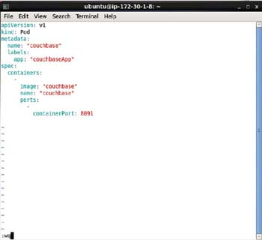

**Figure 9-6:**Pod Definition file couchbase.yaml in vi Editor

Run the following command to create a Pod from the definition file.

kubectl create -f couchbase.yaml

A Pod gets created as indicated by the "pods/couchbase" output in [Figure 9-7](https://viewer.books24x7.com/assetviewer.aspx?bookid=113388&chunkid=568365072&resumebookmarkid=a546b65e-d1be-e911-b9b2-00505695593a).

[Larger View](https://viewer.books24x7.com/assetviewer.aspx?bookid=113388&chunkid=568365072&resumebookmarkid=a546b65e-d1be-e911-b9b2-00505695593a)

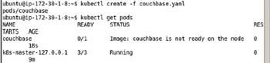

**Figure 9-7:**Creating a Pod from the Definition File

Subsequently list the Pods.

kubectl get pods

A Pod called "couchbase" gets listed as shown in [Figure 9-7](https://viewer.books24x7.com/assetviewer.aspx?bookid=113388&chunkid=568365072&resumebookmarkid=a546b65e-d1be-e911-b9b2-00505695593a). Initially the STATUS could be different from "Running" and the READY column could be not ready; 1/1 is ready state and 0/1 is not ready.

Run the following command again after a few more seconds.

kubectl get pods

The couchbase Pod is listed as "Running" and READY- > 1/1 as shown in [Figure 9-8](https://viewer.books24x7.com/assetviewer.aspx?bookid=113388&chunkid=568365072&resumebookmarkid=a546b65e-d1be-e911-b9b2-00505695593a).

[Larger View](https://viewer.books24x7.com/assetviewer.aspx?bookid=113388&chunkid=568365072&resumebookmarkid=a546b65e-d1be-e911-b9b2-00505695593a)

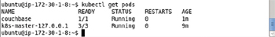

**Figure 9-8:**Listing the couchbase Pod

**Creating a Service**

In this section we shall create a service using a service definition file. Create a couchbase-service.yaml file and add the following ([Table 9-2](https://viewer.books24x7.com/assetviewer.aspx?bookid=113388&chunkid=568365072&resumebookmarkid=a546b65e-d1be-e911-b9b2-00505695593a)) fields to the file.

**Table 9-2: Service Definition File couchbase-service.yaml**[[](https://viewer.books24x7.com/outputobject.aspx?bookid=113388&chunkid=568365072&objectid=ch9_tab2&objecttype=spreadsheet) Open table as spreadsheet](https://viewer.books24x7.com/outputobject.aspx?bookid=113388&chunkid=568365072&objectid=ch9_tab2&objecttype=spreadsheet" \t "_blank)

| **Field** | **Description** | **Value** |
| --- | --- | --- |
| apiVersion |  | v1 |
| kind | The kind of definition file. | Service |
| metadata | The service metadata. |  |
| metadata - > labels | The service labels. | app: couchbaseApp |
| metadata - > name | The service name. | couchbase |
| spec | The service specification. |  |
| spec - > ports | The ports exposed by the service. |  |
| spec - > ports - > port | A port exposed by the service. | 8091 |
| spec - > ports - > targetPort | The target port for the service, which could be a port number or the name of a port on the backend. The target port setting adds flexibility as the port number could be modified while the port name is kept fixed. | 8091 |
| spec - > selector | The Pod selector, which could be one or more label key:value expressions/labels. All of the key:value expressions in a selector must match with a Pod's labels for the Pod to be selected by the service. A Pod could have additional labels but must include labels in the selector to be selected by the service. Service routes traffic to the Pods with label/s matching the selector expression/s. Only a single selector expression is used in the example service definition file. If the selector is empty all Pods are selected. The app: couchbaseApp setting defaults to selector app = couchbaseApp. | app: couchbaseApp |
| spec - > selector - > type | The service type. | LoadBalancer |

The couchbase-service.yaml is listed.

apiVersion: v1

kind: Service

metadata:

labels:

app: couchbaseApp

name: couchbase

spec:

ports:

-

port: 8091

targetPort: 8091

selector:

app: couchbaseApp

type: LoadBalancer

Create a service from the definition file with the following command.

kubectl create -f couchbase-service.yaml

Subsequently list the running services.

kubectl get services

An output of "services/couchbase" as shown in [Figure 9-9](https://viewer.books24x7.com/assetviewer.aspx?bookid=113388&chunkid=568365072&resumebookmarkid=a546b65e-d1be-e911-b9b2-00505695593a) indicates that the couchbaseservice has been created. The "couchbase" service gets listed, also shown in [Figure 9-9](https://viewer.books24x7.com/assetviewer.aspx?bookid=113388&chunkid=568365072&resumebookmarkid=a546b65e-d1be-e911-b9b2-00505695593a).

[Larger View](https://viewer.books24x7.com/assetviewer.aspx?bookid=113388&chunkid=568365072&resumebookmarkid=a546b65e-d1be-e911-b9b2-00505695593a)

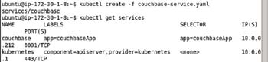

**Figure 9-9:**Listing the couchbase Service

List the service endpoints with the following command.

kubectl get endpoints

The service endpoint for the couchbase service gets listed as shown in [Figure 9-10](https://viewer.books24x7.com/assetviewer.aspx?bookid=113388&chunkid=568365072&resumebookmarkid=a546b65e-d1be-e911-b9b2-00505695593a).

[Larger View](https://viewer.books24x7.com/assetviewer.aspx?bookid=113388&chunkid=568365072&resumebookmarkid=a546b65e-d1be-e911-b9b2-00505695593a)

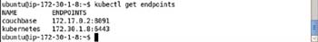

**Figure 9-10:**Listing the Endpoints

**Creating a Replication Controller**

In this section we shall create a replication controller using a definition file. Create a couchbase-rc.yaml file and add the following ([Table 9-3](https://viewer.books24x7.com/assetviewer.aspx?bookid=113388&chunkid=568365072&resumebookmarkid=a546b65e-d1be-e911-b9b2-00505695593a)) fields to the file.

**Table 9-3: Definition File for Replication Controller**[[](https://viewer.books24x7.com/outputobject.aspx?bookid=113388&chunkid=568365072&objectid=ch9_tab3&objecttype=spreadsheet) Open table as spreadsheet](https://viewer.books24x7.com/outputobject.aspx?bookid=113388&chunkid=568365072&objectid=ch9_tab3&objecttype=spreadsheet" \t "_blank)

| **Field** | **Description** | **Value** | **Required Field (includes default settings)** |
| --- | --- | --- | --- |
| apiVersion |  | v1 | yes |
| kind | The kind of definition file. | ReplicationController | yes |
| metadata | The replication controller metadata. |  | yes |
| metadata - > labels | The replication controller labels. | app: couchbaseApp | no |
| metadata - > name | The replication controller name. | couchbase | yes |
| spec | The replication controller specification. |  | yes |
| spec - > replicas | The number of Pod replicas. Defaults to 1 replica. | 2 | yes |
| spec - > selector | One or more key:value expressions for selecting the Pods to manage. Pods that include label/s with the same expression/s as the selector expression/s are managed by the replication controller. A Pod could include additional labels but must include the ones in the selector to be managed by the replication controller. The selector defaults to the spec - > template - > metadata - > labels key:value expression/s if not specified. A setting of app: couchbaseApp translates to selector app = couchbaseApp. | app: couchbaseApp | yes |
| spec - > template | The Pod template. |  | yes |
| spec - > template - > metadata | The Pod template metadata. |  | yes |
| spec - > template - > metadata - > labels | The Pod template labels. | app: couchbaseApp | yes |
| spec - > template - > spec | The Pod template specification. |  | yes |
| spec - > template - > spec - > containers | The containers configuration for the Pod template. |  | yes |
| spec - > template - > spec - > containers - > image | The Docker image. | couchbase | yes |
| spec - > template - > spec - > containers - > name | The container name. | couchbase | yes |
| spec - > template - > spec - > containers - > ports | The container ports. |  | no |
| spec - > template - > spec - > containers - > ports - > containerPort | A container port. | 8091 | no |

The couchbase-rc.yaml is listed.

apiVersion: v1

kind: ReplicationController

metadata:

labels:

app: couchbaseApp

name: couchbase

spec:

replicas: 2

selector:

app: couchbaseApp

template:

metadata:

labels:

app: couchbaseApp

spec:

containers:

-

image: couchbase

name: couchbase

ports:

-

containerPort: 8091

The couchbase-rc.yaml may be created in vi editor as shown in [Figure 9-11](https://viewer.books24x7.com/assetviewer.aspx?bookid=113388&chunkid=568365072&resumebookmarkid=a546b65e-d1be-e911-b9b2-00505695593a).

[Larger View](https://viewer.books24x7.com/assetviewer.aspx?bookid=113388&chunkid=568365072&resumebookmarkid=a546b65e-d1be-e911-b9b2-00505695593a)

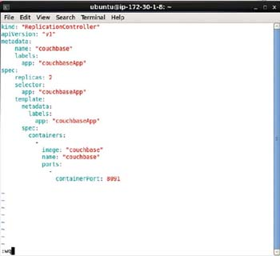

**Figure 9-11:**Replication Controller Definition File couchbase-rc.yaml in vi Editor

Create the replication controller with the following command.

kubectl create -f couchbase-rc.yaml

Subsequently, list the replication controllers.

kubectl get rc

An output of "replicationcontrollers/couchbase" as shown in [Figure 9-12](https://viewer.books24x7.com/assetviewer.aspx?bookid=113388&chunkid=568365072&resumebookmarkid=a546b65e-d1be-e911-b9b2-00505695593a) indicates that the "couchbase" replication controller has been created. The "couchbase" replication controller gets listed with the second command. The REPLICAS is listed as 2, but it does not imply that the replication controller created two new replicas. The replication controller manages Pods based on selector expression matching a Pod label. If some other Pod with the matching label is already running it is counted toward the replicas setting.

[Larger View](https://viewer.books24x7.com/assetviewer.aspx?bookid=113388&chunkid=568365072&resumebookmarkid=a546b65e-d1be-e911-b9b2-00505695593a)

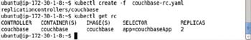

**Figure 9-12:**Creating and listing a Replication Controller from the Definition File

**Listing the Pods**

To list the Pods run the following command.

kubectl get pods

Two Pods get listed as shown in [Figure 9-13](https://viewer.books24x7.com/assetviewer.aspx?bookid=113388&chunkid=568365072&resumebookmarkid=a546b65e-d1be-e911-b9b2-00505695593a), and one of the Pods is the Pod created earlier using a Pod definition file. The label in the Pod definition file was app: "couchbaseApp," which is also the selector expression for the replication controller. The expression app: "couchbaseApp" translates to app= couchbaseApp. As a result only one new Pod gets created when the replication controller with replicas

[Larger View](https://viewer.books24x7.com/assetviewer.aspx?bookid=113388&chunkid=568365072&resumebookmarkid=a546b65e-d1be-e911-b9b2-00505695593a)

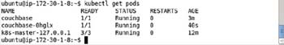

**Figure 9-13:**Listing the Pods for Couchbase Server

**Listing the Logs**

To list the logs for a Pod run the kubectl logs command. The pod name may be copied from the preceding listing of Pods.

kubectl logs couchbase-0hglx

The output is shown in [Figure 9-14](https://viewer.books24x7.com/assetviewer.aspx?bookid=113388&chunkid=568365072&resumebookmarkid=a546b65e-d1be-e911-b9b2-00505695593a). The output indicates that the WEB UI is available at http://<ip>:8091.

[Larger View](https://viewer.books24x7.com/assetviewer.aspx?bookid=113388&chunkid=568365072&resumebookmarkid=a546b65e-d1be-e911-b9b2-00505695593a)



**Figure 9-14:**Listing Pod Logs

**Describing the Service**

To describe the couchbase service run the following command.

kubectl describe svc couchbase

The service name, namespace, labels, selector, type, IP, Port, NodePort, and endpoints get listed as shown in [Figure 9-15](https://viewer.books24x7.com/assetviewer.aspx?bookid=113388&chunkid=568365072&resumebookmarkid=a546b65e-d1be-e911-b9b2-00505695593a). The selector is listed as app=couchbaseApp.

[Larger View](https://viewer.books24x7.com/assetviewer.aspx?bookid=113388&chunkid=568365072&resumebookmarkid=a546b65e-d1be-e911-b9b2-00505695593a)

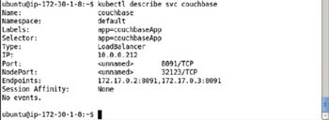

**Figure 9-15:**Describing the Service for Couchbase

**Listing the Endpoints**

List the endpoints again.

kubectl get endpoints

When the endpoints were listed earlier only one endpoint was listed because only one Pod was running. With two Pods running two endpoints get listed as shown in [Figure 9-16](https://viewer.books24x7.com/assetviewer.aspx?bookid=113388&chunkid=568365072&resumebookmarkid=a546b65e-d1be-e911-b9b2-00505695593a).

[Larger View](https://viewer.books24x7.com/assetviewer.aspx?bookid=113388&chunkid=568365072&resumebookmarkid=a546b65e-d1be-e911-b9b2-00505695593a)

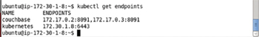

**Figure 9-16:**Listing the Endpoints for Couchbase

**Setting Port Forwarding**

When we listed the logs for a Couchbase Pod the URL to invoke the web console was listed as http://<ip>:8091. The < ip > is the service endpoint of the Pod. The previous section listed two service endpoints. Invoking either of these on a host browser, for example, [http://172.17.0.2:8091](http://172.17.0.2:8091/) would open the web console. An Amazon EC2 Ubuntu instance does not install a web browser by default. Alternatively, we shall set port forwarding to a local machine and open the web console from a browser on a local machine, which is required to have a browser available. To set port forwarding we need to know the Public DNS of the Amazon EC2 instance running Kubernetes. The Public DNS may be obtained from the Amazon EC2 console as shown in [Figure 9-17](https://viewer.books24x7.com/assetviewer.aspx?bookid=113388&chunkid=568365072&resumebookmarkid=a546b65e-d1be-e911-b9b2-00505695593a).

[Larger View](https://viewer.books24x7.com/assetviewer.aspx?bookid=113388&chunkid=568365072&resumebookmarkid=a546b65e-d1be-e911-b9b2-00505695593a)

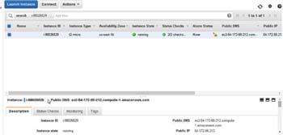

**Figure 9-17:**Obtaining the Public DNS

The ports to forward to on the local machine must be open and not already bound. As an example, bind one of the endpoints to port 8093 on localhost and the other to port 8094 on the localhost with the following commands.

ssh -i "docker.pem" -f -nNT -L 8093:172.17.0.3:8091 ubuntu@ec2-54-172-55-212.compute-1.

amazonaws.com

ssh -i "docker.pem" -f -nNT -L 8094:172.17.0.2:8091 ubuntu@ec2-54-172-55-212.compute-1.

amazonaws.com

The port forwarding from the service endpoints to localhost ports gets set as shown in [Figure 9-18](https://viewer.books24x7.com/assetviewer.aspx?bookid=113388&chunkid=568365072&resumebookmarkid=a546b65e-d1be-e911-b9b2-00505695593a).

[Larger View](https://viewer.books24x7.com/assetviewer.aspx?bookid=113388&chunkid=568365072&resumebookmarkid=a546b65e-d1be-e911-b9b2-00505695593a)

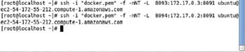

**Figure 9-18:**Setting Port Forwarding to localhost:8093 and localhost:8094

**Logging into Couchbase Web Console**

Two ports are available on the local machine to open the Couchbase web console, 8093 and 8094. Either or both of these could be used to open a Couchbase web console. For example, open the URL [http://localhost:8093](http://localhost:8093/) in a web browser. The Couchbase Console gets opened as shown in [Figure 9-19](https://viewer.books24x7.com/assetviewer.aspx?bookid=113388&chunkid=568365072&resumebookmarkid=a546b65e-d1be-e911-b9b2-00505695593a). Click on Setup to set up the Couchbase server.

[Larger View](https://viewer.books24x7.com/assetviewer.aspx?bookid=113388&chunkid=568365072&resumebookmarkid=a546b65e-d1be-e911-b9b2-00505695593a)

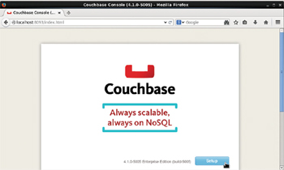

**Figure 9-19:**Setting Up Couchbase Server

**Configuring Couchbase Server**

In this section we shall configure the Couchbase server, which is not directly related to using Kubernetes but is discussed for completeness. When the Setup button is clicked the CONFIGURE SERVER window gets displayed as shown in [Figure 9-20](https://viewer.books24x7.com/assetviewer.aspx?bookid=113388&chunkid=568365072&resumebookmarkid=a546b65e-d1be-e911-b9b2-00505695593a).

[Larger View](https://viewer.books24x7.com/assetviewer.aspx?bookid=113388&chunkid=568365072&resumebookmarkid=a546b65e-d1be-e911-b9b2-00505695593a)

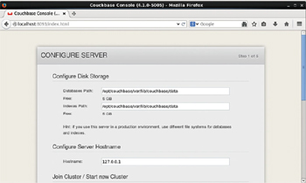

**Figure 9-20:**Configuring Server Disk Storage, Hostname

Keep the default settings and scroll down to select Start a new cluster. The RAM settings may have to be reduced if sufficient RAM is not available. Click on Next as shown in [Figure 9-21](https://viewer.books24x7.com/assetviewer.aspx?bookid=113388&chunkid=568365072&resumebookmarkid=a546b65e-d1be-e911-b9b2-00505695593a).

[Larger View](https://viewer.books24x7.com/assetviewer.aspx?bookid=113388&chunkid=568365072&resumebookmarkid=a546b65e-d1be-e911-b9b2-00505695593a)

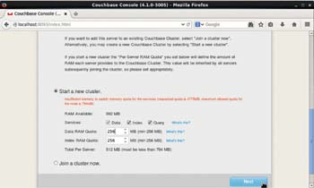

**Figure 9-21:**Starting New Cluster

Some sample buckets get listed but a sample bucket is not required to be selected. Click on Next as shown in [Figure 9-22](https://viewer.books24x7.com/assetviewer.aspx?bookid=113388&chunkid=568365072&resumebookmarkid=a546b65e-d1be-e911-b9b2-00505695593a).

[Larger View](https://viewer.books24x7.com/assetviewer.aspx?bookid=113388&chunkid=568365072&resumebookmarkid=a546b65e-d1be-e911-b9b2-00505695593a)

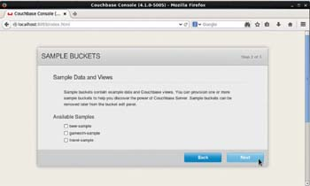

**Figure 9-22:**Sample Buckets are not required to be selected

The Create Default Bucket settings include the Bucket Type, which should be Couchbase as shown in [Figure 9-23](https://viewer.books24x7.com/assetviewer.aspx?bookid=113388&chunkid=568365072&resumebookmarkid=a546b65e-d1be-e911-b9b2-00505695593a). Replicas should be enabled with the "Enable" check box.

[Larger View](https://viewer.books24x7.com/assetviewer.aspx?bookid=113388&chunkid=568365072&resumebookmarkid=a546b65e-d1be-e911-b9b2-00505695593a)

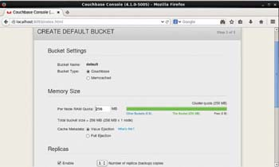

**Figure 9-23:**Configuring Default Bucket

Scroll down to enable the Flush mode with the "Enable" check box. Click on Next as shown in [Figure 9-24](https://viewer.books24x7.com/assetviewer.aspx?bookid=113388&chunkid=568365072&resumebookmarkid=a546b65e-d1be-e911-b9b2-00505695593a).

[Larger View](https://viewer.books24x7.com/assetviewer.aspx?bookid=113388&chunkid=568365072&resumebookmarkid=a546b65e-d1be-e911-b9b2-00505695593a)

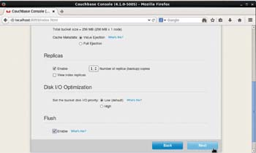

**Figure 9-24:**Enabling Flush Mode and completing Server Configuration

Next, accept the terms and conditions as shown in [Figure 9-25](https://viewer.books24x7.com/assetviewer.aspx?bookid=113388&chunkid=568365072&resumebookmarkid=a546b65e-d1be-e911-b9b2-00505695593a) and click on Next.

[Larger View](https://viewer.books24x7.com/assetviewer.aspx?bookid=113388&chunkid=568365072&resumebookmarkid=a546b65e-d1be-e911-b9b2-00505695593a)

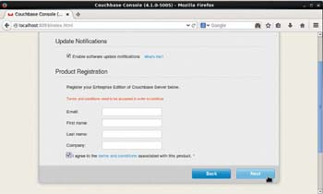

**Figure 9-25:**Accepting Terms and Conditions

To secure the server specify a Password and specify the same password in the Verify Password field as shown in [Figure 9-26](https://viewer.books24x7.com/assetviewer.aspx?bookid=113388&chunkid=568365072&resumebookmarkid=a546b65e-d1be-e911-b9b2-00505695593a).

[Larger View](https://viewer.books24x7.com/assetviewer.aspx?bookid=113388&chunkid=568365072&resumebookmarkid=a546b65e-d1be-e911-b9b2-00505695593a)

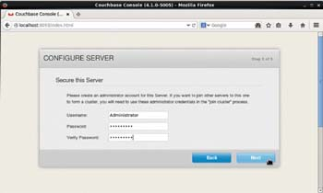

**Figure 9-26:**Securing the Server with Username and Password

The Couchbase server gets configured. Select the Server Nodes tab and the Server Node Name is listed as shown in [Figure 9-27](https://viewer.books24x7.com/assetviewer.aspx?bookid=113388&chunkid=568365072&resumebookmarkid=a546b65e-d1be-e911-b9b2-00505695593a). The Server Node Name is one of the service endpoints.

[Larger View](https://viewer.books24x7.com/assetviewer.aspx?bookid=113388&chunkid=568365072&resumebookmarkid=a546b65e-d1be-e911-b9b2-00505695593a)

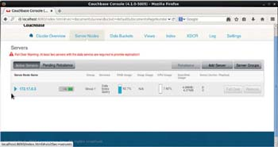

**Figure 9-27:**Server Node Name is the same as a Service Endpoint

**Adding Documents**

Next, we shall add some documents to the Couchbase server. Select the Data Buckets tab as shown in [Figure 9-28](https://viewer.books24x7.com/assetviewer.aspx?bookid=113388&chunkid=568365072&resumebookmarkid=a546b65e-d1be-e911-b9b2-00505695593a).

[Larger View](https://viewer.books24x7.com/assetviewer.aspx?bookid=113388&chunkid=568365072&resumebookmarkid=a546b65e-d1be-e911-b9b2-00505695593a)

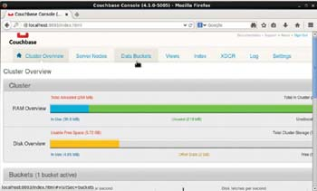

**Figure 9-28:**Selecting Data Buckets Tab

The default bucket gets listed as shown in [Figure 9-29](https://viewer.books24x7.com/assetviewer.aspx?bookid=113388&chunkid=568365072&resumebookmarkid=a546b65e-d1be-e911-b9b2-00505695593a). Click on Documents.

[Larger View](https://viewer.books24x7.com/assetviewer.aspx?bookid=113388&chunkid=568365072&resumebookmarkid=a546b65e-d1be-e911-b9b2-00505695593a)

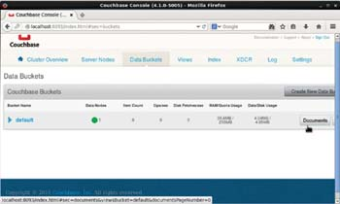

**Figure 9-29:**Clicking on Documents Button for the default Bucket

Initially the "default" bucket is empty as shown in [Figure 9-30](https://viewer.books24x7.com/assetviewer.aspx?bookid=113388&chunkid=568365072&resumebookmarkid=a546b65e-d1be-e911-b9b2-00505695593a).

[Larger View](https://viewer.books24x7.com/assetviewer.aspx?bookid=113388&chunkid=568365072&resumebookmarkid=a546b65e-d1be-e911-b9b2-00505695593a)

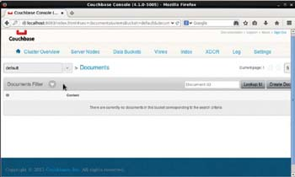

**Figure 9-30:**Initially no Documents are present in the default Data Bucket

Click on Create Document to add a document as shown in [Figure 9-31](https://viewer.books24x7.com/assetviewer.aspx?bookid=113388&chunkid=568365072&resumebookmarkid=a546b65e-d1be-e911-b9b2-00505695593a).

[Larger View](https://viewer.books24x7.com/assetviewer.aspx?bookid=113388&chunkid=568365072&resumebookmarkid=a546b65e-d1be-e911-b9b2-00505695593a)

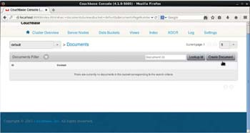

**Figure 9-31:**Clicking on Create Document

In the Create Document dialog specify a Document Id and click on Create as shown in [Figure 9-32](https://viewer.books24x7.com/assetviewer.aspx?bookid=113388&chunkid=568365072&resumebookmarkid=a546b65e-d1be-e911-b9b2-00505695593a).

[Larger View](https://viewer.books24x7.com/assetviewer.aspx?bookid=113388&chunkid=568365072&resumebookmarkid=a546b65e-d1be-e911-b9b2-00505695593a)

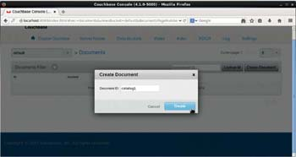

**Figure 9-32:**Specifying Document ID

A new JSON document with default fields gets added as shown in [Figure 9-33](https://viewer.books24x7.com/assetviewer.aspx?bookid=113388&chunkid=568365072&resumebookmarkid=a546b65e-d1be-e911-b9b2-00505695593a).

[Larger View](https://viewer.books24x7.com/assetviewer.aspx?bookid=113388&chunkid=568365072&resumebookmarkid=a546b65e-d1be-e911-b9b2-00505695593a)

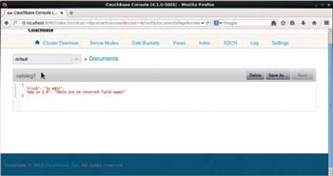

**Figure 9-33:**The catalog1 Document gets created with Default Fields

Copy and paste the following JSON document into the catalog1 document.

{

"journal": "Oracle Magazine",

"publisher": "Oracle Publishing",

"edition": "November-December 2013",

"title": "Quintessential and Collaborative",

"author": "Tom Haunert"

}

Click on Save to update the catalog1 document as shown in [Figure 9-34](https://viewer.books24x7.com/assetviewer.aspx?bookid=113388&chunkid=568365072&resumebookmarkid=a546b65e-d1be-e911-b9b2-00505695593a).

[Larger View](https://viewer.books24x7.com/assetviewer.aspx?bookid=113388&chunkid=568365072&resumebookmarkid=a546b65e-d1be-e911-b9b2-00505695593a)

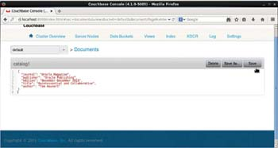

**Figure 9-34:**Saving a JSON Document

The catalog1 document gets saved and gets listed when the Documents link for the "default" bucket is selected as shown in [Figure 9-35](https://viewer.books24x7.com/assetviewer.aspx?bookid=113388&chunkid=568365072&resumebookmarkid=a546b65e-d1be-e911-b9b2-00505695593a).

[Larger View](https://viewer.books24x7.com/assetviewer.aspx?bookid=113388&chunkid=568365072&resumebookmarkid=a546b65e-d1be-e911-b9b2-00505695593a)

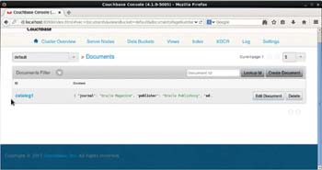

**Figure 9-35:**The catalog1 Document in default Bucket

Similarly add another document with Document ID as catalog2 and copy and paste the following listing to the document.

{

"journal": "Oracle Magazine",

"publisher": "Oracle Publishing",

"edition": "November December 2013",

"title": "Engineering as a Service",

"author": "David A. Kelly",

}

The catalog2 document is shown in [Figure 9-36](https://viewer.books24x7.com/assetviewer.aspx?bookid=113388&chunkid=568365072&resumebookmarkid=a546b65e-d1be-e911-b9b2-00505695593a).

[Larger View](https://viewer.books24x7.com/assetviewer.aspx?bookid=113388&chunkid=568365072&resumebookmarkid=a546b65e-d1be-e911-b9b2-00505695593a)

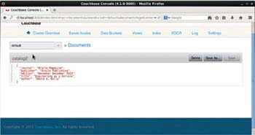

**Figure 9-36:**Adding another Document catalog2

The Documents link for the "default" bucket links the two documents added as shown in [Figure 9-37](https://viewer.books24x7.com/assetviewer.aspx?bookid=113388&chunkid=568365072&resumebookmarkid=a546b65e-d1be-e911-b9b2-00505695593a).

[Larger View](https://viewer.books24x7.com/assetviewer.aspx?bookid=113388&chunkid=568365072&resumebookmarkid=a546b65e-d1be-e911-b9b2-00505695593a)

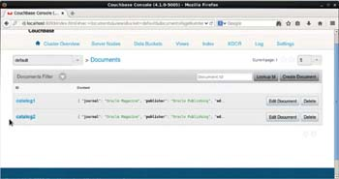

**Figure 9-37:**Listing the two Documents in the default Bucket

**Starting an Interactive Shell**

Next, we shall start and interactive bash shell to access Couchbase server from the command line. Obtain the container id for one of the Docker containers based on the Docker image "couchbase" as shown in [Figure 9-38](https://viewer.books24x7.com/assetviewer.aspx?bookid=113388&chunkid=568365072&resumebookmarkid=a546b65e-d1be-e911-b9b2-00505695593a).

[Larger View](https://viewer.books24x7.com/assetviewer.aspx?bookid=113388&chunkid=568365072&resumebookmarkid=a546b65e-d1be-e911-b9b2-00505695593a)

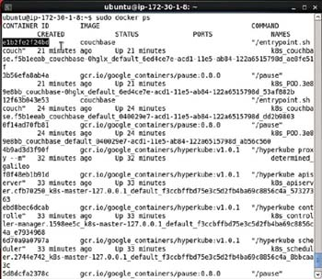

**Figure 9-38:**Obtaining the Container Id

Using the container id, start an interactive shell.

sudo docker exec -it e1b2fe2f24bd bash

An interactive shell gets started as shown in [Figure 9-39](https://viewer.books24x7.com/assetviewer.aspx?bookid=113388&chunkid=568365072&resumebookmarkid=a546b65e-d1be-e911-b9b2-00505695593a).

[Larger View](https://viewer.books24x7.com/assetviewer.aspx?bookid=113388&chunkid=568365072&resumebookmarkid=a546b65e-d1be-e911-b9b2-00505695593a)



**Figure 9-39:**Starting an Interactive Shell

**Using the cbtransfer Tool**

From the interactive shell command-line tools may be run to access the Couchbase server. As an example run the cbtransfer tool, which is used to transfer data between clusters and to/from files, to output the documents in the default bucket at server [http://172.17.0.3:8091](http://172.17.0.3:8091/)to stdout.

cbtransfer http://172.17.0.3:8091/ stdout:

The two documents added from the web console get output as shown in [Figure 9-40](https://viewer.books24x7.com/assetviewer.aspx?bookid=113388&chunkid=568365072&resumebookmarkid=a546b65e-d1be-e911-b9b2-00505695593a).

[Larger View](https://viewer.books24x7.com/assetviewer.aspx?bookid=113388&chunkid=568365072&resumebookmarkid=a546b65e-d1be-e911-b9b2-00505695593a)

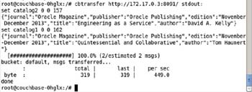

**Figure 9-40:**Using the cbtransfer Tool

In the next section we shall create a Couchbase cluster imperatively using Kubernetes on the command line. As we shall be using the same replication controller name and service name, delete the replication controller "couchbase" and also delete the service called "couchbase."

kubectl delete rc couchbase

kubectl delete svc couchbase

**Creating a Couchbase Cluster Imperatively**

In the following subsections we shall create a Couchbase cluster on the command line.

**Creating a Replication Controller**

Create a replication controller called "couchbase" using the Docker image "couchbase" with two replicas and container port as 8091 with the following command.

kubectl run couchbase --image=couchbase --replicas=2 --port=8091

The replication controller gets created as shown in [Figure 9-41](https://viewer.books24x7.com/assetviewer.aspx?bookid=113388&chunkid=726571142&resumebookmarkid=a546b65e-d1be-e911-b9b2-00505695593a). The default selector is "run=couchbase," which implies that pods with the label "run=couchbase" shall be managed by the replication controller.

[Larger View](https://viewer.books24x7.com/assetviewer.aspx?bookid=113388&chunkid=726571142&resumebookmarkid=a546b65e-d1be-e911-b9b2-00505695593a)

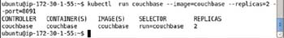

**Figure 9-41:**Creating a Replication Controller Imperatively

List the replication controllers with the following command.

kubectl get rc

The couchbase replication controller gets listed as shown in [Figure 9-42](https://viewer.books24x7.com/assetviewer.aspx?bookid=113388&chunkid=726571142&resumebookmarkid=a546b65e-d1be-e911-b9b2-00505695593a).

[Larger View](https://viewer.books24x7.com/assetviewer.aspx?bookid=113388&chunkid=726571142&resumebookmarkid=a546b65e-d1be-e911-b9b2-00505695593a)



**Figure 9-42:**Listing the Replication Controllers

**Listing the Pods**

To list the Pods run the following command.

kubectl get pods

The two pods get listed as shown in [Figure 9-43](https://viewer.books24x7.com/assetviewer.aspx?bookid=113388&chunkid=726571142&resumebookmarkid=a546b65e-d1be-e911-b9b2-00505695593a).

[Larger View](https://viewer.books24x7.com/assetviewer.aspx?bookid=113388&chunkid=726571142&resumebookmarkid=a546b65e-d1be-e911-b9b2-00505695593a)

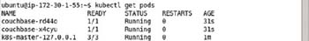

**Figure 9-43:**Listing the Pods

To describe any particular Pod run the kubectl describe pod command, for example, the Pod couchbase-rd44o is described with the following command.

kubectl describe pod couchbase-rd44o

The Pod detail gets output as shown in [Figure 9-44](https://viewer.books24x7.com/assetviewer.aspx?bookid=113388&chunkid=726571142&resumebookmarkid=a546b65e-d1be-e911-b9b2-00505695593a). The Pod label is listed as run=couchbase.

[Larger View](https://viewer.books24x7.com/assetviewer.aspx?bookid=113388&chunkid=726571142&resumebookmarkid=a546b65e-d1be-e911-b9b2-00505695593a)

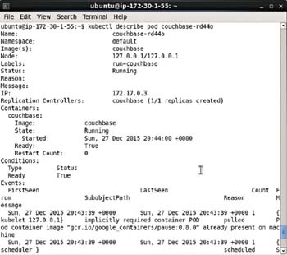

**Figure 9-44:**Describing a Pod

**Creating a Service**

To create a service from the replication controller exposed at port 8091, run the following command, which also specified the service type.

kubectl expose rc couchbase --port=8091 --type=LoadBalancer

Subsequently list the services.

kubectl get services

The couchbase service gets created and listed as shown in [Figure 9-45](https://viewer.books24x7.com/assetviewer.aspx?bookid=113388&chunkid=726571142&resumebookmarkid=a546b65e-d1be-e911-b9b2-00505695593a).

[Larger View](https://viewer.books24x7.com/assetviewer.aspx?bookid=113388&chunkid=726571142&resumebookmarkid=a546b65e-d1be-e911-b9b2-00505695593a)

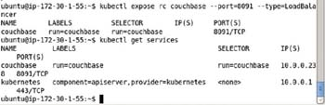

**Figure 9-45:**Creating a Service for Couchbase Imperatively

To describe the couchbase service run the following command.

kubectl describe svc couchbase

The service name, namespace, labels, selector, type, Ip, port, node port, and endpoints get listed as shown in [Figure 9-46](https://viewer.books24x7.com/assetviewer.aspx?bookid=113388&chunkid=726571142&resumebookmarkid=a546b65e-d1be-e911-b9b2-00505695593a). Two endpoints are listed because the service manages two pods.

[Larger View](https://viewer.books24x7.com/assetviewer.aspx?bookid=113388&chunkid=726571142&resumebookmarkid=a546b65e-d1be-e911-b9b2-00505695593a)

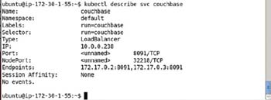

**Figure 9-46:**Describing a Service

**Scaling the Cluster**

A Couchbase cluster may be scaled up or down using the Kubernetes cluster manager. For example, to scale down the replication controller called "couchbase" to 1 replica, run the following kubectl scale command.

kubectl scale rc couchbase --replicas=1

An output of "scaled" indicates that the rc has been scaled. But the "scaled" output does not always imply that the scaled number of replicas are running and ready. Run the following command to list the Pods.

kubectl get pods

A single Couchbase Pod gets listed as shown in [Figure 9-47](https://viewer.books24x7.com/assetviewer.aspx?bookid=113388&chunkid=726571142&resumebookmarkid=a546b65e-d1be-e911-b9b2-00505695593a).

[Larger View](https://viewer.books24x7.com/assetviewer.aspx?bookid=113388&chunkid=726571142&resumebookmarkid=a546b65e-d1be-e911-b9b2-00505695593a)

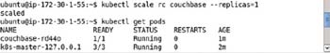

**Figure 9-47:**Scaling Down the Couchbase Cluster to a Single Pod

Run the following command to list the replication controllers and the couchbase rc is listed with replicas as 1 as shown in [Figure 9-48](https://viewer.books24x7.com/assetviewer.aspx?bookid=113388&chunkid=726571142&resumebookmarkid=a546b65e-d1be-e911-b9b2-00505695593a).

kubectl get rc

To scale the rc back to 2 Pods run the following command.

kubectl scale rc couchbase --replicas=2

Subsequently list the Pods.

kubectl get pods

Initially the new Pod to be added could be not running or not ready but after a few seconds two Pods get listed as running and ready as shown in [Figure 9-48](https://viewer.books24x7.com/assetviewer.aspx?bookid=113388&chunkid=726571142&resumebookmarkid=a546b65e-d1be-e911-b9b2-00505695593a).

[Larger View](https://viewer.books24x7.com/assetviewer.aspx?bookid=113388&chunkid=726571142&resumebookmarkid=a546b65e-d1be-e911-b9b2-00505695593a)

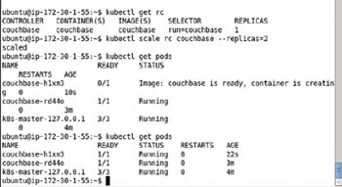

**Figure 9-48:**Scaling Up the Couchbase Cluster

**Keeping the Replication Level**

The main purpose of a replication controller is to keep the number of replicas to the configured level. With 2 replicas configured in the couchbase rc the number of Pods is maintained at 2. As an example, delete one of the Pods.

kubectl delete pod couchbase-4z3hx

One pod gets deleted, but it takes the total number of pods to 1, which is below the number of configured replicas. As a result the replication controller starts a new replica. Subsequently list the pods.

kubectl get pods

Initially the new Pod could be not running and/or not ready but after a few seconds two pods are running and ready as shown in [Figure 9-49](https://viewer.books24x7.com/assetviewer.aspx?bookid=113388&chunkid=726571142&resumebookmarkid=a546b65e-d1be-e911-b9b2-00505695593a).

[Larger View](https://viewer.books24x7.com/assetviewer.aspx?bookid=113388&chunkid=726571142&resumebookmarkid=a546b65e-d1be-e911-b9b2-00505695593a)

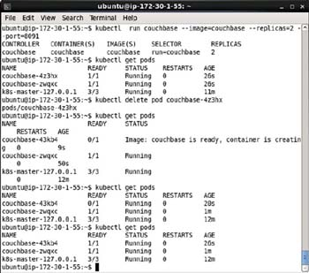

**Figure 9-49:**Running the kubectl get pods Command Multiple Times until all Pods are Running and Ready

Describe the couchbase service.

kubectl describe svc couchbase

Two endpoints get listed as shown in [Figure 9-50](https://viewer.books24x7.com/assetviewer.aspx?bookid=113388&chunkid=726571142&resumebookmarkid=a546b65e-d1be-e911-b9b2-00505695593a).

[Larger View](https://viewer.books24x7.com/assetviewer.aspx?bookid=113388&chunkid=726571142&resumebookmarkid=a546b65e-d1be-e911-b9b2-00505695593a)

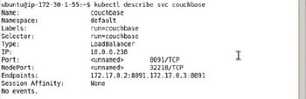

**Figure 9-50:**Describing the couchbase Service

**Setting Port Forwarding**

Set port forwarding of a service endpoint to a localhost port, for example, port 8095, as discussed earlier.

ssh -i "docker.pem" -f -nNT -L 8095:172.17.0.2:8091 ubuntu@ec2-52-91-80-177.compute-1.

amazonaws.com

The preceding command does not generate any output as shown in [Figure 9-51](https://viewer.books24x7.com/assetviewer.aspx?bookid=113388&chunkid=726571142&resumebookmarkid=a546b65e-d1be-e911-b9b2-00505695593a).

[Larger View](https://viewer.books24x7.com/assetviewer.aspx?bookid=113388&chunkid=726571142&resumebookmarkid=a546b65e-d1be-e911-b9b2-00505695593a)



**Figure 9-51:**Setting Port Forwarding

**Logging in to Couchbase Admin Console**

Login to the Couchbase Web Console using the forwarded port on localhost.

<http://localhost:8095/index.html>

The Couchbase Web Console gets displayed as shown in [Figure 9-52](https://viewer.books24x7.com/assetviewer.aspx?bookid=113388&chunkid=726571142&resumebookmarkid=a546b65e-d1be-e911-b9b2-00505695593a).

[Larger View](https://viewer.books24x7.com/assetviewer.aspx?bookid=113388&chunkid=726571142&resumebookmarkid=a546b65e-d1be-e911-b9b2-00505695593a)

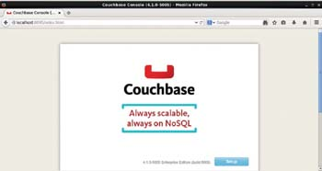

**Figure 9-52:**Displaying the Couchbase Console

### Summary

In this chapter we used Kubernetes cluster manager to create a Couchbase cluster. We discussed both the declarative and imperative approaches. The declarative approach makes use of definition files and the imperative approach makes use of command-line configuration parameters. We demonstrated accessing the Couchbase Web Console from a localhost browser using port forwarding. We also used the cbtransfer tool in an interactive shell for a Docker container running Couchbase server. Docker image "couchbase" is used to create a Couchbase server. In the next chapter we shall discuss using Kubernetes cluster manager for an Apache Hadoop cluster.

**Part IV: Apache Hadoop Ecosystem**

Chapter List

1. [Chapter 10:](http://viewer.books24x7.com/assetviewer.aspx?bkid=113388&destid=868#868) Using Apache Hadoop Ecosystem
2. [Chapter 11:](http://viewer.books24x7.com/assetviewer.aspx?bkid=113388&destid=980#980) Using Apache Solr
3. [Chapter 12:](http://viewer.books24x7.com/assetviewer.aspx?bkid=113388&destid=1076#1076) Using Apache Kafka

**Kubernetes Microservices with Docker**

Chapter 10 - Using Apache Hadoop Ecosystem

Apress © 2016

## Chapter 10: Using Apache Hadoop Ecosystem

**© Deepak Vohra 2016  
D. Vohra, *Kubernetes Microservices with Docker*, DOI 10.1007/978-1-4842-1907-2\_10**

### Overview

Apache Hadoop has evolved to be the de facto framework for processing large quantities of data. Apache Hadoop ecosystem consists of a several projects including Apache Hive and Apache HBase. The Docker image "svds/cdh" is based on the latest CDH release and includes all the main frameworks in the Apache Hadoop ecosystem. All the frameworks such as Apache Hadoop, Apache Hive, and Apache HBase are installed in the same Docker image as a result facilitating development of applications that make use of multiple frameworks from the Apache Hadoop ecosystem. In this chapter we shall discuss using Kubernetes cluster manager to manage a cluster of Pods based on the svds/cdh image.

**Setting the Environment**

The following software is required to be installed for this chapter, which is the same as the software used in other chapters except for the Docker image.

* -Docker Engine (latest version)
* -Kubernetes Cluster Manager (version 1.01)
* -Kubectl (version 1.01)
* -Docker image svds/cdh (latest version)

Install the software as discussed in [chapter 1](http://viewer.books24x7.com/assetviewer.aspx?bkid=113388&destid=28#28) on an Ubuntu instance on Amazon EC2. SSH Login to the Ubuntu instance.

ssh -i "docker.pem" ubuntu@54.86.45.173

Start the Docker engine with the following command.

sudo service docker start

Subsequently run the following command to verify the status of Docker.

sudo service docker status

As shown in [Figure 10-1](https://viewer.books24x7.com/assetviewer.aspx?bookid=113388&chunkid=380259391&resumebookmarkid=a546b65e-d1be-e911-b9b2-00505695593a), Docker should be listed as "running."

[Larger View](https://viewer.books24x7.com/assetviewer.aspx?bookid=113388&chunkid=380259391&resumebookmarkid=a546b65e-d1be-e911-b9b2-00505695593a)



**Figure 10-1:**Starting Docker

List the services with the following command.

kubectl get services

The kubernetes service should be listed as running as shown in [Figure 10-2](https://viewer.books24x7.com/assetviewer.aspx?bookid=113388&chunkid=380259391&resumebookmarkid=a546b65e-d1be-e911-b9b2-00505695593a)

[Larger View](https://viewer.books24x7.com/assetviewer.aspx?bookid=113388&chunkid=380259391&resumebookmarkid=a546b65e-d1be-e911-b9b2-00505695593a)

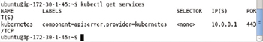

**Figure 10-2:**Listing the "kubernetes" Service

List the Pods with the following command.

kubectl get pods

List the nodes with the following command.

kubectl get nodes

The only Pod that gets listed is for Kubernetes as shown in [Figure 10-3](https://viewer.books24x7.com/assetviewer.aspx?bookid=113388&chunkid=380259391&resumebookmarkid=a546b65e-d1be-e911-b9b2-00505695593a). The node 127.0.0.1 also gets listed.

[Larger View](https://viewer.books24x7.com/assetviewer.aspx?bookid=113388&chunkid=380259391&resumebookmarkid=a546b65e-d1be-e911-b9b2-00505695593a)

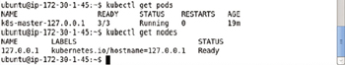

**Figure 10-3:**Listing the Pod and Node for Kubernetes

**Creating an Apache Hadoop Cluster Declaratively**

In the following subsections we shall create a Kubernetes service and a Kubernetes replication controller declaratively using definition files. A service is the external interface for Pods and routes client requests to one of the Pods. A replication controller manages the replication level of the Pods and maintains the number of replicas to the specified value in the definition file. The replication controller is also used to scale the cluster of Pods.

**Creating a Service**

To run a service for the CDH Pods create a service definition file cdh-service.yaml and add the following ([Table 10-1](https://viewer.books24x7.com/assetviewer.aspx?bookid=113388&chunkid=387539218&resumebookmarkid=a546b65e-d1be-e911-b9b2-00505695593a)) fields to the definition file.

**Table 10-1: Service Definition File Fields**[[](https://viewer.books24x7.com/outputobject.aspx?bookid=113388&chunkid=387539218&objectid=ch10_tab1&objecttype=spreadsheet) Open table as spreadsheet](https://viewer.books24x7.com/outputobject.aspx?bookid=113388&chunkid=387539218&objectid=ch10_tab1&objecttype=spreadsheet" \t "_blank)

| **Field** | **Description** | **Value** | **Required Field (including defaults)** |
| --- | --- | --- | --- |
| apiVersion |  | v1 | yes |
| kind | The kind of definition file. | Service | yes |
| metadata | The service metadata. |  | yes |
| metadata - > labels | The service labels. | app: cdh | no |
| metadata - > name | The service name. | cdh | yes |
| spec | The service specification. |  | yes |
| spec - > ports | The ports exposed by the service. |  | yes |
| spec - > ports - > port | A port exposed by the service. The 50010 port is for the DataNode. | 50010 |  |
| spec - > ports - > port | Another port exposed by the service. The 8020 port is for the NameNode. | 8020 |  |
| spec - > selector | The Pod selector. Service routes traffic to the Pods with a label matching the selector expression. | app: cdh | yes |
| spec - > selector - > type | The service type. | LoadBalancer | no |

The service definition file cdh-service.yaml is listed:

apiVersion: v1

kind: Service

metadata:

labels:

app: cdh

name: cdh

spec:

ports:

-

port: 50010

-

port: 8020

selector:

app: cdh

type: LoadBalancer

The service definition file may be created and saved in the vi editor as shown in [Figure 10-4](https://viewer.books24x7.com/assetviewer.aspx?bookid=113388&chunkid=387539218&resumebookmarkid=a546b65e-d1be-e911-b9b2-00505695593a).

[Larger View](https://viewer.books24x7.com/assetviewer.aspx?bookid=113388&chunkid=387539218&resumebookmarkid=a546b65e-d1be-e911-b9b2-00505695593a)

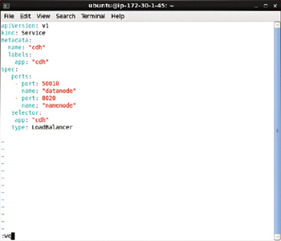

**Figure 10-4:**Service Definition File in vi Editor

Create a service from the definition file with the following command.

kubectl create -f cdh-service.yaml

Subsequently list the services.

kubectl get services

An output of "services/cdh" from the first command indicates that the service has been created as shown in [Figure 10-5](https://viewer.books24x7.com/assetviewer.aspx?bookid=113388&chunkid=387539218&resumebookmarkid=a546b65e-d1be-e911-b9b2-00505695593a). The second command lists the service called "cdh." The service selector is listed as app = cdh in the SELECTOR column.

[Larger View](https://viewer.books24x7.com/assetviewer.aspx?bookid=113388&chunkid=387539218&resumebookmarkid=a546b65e-d1be-e911-b9b2-00505695593a)

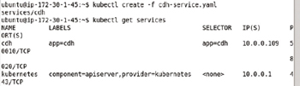

**Figure 10-5:**Creating a Service from a Definition File

**Creating a Replication Controller**

In this section we shall create a replication controller using a definition file. Create a cdh-rc.yaml file and add the following ([Table 10-2](https://viewer.books24x7.com/assetviewer.aspx?bookid=113388&chunkid=387539218&resumebookmarkid=a546b65e-d1be-e911-b9b2-00505695593a)) fields to the file.

**Table 10-2: Replication Controller Definition File Fields**[[](https://viewer.books24x7.com/outputobject.aspx?bookid=113388&chunkid=387539218&objectid=ch10_tab2&objecttype=spreadsheet) Open table as spreadsheet](https://viewer.books24x7.com/outputobject.aspx?bookid=113388&chunkid=387539218&objectid=ch10_tab2&objecttype=spreadsheet" \t "_blank)

| **Field** | **Description** | **Value** |
| --- | --- | --- |
| apiVersion |  | v1 |
| kind | The kind of definition file. | ReplicationController |
| metadata | The replication controller metadata. |  |
| metadata - > labels | The replication controller labels. | app: cdh |
| metadata - > name | The replication controller name. | cdh-rc |
| spec | The replication controller specification. |  |
| spec - > replicas | The number of Pod replicas. | 2 |
| spec - > selector | Selector key:value expression/s for selecting the Pods to manage. Pods with label/s the same as the selector expression/s are managed by the replication controller. For a single selector expression the selector expression must be the same as a spec - > template - > metadata - > labels label. The selector defaults to the spec - > template - > metadata - > labels if not specified. | Not set. Defaults to the same value as the key:value pairs in spec - > template - > metadata - > labels. |
| spec - > template | The Pod template. |  |
| spec - > template- > metadata | The Pod template metadata. |  |
| spec - > template- > metadata- > labels | The Pod template labels. | app: cdh name: cdh |
| spec - > template - > spec | The Pod template specification |  |
| spec - > template - > spec- > containers | The containers configuration for the Pod template |  |
| spec - > template - > spec- > containers - > image | The Docker image | svds/cdh |
| spec - > template - > spec - > containers - > name | The container name | cdh |

The definition file for the replication controller, cdh-rc.yaml, is listed.

apiVersion: v1

kind: ReplicationController

metadata:

labels:

app: cdh

name: cdh-rc

spec:

replicas: 2

template:

metadata:

labels:

app: cdh

name: cdh

spec:

containers:

image: svds/cdh

name: cdh

Run the following command to create a replication controller from the definition file.

kubectl create -f cdh-rc.yaml

List the replication controllers.

kubectl get rc

The first command outputs "replicationcontrollers/cdh," which implies that an rc has been created successfully. The second command lists the replication controllers. The replication controller "cdh" gets listed as shown in [Figure 10-6](https://viewer.books24x7.com/assetviewer.aspx?bookid=113388&chunkid=387539218&resumebookmarkid=a546b65e-d1be-e911-b9b2-00505695593a). The SELECTOR was not specified in the replication controller file and is listed as the same two key:value pairs, app=cdh,name=cdh, as the template labels. A Pod managed by the replication controller must include both of these labels, and may include additional labels. The number of replicas is set to 2.

[Larger View](https://viewer.books24x7.com/assetviewer.aspx?bookid=113388&chunkid=387539218&resumebookmarkid=a546b65e-d1be-e911-b9b2-00505695593a)

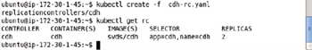

**Figure 10-6:**Creating a Replication Controller from a Definition File

**Listing the Pods**

To list the Pods run the following command.

kubectl get pods

Two Pods get listed as shown in [Figure 10-7](https://viewer.books24x7.com/assetviewer.aspx?bookid=113388&chunkid=387539218&resumebookmarkid=a546b65e-d1be-e911-b9b2-00505695593a). Initially the Pods could be listed as not running or/and not ready. A not ready pod is indicated by the 0/1 value in the READY column, which implies that 0 of 1 containers in the Pod are rready.

[Larger View](https://viewer.books24x7.com/assetviewer.aspx?bookid=113388&chunkid=387539218&resumebookmarkid=a546b65e-d1be-e911-b9b2-00505695593a)

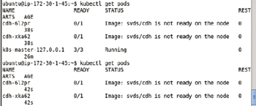

**Figure 10-7:**Listing the Pods for CDH, created but not Ready

Run the same command again to list the Pods.

kubectl get pods

The two Pods should get listed as STATUS- > Running and READY- > 1/1 as shown in [Figure 10-8](https://viewer.books24x7.com/assetviewer.aspx?bookid=113388&chunkid=387539218&resumebookmarkid=a546b65e-d1be-e911-b9b2-00505695593a).

[Larger View](https://viewer.books24x7.com/assetviewer.aspx?bookid=113388&chunkid=387539218&resumebookmarkid=a546b65e-d1be-e911-b9b2-00505695593a)

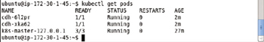

**Figure 10-8:**Listing the Pods as Ready

**Listing Logs**

To list the logs for a particular Pod, for example, the cdh-612pr Pod, run the following command.

kubectl logs cdh-612pr

The output from the command lists the logs, which indicate that the Hadoop datanode, namenode, secondarynamenode, resourcemanager, and nodemanager have been started as shown in [Figure 10-9](https://viewer.books24x7.com/assetviewer.aspx?bookid=113388&chunkid=387539218&resumebookmarkid=a546b65e-d1be-e911-b9b2-00505695593a).

[Larger View](https://viewer.books24x7.com/assetviewer.aspx?bookid=113388&chunkid=387539218&resumebookmarkid=a546b65e-d1be-e911-b9b2-00505695593a)

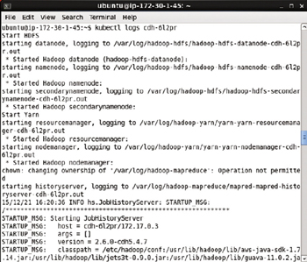

**Figure 10-9:**Listing Pod Logs

Other components such as HBase are also started.

**Scaling a Cluster**

Initially the CDH cluster has 2 replicas. To scale the replicas to 4 run the following command.

kubectl scale rc cdh --replicas=4

Subsequently list the Pods in the cluster.

kubectl get pods

After scaling up the cluster 4 Pods get listed instead of the 2 listed initially. Some of the Pods could be listed as not running or not ready. Run the preceding command after a few seconds periodically, and all the pods should get started as shown in [Figure 10-10](https://viewer.books24x7.com/assetviewer.aspx?bookid=113388&chunkid=387539218&resumebookmarkid=a546b65e-d1be-e911-b9b2-00505695593a).

[Larger View](https://viewer.books24x7.com/assetviewer.aspx?bookid=113388&chunkid=387539218&resumebookmarkid=a546b65e-d1be-e911-b9b2-00505695593a)

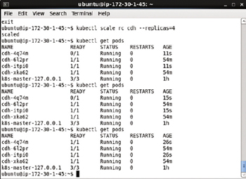

**Figure 10-10:**Scaling the Pod Cluster

**Starting an Interactive Shell**

As the "svds/cdh" Docker image is based on the Linux "ubuntu" Docker image an interactive bash shell may be started to access Docker containers based on the svds/cdh Docker image. To start an interactive bash shell for the cdh software we need to obtain the container id for a Docker container running the "cdh" image as shown in [Figure 10-11](https://viewer.books24x7.com/assetviewer.aspx?bookid=113388&chunkid=387539218&resumebookmarkid=a546b65e-d1be-e911-b9b2-00505695593a).

[Larger View](https://viewer.books24x7.com/assetviewer.aspx?bookid=113388&chunkid=387539218&resumebookmarkid=a546b65e-d1be-e911-b9b2-00505695593a)

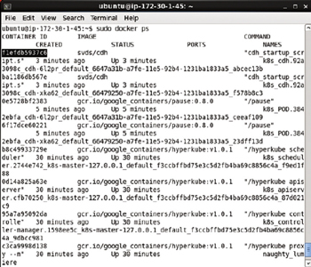

**Figure 10-11:**Copying the Docker Container Id

Subsequently start the interactive shell using the container id.

sudo docker exec -it f1efdb5937c6 bash

The interactive shell gets started as shown in [Figure 10-12](https://viewer.books24x7.com/assetviewer.aspx?bookid=113388&chunkid=387539218&resumebookmarkid=a546b65e-d1be-e911-b9b2-00505695593a).

[Larger View](https://viewer.books24x7.com/assetviewer.aspx?bookid=113388&chunkid=387539218&resumebookmarkid=a546b65e-d1be-e911-b9b2-00505695593a)



**Figure 10-12:**Starting an Interactive Shell

**Running a MapReduce Application**

In this section we shall run an example MapReduce application in the interactive shell. The hdfs command is used to run a MapReduce application. Invoke the hdfs command in the interactive shell.

hdfs

The command usage should get displayed as shown in [Figure 10-13](https://viewer.books24x7.com/assetviewer.aspx?bookid=113388&chunkid=387539218&resumebookmarkid=a546b65e-d1be-e911-b9b2-00505695593a).

[Larger View](https://viewer.books24x7.com/assetviewer.aspx?bookid=113388&chunkid=387539218&resumebookmarkid=a546b65e-d1be-e911-b9b2-00505695593a)

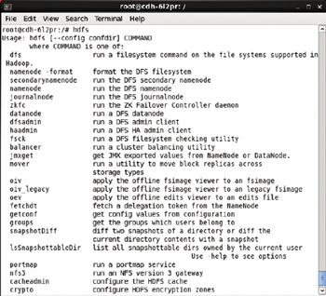

**Figure 10-13:**Command Usage for hdfs Command

To change user to "hdfs" run the following command.

su –l hdfs

The user becomes "hdfs" as shown in [Figure 10-14](https://viewer.books24x7.com/assetviewer.aspx?bookid=113388&chunkid=387539218&resumebookmarkid=a546b65e-d1be-e911-b9b2-00505695593a).

[Larger View](https://viewer.books24x7.com/assetviewer.aspx?bookid=113388&chunkid=387539218&resumebookmarkid=a546b65e-d1be-e911-b9b2-00505695593a)



**Figure 10-14:**Setting User as hdfs

Next, we shall run a wordcount application. We shall get input from the /input directory files and output in the /output directory. Create the /input directory and set its permissions to global (777).

hdfs dfs -mkdir /input

hdfs dfs -chmod -R 777 /input

The /input directory gets created and its permissions get set to global as shown in [Figure 10-15](https://viewer.books24x7.com/assetviewer.aspx?bookid=113388&chunkid=387539218&resumebookmarkid=a546b65e-d1be-e911-b9b2-00505695593a).

[Larger View](https://viewer.books24x7.com/assetviewer.aspx?bookid=113388&chunkid=387539218&resumebookmarkid=a546b65e-d1be-e911-b9b2-00505695593a)

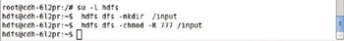

**Figure 10-15:**Creating the Input Directory

Create an input file input.1.txt in the vi editor.

sudo vi input1.txt

Add the following text to input1.txt.

Hello World Application for Apache Hadoop

Hello World and Hello Apache Hadoop

The input1.txt is shown in the vi editor in [Figure 10-16](https://viewer.books24x7.com/assetviewer.aspx?bookid=113388&chunkid=387539218&resumebookmarkid=a546b65e-d1be-e911-b9b2-00505695593a).

[Larger View](https://viewer.books24x7.com/assetviewer.aspx?bookid=113388&chunkid=387539218&resumebookmarkid=a546b65e-d1be-e911-b9b2-00505695593a)

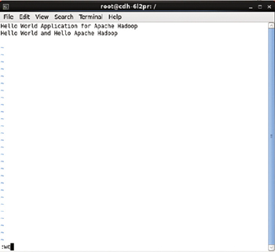

**Figure 10-16:**Creating an Input Text File

Put the input1.txt in the HDFS directory /input with the following command, which should be run with sudo –u hdfs if run as root user. If the user is already set to "hdfs" omit the "sudo -u hdfs" from the command.

sudo -u hdfs hdfs dfs -put input1.txt /input

The input1.txt file gets added to the /input directory and no output is generated from the command as shown in [Figure 10-17](https://viewer.books24x7.com/assetviewer.aspx?bookid=113388&chunkid=387539218&resumebookmarkid=a546b65e-d1be-e911-b9b2-00505695593a).

[Larger View](https://viewer.books24x7.com/assetviewer.aspx?bookid=113388&chunkid=387539218&resumebookmarkid=a546b65e-d1be-e911-b9b2-00505695593a)



**Figure 10-17:**Putting the Input Text File in HDFS

Similarly create another file input2.txt.

sudo vi input2.txt

Add the following text to input2.txt.

Hello World

Hello Apache Hadoop

Save the input2.txt with the :wq command in the vi editor as shown in [Figure 10-18](https://viewer.books24x7.com/assetviewer.aspx?bookid=113388&chunkid=387539218&resumebookmarkid=a546b65e-d1be-e911-b9b2-00505695593a).

[Larger View](https://viewer.books24x7.com/assetviewer.aspx?bookid=113388&chunkid=387539218&resumebookmarkid=a546b65e-d1be-e911-b9b2-00505695593a)

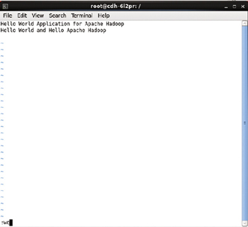

**Figure 10-18:**Creating another Text File input2.txt

Put the input2.txt into the /input directory.

sudo -u hdfs hdfs dfs -put input2.txt /input

The input2.txt also gets added to the /input directory as shown in [Figure 10-19](https://viewer.books24x7.com/assetviewer.aspx?bookid=113388&chunkid=387539218&resumebookmarkid=a546b65e-d1be-e911-b9b2-00505695593a).

[Larger View](https://viewer.books24x7.com/assetviewer.aspx?bookid=113388&chunkid=387539218&resumebookmarkid=a546b65e-d1be-e911-b9b2-00505695593a)



**Figure 10-19:**Putting the input2.txt File into HDFS

The files in the /input directory in the HDFS may be listed with the following command.

hdfs dfs -ls /input

The two files added input1.txt and input2.txt get listed as shown in [Figure 10-20](https://viewer.books24x7.com/assetviewer.aspx?bookid=113388&chunkid=387539218&resumebookmarkid=a546b65e-d1be-e911-b9b2-00505695593a).

[Larger View](https://viewer.books24x7.com/assetviewer.aspx?bookid=113388&chunkid=387539218&resumebookmarkid=a546b65e-d1be-e911-b9b2-00505695593a)

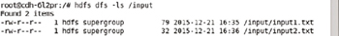

**Figure 10-20:**Listing the Files in HDFS

Next, run the wordcount example application with the following command in which the jar file containing the example application is specified with the jar parameter and the /input and /output directories are set as the last two command parameters for the input directory and the output directory respectively.

sudo -u hdfs hadoop jar /usr/lib/hadoop-mapreduce/hadoop-mapreduce-examples-2.6.0-

cdh5.4.7.jar wordcount /input /output

A MapReduce job gets started as shown in [Figure 10-21](https://viewer.books24x7.com/assetviewer.aspx?bookid=113388&chunkid=387539218&resumebookmarkid=a546b65e-d1be-e911-b9b2-00505695593a).

[Larger View](https://viewer.books24x7.com/assetviewer.aspx?bookid=113388&chunkid=387539218&resumebookmarkid=a546b65e-d1be-e911-b9b2-00505695593a)

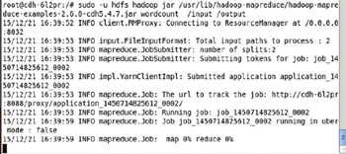

**Figure 10-21:**Startinga YARN Application for Word Count Example

The MapReduce job completes to run the wordcount application. The output from the wordcount MapReduce job, not the word count result, is shown in [Figure 10-22](https://viewer.books24x7.com/assetviewer.aspx?bookid=113388&chunkid=387539218&resumebookmarkid=a546b65e-d1be-e911-b9b2-00505695593a).

[Larger View](https://viewer.books24x7.com/assetviewer.aspx?bookid=113388&chunkid=387539218&resumebookmarkid=a546b65e-d1be-e911-b9b2-00505695593a)

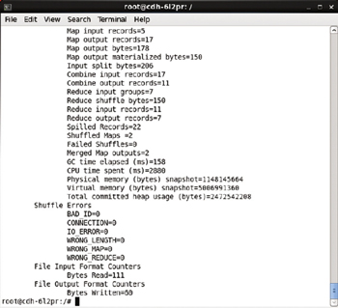

**Figure 10-22:**Output from the MapReduce Job

A more detailed output from the MapReduce application is listed:

root@cdh-6l2pr:/# sudo -u hdfs hadoop jar /usr/lib/hadoop-mapreduce/hadoop-mapreduce-

examples-2.6.0-cdh5.4.7.jar wordcount /input /output

15/12/21 16:39:52 INFO client.RMProxy: Connecting to ResourceManager at /0.0.0.0:8032

15/12/21 16:39:53 INFO input.FileInputFormat: Total input paths to process : 2

15/12/21 16:39:53 INFO mapreduce.JobSubmitter: number of splits:2

15/12/21 16:39:53 INFO mapreduce.JobSubmitter: Submitting tokens for job:

job\_1450714825612\_0002

15/12/21 16:39:53 INFO impl.YarnClientImpl: Submitted application

application\_1450714825612\_0002

15/12/21 16:39:53 INFO mapreduce.Job: The url to track the job: http://cdh-6l2pr:8088/proxy/

application\_1450714825612\_0002/

15/12/21 16:39:53 INFO mapreduce.Job: Running job: job\_1450714825612\_0002

15/12/21 16:39:59 INFO mapreduce.Job: Job job\_1450714825612\_0002 running in uber mode :

false

15/12/21 16:39:59 INFO mapreduce.Job: map 0 % reduce 0 %

15/12/21 16:40:04 INFO mapreduce.Job: map 100 % reduce 0 %

15/12/21 16:40:10 INFO mapreduce.Job: map 100 % reduce 100 %

15/12/21 16:40:10 INFO mapreduce.Job: Job job\_1450714825612\_0002 completed successfully

15/12/21 16:40:10 INFO mapreduce.Job: Counters: 49

File System Counters

FILE: Number of bytes read=144

FILE: Number of bytes written=332672

FILE: Number of read operations=0

FILE: Number of large read operations=0

FILE: Number of write operations=0

HDFS: Number of bytes read=317

HDFS: Number of bytes written=60

HDFS: Number of read operations=9

HDFS: Number of large read operations=0

HDFS: Number of write operations=2

Job Counters

Launched map tasks=2

Launched reduce tasks=1

Data-local map tasks=2

Total time spent by all maps in occupied slots (ms)=4939

Total time spent by all reduces in occupied slots (ms)=2615

Total time spent by all map tasks (ms)=4939

Total time spent by all reduce tasks (ms)=2615

Total vcore-seconds taken by all map tasks=4939

Total vcore-seconds taken by all reduce tasks=2615

Total megabyte-seconds taken by all map tasks=5057536

Total megabyte-seconds taken by all reduce tasks=2677760

Map-Reduce Framework

Map input records=5

Map output records=17

Map output bytes=178

Map output materialized bytes=150

Input split bytes=206

Combine input records=17

Combine output records=11

Reduce input groups=7

Reduce shuffle bytes=150

Reduce input records=11

Reduce output records=7

Spilled Records=22

Shuffled Maps =2

Failed Shuffles=0

Merged Map outputs=2

GC time elapsed (ms)=158

CPU time spent (ms)=2880

Physical memory (bytes) snapshot=1148145664

Virtual memory (bytes) snapshot=5006991360

Total committed heap usage (bytes)=2472542208

Shuffle Errors

BAD\_ID=0

CONNECTION=0

IO\_ERROR=0

WRONG\_LENGTH=0

WRONG\_MAP=0

WRONG\_REDUCE=0

File Input Format Counters

Bytes Read=111

File Output Format Counters

Bytes Written=60

root@cdh-6l2pr:/#

Subsequently, list the files in the /output directory.

bin/hdfs dfs -ls /output

Two files get listed: \_SUCCESS and part-r-00000 as shown in [Figure 10-23](https://viewer.books24x7.com/assetviewer.aspx?bookid=113388&chunkid=387539218&resumebookmarkid=a546b65e-d1be-e911-b9b2-00505695593a). The \_SUCCESSfile is to indicate that the MapReduce command completed successfully and the part-r-00000 command contains the result of the word count.

[Larger View](https://viewer.books24x7.com/assetviewer.aspx?bookid=113388&chunkid=387539218&resumebookmarkid=a546b65e-d1be-e911-b9b2-00505695593a)

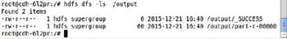

**Figure 10-23:**Listing the Files generated by the MapReduce Job

To list the result of the wordcount application run the following command.

hdfs dfs -cat /output/part-r-00000

The word count for each of the words in the input gets listed as shown in [Figure 10-24](https://viewer.books24x7.com/assetviewer.aspx?bookid=113388&chunkid=387539218&resumebookmarkid=a546b65e-d1be-e911-b9b2-00505695593a).

[Larger View](https://viewer.books24x7.com/assetviewer.aspx?bookid=113388&chunkid=387539218&resumebookmarkid=a546b65e-d1be-e911-b9b2-00505695593a)

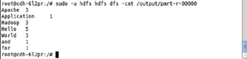

**Figure 10-24:**The Word Count for the Input Files

**Running Hive**

Apache Hive is a data warehouse framework for storing, managing, and querying large data sets in HDFS. As mentioned before all/most of the components of CDH get installed when the svds/cdh image is run. In this section we shall test the Apache Hive framework. The Hive configuration directory is in the Hive conf directory, in the /etc/hive directory. Change directory (cd) to the /etc/hive directory.

cd /etc/hive

The conf directory gets listed as shown in [Figure 10-25](https://viewer.books24x7.com/assetviewer.aspx?bookid=113388&chunkid=450112182&resumebookmarkid=a546b65e-d1be-e911-b9b2-00505695593a).

[Larger View](https://viewer.books24x7.com/assetviewer.aspx?bookid=113388&chunkid=450112182&resumebookmarkid=a546b65e-d1be-e911-b9b2-00505695593a)

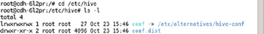

**Figure 10-25:**Listing the Files and Directories in the Hive Root Directory

The Hive metastore is kept in the /var/lib/hive directory. Cd to the /var/lib/hivedirectory.

cd /var/lib/hive

The metastore directory gets listed as shown in [Figure 10-26](https://viewer.books24x7.com/assetviewer.aspx?bookid=113388&chunkid=450112182&resumebookmarkid=a546b65e-d1be-e911-b9b2-00505695593a).

[Larger View](https://viewer.books24x7.com/assetviewer.aspx?bookid=113388&chunkid=450112182&resumebookmarkid=a546b65e-d1be-e911-b9b2-00505695593a)

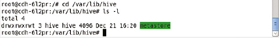

**Figure 10-26:**Listing the Hive Metastore Directory

The Hive home directory is /usr/lib/hive. Cd to the /usr/lib/hive directory. Subsequently list the files and directories.

cd /usr/lib/hive

ls -l

The bin, conf, and lib directories for Apache Hive getlisted as shown in [Figure 10-27](https://viewer.books24x7.com/assetviewer.aspx?bookid=113388&chunkid=450112182&resumebookmarkid=a546b65e-d1be-e911-b9b2-00505695593a). The bin directory contains the executables, the conf directory the configuration files, and the libdirectory the jar files.

[Larger View](https://viewer.books24x7.com/assetviewer.aspx?bookid=113388&chunkid=450112182&resumebookmarkid=a546b65e-d1be-e911-b9b2-00505695593a)

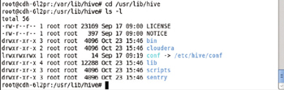

**Figure 10-27:**The Hive Home Directory

All the environment variables are preconfigured. Run the following command to start the Beeline CLI.

beeline

Beeline version 1.1.0-cdh5.4.7 gets started as shown in [Figure 10-28](https://viewer.books24x7.com/assetviewer.aspx?bookid=113388&chunkid=450112182&resumebookmarkid=a546b65e-d1be-e911-b9b2-00505695593a).

[Larger View](https://viewer.books24x7.com/assetviewer.aspx?bookid=113388&chunkid=450112182&resumebookmarkid=a546b65e-d1be-e911-b9b2-00505695593a)



**Figure 10-28:**Starting Beeline CLI

Initially no connection to the Apache Hive server is available. To demonstrate, run the following commands to set the database as default and show the tables.

use default;

show tables;

The message "No current connection" is displayed as shown in [Figure 10-29](https://viewer.books24x7.com/assetviewer.aspx?bookid=113388&chunkid=450112182&resumebookmarkid=a546b65e-d1be-e911-b9b2-00505695593a).

[Larger View](https://viewer.books24x7.com/assetviewer.aspx?bookid=113388&chunkid=450112182&resumebookmarkid=a546b65e-d1be-e911-b9b2-00505695593a)

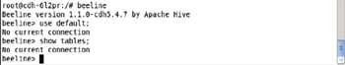

**Figure 10-29:**No Current Connection

Connect with Hive2 server using the default settings for the driver, username, and password as indicated by the three empty ""

Iconnect jdbc:hive2://localhost:10000/default "" "" ""

Apache Hive2 server gets connected to using the Apache Hive JDBC driver as shown in [Figure 10-30](https://viewer.books24x7.com/assetviewer.aspx?bookid=113388&chunkid=450112182&resumebookmarkid=a546b65e-d1be-e911-b9b2-00505695593a).

[Larger View](https://viewer.books24x7.com/assetviewer.aspx?bookid=113388&chunkid=450112182&resumebookmarkid=a546b65e-d1be-e911-b9b2-00505695593a)

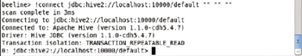

**Figure 10-30:**Connecting with Hive Server

Run the commands to set the database to default and show the tables.

use default;

show tables;

The database connected to is already default, and the first command essentially is redundant but what is to be noted is the error generated earlier is not generated. The second command lists the table and because initially the default database does not have any tables, none get listed. The output from the preceding commands is shown in [Figure 10-31](https://viewer.books24x7.com/assetviewer.aspx?bookid=113388&chunkid=450112182&resumebookmarkid=a546b65e-d1be-e911-b9b2-00505695593a).

[Larger View](https://viewer.books24x7.com/assetviewer.aspx?bookid=113388&chunkid=450112182&resumebookmarkid=a546b65e-d1be-e911-b9b2-00505695593a)



**Figure 10-31:**Setting the database to Use and the listing to the Hive Tables

Before creating a Hive table we need to set the permissions for the /user/hive/warehousedirectory to global (777).

sudo –u hdfs hdfs dfs –chmod –R 777 /user/hive/warehouse

Permissions for the Hive warehouse directory get set as shown in [Figure 10-32](https://viewer.books24x7.com/assetviewer.aspx?bookid=113388&chunkid=450112182&resumebookmarkid=a546b65e-d1be-e911-b9b2-00505695593a).

[Larger View](https://viewer.books24x7.com/assetviewer.aspx?bookid=113388&chunkid=450112182&resumebookmarkid=a546b65e-d1be-e911-b9b2-00505695593a)



**Figure 10-32:**Setting Permissions on the Hive Warehouse Directory

Create a table called wlslog with the following HiveQL command.

CREATE TABLE wlslog(time\_stamp STRING,category STRING,type STRING,servername STRING,code

STRING,msg STRING) ROW FORMAT DELIMITED FIELDS TERMINATED BY ',' LINES TERMINATED BY '\n';

The wlslog table gets created in the default database as shown in [Figure 10-33](https://viewer.books24x7.com/assetviewer.aspx?bookid=113388&chunkid=450112182&resumebookmarkid=a546b65e-d1be-e911-b9b2-00505695593a).

[Larger View](https://viewer.books24x7.com/assetviewer.aspx?bookid=113388&chunkid=450112182&resumebookmarkid=a546b65e-d1be-e911-b9b2-00505695593a)

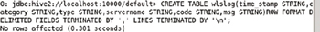

**Figure 10-33:**Creating a Hive Table called wlslog

Describe the wlslog table with the following command.

desc wlslog;

The table columns (name and data type) get listed as shown in [Figure 10-34](https://viewer.books24x7.com/assetviewer.aspx?bookid=113388&chunkid=450112182&resumebookmarkid=a546b65e-d1be-e911-b9b2-00505695593a).

[Larger View](https://viewer.books24x7.com/assetviewer.aspx?bookid=113388&chunkid=450112182&resumebookmarkid=a546b65e-d1be-e911-b9b2-00505695593a)

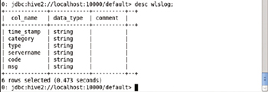

**Figure 10-34:**Describing the Hive Table wlslog

Add 7 rows of data to the wlslog table.

INSERT INTO TABLE wlslog VALUES ('Apr-8-2014-7:06:16-PM-PDT','Notice','WebLogicServer',

'AdminServer,BEA-000365','Server state changed to STANDBY');

INSERT INTO TABLE wlslog VALUES ('Apr-8-2014-7:06:17-PM-PDT','Notice','WebLogicServer',

'AdminServer','BEA-000365','Server state changed to STARTING');

INSERT INTO TABLE wlslog VALUES ('Apr-8-2014-7:06:18-PM-PDT','Notice','WebLogicServer',

'AdminServer','BEA-000365','Server state changed to ADMIN');

INSERT INTO TABLE wlslog VALUES ('Apr-8-2014-7:06:19-PM-PDT','Notice','WebLogicServer',

'AdminServer','BEA-000365','Server state changed to RESUMING');

INSERT INTO TABLE wlslog VALUES ('Apr-8-2014-7:06:20-PM-PDT','Notice','WebLogicServer',

'AdminServer','BEA-000331','Started WebLogic AdminServer');

INSERT INTO TABLE wlslog VALUES ('Apr-8-2014-7:06:21-PM-PDT','Notice','WebLogicServer',

'AdminServer','BEA-000365','Server state changed to RUNNING');

INSERT INTO TABLE wlslog VALUES ('Apr-8-2014-7:06:22-PM-PDT','Notice','WebLogicServer',

'AdminServer','BEA-000360','Server started in RUNNING mode');

A MapReduce job runs for each INSERT statement to add the data to Hive table wlslog as shown in [Figure 10-35](https://viewer.books24x7.com/assetviewer.aspx?bookid=113388&chunkid=450112182&resumebookmarkid=a546b65e-d1be-e911-b9b2-00505695593a).

[Larger View](https://viewer.books24x7.com/assetviewer.aspx?bookid=113388&chunkid=450112182&resumebookmarkid=a546b65e-d1be-e911-b9b2-00505695593a)

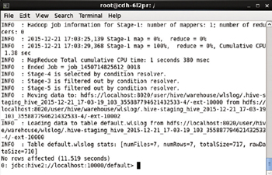

**Figure 10-35:**Adding Data to Hive Table wlslog

Subsequently query the wlslog table.

select \* from wlslog;

The 7 rows of data added get listed as shown in [Figure 10-36](https://viewer.books24x7.com/assetviewer.aspx?bookid=113388&chunkid=450112182&resumebookmarkid=a546b65e-d1be-e911-b9b2-00505695593a).

[Larger View](https://viewer.books24x7.com/assetviewer.aspx?bookid=113388&chunkid=450112182&resumebookmarkid=a546b65e-d1be-e911-b9b2-00505695593a)

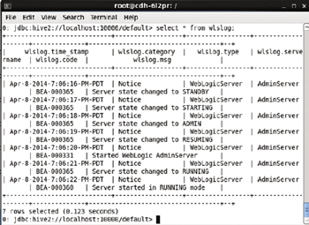

**Figure 10-36:**Querying the Hive Table

To quit the Beeline CLI run the following command.

!q

As shown in [Figure 10-37](https://viewer.books24x7.com/assetviewer.aspx?bookid=113388&chunkid=450112182&resumebookmarkid=a546b65e-d1be-e911-b9b2-00505695593a) the Hive Beeline CLI gets exited. The interactive shell command prompt gets displayed.

[Larger View](https://viewer.books24x7.com/assetviewer.aspx?bookid=113388&chunkid=450112182&resumebookmarkid=a546b65e-d1be-e911-b9b2-00505695593a)



**Figure 10-37:**Exiting the Beeline CLI

From the interactive shell any of the frameworks in CDH may be run. Next, we shall run Apache HBase.

**Running HBase**

Apache HBase is the Apache Hadoop database, which also stores data in HDFS by default. To start the HBase shell run the following command from a bash shell for a Docker container based on the svds/cdh Docker image.

hbase shell

HBase shell gets started as shown in [Figure 10-38](https://viewer.books24x7.com/assetviewer.aspx?bookid=113388&chunkid=494536465&resumebookmarkid=a546b65e-d1be-e911-b9b2-00505695593a).

[Larger View](https://viewer.books24x7.com/assetviewer.aspx?bookid=113388&chunkid=494536465&resumebookmarkid=a546b65e-d1be-e911-b9b2-00505695593a)

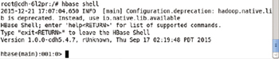

**Figure 10-38:**Starting HBase Shell

Create a table called 'wlslog' with column family 'log'

create 'wlslog', 'log'

The wlslog table gets created as shown in [Figure 10-39](https://viewer.books24x7.com/assetviewer.aspx?bookid=113388&chunkid=494536465&resumebookmarkid=a546b65e-d1be-e911-b9b2-00505695593a).

[Larger View](https://viewer.books24x7.com/assetviewer.aspx?bookid=113388&chunkid=494536465&resumebookmarkid=a546b65e-d1be-e911-b9b2-00505695593a)

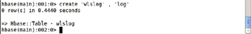

**Figure 10-39:**Creating a HBase Table

Put 7 rows of data into the wlslog table.

put 'wlslog', 'log1', 'log:time\_stamp', 'Apr-8-2014-7:06:16-PM-PDT'

put 'wlslog', 'log1', 'log:category', 'Notice'

put 'wlslog', 'log1', 'log:type', 'WeblogicServer'

put 'wlslog', 'log1', 'log:servername', 'AdminServer'

put 'wlslog', 'log1', 'log:code', 'BEA-000365'

put 'wlslog', 'log1', 'log:msg', 'Server state changed to STANDBY'

put 'wlslog', 'log2', 'log:time\_stamp', 'Apr-8-2014-7:06:17-PM-PDT'

put 'wlslog', 'log2', 'log:category', 'Notice'

put 'wlslog', 'log2', 'log:type', 'WeblogicServer'

put 'wlslog', 'log2', 'log:servername', 'AdminServer'

put 'wlslog', 'log2', 'log:code', 'BEA-000365'

put 'wlslog', 'log2', 'log:msg', 'Server state changed to STARTING'

put 'wlslog', 'log3', 'log:time\_stamp', 'Apr-8-2014-7:06:18-PM-PDT'

put 'wlslog', 'log3', 'log:category', 'Notice'

put 'wlslog', 'log3', 'log:type', 'WeblogicServer'

put 'wlslog', 'log3', 'log:servername', 'AdminServer'

put 'wlslog', 'log3', 'log:code', 'BEA-000365'

put 'wlslog', 'log3', 'log:msg', 'Server state changed to ADMIN'

put 'wlslog', 'log4', 'log:time\_stamp', 'Apr-8-2014-7:06:19-PM-PDT'

put 'wlslog', 'log4', 'log:category', 'Notice'

put 'wlslog', 'log4', 'log:type', 'WeblogicServer'

put 'wlslog', 'log4', 'log:servername', 'AdminServer'

put 'wlslog', 'log4', 'log:code', 'BEA-000365'

put 'wlslog', 'log4', 'log:msg', 'Server state changed to RESUMING'

put 'wlslog', 'log5', 'log:time\_stamp', 'Apr-8-2014-7:06:20-PM-PDT'

put 'wlslog', 'log5', 'log:category', 'Notice'

put 'wlslog', 'log5', 'log:type', 'WeblogicServer'

put 'wlslog', 'log5', 'log:servername', 'AdminServer'

put 'wlslog', 'log5', 'log:code', 'BEA-000331'

put 'wlslog', 'log5', 'log:msg', 'Started Weblogic AdminServer'

put 'wlslog', 'log6', 'log:time\_stamp', 'Apr-8-2014-7:06:21-PM-PDT'

put 'wlslog', 'log6', 'log:category', 'Notice'

put 'wlslog', 'log6', 'log:type', 'WeblogicServer'

put 'wlslog', 'log6', 'log:servername', 'AdminServer'

put 'wlslog', 'log6', 'log:code', 'BEA-000365'

put 'wlslog', 'log6', 'log:msg', 'Server state changed to RUNNING'

put 'wlslog', 'log7', 'log:time\_stamp', 'Apr-8-2014-7:06:22-PM-PDT'

put 'wlslog', 'log7', 'log:category', 'Notice'

put 'wlslog', 'log7', 'log:type', 'WeblogicServer'

put 'wlslog', 'log7', 'log:servername', 'AdminServer'

put 'wlslog', 'log7', 'log:code', 'BEA-000360'

put 'wlslog', 'log7', 'log:msg', 'Server started in RUNNING mode'

The output from the put commands is shown in [Figure 10-40](https://viewer.books24x7.com/assetviewer.aspx?bookid=113388&chunkid=494536465&resumebookmarkid=a546b65e-d1be-e911-b9b2-00505695593a).

[Larger View](https://viewer.books24x7.com/assetviewer.aspx?bookid=113388&chunkid=494536465&resumebookmarkid=a546b65e-d1be-e911-b9b2-00505695593a)

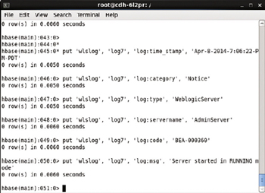

**Figure 10-40:**Putting Data into HBase Table

To list the tables run the following command.

list

The wlslog table gets listed as shown in [Figure 10-41](https://viewer.books24x7.com/assetviewer.aspx?bookid=113388&chunkid=494536465&resumebookmarkid=a546b65e-d1be-e911-b9b2-00505695593a).

[Larger View](https://viewer.books24x7.com/assetviewer.aspx?bookid=113388&chunkid=494536465&resumebookmarkid=a546b65e-d1be-e911-b9b2-00505695593a)

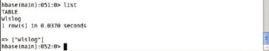

**Figure 10-41:**Listing HBase Tables

To get the data in row with row key 'log1' run the following command.

get 'wlslog', 'log1'

A single row of data gets listed as shown in [Figure 10-42](https://viewer.books24x7.com/assetviewer.aspx?bookid=113388&chunkid=494536465&resumebookmarkid=a546b65e-d1be-e911-b9b2-00505695593a).

[Larger View](https://viewer.books24x7.com/assetviewer.aspx?bookid=113388&chunkid=494536465&resumebookmarkid=a546b65e-d1be-e911-b9b2-00505695593a)

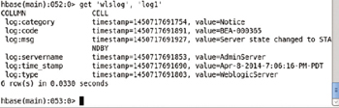

**Figure 10-42:**Getting a Single Row of Data

Get the data in a single column, the log.msg column from row with row key log7. A column is specified with column family:column format.

get 'wlslog', 'log7', {COLUMNS=>['log:msg']}

The single column data gets output as shown in [Figure 10-43](https://viewer.books24x7.com/assetviewer.aspx?bookid=113388&chunkid=494536465&resumebookmarkid=a546b65e-d1be-e911-b9b2-00505695593a).

[Larger View](https://viewer.books24x7.com/assetviewer.aspx?bookid=113388&chunkid=494536465&resumebookmarkid=a546b65e-d1be-e911-b9b2-00505695593a)

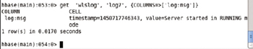

**Figure 10-43:**Getting a Single Column Value in a Row

The scan command is shown in [Figure 10-44](https://viewer.books24x7.com/assetviewer.aspx?bookid=113388&chunkid=494536465&resumebookmarkid=a546b65e-d1be-e911-b9b2-00505695593a).

scan 'wlslog'

The scan command is shown in [Figure 10-44](https://viewer.books24x7.com/assetviewer.aspx?bookid=113388&chunkid=494536465&resumebookmarkid=a546b65e-d1be-e911-b9b2-00505695593a).

[Larger View](https://viewer.books24x7.com/assetviewer.aspx?bookid=113388&chunkid=494536465&resumebookmarkid=a546b65e-d1be-e911-b9b2-00505695593a)

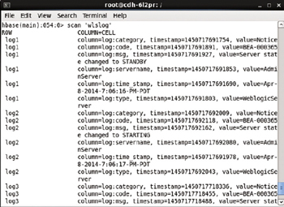

**Figure 10-44:**Scanning a HBase Table

All the data from the wlslog table gets listed as shown in [Figure 10-45](https://viewer.books24x7.com/assetviewer.aspx?bookid=113388&chunkid=494536465&resumebookmarkid=a546b65e-d1be-e911-b9b2-00505695593a).

[Larger View](https://viewer.books24x7.com/assetviewer.aspx?bookid=113388&chunkid=494536465&resumebookmarkid=a546b65e-d1be-e911-b9b2-00505695593a)

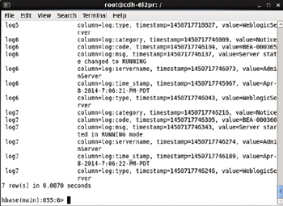

**Figure 10-45:**The scan Command outputs 7 Rows of Data

### Deleting the Replication Controller and Service

In the next section we shall create a cluster for the svds/cdh image imperatively on the command line. Delete the replication controller and the service created declaratively.

kubectl delete rc cdh

kubectl delete service cdh

**Creating an Apache Hadoop Cluster Imperatively**

In the following subsections we shall create a CDH cluster from the svds/cdh Docker image on the command line. First, we shall create a replication controller.

**Creating a Replication Controller**

Run the following command to create a replication controller called cdh with 2 replicas.

kubectl run cdh --image=svds/cdh --replicas=2

The cdh controller gets created as shown in [Figure 10-46](https://viewer.books24x7.com/assetviewer.aspx?bookid=113388&chunkid=785190162&resumebookmarkid=a546b65e-d1be-e911-b9b2-00505695593a). The selector is set to run=cdh by default.

[Larger View](https://viewer.books24x7.com/assetviewer.aspx?bookid=113388&chunkid=785190162&resumebookmarkid=a546b65e-d1be-e911-b9b2-00505695593a)



**Figure 10-46:**Creating a Replication Controller Imperatively

List the replication controllers.

kubectl get rc

The cdh replication controller gets listed as shown in [Figure 10-47](https://viewer.books24x7.com/assetviewer.aspx?bookid=113388&chunkid=785190162&resumebookmarkid=a546b65e-d1be-e911-b9b2-00505695593a).

[Larger View](https://viewer.books24x7.com/assetviewer.aspx?bookid=113388&chunkid=785190162&resumebookmarkid=a546b65e-d1be-e911-b9b2-00505695593a)



**Figure 10-47:**Getting the Replication Controller

**Listing the Pods**

To list the Pods in the cluster run the following command.

kubectl get pods

The two Pods get listed. Initially some or all of the Pods could be not "Running" or not in the READY state 1/1 as shown in [Figure 10-48](https://viewer.books24x7.com/assetviewer.aspx?bookid=113388&chunkid=785190162&resumebookmarkid=a546b65e-d1be-e911-b9b2-00505695593a).

[Larger View](https://viewer.books24x7.com/assetviewer.aspx?bookid=113388&chunkid=785190162&resumebookmarkid=a546b65e-d1be-e911-b9b2-00505695593a)

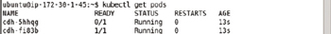

**Figure 10-48:**Listing the Pods with some Pod/s not READY yet

Run the preceding command again after a few seconds.

kubectl get pods

All the pods should be listed with STATUS "Running" and READY state 1/1 as shown in [Figure 10-49](https://viewer.books24x7.com/assetviewer.aspx?bookid=113388&chunkid=785190162&resumebookmarkid=a546b65e-d1be-e911-b9b2-00505695593a).

[Larger View](https://viewer.books24x7.com/assetviewer.aspx?bookid=113388&chunkid=785190162&resumebookmarkid=a546b65e-d1be-e911-b9b2-00505695593a)

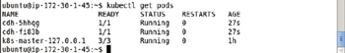

**Figure 10-49:**Listing all Pods as Running and Ready

**Scaling a Cluster**

To scale the cluster to 4 replicas run the following command.

kubectl scale rc cdh --replicas=4

Subsequently list the Pods.

kubectl get pods

An output of "scaled" from the first command indicates that the cluster got scaled. The second command lists 4 Pods instead of the 2 created initially as shown in [Figure 10-50](https://viewer.books24x7.com/assetviewer.aspx?bookid=113388&chunkid=785190162&resumebookmarkid=a546b65e-d1be-e911-b9b2-00505695593a). The second command may have to be run multiple times to list all Pods with STATUS "Running" and READY state 1/1.

[Larger View](https://viewer.books24x7.com/assetviewer.aspx?bookid=113388&chunkid=785190162&resumebookmarkid=a546b65e-d1be-e911-b9b2-00505695593a)

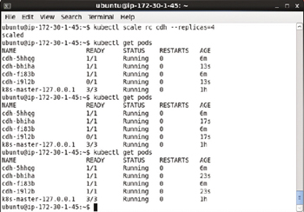

**Figure 10-50:**Scaling the CDH Cluster

**Creating a Service**

A service exposes the Pods managed by the replication controller at service endpoints, which are just host:port settings at which external clients may invoke the application. Run the following command to create a service.

kubectl expose rc cdh --type=LoadBalancer

Subsequently list the services.

kubectl get services

The "cdh" service gets listed with default settings for SELECTOR and PORT as shown in [Figure 10-51](https://viewer.books24x7.com/assetviewer.aspx?bookid=113388&chunkid=785190162&resumebookmarkid=a546b65e-d1be-e911-b9b2-00505695593a). The default service selector is run=cdh, which has the default format run =<servicename>. The default port is 8020.

[Larger View](https://viewer.books24x7.com/assetviewer.aspx?bookid=113388&chunkid=785190162&resumebookmarkid=a546b65e-d1be-e911-b9b2-00505695593a)

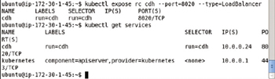

**Figure 10-51:**Creating a Service

**Starting an Interactive Shell**

The interactive shell may be started just as for a CDH cluster started declaratively. Copy the container id for a Docker container running the CDH image and run the following command, which includes the container id, to start an interactive bash shell.

sudo docker exec -it 42f2d8f40fl7 bash

The interactive shell gets started as shown in [Figure 10-52](https://viewer.books24x7.com/assetviewer.aspx?bookid=113388&chunkid=785190162&resumebookmarkid=a546b65e-d1be-e911-b9b2-00505695593a).

[Larger View](https://viewer.books24x7.com/assetviewer.aspx?bookid=113388&chunkid=785190162&resumebookmarkid=a546b65e-d1be-e911-b9b2-00505695593a)



**Figure 10-52:**Starting an Interactive Shell

Run the hdfs command.

hdfs

The hdfs command usage gets output as shown in [Figure 10-53](https://viewer.books24x7.com/assetviewer.aspx?bookid=113388&chunkid=785190162&resumebookmarkid=a546b65e-d1be-e911-b9b2-00505695593a).

[Larger View](https://viewer.books24x7.com/assetviewer.aspx?bookid=113388&chunkid=785190162&resumebookmarkid=a546b65e-d1be-e911-b9b2-00505695593a)

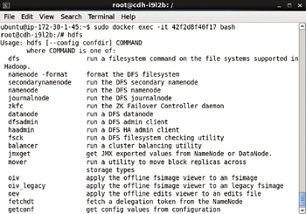

**Figure 10-53:**Command Usage for hdfs Command

### Summary

In this chapter we used the Kubernetes cluster manager to create a cluster of Pods based on the Docker image svds/cdh. We used both the declarative and imperative approaches to create the cluster. We scaled the cluster using the kubectl scale command. We also demonstrated using some of the Apache Hadoop frameworks packaged in the cdh image. We ran a MapReduce wordcount example application. We also ran the Apache Hive and Apache HBase tools. In the next chapter we shall discuss using Kubernetes with the indexing and storage framework Apache Solr.

**Kubernetes Microservices with Docker**

Chapter 11 - Using Apache Solr

Apress © 2016

## Chapter 11: Using Apache Solr

**© Deepak Vohra 2016  
D. Vohra, *Kubernetes Microservices with Docker*, DOI 10.1007/978-1-4842-1907-2\_11**

### Overview

Apache Solr is an Apache Lucene-based enterprise search platform providing features such as full-text search, near real-time indexing, and database integration. Apache Solr runs as a full-text search server within a servlet container, the default being Jetty, which is included with the Solr installation. In this chapter we shall discuss using Kubernetes cluster manager with Apache Solr. We shall be using only the declarative approach, which makes use of definition files, for creating and managing a Solr cluster.

**Setting the Environment**

The following software is required for this chapter.

* -Docker Engine (latest version)
* -Kubernetes (version 1.01)
* -Kubectl (version 1.01)
* -Docker image for Apache Solr (latest version)

We have used the same Amazon EC2 instance AMI as in the other chapters. SSH login to the Ubuntu instance from a local machine.

ssh -i "docker.pem" ubuntu@54.152.82.142

Install the required software as discussed in [chapter 1](http://viewer.books24x7.com/assetviewer.aspx?bkid=113388&destid=28#28). Start Docker and verify its status.

sudo service docker start

sudo service docker status

As shown in [Figure 11-1](https://viewer.books24x7.com/assetviewer.aspx?bookid=113388&chunkid=518292684&resumebookmarkid=a546b65e-d1be-e911-b9b2-00505695593a) Docker should be running.

[Larger View](https://viewer.books24x7.com/assetviewer.aspx?bookid=113388&chunkid=518292684&resumebookmarkid=a546b65e-d1be-e911-b9b2-00505695593a)

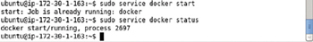

**Figure 11-1:**Starting Docker and Verifying Status

List the services.

kubectl get services

As shown in [Figure 11-2](https://viewer.books24x7.com/assetviewer.aspx?bookid=113388&chunkid=518292684&resumebookmarkid=a546b65e-d1be-e911-b9b2-00505695593a) Kubernetes service should be running.

[Larger View](https://viewer.books24x7.com/assetviewer.aspx?bookid=113388&chunkid=518292684&resumebookmarkid=a546b65e-d1be-e911-b9b2-00505695593a)

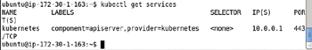

**Figure 11-2:**Listing the "kubernetes" Service

To list the nodes run the following command.

kubectl get nodes

The 127.0.0.1 node gets listed as shown in [Figure 11-3](https://viewer.books24x7.com/assetviewer.aspx?bookid=113388&chunkid=518292684&resumebookmarkid=a546b65e-d1be-e911-b9b2-00505695593a).

[Larger View](https://viewer.books24x7.com/assetviewer.aspx?bookid=113388&chunkid=518292684&resumebookmarkid=a546b65e-d1be-e911-b9b2-00505695593a)

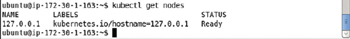

**Figure 11-3:**Listing a Single Node

List the endpoints with the following command.

kubectl get endpoints

Initially only the endpoint for kubernetes is listed as shown in [Figure 11-4](https://viewer.books24x7.com/assetviewer.aspx?bookid=113388&chunkid=518292684&resumebookmarkid=a546b65e-d1be-e911-b9b2-00505695593a).

[Larger View](https://viewer.books24x7.com/assetviewer.aspx?bookid=113388&chunkid=518292684&resumebookmarkid=a546b65e-d1be-e911-b9b2-00505695593a)

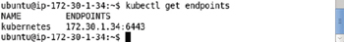

**Figure 11-4:**Listing "kubernetes" Endpoint

### Creating a Service

Create a definition file solr-service.yaml and add the following ([Table 11-1](https://viewer.books24x7.com/assetviewer.aspx?bookid=113388&chunkid=998074559&resumebookmarkid=a546b65e-d1be-e911-b9b2-00505695593a)) fields to the definition file.M

**Table 11-1: Service Definition File for Apache Solr**[[](https://viewer.books24x7.com/outputobject.aspx?bookid=113388&chunkid=998074559&objectid=ch11_tab1&objecttype=spreadsheet) Open table as spreadsheet](https://viewer.books24x7.com/outputobject.aspx?bookid=113388&chunkid=998074559&objectid=ch11_tab1&objecttype=spreadsheet" \t "_blank)

| **Field** | **Description** | **Value** |
| --- | --- | --- |
| apiVersion |  | v1 |
| kind | The kind of definition file. | Service |
| metadata | The service metadata. |  |
| metadata - > labels | The service labels. Not required. | app: solrApp |
| metadata - > name | The service name. Required. | solr-service |
| spec | The service specification. |  |
| spec - > ports | The ports exposed by the service. |  |
| spec - > ports- > port | A port exposed by the service. | 8983 |
| spec - > ports- > targetPort | The target port. | 8983 |
| spec - > selector | The Pod selector. Service routes traffic to the Pods with a label matching the selector expression. | app: solrApp |

The solr-service.yaml is listed.

apiVersion: v1

kind: Service

metadata:

labels:

app: solrApp

name: solr-service

spec:

ports:

-

port: 8983

targetPort: 8983

selector:

app: solrApp

The solr-service.yaml may be edited in the vi editor and saved with :wq as shown in [Figure 11-5](https://viewer.books24x7.com/assetviewer.aspx?bookid=113388&chunkid=998074559&resumebookmarkid=a546b65e-d1be-e911-b9b2-00505695593a).

[Larger View](https://viewer.books24x7.com/assetviewer.aspx?bookid=113388&chunkid=998074559&resumebookmarkid=a546b65e-d1be-e911-b9b2-00505695593a)

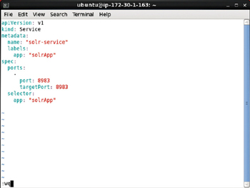

**Figure 11-5:**Service Definition File in vi Editor

Create a service from the definition file with the following command.

kubectl create -f solr-service.yaml

Subsequently list the services.

kubectl get services

An output of "services/solr-service" as shown in [Figure 11-6](https://viewer.books24x7.com/assetviewer.aspx?bookid=113388&chunkid=998074559&resumebookmarkid=a546b65e-d1be-e911-b9b2-00505695593a) indicates that the service has been created. Subsequently the solr-service gets listed. The service has label app=solrApp and selector app=solrApp.

[Larger View](https://viewer.books24x7.com/assetviewer.aspx?bookid=113388&chunkid=998074559&resumebookmarkid=a546b65e-d1be-e911-b9b2-00505695593a)

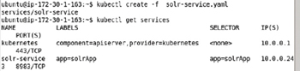

**Figure 11-6:**Creating a Service from Definition File

**Listing Service Endpoints**

To list the endpoints run the following command.

kubectl get endpoints

As the solr-service is not managing any Pods initially, no endpoint gets listed as shown in [Figure 11-7](https://viewer.books24x7.com/assetviewer.aspx?bookid=113388&chunkid=281019981&resumebookmarkid=a546b65e-d1be-e911-b9b2-00505695593a).

[Larger View](https://viewer.books24x7.com/assetviewer.aspx?bookid=113388&chunkid=281019981&resumebookmarkid=a546b65e-d1be-e911-b9b2-00505695593a)

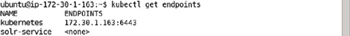

**Figure 11-7:**Listing the Endpoint for the Solr Service

**Describing the Service**

To describe the solr-service run the following command.

kubectl describe service solr-service

The service name, namespace, labels, selector, type, IP, Port, endpoints, and events get listed as shown in [Figure 11-8](https://viewer.books24x7.com/assetviewer.aspx?bookid=113388&chunkid=531301507&resumebookmarkid=a546b65e-d1be-e911-b9b2-00505695593a).

[Larger View](https://viewer.books24x7.com/assetviewer.aspx?bookid=113388&chunkid=531301507&resumebookmarkid=a546b65e-d1be-e911-b9b2-00505695593a)

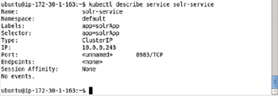

**Figure 11-8:**Describing the Apache Solr Service

**Creating a Replication Controller**

Create a definition file solr-rc.yaml for the replication controller and add the following ([Table 11-2](https://viewer.books24x7.com/assetviewer.aspx?bookid=113388&chunkid=470095663)) fields to the definition file.

**Table 11-2: Replication Controller Definition File Fields**[[](https://viewer.books24x7.com/outputobject.aspx?bookid=113388&chunkid=470095663&objectid=ch11_tab2&objecttype=spreadsheet) Open table as spreadsheet](https://viewer.books24x7.com/outputobject.aspx?bookid=113388&chunkid=470095663&objectid=ch11_tab2&objecttype=spreadsheet" \t "_blank)

| **Field** | **Description** | **Value** |
| --- | --- | --- |
| apiVersion |  | v1 |
| kind | The kind of definition file. | Replication Controller |
| metadata | The replication controller metadata. |  |
| metadata - > labels | The replication controller labels. | app: solrApp |
| metadata - > name | The replication controller name. | solr-rc |
| spec | The replication controller specification. |  |
| spec - > replicas | The number of Pod replicas. | 2 |
| spec - > selector | A key: value expression for selecting the Pods to manage. Pods with a label the same as the selector expression are managed by the replication controller. For a single label/selector expression Pod/Replication Controller combination the selector expression must be the same as the spec- > template- > metadata- > labels expression. The selector defaults to the spec- > template- > metadata- > labels not specified. The app: solrApp setting translates to app=solrApp. | app: solrApp |
| spec - > template | The Pod template. |  |
| spec - > template - > metadata | The Pod template metadata. |  |
| spec - > template- > metadata- > labels | The Pod template labels. | app: solrApp |
| spec - > template - > spec | The Pod template specification. |  |
| spec - > template - > spec - > containers | The containers configuration for the Pod template. |  |
| spec - > template - > spec - > containers - > image | The Docker image. | solr |
| spec - > template - > spec - > containers - > name | The container name. | solr |
| spec - > template - > spec - > containers - > ports | Container ports. |  |
| spec - > template - > spec - > containers - > ports - > containerPort | Container port for Solr server. | 8983 |
| spec - > template - > spec - > containers - > ports - > name | Solr port name. | solrApp |

The solr-rc.yaml is listed.

apiVersion: v1

kind: ReplicationController

metadata:

labels:

app: solrApp

name: solr-rc

spec:

replicas: 2

selector:

app: solrApp

template:

metadata:

labels:

app: solrApp

spec:

containers:

-

image: solr

name: solr

ports:

-

containerPort: 8983

name: solrApp

The solr-rc.yaml definition file may be created and saved in vi editor as shown in [Figure 11-9](https://viewer.books24x7.com/assetviewer.aspx?bookid=113388&chunkid=470095663).

[Larger View](https://viewer.books24x7.com/assetviewer.aspx?bookid=113388&chunkid=470095663)

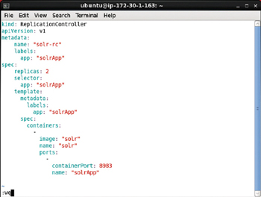

**Figure 11-9:**Replication Controller Definition File in vi Editor

Run the following command to create a replication controller from the definition file.

kubectl create -f solr-rc.yaml

The solr-rc replication controller gets created as shown in [Figure 11-10](https://viewer.books24x7.com/assetviewer.aspx?bookid=113388&chunkid=470095663). Subsequently list the replication controllers.

kubectl get rc

The solr-rc replication controller gets listed as shown in [Figure 11-10](https://viewer.books24x7.com/assetviewer.aspx?bookid=113388&chunkid=470095663).

[Larger View](https://viewer.books24x7.com/assetviewer.aspx?bookid=113388&chunkid=470095663)

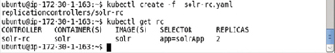

**Figure 11-10:**Creating a Replication Controller from Definition File

**Listing the Pods**

List the Pods with the following command.

kubectl get pods

The two Pods created by the replication controller get listed as shown in [Figure 11-11](https://viewer.books24x7.com/assetviewer.aspx?bookid=113388&chunkid=209738342&resumebookmarkid=74f9578a-74bf-e911-b9b2-00505695593a). Initially some of the Pods could be not running and not ready.

[Larger View](https://viewer.books24x7.com/assetviewer.aspx?bookid=113388&chunkid=209738342&resumebookmarkid=74f9578a-74bf-e911-b9b2-00505695593a)

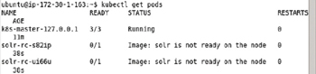

**Figure 11-11:**Listing the Pods, all of them not yet Ready

Run the same command again after a few seconds to list the Pods again.

kubectl get pods

The Pods should get listed with STATUS "Running" and READY state 1/1 as shown in [Figure 11-12](https://viewer.books24x7.com/assetviewer.aspx?bookid=113388&chunkid=209738342&resumebookmarkid=74f9578a-74bf-e911-b9b2-00505695593a).

[Larger View](https://viewer.books24x7.com/assetviewer.aspx?bookid=113388&chunkid=209738342&resumebookmarkid=74f9578a-74bf-e911-b9b2-00505695593a)

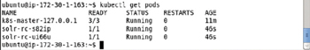

**Figure 11-12:**Listing the Pods as Ready

To describe the solr-service run the following command.

kubectl describe svc solr-service

The service description gets listed as shown in [Figure 11-13](https://viewer.books24x7.com/assetviewer.aspx?bookid=113388&chunkid=209738342&resumebookmarkid=74f9578a-74bf-e911-b9b2-00505695593a). The service endpoints for the two Pods are also listed. A service is accessed at its endpoints. When described previously, before creating the replication controller, no service endpoints got listed as shown in [Figure 11-8](http://viewer.books24x7.com/assetviewer.aspx?bkid=113388&destid=1000#1000).

[Larger View](https://viewer.books24x7.com/assetviewer.aspx?bookid=113388&chunkid=209738342&resumebookmarkid=74f9578a-74bf-e911-b9b2-00505695593a)

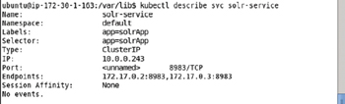

**Figure 11-13:**Describing the Solr Service including the Service Endpoints

The endpoints may also be listed separately.

kubectl get endpoints

The endpoints get listed as shown in [Figure 11-14](https://viewer.books24x7.com/assetviewer.aspx?bookid=113388&chunkid=209738342&resumebookmarkid=74f9578a-74bf-e911-b9b2-00505695593a).

[Larger View](https://viewer.books24x7.com/assetviewer.aspx?bookid=113388&chunkid=209738342&resumebookmarkid=74f9578a-74bf-e911-b9b2-00505695593a)

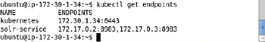

**Figure 11-14:**Listing the Endpoints for Solr Service

**Describing a Replication Controller**

To describe the replication controller solr-rc run the following command.

kubectl describe rc solr-rc

The replication controller description gets listed as shown in [Figure 11-15](https://viewer.books24x7.com/assetviewer.aspx?bookid=113388&chunkid=719069677&resumebookmarkid=74f9578a-74bf-e911-b9b2-00505695593a).

[Larger View](https://viewer.books24x7.com/assetviewer.aspx?bookid=113388&chunkid=719069677&resumebookmarkid=74f9578a-74bf-e911-b9b2-00505695593a)

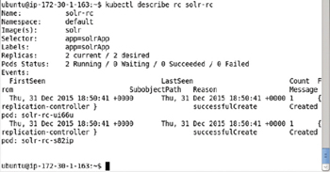

**Figure 11-15:**Describing the Replication Controller

**Listing the Logs**

To list the logs for a particular command run the kubectl logs command. For example, logs for the solr-rc-s82ip Pod are listed with the following command.

kubectl logs solr-rc-s82ip

In the log output the Solr server is starting as shown in [Figure 11-16](https://viewer.books24x7.com/assetviewer.aspx?bookid=113388&chunkid=639935442&resumebookmarkid=74f9578a-74bf-e911-b9b2-00505695593a).

[Larger View](https://viewer.books24x7.com/assetviewer.aspx?bookid=113388&chunkid=639935442&resumebookmarkid=74f9578a-74bf-e911-b9b2-00505695593a)

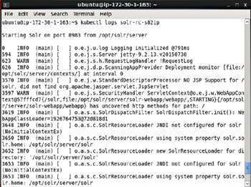

**Figure 11-16:**Listing Logs for the Pod

After the server has started the output "Server Started" gets output as shown in [Figure 11-17](https://viewer.books24x7.com/assetviewer.aspx?bookid=113388&chunkid=639935442&resumebookmarkid=74f9578a-74bf-e911-b9b2-00505695593a).

[Larger View](https://viewer.books24x7.com/assetviewer.aspx?bookid=113388&chunkid=639935442&resumebookmarkid=74f9578a-74bf-e911-b9b2-00505695593a)

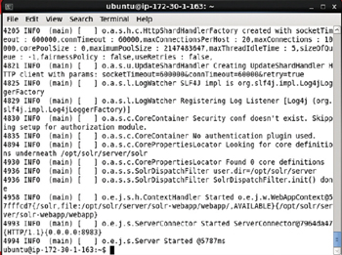

**Figure 11-17:**Listing the Solr Server as started

**Starting an Interactive Shell**

As the "solr" Docker image inherits from the "java:openjdk-8-jre" Docker image, which further inherits from the "buildpack-deps:jessie-curl" image, which inherits from Docker image "debian" for Linux an interactive bash shell may be started to access a Docker container based on the "solr" Docker image. To access the Solr software we need to start an interactive bash shell for a Docker container running Solr. Obtain the container if for a Docker container running Solr with the following command.

sudo docker ps

The Docker containers get listed as shown in [Figure 11-18](https://viewer.books24x7.com/assetviewer.aspx?bookid=113388&chunkid=162670875&resumebookmarkid=74f9578a-74bf-e911-b9b2-00505695593a).

[Larger View](https://viewer.books24x7.com/assetviewer.aspx?bookid=113388&chunkid=162670875&resumebookmarkid=74f9578a-74bf-e911-b9b2-00505695593a)

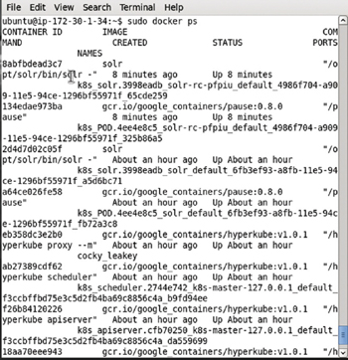

**Figure 11-18:**Listing the Docker Container for Apache Solr

Copy the container if and start an interactive shell.

sudo docker exec -it 2d4d7d02c05f bash

The interactive shell gets started as shown in [Figure 11-19](https://viewer.books24x7.com/assetviewer.aspx?bookid=113388&chunkid=162670875&resumebookmarkid=74f9578a-74bf-e911-b9b2-00505695593a). To list the status of the Solr server run the following command.

bin/solr status

[Larger View](https://viewer.books24x7.com/assetviewer.aspx?bookid=113388&chunkid=162670875&resumebookmarkid=74f9578a-74bf-e911-b9b2-00505695593a)

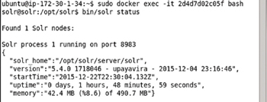

**Figure 11-19:**Listing the Solr Status in an Interactive Shell for the Docker Container

Solr 5.x introduce *configsets*. The configsets directory consists of example configurations that may be used as a base to create new Solr cores or collections. The configsets replace the collection1 example core configuration in Solr 4.x. Cd (change directory) to the configsets directory.

cd /opt/solr/server/solr/configsets

List the files and directories in the configsets directory.

ls –l

Three example configurations get listed as shown in [Figure 11-20](https://viewer.books24x7.com/assetviewer.aspx?bookid=113388&chunkid=162670875&resumebookmarkid=74f9578a-74bf-e911-b9b2-00505695593a).

[Larger View](https://viewer.books24x7.com/assetviewer.aspx?bookid=113388&chunkid=162670875&resumebookmarkid=74f9578a-74bf-e911-b9b2-00505695593a)

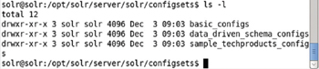

**Figure 11-20:**Listing the Example Configurations

When we create a Solr core later in the chapter we shall be using the basic\_configs configuration. List the files in the //configsets/ basic\_configs/conf directory.

cd conf

ls –l

The configuration files for basic\_configs example get listed and include the schema.xmland solrconfig.xml as shown in [Figure 11-21](https://viewer.books24x7.com/assetviewer.aspx?bookid=113388&chunkid=162670875&resumebookmarkid=74f9578a-74bf-e911-b9b2-00505695593a).

[Larger View](https://viewer.books24x7.com/assetviewer.aspx?bookid=113388&chunkid=162670875&resumebookmarkid=74f9578a-74bf-e911-b9b2-00505695593a)

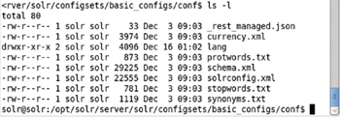

**Figure 11-21:**Listing the Configuration Files in the basic\_configs Example Configuration

**Creating a Solr Core**

A new Solr core may also be created from the command line. The solr create command is used to create a new core or a collection. As an example, create a core called wlslog with the solr create\_core command. Use the configset basic\_configs with the –d option. The default config set used if none is specified (with the –d option) is data\_driven\_schema\_configs. Cd to the /opt/solr directory and run the following command.

bin/solr create\_core -c wlslog -d /opt/solr/server/solr/configsets/basic\_configs

A Solr core called wlslog gets created as shown in [Figure 11-22](https://viewer.books24x7.com/assetviewer.aspx?bookid=113388&chunkid=933583028&resumebookmarkid=74f9578a-74bf-e911-b9b2-00505695593a).

[Larger View](https://viewer.books24x7.com/assetviewer.aspx?bookid=113388&chunkid=933583028&resumebookmarkid=74f9578a-74bf-e911-b9b2-00505695593a)

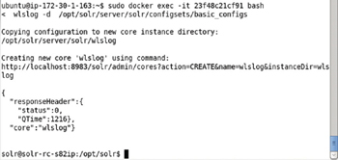

**Figure 11-22:**Creating a Solr Core called wlslog

**Indexing Documents**

Apache Solr provides the post tool for indexing documents from the command line. The post tool supports different input file formats such as XML, CSV and JSON. We shall index an XML format document Save the following XML document to the wlslog.xml file.

<add>

<doc>

<field name="id">wlslog1</field>

<field name="time\_stamp\_s">Apr-8-2014-7:06:16-PM-PDT</field>

<field name="category\_s">Notice</field>

<field name="type\_s">WebLogicServer</field>

<field name="servername\_s">AdminServer</field>

<field name="code\_s">BEA-000365</field>

<field name="msg\_s">Server state changed to STANDBY</field>

</doc>

<doc>

<field name="id">wlslog2</field>

<field name="time\_stamp\_s">Apr-8-2014-7:06:17-PM-PDT</field>

<field name="category\_s">Notice</field>

<field name="type\_s">WebLogicServer</field>

<field name="servername\_s">AdminServer</field>

<field name="code">BEA-000365</field>

<field name="msg\_s">Server state changed to STARTING</field>

</doc>

<doc>

<field name="id">wlslog3</field>

<field name="time\_stamp\_s">Apr-8-2014-7:06:18-PM-PDT</field>

<field name="category\_s">Notice</field>

<field name="type\_s">WebLogicServer</field>

<field name="servername\_s">AdminServer</field>

<field name="code">BEA-000365</field>

<field name="msg\_s">Server state changed to ADMIN</field>

</doc>

<doc>

<field name="id">wlslog4</field>

<field name="time\_stamp\_s">Apr-8-2014-7:06:19-PM-PDT</field>

<field name="category\_s">Notice</field>

<field name="type\_s">WebLogicServer</field>

<field name="servername\_s">AdminServer</field>

<field name="code">BEA-000365</field>

<field name="msg\_s">Server state changed to RESUMING</field>

</doc>

<doc>

<field name="id">wlslog5</field>

<field name="time\_stamp\_s">Apr-8-2014-7:06:20-PM-PDT</field>

<field name="category\_s">Notice</field>

<field name="type\_s">WebLogicServer</field>

<field name="servername\_s">AdminServer</field>

<field name="code">BEA-000331</field>

<field name="msg\_s">Started WebLogic AdminServer</field>

</doc>

<doc>

<field name="id">wlslog6</field>

<field name="time\_stamp\_s">Apr-8-2014-7:06:21-PM-PDT</field>

<field name="category\_s">Notice</field>

<field name="type\_s">WebLogicServer</field>

<field name="servername\_s">AdminServer</field>

<field name="code">BEA-000365</field>

<field name="msg\_s">Server state changed to RUNNING</field>

</doc>

<doc>

<field name="id">wlslog7</field>

<field name="time\_stamp\_s">Apr-8-2014-7:06:22-PM-PDT</field>

<field name="category\_s">Notice</field>

<field name="type\_s">WebLogicServer</field>

<field name="servername\_s">AdminServer</field>

<field name="code">BEA-000360</field>

<field name="msg\_s">Server started in RUNNING mode</field>

</doc>

</add>

The wlslog.xml file may be created in the vi editor and saved with the :wq command as shown in [Figure 11-23](https://viewer.books24x7.com/assetviewer.aspx?bookid=113388&chunkid=919429973&resumebookmarkid=74f9578a-74bf-e911-b9b2-00505695593a).

[Larger View](https://viewer.books24x7.com/assetviewer.aspx?bookid=113388&chunkid=919429973&resumebookmarkid=74f9578a-74bf-e911-b9b2-00505695593a)

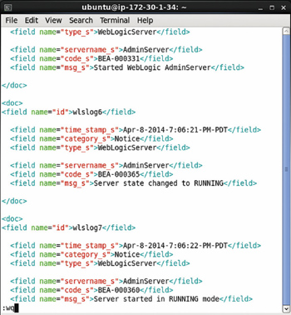

**Figure 11-23:**The wlslog.xml File

Cd to the /opt/solr directory and run the post tool to add the documents in the wlslog.xmlfile to Solr server.

bin/post -c wlslog ./wlslog.xml

One file gets indexed as shown in [Figure 11-24](https://viewer.books24x7.com/assetviewer.aspx?bookid=113388&chunkid=919429973&resumebookmarkid=74f9578a-74bf-e911-b9b2-00505695593a).

[Larger View](https://viewer.books24x7.com/assetviewer.aspx?bookid=113388&chunkid=919429973&resumebookmarkid=74f9578a-74bf-e911-b9b2-00505695593a)

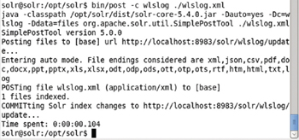

**Figure 11-24:**Posting the wlslog.xml File to the Solr Index

**Accessing Solr on Command Line with a REST Client**

Solr request handler commands such as /update, /select may be run using a REST client such as curl and wget. In this section we shall use the curl tool to run some of the /selectrequest handler commands. For example, query all documents using the following curl command.

curl http://localhost:8983/solr/wlslog/select?q=\*%3A\*&wt=json&indent=true

The curl command is shown in [Figure 11-25](https://viewer.books24x7.com/assetviewer.aspx?bookid=113388&chunkid=573356396&resumebookmarkid=74f9578a-74bf-e911-b9b2-00505695593a).

[Larger View](https://viewer.books24x7.com/assetviewer.aspx?bookid=113388&chunkid=573356396&resumebookmarkid=74f9578a-74bf-e911-b9b2-00505695593a)

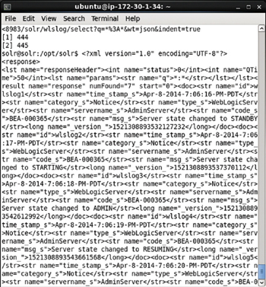

**Figure 11-25:**Using curl to send a Request to Solr Server with Request Handler /select

The 7 documents added get listed as shown in [Figure 11-26](https://viewer.books24x7.com/assetviewer.aspx?bookid=113388&chunkid=573356396&resumebookmarkid=74f9578a-74bf-e911-b9b2-00505695593a).

[Larger View](https://viewer.books24x7.com/assetviewer.aspx?bookid=113388&chunkid=573356396&resumebookmarkid=74f9578a-74bf-e911-b9b2-00505695593a)

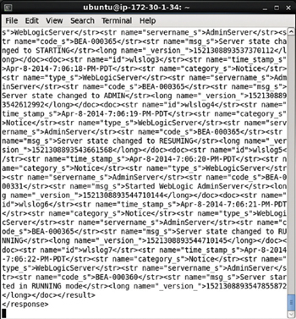

**Figure 11-26:**Listing the Documents returned by the /select Request Handler

As another example run the /select request handler to query for the document with id wlslog7.

curl http://localhost:8983/solr/wlslog/select?q=id:wlslog7&wt=json&indent=true

The document for id wlslog7 gets listed as shown in [Figure 11-27](https://viewer.books24x7.com/assetviewer.aspx?bookid=113388&chunkid=573356396&resumebookmarkid=74f9578a-74bf-e911-b9b2-00505695593a).

[Larger View](https://viewer.books24x7.com/assetviewer.aspx?bookid=113388&chunkid=573356396&resumebookmarkid=74f9578a-74bf-e911-b9b2-00505695593a)

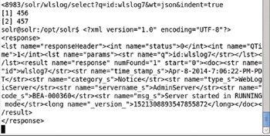

**Figure 11-27:**Querying for a Single Document with id wlslog7 using /select Request Handler and curl

Documents may be deleted with the post tool. For example, delete a document with id wlslog1 using the following command.

bin/post -c wlslog -d "<delete><id>wlslog1</idx/delete>"

The document with id wlslog1 gets deleted as shown in [Figure 11-28](https://viewer.books24x7.com/assetviewer.aspx?bookid=113388&chunkid=573356396&resumebookmarkid=74f9578a-74bf-e911-b9b2-00505695593a).

[Larger View](https://viewer.books24x7.com/assetviewer.aspx?bookid=113388&chunkid=573356396&resumebookmarkid=74f9578a-74bf-e911-b9b2-00505695593a)

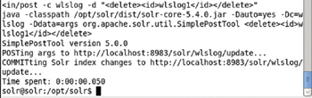

**Figure 11-28:**Deleting a Document using post Tool

Subsequently run the following curl command to list the documents in the wlslog index.

curl http://localhost:8983/solr/wlslog/select?q=\*%3A\*&wt=json&indent=true

The document with id wlslog1 does not get listed as shown in [Figure 11-29](https://viewer.books24x7.com/assetviewer.aspx?bookid=113388&chunkid=573356396&resumebookmarkid=74f9578a-74bf-e911-b9b2-00505695593a).

[Larger View](https://viewer.books24x7.com/assetviewer.aspx?bookid=113388&chunkid=573356396&resumebookmarkid=74f9578a-74bf-e911-b9b2-00505695593a)

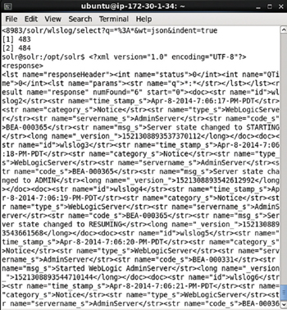

**Figure 11-29:**Querying after Deleting a Document

The /update request handler may be used to delete documents as in the following curl command, which deletes all documents in the wlslog core.

curl http://localhost:8983/solr/wlslog/update --data '<delete><query>\*:\*</query></delete>'

-H 'Content-type:text/xml; charset=utf-8'

If auto commit has not been configured the following curl command must be run to commit the changes.

curl http://localhost:8983/solr/wlslog/update --data '<commit/>' -H 'Content-type:text/xml;

charset=utf-8'

Subsequently run the curl command to invoke the /select request handler.

curl http://localhost:8983/solr/wlslog/select?q=\*%3A\*&wt=json&indent=true

No document gets listed as all have been deleted as shown in [Figure 11-30](https://viewer.books24x7.com/assetviewer.aspx?bookid=113388&chunkid=573356396&resumebookmarkid=74f9578a-74bf-e911-b9b2-00505695593a).

[Larger View](https://viewer.books24x7.com/assetviewer.aspx?bookid=113388&chunkid=573356396&resumebookmarkid=74f9578a-74bf-e911-b9b2-00505695593a)

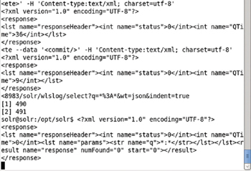

**Figure 11-30:**Deleting all Documents in Solr Index with /update

**Setting Port Forwarding**

If we were running Kubernetes on a local machine we could have opened the Solr Admin Console with url [http://localhost:8983](http://localhost:8983/) but because we are using Amazon EC2 instance we need to set port forwarding on a local machine with a web browser from localhost:8983 to 172.17.0.2:8983. Set port forwarding from localhost port 8983 with the following command run from a local machine.

ssh -i key-pair-file -f -nNT -L 8983:172.17.0.2:8983 ubuntu@ec2-54-152-82-142.compute-1.

amazonaws.com

The preceding command forwards the localhost:8983 URL to endpoint 172.17.0.2:8983 as shown in [Figure 11-31](https://viewer.books24x7.com/assetviewer.aspx?bookid=113388&chunkid=987957961&resumebookmarkid=74f9578a-74bf-e911-b9b2-00505695593a).

[Larger View](https://viewer.books24x7.com/assetviewer.aspx?bookid=113388&chunkid=987957961&resumebookmarkid=74f9578a-74bf-e911-b9b2-00505695593a)



**Figure 11-31:**Setting Port Forwarding to localhost

**Accessing Solr in Admin Console**

After port forwarding the Solr Admin Console may be accessed from the local machine using the url [http://localhost:8983](http://localhost:8983/) as shown in [Figure 11-32](https://viewer.books24x7.com/assetviewer.aspx?bookid=113388&chunkid=511922271&resumebookmarkid=74f9578a-74bf-e911-b9b2-00505695593a). Select the wlslog core in the Core Selector as shown in [Figure 11-32](https://viewer.books24x7.com/assetviewer.aspx?bookid=113388&chunkid=511922271&resumebookmarkid=74f9578a-74bf-e911-b9b2-00505695593a).

[Larger View](https://viewer.books24x7.com/assetviewer.aspx?bookid=113388&chunkid=511922271&resumebookmarkid=74f9578a-74bf-e911-b9b2-00505695593a)

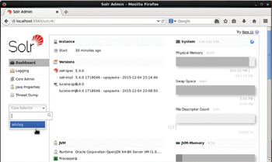

**Figure 11-32:**Displaying the Solr Admin Console

Select the Documents tab and set Document Type as XML for the /update Request handler as shown in [Figure 11-33](https://viewer.books24x7.com/assetviewer.aspx?bookid=113388&chunkid=511922271&resumebookmarkid=74f9578a-74bf-e911-b9b2-00505695593a). Copy and paste the XML document wlslog.xml listed earlier in the Document (s) field and click on Submit Document.

[Larger View](https://viewer.books24x7.com/assetviewer.aspx?bookid=113388&chunkid=511922271&resumebookmarkid=74f9578a-74bf-e911-b9b2-00505695593a)

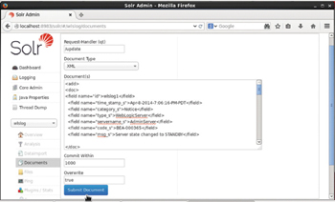

**Figure 11-33:**Adding Document to the wlslog Core

An output of "success" as shown in [Figure 11-34](https://viewer.books24x7.com/assetviewer.aspx?bookid=113388&chunkid=511922271&resumebookmarkid=74f9578a-74bf-e911-b9b2-00505695593a) indicates that the documents got indexed.

[Larger View](https://viewer.books24x7.com/assetviewer.aspx?bookid=113388&chunkid=511922271&resumebookmarkid=74f9578a-74bf-e911-b9b2-00505695593a)

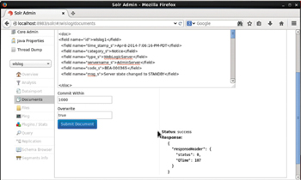

**Figure 11-34:**Response from adding Documents

Next, we shall query the wlslog index. Select the Query tab as shown in [Figure 11-35](https://viewer.books24x7.com/assetviewer.aspx?bookid=113388&chunkid=511922271&resumebookmarkid=74f9578a-74bf-e911-b9b2-00505695593a).

[Larger View](https://viewer.books24x7.com/assetviewer.aspx?bookid=113388&chunkid=511922271&resumebookmarkid=74f9578a-74bf-e911-b9b2-00505695593a)

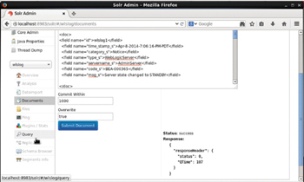

**Figure 11-35:**Selecting the Query Tab

With the Request Handler as /select the query is "\*:\*" by default as shown in [Figure 11-36](https://viewer.books24x7.com/assetviewer.aspx?bookid=113388&chunkid=511922271&resumebookmarkid=74f9578a-74bf-e911-b9b2-00505695593a).

[Larger View](https://viewer.books24x7.com/assetviewer.aspx?bookid=113388&chunkid=511922271&resumebookmarkid=74f9578a-74bf-e911-b9b2-00505695593a)

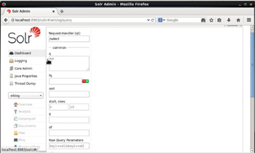

**Figure 11-36:**Using the Request Handler /select to Query Solr index wlslog

Click on Execute Query as shown in [Figure 11-37](https://viewer.books24x7.com/assetviewer.aspx?bookid=113388&chunkid=511922271&resumebookmarkid=74f9578a-74bf-e911-b9b2-00505695593a).

[Larger View](https://viewer.books24x7.com/assetviewer.aspx?bookid=113388&chunkid=511922271&resumebookmarkid=74f9578a-74bf-e911-b9b2-00505695593a)

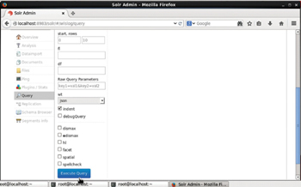

**Figure 11-37:**Submitting a Query to select all Documents in the wlslog Index

Because we have not set auto commit the documents added have not yet been indexed. As a result no document gets listed as shown in [Figure 11-38](https://viewer.books24x7.com/assetviewer.aspx?bookid=113388&chunkid=511922271&resumebookmarkid=74f9578a-74bf-e911-b9b2-00505695593a).

[Larger View](https://viewer.books24x7.com/assetviewer.aspx?bookid=113388&chunkid=511922271&resumebookmarkid=74f9578a-74bf-e911-b9b2-00505695593a)

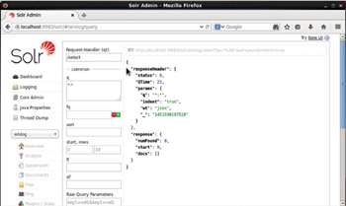

**Figure 11-38:**Response from the Query

We need to reload the core for the added documents to get indexed. Alternatively we could restart the Solr server but reloading the core is a quicker option. Select Core Admin and click on Reload as shown in [Figure 11-39](https://viewer.books24x7.com/assetviewer.aspx?bookid=113388&chunkid=511922271&resumebookmarkid=74f9578a-74bf-e911-b9b2-00505695593a).

[Larger View](https://viewer.books24x7.com/assetviewer.aspx?bookid=113388&chunkid=511922271&resumebookmarkid=74f9578a-74bf-e911-b9b2-00505695593a)

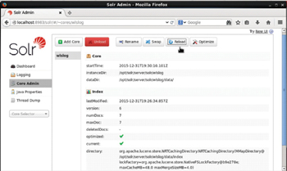

**Figure 11-39:**Reloading the Core

Run the query again and as shown in [Figure 11-40](https://viewer.books24x7.com/assetviewer.aspx?bookid=113388&chunkid=511922271&resumebookmarkid=74f9578a-74bf-e911-b9b2-00505695593a) the 7 documents added get listed.

[Larger View](https://viewer.books24x7.com/assetviewer.aspx?bookid=113388&chunkid=511922271&resumebookmarkid=74f9578a-74bf-e911-b9b2-00505695593a)

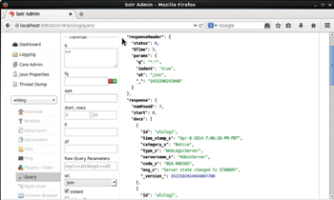

**Figure 11-40:**Query Response with 7 Documents

The \_version\_ field has been added to each document automatically by the Solr server as shown in [Figure 11-41](https://viewer.books24x7.com/assetviewer.aspx?bookid=113388&chunkid=511922271&resumebookmarkid=74f9578a-74bf-e911-b9b2-00505695593a).

[Larger View](https://viewer.books24x7.com/assetviewer.aspx?bookid=113388&chunkid=511922271&resumebookmarkid=74f9578a-74bf-e911-b9b2-00505695593a)

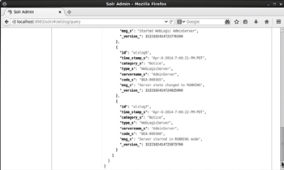

**Figure 11-41:**The \_version\_Field is added to each Document stored in Solr Index Automatically by the Solr Server

### Scaling the Cluster

To scale the Solr pod cluster run the kubectl scale command. For example, to scale to 4 Pods set replicas as 4.

kubectl scale rc solr-rc --replicas=4

An output of "scaled" indicates that the Solr cluster has been scaled. Subsequently run the following command to list the Pods.

kubectl get pods

The number of Pods listed is 4 instead of the 2 to start with as shown in [Figure 11-42](https://viewer.books24x7.com/assetviewer.aspx?bookid=113388&chunkid=164209116&resumebookmarkid=74f9578a-74bf-e911-b9b2-00505695593a). Some of the Pods could be not running or not ready initially.

[Larger View](https://viewer.books24x7.com/assetviewer.aspx?bookid=113388&chunkid=164209116&resumebookmarkid=74f9578a-74bf-e911-b9b2-00505695593a)

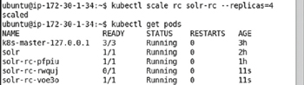

**Figure 11-42:**Scaling the Apache Solr Cluster to 4 Pods

### Summary

Apache Solr is an indexing and search engine that makes use of the local filesystem to store data. In this chapter we used Docker image "solr" with Kubernetes cluster manage to create and manage a cluster of Solr instances. We demonstrated accessing a Solr instance from an interactive shell for a Docker container and also using the Admin Console. In the next chapter we shall use Kubernetes with Apache Kafka.

**Kubernetes Microservices with Docker**

Chapter 12 - Using Apache Kafka

Apress © 2016

## Chapter 12: Using Apache Kafka

**© Deepak Vohra 2016  
D. Vohra, *Kubernetes Microservices with Docker*, DOI 10.1007/978-1-4842-1907-2\_12**

### Overview

Apache Kafka is publish-subscribe, high throughput, distributed messaging system. A single broker in Kafka could handle 100s MB (Terabytes)/sec of reads & writes from multiple clients. Messages are replicated across the cluster and persisted to disk. Kafka could be used for stream processing, web site activity tracking, metrics collection, and monitoring and log aggregation.

The main components of Kafka architecture are Producer, Broker, Topic, and Consumer. Kafka keeps feeds of messages in topics. Producers send (or write) messages to topics and Consumers consume (or read) messages from topics. Messages are byte arrays of data and could be in any format with String, JSON, and Avro being the most common. Messages are retained for a specified amount of time. A Zookeeper coordinates the Kafka cluster. In a single producer–consumer architecture, a single Producer sends messages to a Topic and a single Consumer consumes messages from the topic.

Kafka is similar to Flume in that it streams messages, but Kafka is designed for a different purpose. While Flume is designed to stream messages to a sink such as HDFS or HBase, Kafka is designed for messages to be consumed by multiple applications.

In this chapter we shall discuss using Kubernetes cluster manager with Apache Kafka.

**Setting the Environment**

We have used an Amazon EC2 instance created from AMI Ubuntu Server 14.04 LTS (HVM), SSD Volume Type - ami-d05e75b8. The following software is required for this chapter.

* -Docker Engine (latest version)
* -Kubernetes Cluster Manager (version 1.01)
* -Kubectl (version 1.01)
* -Docker image dockerkafka/kafka (latest version)

We have used the Docker image dockerkafka/kafka in this chapter. The default settings of the dockerkafka/kafka image Dockerfile are not suitable for orchestration with Kubernetes. In the next section we have modified and rebuilt the default Docker image. First, connect with the Ubuntu instance using the Public IP Address for the Amazon EC2 instance.

ssh -i "docker.pem" ubuntu@54.146.140.160

The Ubuntu instance gets connected to as shown in [Figure 12-1](https://viewer.books24x7.com/assetviewer.aspx?bookid=113388&chunkid=941676507&resumebookmarkid=74f9578a-74bf-e911-b9b2-00505695593a).

[Larger View](https://viewer.books24x7.com/assetviewer.aspx?bookid=113388&chunkid=941676507&resumebookmarkid=74f9578a-74bf-e911-b9b2-00505695593a)

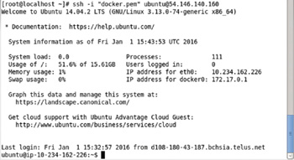

**Figure 12-1:**Connecting to an Ubuntu Instance on Amazon EC2

Install the required software as discussed in [chapter 1](http://viewer.books24x7.com/assetviewer.aspx?bkid=113388&destid=28#28). Start the Docker service and find its status.

sudo service docker start

sudo service docker status

Docker should be listed as running as shown in [Figure 12-2](https://viewer.books24x7.com/assetviewer.aspx?bookid=113388&chunkid=941676507&resumebookmarkid=74f9578a-74bf-e911-b9b2-00505695593a).

[Larger View](https://viewer.books24x7.com/assetviewer.aspx?bookid=113388&chunkid=941676507&resumebookmarkid=74f9578a-74bf-e911-b9b2-00505695593a)

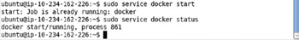

**Figure 12-2:**Starting Docker

List the Kubernetes services.

kubectl get services

The "kubernetes" service should be listed as shown in [Figure 12-3](https://viewer.books24x7.com/assetviewer.aspx?bookid=113388&chunkid=941676507&resumebookmarkid=74f9578a-74bf-e911-b9b2-00505695593a).

[Larger View](https://viewer.books24x7.com/assetviewer.aspx?bookid=113388&chunkid=941676507&resumebookmarkid=74f9578a-74bf-e911-b9b2-00505695593a)

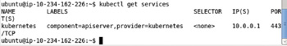

**Figure 12-3:**Listing the "kubernetes" Service

**Modifying the Docker Image**

The procedure to start Apache Kafka involves the following sequence.

1. Start Zookeeper Server
2. Start Apache Kafka Server

The Apache Kafka Server has a dependency on Zookeeper server and as a result requires the Zookeeper server to be running before the Kafka server may be started. The Kafka server makes use of the server.properties configuration file when started. The default settings in the server.properties file are not suitable for the Kafka server to start based on a Zookeeper server running at localhost:2l8l. We need to modify the connect url for Zookeeper in the server.properties file.

In this section we shall download the dockerkafka/kafka image, modify the server.properties and rebuild the Docker image. Download the source code for the dockerkafka/kafka image with the following command.

git clone https://github.com/DockerKafka/kafka-docker.git

The source code for the dockerkafka/kafka image gets downloaded as shown in [Figure 12-4](https://viewer.books24x7.com/assetviewer.aspx?bookid=113388&chunkid=177028123&resumebookmarkid=74f9578a-74bf-e911-b9b2-00505695593a).

[Larger View](https://viewer.books24x7.com/assetviewer.aspx?bookid=113388&chunkid=177028123&resumebookmarkid=74f9578a-74bf-e911-b9b2-00505695593a)

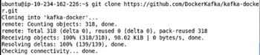

**Figure 12-4:**Downloading the kafka-docker Docker Image Source Code

Change directory (cd) to the kafka-docker directory and list the files/directories.

cd kafka-docker

ls –l

The files/directories in the Docker image get listed as shown in [Figure 12-5](https://viewer.books24x7.com/assetviewer.aspx?bookid=113388&chunkid=177028123&resumebookmarkid=74f9578a-74bf-e911-b9b2-00505695593a).

[Larger View](https://viewer.books24x7.com/assetviewer.aspx?bookid=113388&chunkid=177028123&resumebookmarkid=74f9578a-74bf-e911-b9b2-00505695593a)

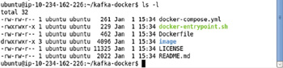

**Figure 12-5:**Listing the Dockerfile and Image Directory for the kafka-source Docker Image

We need to modify the settings in the server.properties file, which is in the image/confdirectory. Cd to the image/conf directory and list the directory's file/directories.

cd image/conf

ls –l

The server.properties file gets listed as shown in [Figure 12-6](https://viewer.books24x7.com/assetviewer.aspx?bookid=113388&chunkid=177028123&resumebookmarkid=74f9578a-74bf-e911-b9b2-00505695593a).

[Larger View](https://viewer.books24x7.com/assetviewer.aspx?bookid=113388&chunkid=177028123&resumebookmarkid=74f9578a-74bf-e911-b9b2-00505695593a)

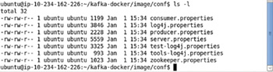

**Figure 12-6:**Listing the Configuration Files for the Docker Image

Open the server.properties file in a vi editor.

sudo vi server.properties

The server.properties file is shown in [Figure 12-7](https://viewer.books24x7.com/assetviewer.aspx?bookid=113388&chunkid=177028123&resumebookmarkid=74f9578a-74bf-e911-b9b2-00505695593a). Uncomment the line with the host.name=localhost setting.

[Larger View](https://viewer.books24x7.com/assetviewer.aspx?bookid=113388&chunkid=177028123&resumebookmarkid=74f9578a-74bf-e911-b9b2-00505695593a)

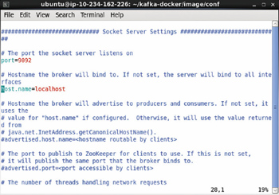

**Figure 12-7:**Uncommenting the host.name Property

As shown in [Figure 12-8](https://viewer.books24x7.com/assetviewer.aspx?bookid=113388&chunkid=177028123&resumebookmarkid=74f9578a-74bf-e911-b9b2-00505695593a) the default setting for the zookeeper.connect is zookeeper:2181.

[Larger View](https://viewer.books24x7.com/assetviewer.aspx?bookid=113388&chunkid=177028123&resumebookmarkid=74f9578a-74bf-e911-b9b2-00505695593a)

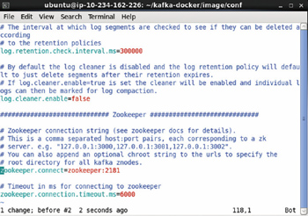

**Figure 12-8:**The default setting for the zookeeper.connect Property

Modify the zookeeper.connect setting to localhost:2181 as shown in [Figure 12-9](https://viewer.books24x7.com/assetviewer.aspx?bookid=113388&chunkid=177028123&resumebookmarkid=74f9578a-74bf-e911-b9b2-00505695593a). Save the modified file with :wq. We need to modify the setting because no such host as "zookeeper" exists by default.

[Larger View](https://viewer.books24x7.com/assetviewer.aspx?bookid=113388&chunkid=177028123&resumebookmarkid=74f9578a-74bf-e911-b9b2-00505695593a)

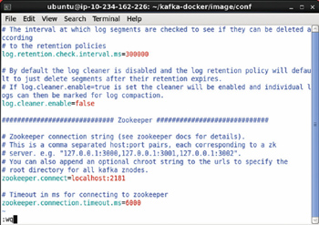

**Figure 12-9:**Setting zookeeper.connect to localhost: 2181

Subsequently cd back to the root directory for the Docker image, the kafka-dockerdirectory, and run the following command to rebuild the Docker image.

sudo docker build -t dockerkafka/kafka:v2.

The output from the command is shown in [Figure 12-10](https://viewer.books24x7.com/assetviewer.aspx?bookid=113388&chunkid=177028123&resumebookmarkid=74f9578a-74bf-e911-b9b2-00505695593a).

[Larger View](https://viewer.books24x7.com/assetviewer.aspx?bookid=113388&chunkid=177028123&resumebookmarkid=74f9578a-74bf-e911-b9b2-00505695593a)

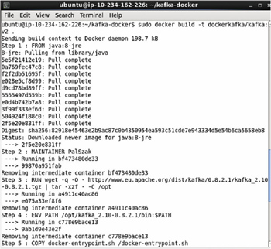

**Figure 12-10:**Rebuilding the Docker Image for Kafka

Docker image gets rebuilt as shown in [Figure 12-11](https://viewer.books24x7.com/assetviewer.aspx?bookid=113388&chunkid=177028123&resumebookmarkid=74f9578a-74bf-e911-b9b2-00505695593a).

[Larger View](https://viewer.books24x7.com/assetviewer.aspx?bookid=113388&chunkid=177028123&resumebookmarkid=74f9578a-74bf-e911-b9b2-00505695593a)

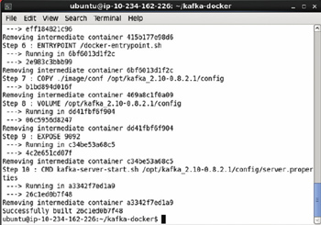

**Figure 12-11:**Completing the Rebuild of the Docker Image

The Docker image we shall use subsequently is not dockerkafka/kafka but is dockerkafka/kafka:v2.

**Creating a Service**

Create a service definition file called kafka-service.yaml and add the following ([Table 12-1](https://viewer.books24x7.com/assetviewer.aspx?bookid=113388&chunkid=543554911&resumebookmarkid=74f9578a-74bf-e911-b9b2-00505695593a)) fields to the file.

**Table 12-1: The Fields in the Service Definition File**[[](https://viewer.books24x7.com/outputobject.aspx?bookid=113388&chunkid=543554911&objectid=ch12_tab1&objecttype=spreadsheet) Open table as spreadsheet](https://viewer.books24x7.com/outputobject.aspx?bookid=113388&chunkid=543554911&objectid=ch12_tab1&objecttype=spreadsheet" \t "_blank)

| **Field** | **Description** | **Value** |
| --- | --- | --- |
| apiVersion |  | v1 |
| kind | The kind of definition file. | Service |
| metadata | The service metadata. |  |
| metadata - > labels | The service labels. Not required. | app: kafkaApp |
| metadata - > name | The service name. Required. | kafka |
| spec | The service specification. |  |
| spec - > ports | The ports exposed by the service. |  |
| spec - > ports- > port | A port exposed by the service. The 9092 port is used for the Kafka server. | port: 9092 targetPort: 9092 |
| spec - > ports- > port | Another port exposed by the service. The 2181 port is for the Zookeeper. | port: 2181 targetPort: 2181 |
| spec - > selector | The Pod selector. Service routes traffic to the Pods with label matching the selector expression. | app: kafkaApp |
| spec - > selector- > type | The service type. | LoadBalanc |

The kafka-service.yaml is listed.

apiVersion: v1

kind: Service

metadata:

labels:

app: kafkaApp

name: kafka

spec:

ports:

-

port: 9092

targetPort: 9092

-

port: 2181

targetPort: 2181

selector:

app: kafkaApp

type: LoadBalancer

The kafka-service.yaml maybe created in vi editor and saved with :wq as shown in [Figure 12-12](https://viewer.books24x7.com/assetviewer.aspx?bookid=113388&chunkid=543554911&resumebookmarkid=74f9578a-74bf-e911-b9b2-00505695593a).

[Larger View](https://viewer.books24x7.com/assetviewer.aspx?bookid=113388&chunkid=543554911&resumebookmarkid=74f9578a-74bf-e911-b9b2-00505695593a)

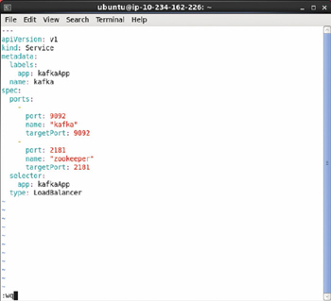

**Figure 12-12:**Service Definition File in vi Editor

Create the service from the definition file.

kubectl create -f kafka-service.yaml

Subsequently list the services.

kubectl get services

The "kafka" service gets listed as shown in [Figure 12-13](https://viewer.books24x7.com/assetviewer.aspx?bookid=113388&chunkid=543554911&resumebookmarkid=74f9578a-74bf-e911-b9b2-00505695593a). The service selector is app = kafkaApp.

[Larger View](https://viewer.books24x7.com/assetviewer.aspx?bookid=113388&chunkid=543554911&resumebookmarkid=74f9578a-74bf-e911-b9b2-00505695593a)

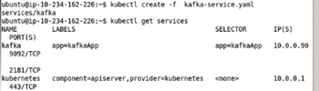

**Figure 12-13:**Creating a Service from the Definition File

**Creating a Replication Controller**

Create a definition file called kafka-rc.yaml for the replication controller and add the following ([Table 12-2](https://viewer.books24x7.com/assetviewer.aspx?bookid=113388&chunkid=439669903&resumebookmarkid=74f9578a-74bf-e911-b9b2-00505695593a)) fields.

**Table 12-2: Fields in the Replication Controller Definition File**[[](https://viewer.books24x7.com/outputobject.aspx?bookid=113388&chunkid=439669903&objectid=ch12_tab2&objecttype=spreadsheet) Open table as spreadsheet](https://viewer.books24x7.com/outputobject.aspx?bookid=113388&chunkid=439669903&objectid=ch12_tab2&objecttype=spreadsheet" \t "_blank)

| **Field** | **Description** | **Value** |
| --- | --- | --- |
| apiVersion |  | v1 |
| kind | The kind of definition file. | ReplicationController |
| metadata | The replication controller metadata. |  |
| metadata - > labels | The replication controller labels. | app: kafkaApp name: kafka-rc |
| spec | The replication controller specification. |  |
| spec - > replicas | The number of Pod replicas. | 2 |
| spec - > selector | A key:value expression for selecting the Pods to manage. Pods with a label the same as the selector expression are managed by the replication controller. The selector expression must be the same as the spec- > template- > metadata- > labels expression. The selector defaults to the spec- > template- > metadata- > labels key:value expression if not specified. | app: kafkaApp |
| spec - > template | The Pod template. |  |
| spec - > template- > metadata | The Pod template metadata. |  |
| spec -template - > metadata - > labels | The Pod template labels. | app: kafkaApp |
| spec - > template - > spec | The Pod template specification. |  |
| spec - > template - > spec - > containers | The containers configuration for the Pod template. |  |
| spec - > template - > spec - > containers - > command | The command/s to run for the Docker image. The default command in the Dockerfile is CMD ["kafka-server-start.sh", "/opt/kafka\_2.10-0.8.2.1/config/server.properties"]. The default command starts the Kakfa server, but we want the Zookeeper server before the Kafka server as the Kafka server won't start unless the Zookeeper server is running. The modified command starts only the Zookeeper server. We shall start the Kafka server separately. | - zookeeper-server- start. sh - /opt/ kafka\_2.10-0.8.2.1/ config/zookeeper. properties |
| spec - > template - > spec - > containers - > image | The Docker image. | dockerkafka/kafka:v2 |
| spec - > template - > spec - > containers - > name | The container name | zookeeper |
| ports | Specifies the container port/s. | containerPort: 2181 |

The kafka-rc.yaml is listed.

---

apiVersion: v1

kind: ReplicationController

metadata:

labels:

app: kafkaApp

name: kafka-rc

spec:

replicas: 1

selector:

app: kafkaApp

template:

metadata:

labels:

app: kafkaApp

spec:

containers:

-

command:

- zookeeper-server-start.sh

- /opt/kafka\_2.10-0.8.2.1/config/zookeeper.properties

image: "dockerkafka/kafka:v2"

name: zookeeper

ports:

-

containerPort: 2181

The kafka-rc.yaml file maybe created and saved in the vi editor as shown in [Figure 12-14](https://viewer.books24x7.com/assetviewer.aspx?bookid=113388&chunkid=439669903&resumebookmarkid=74f9578a-74bf-e911-b9b2-00505695593a).

[Larger View](https://viewer.books24x7.com/assetviewer.aspx?bookid=113388&chunkid=439669903&resumebookmarkid=74f9578a-74bf-e911-b9b2-00505695593a)

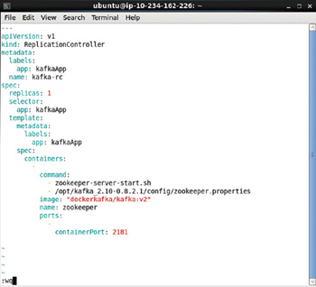

**Figure 12-14:**Replication Controller Definition File in vi Editor

Create the replication controller from the definition file.

kubectl create -f kafka-rc.yaml

Subsequently list the replication controllers.

kubectl get rc

The replication controller gets created and listed as shown in [Figure 12-15](https://viewer.books24x7.com/assetviewer.aspx?bookid=113388&chunkid=439669903&resumebookmarkid=74f9578a-74bf-e911-b9b2-00505695593a).

[Larger View](https://viewer.books24x7.com/assetviewer.aspx?bookid=113388&chunkid=439669903&resumebookmarkid=74f9578a-74bf-e911-b9b2-00505695593a)

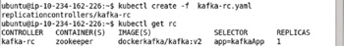

**Figure 12-15:**Creating the Replication Controller from the Definition File

To describe the kafka-rc run the following command.

kubectl describe rc kafka-rc

The replication controller description gets listed as shown in [Figure 12-16](https://viewer.books24x7.com/assetviewer.aspx?bookid=113388&chunkid=439669903&resumebookmarkid=74f9578a-74bf-e911-b9b2-00505695593a).

[Larger View](https://viewer.books24x7.com/assetviewer.aspx?bookid=113388&chunkid=439669903&resumebookmarkid=74f9578a-74bf-e911-b9b2-00505695593a)

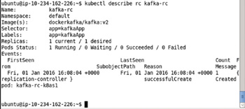

**Figure 12-16:**Describing the Replication Controller

### Listing the Pods

To list the Pods run the following command.

kubectl get pods

The Pods get listed as shown in [Figure 12-17](https://viewer.books24x7.com/assetviewer.aspx?bookid=113388&chunkid=934919608&resumebookmarkid=74f9578a-74bf-e911-b9b2-00505695593a).

[Larger View](https://viewer.books24x7.com/assetviewer.aspx?bookid=113388&chunkid=934919608&resumebookmarkid=74f9578a-74bf-e911-b9b2-00505695593a)

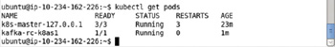

**Figure 12-17:**Listing the pods for Kafka

**Describing a Pod**

Only a single Pod is created because the "replicas" setting in the definition file kafka-rc.yaml is 1. To describe the Pod run the following command.

kubectl describe pod kafka-rc-k8as1

The pod description gets listed as shown in [Figure 12-18](https://viewer.books24x7.com/assetviewer.aspx?bookid=113388&chunkid=752756925&resumebookmarkid=74f9578a-74bf-e911-b9b2-00505695593a). The Pod label app=kafkaApp is the same as the service selector and the replication controller selector which makes the Pod manageable by the service and the replication controller.

[Larger View](https://viewer.books24x7.com/assetviewer.aspx?bookid=113388&chunkid=752756925&resumebookmarkid=74f9578a-74bf-e911-b9b2-00505695593a)

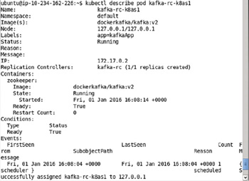

**Figure 12-18:**Describing a pod for Kafka

When the Pod is created and started, the Zookeeper server gets started as the command for the modified Docker image is to start the Zookeeper server. Next we shall start the Kafka server from an interactive shell for the Docker container for the modified Docker image.

**Starting an Interactive Shell**

To be able to start an interactive bash shell to access the Kafka software installed we need to know the container id for the Docker container running the modified Docker image. List the Docker containers with the following command.

sudo docker ps

The Docker containers get listed as shown in [Figure 12-19](https://viewer.books24x7.com/assetviewer.aspx?bookid=113388&chunkid=535617793&resumebookmarkid=74f9578a-74bf-e911-b9b2-00505695593a).

[Larger View](https://viewer.books24x7.com/assetviewer.aspx?bookid=113388&chunkid=535617793&resumebookmarkid=74f9578a-74bf-e911-b9b2-00505695593a)

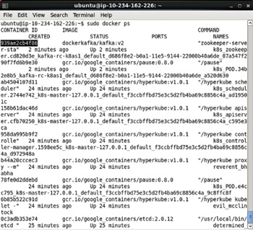

**Figure 12-19:**Obtaining the Docker Container Id

Copy the container id and start the interactive bash shell.

sudo docker exec -it 939ae2cb4f86 bash

The interactive shell gets started as shown in [Figure 12-20](https://viewer.books24x7.com/assetviewer.aspx?bookid=113388&chunkid=535617793&resumebookmarkid=74f9578a-74bf-e911-b9b2-00505695593a).

[Larger View](https://viewer.books24x7.com/assetviewer.aspx?bookid=113388&chunkid=535617793&resumebookmarkid=74f9578a-74bf-e911-b9b2-00505695593a)



**Figure 12-20:**Starting the Interactive TTY for the Docker Container

**Starting the Kafka Server**

The configuration properties for Kafka server are set in the config/server.properties file, which we modified when we rebuilt the Docker image. As the Zookeeper is already running, start the Kafka server with the following command.

kafka-server-start.sh /opt/kafka\_2.10-0.8.2.1/config/server.properties

The preceding command is shown in [Figure 12-21](https://viewer.books24x7.com/assetviewer.aspx?bookid=113388&chunkid=466465077&resumebookmarkid=74f9578a-74bf-e911-b9b2-00505695593a).

[Larger View](https://viewer.books24x7.com/assetviewer.aspx?bookid=113388&chunkid=466465077&resumebookmarkid=74f9578a-74bf-e911-b9b2-00505695593a)

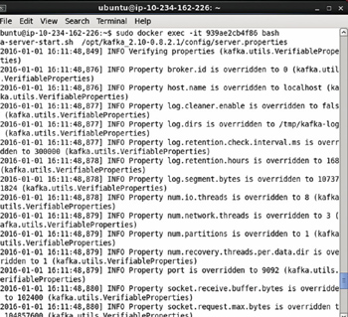

**Figure 12-21:**Starting the Kafka Server

Kafka server gets started as shown in [Figure 12-22](https://viewer.books24x7.com/assetviewer.aspx?bookid=113388&chunkid=466465077&resumebookmarkid=74f9578a-74bf-e911-b9b2-00505695593a).

[Larger View](https://viewer.books24x7.com/assetviewer.aspx?bookid=113388&chunkid=466465077&resumebookmarkid=74f9578a-74bf-e911-b9b2-00505695593a)

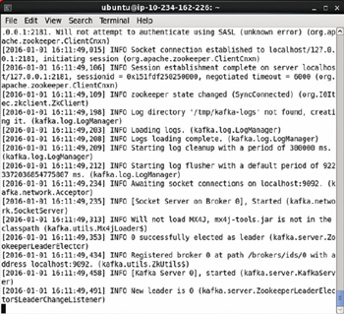

**Figure 12-22:**Kafka Server started at localhost:9092

### Creating a Topic

Next, create a topic called 'kafka-on-kubernetes' with the following command. Set the number of partitions to 1 and replication factor to 1. The Zookeeper is set to localhost:2181.

kafka-topics.sh --create --topic kafka-on-kubernetes --zookeeper localhost:2181

--replication-factor 1 --partitions 1

As shown in [Figure 12-23](https://viewer.books24x7.com/assetviewer.aspx?bookid=113388&chunkid=267234332&resumebookmarkid=74f9578a-74bf-e911-b9b2-00505695593a) the kafka-on-kubernetes topic gets created.

[Larger View](https://viewer.books24x7.com/assetviewer.aspx?bookid=113388&chunkid=267234332&resumebookmarkid=74f9578a-74bf-e911-b9b2-00505695593a)



**Figure 12-23:**Creating a Kafka Topic

### Starting a Kafka Producer

A Kafka producer is used to produce messages. After starting the ZooKeeper and the Kafka server, start the Kafka producer. Specify the topic with the –topic option as 'kafka-on-kubernetesl The --broker-list specifies the Kafka server as localhost:9092, which are the settings configured in server.properties file.

kafka-console-producer.sh --topic kafka-on-kubernetes --broker-list localhost:909

As shown in [Figure 12-24](https://viewer.books24x7.com/assetviewer.aspx?bookid=113388&chunkid=477149038&resumebookmarkid=74f9578a-74bf-e911-b9b2-00505695593a) the Kafka producer gets started.

[Larger View](https://viewer.books24x7.com/assetviewer.aspx?bookid=113388&chunkid=477149038&resumebookmarkid=74f9578a-74bf-e911-b9b2-00505695593a)

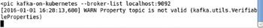

**Figure 12-24:**Starting a Kafka Producer

**Starting a Kafka Consumer**

A Kafka consumer consumes messages. Start the Kafka consumer with the following command. Specify the topic with the –topic option as 'kafka-on-kubernetesl The --zookeeper specifies the Zookeeper server as localhost:2181, which are the settings configured in server.properties file. The --from-beginning option specifies that messages from the beginning are to be consumed, not just the messages consumed after the consumer was started.

kafka-console-consumer.sh --topic kafka-on-kubernetes --from-beginning --zookeeper

localhost:2181

As shown in [Figure 12-25](https://viewer.books24x7.com/assetviewer.aspx?bookid=113388&chunkid=374656449&resumebookmarkid=74f9578a-74bf-e911-b9b2-00505695593a) the Kafka producer gets started.

[Larger View](https://viewer.books24x7.com/assetviewer.aspx?bookid=113388&chunkid=374656449&resumebookmarkid=74f9578a-74bf-e911-b9b2-00505695593a)



**Figure 12-25:**Starting a Kafka Consumer

### Producing and Consuming Messages

Having started the Producer and the Consumer, we shall produce message/s at the Producer and consume message/s at the Consumer. At the Producer add a message, for example, "Message from Kafka Producer" as shown in [Figure 12-26](https://viewer.books24x7.com/assetviewer.aspx?bookid=113388&chunkid=440386996&resumebookmarkid=74f9578a-74bf-e911-b9b2-00505695593a) and click on Enter button. The message gets sent.

[Larger View](https://viewer.books24x7.com/assetviewer.aspx?bookid=113388&chunkid=440386996&resumebookmarkid=74f9578a-74bf-e911-b9b2-00505695593a)

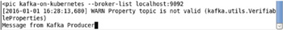

**Figure 12-26:**Producing a Message at the Kafka Producer

At the Consumer the message gets consumed as shown in [Figure 12-27](https://viewer.books24x7.com/assetviewer.aspx?bookid=113388&chunkid=440386996&resumebookmarkid=74f9578a-74bf-e911-b9b2-00505695593a).

[Larger View](https://viewer.books24x7.com/assetviewer.aspx?bookid=113388&chunkid=440386996&resumebookmarkid=74f9578a-74bf-e911-b9b2-00505695593a)



**Figure 12-27:**Consuming a Message at the Kafka Consumer

Send more messages at the Producer as shown in [Figure 12-28](https://viewer.books24x7.com/assetviewer.aspx?bookid=113388&chunkid=440386996&resumebookmarkid=74f9578a-74bf-e911-b9b2-00505695593a).

[Larger View](https://viewer.books24x7.com/assetviewer.aspx?bookid=113388&chunkid=440386996&resumebookmarkid=74f9578a-74bf-e911-b9b2-00505695593a)

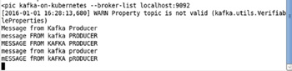

**Figure 12-28:**Producing More Messages at the Kafka Producer

And the messages get consumed at the Consumer as shown in [Figure 12-29](https://viewer.books24x7.com/assetviewer.aspx?bookid=113388&chunkid=440386996&resumebookmarkid=74f9578a-74bf-e911-b9b2-00505695593a).

[Larger View](https://viewer.books24x7.com/assetviewer.aspx?bookid=113388&chunkid=440386996&resumebookmarkid=74f9578a-74bf-e911-b9b2-00505695593a)

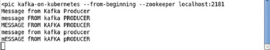

**Figure 12-29:**Consuming More Messages at the Kafka Consumer

### Scaling the Cluster

To scale the cluster to 4 Pods from 1 Pod run the following command.

kubectl scale rc kafka-rc --replicas=4

Subsequently list the Pods.

kubectl get pods

An output of "scaled" indicates that the cluster has been scaled as shown in [Figure 12-30](https://viewer.books24x7.com/assetviewer.aspx?bookid=113388&chunkid=157966988&resumebookmarkid=74f9578a-74bf-e911-b9b2-00505695593a). Subsequently the Pods get listed, also shown in [Figure 12-30](https://viewer.books24x7.com/assetviewer.aspx?bookid=113388&chunkid=157966988&resumebookmarkid=74f9578a-74bf-e911-b9b2-00505695593a).

[Larger View](https://viewer.books24x7.com/assetviewer.aspx?bookid=113388&chunkid=157966988&resumebookmarkid=74f9578a-74bf-e911-b9b2-00505695593a)

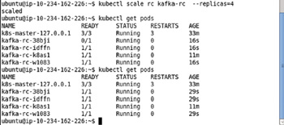

**Figure 12-30:**Scaling the Kafka Cluster

When the number of Pods are increased to 4, the service endpoints also increase to 4. Describe the service kafka.

kubectl describe svc kafka

As shown in [Figure 12-31](https://viewer.books24x7.com/assetviewer.aspx?bookid=113388&chunkid=157966988&resumebookmarkid=74f9578a-74bf-e911-b9b2-00505695593a), 4 endpoints are listed for each of the two services, one for Zookeeper server and the other for the Kafka server.

[Larger View](https://viewer.books24x7.com/assetviewer.aspx?bookid=113388&chunkid=157966988&resumebookmarkid=74f9578a-74bf-e911-b9b2-00505695593a)

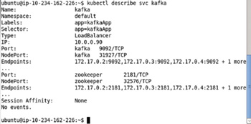

**Figure 12-31:**Describing the Kafka Service with 4 Endpoints

**Deleting Replication Controller and Service**

To delete the replication controller and service run the following commands.

kubectl delete rc kafka-rc

kubectl delete service kafka

As shown in [Figure 12-32](https://viewer.books24x7.com/assetviewer.aspx?bookid=113388&chunkid=782637706&resumebookmarkid=74f9578a-74bf-e911-b9b2-00505695593a) the replication controller and service get deleted.

[Larger View](https://viewer.books24x7.com/assetviewer.aspx?bookid=113388&chunkid=782637706&resumebookmarkid=74f9578a-74bf-e911-b9b2-00505695593a)

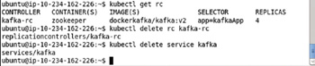

**Figure 12-32:**Deleting the Kafka Replication Controller and Service

### Summary

Apache Kafka is a producer-consumer-based messaging system. In this chapter we discussed managing a Kafka cluster with Kubernetes. Managing the Kafka is different from some of the other applications as two servers have to be started: the Zookeeper server and the Kafka server. And the Kafka server has a dependency on the Zookeeper server, which implies that the Zookeeper must be started before the Kafka server. We needed to modify the default image dockerkafka/kafka for the zookeeper connect url. In the replication controller definition file we used a custom command to run the modified Docker image to start the Zookeeper server, the default settings in the Docker image being to start the Kafka server. All the applications we have run as yet were based on a single container Pod. In the next chapter we shall develop a multi-container Pod.

**Part V: Multi Containers and Nodes**

Chapter List

1. [Chapter 13:](http://viewer.books24x7.com/assetviewer.aspx?bkid=113388&destid=1156#1156) Creating a Multi-Container Pod
2. [Chapter 14:](http://viewer.books24x7.com/assetviewer.aspx?bkid=113388&destid=1233#1233) Installing Kubernetes on a Multi-Node Cluster

## Chapter 13: Creating a Multi-Container Pod

**© Deepak Vohra 2016  
D. Vohra, *Kubernetes Microservices with Docker*, DOI 10.1007/978-1-4842-1907-2\_13**

### Overview

A Pod is the atomic unit of an application managed by Kubernetes. A Pod has a single filesystem and IP Address; the containers in the Pod share the filesystem and networking IP. A Pod could consist of one or more containers. A Pod is defined in a definition file for a Pod or a replication controller using the specification for a Pod (<http://kubernetes.io/v1.1/docs/api-reference/v1/definitions.html#_v1_podspec>). A single container within a Pod is specified using the container specification (<http://kubernetes.io/v1.1/docs/api-reference/v1/definitions.html#_v1_container>). In all of the applications discussed as yet, in preceding chapters, a single container Pod was used. In this chapter we shall develop a multi-container Pod. We have used the tutum/hello-worldand postgres Docker images for the multi-container Pod. Each of these images have been used in a single container Pods in preceding chapters.

### How to find Number of Containers in a Pod?

As discussed previously the Pods may be listed with the following command.

kubectl get pods

The Kubernetes Pod k8s-master-127.0.0.1 Pod has 3/3 in the READYcolumn as shown in [Figure 13-1](https://viewer.books24x7.com/assetviewer.aspx?bookid=113388&chunkid=824610658&resumebookmarkid=74f9578a-74bf-e911-b9b2-00505695593a). The 3/3 indicates that the Pod has 3 containers and all three containers are ready. The n/n in the READY column for any Pod indicates the number of containers ready out of the total number of containers. All the containers are running on a single node as indicated by the subsequent listing of nodes.

[Larger View](https://viewer.books24x7.com/assetviewer.aspx?bookid=113388&chunkid=824610658&resumebookmarkid=74f9578a-74bf-e911-b9b2-00505695593a)

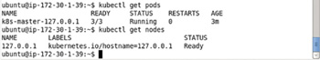

**Figure 13-1:**Listing the Pods and the Number of Containers in the Pods

### Types of Applications Using a Multi-Container Pod

Various types of applications could make use of a multi-container Pod. Some of the examples are as follows:

* -An Apache Sqoop application makes use of a CDH Docker image-based container and a MySQL database Docker image-based container for bulk transferring data from MySQL database into HDFS.
* -An Apache Flume application makes use of a CDH Docker image-based container and a Kafka-based container for streaming data from a Kafka source into HDFS.
* -An Apache Solr application makes use of a Oracle Database-based container and the Solr container for data import from Oracle Database into Solr.
* -An Apache Hive application makes use a CDH container and a MongoDB container to create a Hive table using the MongoDB storage handler.
* -An Apache Solr container and a CDH container are required to store Solr data in HDFS instead of the local filesystem.

**Setting the Environment**

We have used an Amazon EC2 instance created from AMI Ubuntu Server 14.04 LTS (HVM), SSD Volume Type - ami-d05e75b8 to install the following required software.

* -Docker Engine (latest version)
* -Kubernetes (version 1.01)
* -Kubectl (version 1.01)
* -Docker image tutum/hello-world (latest version)
* -Docker image postgres (latest version)

Install Docker, Kubernetes, and Kubectl as discussed in [chapter 1](http://viewer.books24x7.com/assetviewer.aspx?bkid=113388&destid=28#28). To log in to the Ubuntu instance the Public IP Adress may be obtained from the Amazon EC2 console as shown in [Figure 13-2](https://viewer.books24x7.com/assetviewer.aspx?bookid=113388&chunkid=731509858&resumebookmarkid=74f9578a-74bf-e911-b9b2-00505695593a).

[Larger View](https://viewer.books24x7.com/assetviewer.aspx?bookid=113388&chunkid=731509858&resumebookmarkid=74f9578a-74bf-e911-b9b2-00505695593a)

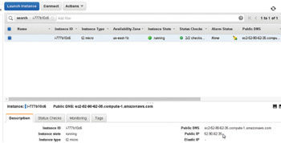

**Figure 13-2:**Obtaining the Public IP Address

SSH Login to the Ubuntu instance.

ssh -i "docker.pem" ubuntu@52.90.62.35

After having installed Docker start Docker and verify its status.

sudo service docker start

sudo service docker status

Docker should be listed as being "running" as shown in [Figure 13-3](https://viewer.books24x7.com/assetviewer.aspx?bookid=113388&chunkid=731509858&resumebookmarkid=74f9578a-74bf-e911-b9b2-00505695593a).

[Larger View](https://viewer.books24x7.com/assetviewer.aspx?bookid=113388&chunkid=731509858&resumebookmarkid=74f9578a-74bf-e911-b9b2-00505695593a)

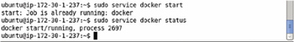

**Figure 13-3:**Starting Docker

**Creating a Service**

Create a service definition file hello-postgres-service.yaml to configure the service ports. We shall be configuring two service ports, one for the hello-world application and the other for the postgres application. The fields in the service definition file are discussed in [Table 13-1](https://viewer.books24x7.com/assetviewer.aspx?bookid=113388&chunkid=931821937&resumebookmarkid=74f9578a-74bf-e911-b9b2-00505695593a).

**Table 13-1: Fields in the Service Definition File**[[](https://viewer.books24x7.com/outputobject.aspx?bookid=113388&chunkid=931821937&objectid=ch13_tab1&objecttype=spreadsheet) Open table as spreadsheet](https://viewer.books24x7.com/outputobject.aspx?bookid=113388&chunkid=931821937&objectid=ch13_tab1&objecttype=spreadsheet" \t "_blank)

| **Field** | **Description** | **Value** |
| --- | --- | --- |
| apiVersion |  | v1 |
| kind | The kind of definition file. | Service |
| metadata | The service metadata. |  |
| metadata - > labels | The service labels. The setting translates to label app = MultiContainerApp | app: MultiContainerApp |
| metadata - > name | The service name. | hello-postgres |
| spec | The service specification. |  |
| spec - > ports | The ports exposed by the service. Two ports are exposed, one for the hello-world application and the other for the postgres application. | name: hello-world port: 8080 name: postgres port: 5432 |
| spec - > selector | The Pod selector. Service routes traffic to the Pods with label matching the selector expression. The setting translates to selector app = MultiContainerApp | app: MultiContainerApp |
| spec - > selector - > type | The service type. | LoadBalancer |

The hello-postgres-service.yaml is listed:

apiVersion: v1

kind: Service

metadata:

labels:

app: MultiContainerApp

name: hello-postgres

spec:

ports:

-

name: hello-world

port: 8080

-

name: postgres

port: 5432

selector:

app: MultiContainerApp

type: LoadBalancer

Create a service from the definition file.

kubectl create -f hello-postgres-service.yaml

Subsequently list the services.

kubectl get services

The hello-postgres service gets created and listed as shown in [Figure 13-4](https://viewer.books24x7.com/assetviewer.aspx?bookid=113388&chunkid=931821937&resumebookmarkid=74f9578a-74bf-e911-b9b2-00505695593a).

[Larger View](https://viewer.books24x7.com/assetviewer.aspx?bookid=113388&chunkid=931821937&resumebookmarkid=74f9578a-74bf-e911-b9b2-00505695593a)

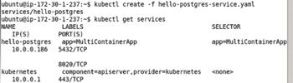

**Figure 13-4:**Creating a Service from the Definition File

**Describing a Service**

The hello-postgres service may be described with the following command.

kubectl describe service hello-postgres

The service description includes the name, namespace, labels, selector, type, IP, ports, and endpoints as shown in [Figure 13-5](https://viewer.books24x7.com/assetviewer.aspx?bookid=113388&chunkid=782211214&resumebookmarkid=74f9578a-74bf-e911-b9b2-00505695593a). Initially the service is not managing any pods and as a result no endpoints are listed.

[Larger View](https://viewer.books24x7.com/assetviewer.aspx?bookid=113388&chunkid=782211214&resumebookmarkid=74f9578a-74bf-e911-b9b2-00505695593a)

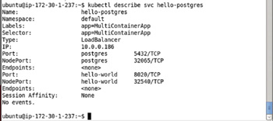

**Figure 13-5:**Describing the Service

### Creating a Replication Container

Create a definition file hello-postgres-rc.yaml for a replication controller. Add the following ([Table 13-2](https://viewer.books24x7.com/assetviewer.aspx?bookid=113388&chunkid=629049185&resumebookmarkid=74f9578a-74bf-e911-b9b2-00505695593a)) fields to the definition file.

**Table 13-2: Fields in the Replication Controller Definition File**[[](https://viewer.books24x7.com/outputobject.aspx?bookid=113388&chunkid=629049185&objectid=ch13_tab2&objecttype=spreadsheet) Open table as spreadsheet](https://viewer.books24x7.com/outputobject.aspx?bookid=113388&chunkid=629049185&objectid=ch13_tab2&objecttype=spreadsheet" \t "_blank)

| **Field** | **Description** | **Value** |
| --- | --- | --- |
| apiVersion |  | v1 |
| kind | The kind of definition file. | ReplicationController |
| metadata | The replication controller metadata. |  |
| metadata - > labels | The replication controller labels. | app: "MultiContainerApp" |
| metadata - > name | The replication controller name. | "hello-postgres" |
| spec | The replication controller specification. |  |
| spec - > replicas | The number of Pod replicas. | 1 |
| spec - > selector | A key:value expression for selecting the Pods to manage. Pods with a label the same as the selector expression is managed by the replication controller. The selector expression must be the same as the spec - > template - > metadata - > labels expression. The selector defaults to the spec- > template - > metadata - > labels key: value expression if not specified. | app: "MultiContainerApp" |
| spec - > template | The Pod template. |  |
| spec - > template- > metadata | The Pod template metadata. |  |
| spec - > template - > metadata - > labels | The Pod template labels. The selector if not specified defaults to this setting. The service selector must be the same as one of the Pod template labels for the service to represent the Pod. The service selector does not default to the same value as the label and we already set the service selector to app: MultiContainerApp. | app: "MultiContainerApp" |
| spec - > template - > spec | The Pod template specification. |  |
| spec - > template - > spec - > containers | The containers configuration for the Pod template. |  |
| spec - > template - > spec - > containers - > image | The Docker image for the hello-world container. | tutum/hello-world |
| spec - > template - > spec - > containers - > name | The container name for the hello-world container. | hello-world |
| ports | Specifies the container port for the helloworld container. | containerPort: 8080 |
| spec - > template - > spec - > containers - > image | The Docker image for the postgres container. | postgres |
| spec - > template - > spec - > containers - > name | The container name for the postgres container. | postgres |
| ports | Container port for postgres container. | containerPort: 5432 |

The hello-postgres-rc.yaml is listed:

apiVersion: v1

kind: ReplicationController

metadata:

labels:

app: "MultiContainerApp"

name: "hello-postgres"

spec:

replicas: 1

selector:

app: "MultiContainerApp"

template:

metadata:

labels:

app: "MultiContainerApp"

spec:

containers:

-

image: "tutum/hello-world"

name: "hello-world"

ports:

-

containerPort: 8080

-

image: "postgres"

name: "postgres"

ports:

-

containerPort: 5432

Create a replication controller from the definition file.

kubectl create -f hello-postgres-rc.yaml

Subsequently list the replication controllers.

kubectl get rc

As shown in [Figure 13-6](https://viewer.books24x7.com/assetviewer.aspx?bookid=113388&chunkid=629049185&resumebookmarkid=74f9578a-74bf-e911-b9b2-00505695593a) the hello-postgres replication controller gets created and listed.

[Larger View](https://viewer.books24x7.com/assetviewer.aspx?bookid=113388&chunkid=629049185&resumebookmarkid=74f9578a-74bf-e911-b9b2-00505695593a)

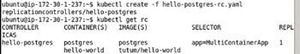

**Figure 13-6:**Creating a Replication Controller from the Definition File

**Listing the Pods**

To list the Pods run the following command.

kubectl get pods

As replicas field is set to 1 in the replication controller only one Pod gets created as shown in [Figure 13-7](https://viewer.books24x7.com/assetviewer.aspx?bookid=113388&chunkid=628183024&resumebookmarkid=74f9578a-74bf-e911-b9b2-00505695593a). The READY column lists 0/2, which indicates that 0 or none of the two containers in the pod are ready. Initially the container could be listed as not running and creating. Run the preceding command after a few seconds and the Pod STATUS should be "Running" and the READY state should be 2/2, implying that 2 of 2 containers are running.

[Larger View](https://viewer.books24x7.com/assetviewer.aspx?bookid=113388&chunkid=628183024&resumebookmarkid=74f9578a-74bf-e911-b9b2-00505695593a)

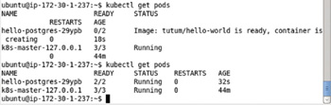

**Figure 13-7:**Listing the Pods

**Listing the Docker Containers**

To list the Docker containers started, run the following command.

sudo docker ps

Two of the listed containers, the container based on the postgres image and the container based on the tutum/hello-world image, as shown in [Figure 13-8](https://viewer.books24x7.com/assetviewer.aspx?bookid=113388&chunkid=809712158&resumebookmarkid=74f9578a-74bf-e911-b9b2-00505695593a), are started with the replication controller hello-postgres.

[Larger View](https://viewer.books24x7.com/assetviewer.aspx?bookid=113388&chunkid=809712158&resumebookmarkid=74f9578a-74bf-e911-b9b2-00505695593a)

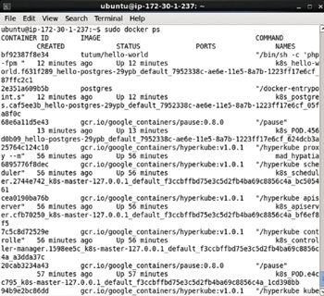

**Figure 13-8:**Listing the Docker Container

**Describing the Service after Creating Replication Controller**

Before we had created the replication controller the service hello-postgres was not associated with any endpoints. After creating the replication controller and the Pod/s, run the following command again to describe the service again.

kubectl describe service hello-postgres

An endpoint is listed for each of the ports exposed by the service as shown in [Figure 13-9](https://viewer.books24x7.com/assetviewer.aspx?bookid=113388&chunkid=439417573&resumebookmarkid=74f9578a-74bf-e911-b9b2-00505695593a).

[Larger View](https://viewer.books24x7.com/assetviewer.aspx?bookid=113388&chunkid=439417573&resumebookmarkid=74f9578a-74bf-e911-b9b2-00505695593a)

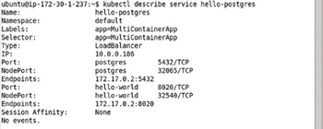

**Figure 13-9:**Describing the Service

**Invoking the Hello World Application on Command Line**

Invoke the service endpoint 172.17.0.2 using curl as follows.

curl 172.17.0.2

The HTML generated by the application gets output as shown in [Figure 13-10](https://viewer.books24x7.com/assetviewer.aspx?bookid=113388&chunkid=288419397&resumebookmarkid=74f9578a-74bf-e911-b9b2-00505695593a).

[Larger View](https://viewer.books24x7.com/assetviewer.aspx?bookid=113388&chunkid=288419397&resumebookmarkid=74f9578a-74bf-e911-b9b2-00505695593a)

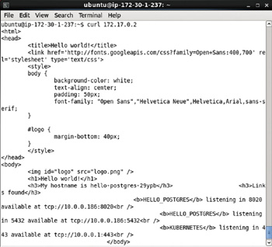

**Figure 13-10:**Invoking an Endpoint for the Service

**Starting the Interactive Shell**

To start an interactive shell for the software installed, either of the Docker containers, listed previously in [Figure 13-8](http://viewer.books24x7.com/assetviewer.aspx?bkid=113388&destid=1185#1185), for the multi-container Pod may be used. Both the containers access the same filesystem and IP. Use the following command to start an interactive shell.

sudo docker exec -it 2e351a609b5b bash

An interactive shell gets started as shown in [Figure 13-11](https://viewer.books24x7.com/assetviewer.aspx?bookid=113388&chunkid=578331693&resumebookmarkid=74f9578a-74bf-e911-b9b2-00505695593a).

[Larger View](https://viewer.books24x7.com/assetviewer.aspx?bookid=113388&chunkid=578331693&resumebookmarkid=74f9578a-74bf-e911-b9b2-00505695593a)



**Figure 13-11:**Starting an Interactive Shell

**Starting PostgreSQL Shell**

To start the PostgreSQL command shell called psql run the following command in the interactive shell.

psql postgres

The psql gets started and the postgres command promptgets displayed as shown in [Figure 13-12](https://viewer.books24x7.com/assetviewer.aspx?bookid=113388&chunkid=182185327&resumebookmarkid=74f9578a-74bf-e911-b9b2-00505695593a).

[Larger View](https://viewer.books24x7.com/assetviewer.aspx?bookid=113388&chunkid=182185327&resumebookmarkid=74f9578a-74bf-e911-b9b2-00505695593a)

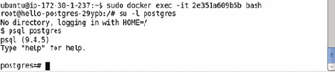

**Figure 13-12:**Starting psql Shell

PostgreSQL with Kubernetes is discussed in [chapter 5](http://viewer.books24x7.com/assetviewer.aspx?bkid=113388&destid=355#355).

**Setting Port Forwarding**

We had earlier invoked the service endpoint to output the HTML generated using curl on the command line, but HTML is best displayed in a browser. As an Amazon EC2 instance does not provide a browser by default, we need to set port forwarding to a local machine to be able to access the service endpoint in a browser. Set the port forwarding for 172.17.0.2:80to localhost:80 with the following command.

ssh -i "docker.pem" -f -nNT -L 80:172.17.0.2:80 ubuntu@ec2-52-90-62-35.compute-1.amazonaws.com

The port forwarding to localhost gets set as shown in [Figure 13-13](https://viewer.books24x7.com/assetviewer.aspx?bookid=113388&chunkid=579733811&resumebookmarkid=413d1879-81bf-e911-b9b2-00505695593a).

[Larger View](https://viewer.books24x7.com/assetviewer.aspx?bookid=113388&chunkid=579733811&resumebookmarkid=413d1879-81bf-e911-b9b2-00505695593a)



**Figure 13-13:**Setting Port Forwarding

The Public DNS for the Amazon EC2 instance may be obtained from the Amazon EC2 console as shown in [Figure 13-14](https://viewer.books24x7.com/assetviewer.aspx?bookid=113388&chunkid=579733811&resumebookmarkid=413d1879-81bf-e911-b9b2-00505695593a).

[Larger View](https://viewer.books24x7.com/assetviewer.aspx?bookid=113388&chunkid=579733811&resumebookmarkid=413d1879-81bf-e911-b9b2-00505695593a)

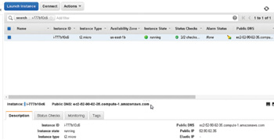

**Figure 13-14:**Obtaining Public DNS

**Opening the Hello World Application in a Browser**

Having set port forwarding the application may be opened in a browser on a local machine with url [http://localhost](http://localhost/) as shown in [Figure 13-15](https://viewer.books24x7.com/assetviewer.aspx?bookid=113388&chunkid=395842971&resumebookmarkid=413d1879-81bf-e911-b9b2-00505695593a). In addition to the hostname the two ports at which the HELLO\_POSTGRES is listening at get listed.

[Larger View](https://viewer.books24x7.com/assetviewer.aspx?bookid=113388&chunkid=395842971&resumebookmarkid=413d1879-81bf-e911-b9b2-00505695593a)

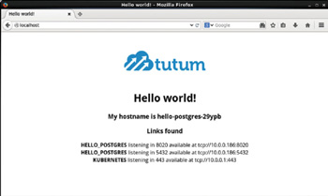

**Figure 13-15:**Invoking the Service Endpoint in a Browser

### Scaling the Cluster

To scale the cluster to 3 replicas or Pods run the following command.

kubectl scale rc hello-postgres --replicas=3

Subsequently list the Pods.

kubectl get pods

Three Pods get listed as shown in [Figure 13-16](https://viewer.books24x7.com/assetviewer.aspx?bookid=113388&chunkid=879442857&resumebookmarkid=413d1879-81bf-e911-b9b2-00505695593a). Some of the Pods could be not running or not ready initially. Run the preceding command again after a few seconds to list all the Pods with STATUS as "Running" and READY state as 2/2.

[Larger View](https://viewer.books24x7.com/assetviewer.aspx?bookid=113388&chunkid=879442857&resumebookmarkid=413d1879-81bf-e911-b9b2-00505695593a)

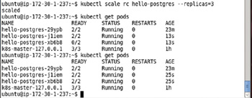

**Figure 13-16:**Scaling the Cluster to 3 Replicas

A Pod may be described using the kubectl describe pod command. For example, describe the hello-postgres-jliem pod with the following command.

kubectl describe pod hello-postgres-jliem

As shown in [Figure 13-17](https://viewer.books24x7.com/assetviewer.aspx?bookid=113388&chunkid=879442857&resumebookmarkid=413d1879-81bf-e911-b9b2-00505695593a) the Pod description gets listed.

[Larger View](https://viewer.books24x7.com/assetviewer.aspx?bookid=113388&chunkid=879442857&resumebookmarkid=413d1879-81bf-e911-b9b2-00505695593a)

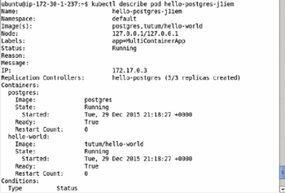

**Figure 13-17:**Describing a Pod

#### Listing the Docker Containers

As each Pod consists of two containers, scaling up the cluster to 3 Pods or replicas starts four new containers, 2 containers for each of the two new Pods. After scaling up the cluster run the following command to list the running Docker containers again using the default output format.

sudo docker ps

A total of 3 containers based on the postgres image and 3 containers based on the tutum/hello-world image get listed as shown in [Figure 13-18](https://viewer.books24x7.com/assetviewer.aspx?bookid=113388&chunkid=879442857&resumebookmarkid=413d1879-81bf-e911-b9b2-00505695593a).

[Larger View](https://viewer.books24x7.com/assetviewer.aspx?bookid=113388&chunkid=879442857&resumebookmarkid=413d1879-81bf-e911-b9b2-00505695593a)

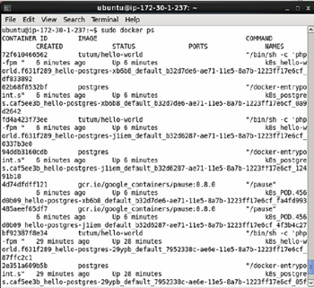

**Figure 13-18:**Listing the Docker Containers

#### Describing the Service after Scaling

Describe the service again after scaling up the cluster.

kubectl describe service hello-postgres

Each of the ports exposed by the service is associated with three endpoints because 3 Pods are running as shown in [Figure 13-19](https://viewer.books24x7.com/assetviewer.aspx?bookid=113388&chunkid=879442857&resumebookmarkid=413d1879-81bf-e911-b9b2-00505695593a).

[Larger View](https://viewer.books24x7.com/assetviewer.aspx?bookid=113388&chunkid=879442857&resumebookmarkid=413d1879-81bf-e911-b9b2-00505695593a)

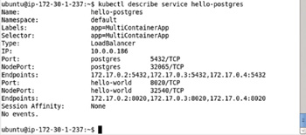

**Figure 13-19:**Describing the Service including the Service Endpoints

#### Setting Port Forwarding

To be able to open the application in a browser we need to set port forwarding to locahost. Set the port forwarding to ports not previously bound. The localhost:80 beind address is already sued up in the port forwarding of the single Pod created earlier. To set port forwarding for the two new Pods use ports 81 and 82 on localhost.

ssh -i "docker.pem" -f -nNT -L 81:172.17.0.3:80 ubuntu@ec2-52-90-62-35.compute-1.amazonaws.com

ssh -i "docker.pem" -f -nNT -L 82:172.17.0.4:80 ubuntu@ec2-52-90-62-35.compute-1.amazonaws.com

The preceding commands do not generate any output but the ports get forwarded to the localhost as shown in [Figure 13-20](https://viewer.books24x7.com/assetviewer.aspx?bookid=113388&chunkid=879442857&resumebookmarkid=413d1879-81bf-e911-b9b2-00505695593a).

[Larger View](https://viewer.books24x7.com/assetviewer.aspx?bookid=113388&chunkid=879442857&resumebookmarkid=413d1879-81bf-e911-b9b2-00505695593a)

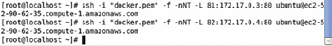

**Figure 13-20:**Setting Port Forwarding

#### Opening the Hello World Application in a Browser

The application may be opened in a browser at each of the forwarded ports; for example, open a browser at [http://localhost:81](http://localhost:81/). The application HTML gets displayed as shown in [Figure 13-21](https://viewer.books24x7.com/assetviewer.aspx?bookid=113388&chunkid=879442857&resumebookmarkid=413d1879-81bf-e911-b9b2-00505695593a). The HELLO\_POSTGRES service is listening at two ports 8020 and 5432.

[Larger View](https://viewer.books24x7.com/assetviewer.aspx?bookid=113388&chunkid=879442857&resumebookmarkid=413d1879-81bf-e911-b9b2-00505695593a)

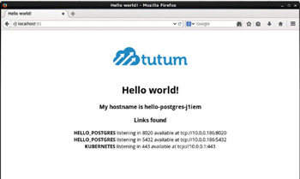

**Figure 13-21:**Invoking a Service Endpoint in a Browser

Similarly open the other service endpoint in a browser with url [http://localhost:82](http://localhost:82/). Different hostnames listening on the same port are forwarded to different ports on the localhost. The service endpoint HTML gets output as shown in [Figure 13-22](https://viewer.books24x7.com/assetviewer.aspx?bookid=113388&chunkid=879442857&resumebookmarkid=413d1879-81bf-e911-b9b2-00505695593a).

[Larger View](https://viewer.books24x7.com/assetviewer.aspx?bookid=113388&chunkid=879442857&resumebookmarkid=413d1879-81bf-e911-b9b2-00505695593a)

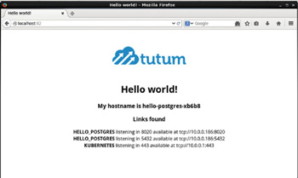

**Figure 13-22:**Invoking another Service Endpoint in a Browser

#### Invoking the Hello World Application from Command Line

As for a single container Pod, each of the two new service endpoints may be invoked on the command line. For example, invoke the 172.17.0.3 endpoint with the following curl command.

curl 172.17.0.3

The HTML for the service endpoint gets output as shown in [Figure 13-23](https://viewer.books24x7.com/assetviewer.aspx?bookid=113388&chunkid=879442857&resumebookmarkid=413d1879-81bf-e911-b9b2-00505695593a).

[Larger View](https://viewer.books24x7.com/assetviewer.aspx?bookid=113388&chunkid=879442857&resumebookmarkid=413d1879-81bf-e911-b9b2-00505695593a)

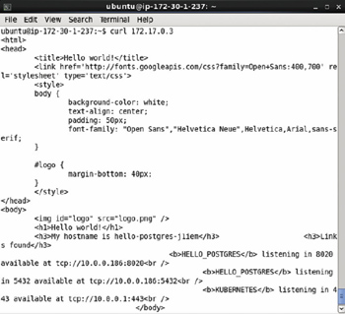

**Figure 13-23:**Invoking a Service Endpoint with curl

Invoke the 172.17.0.4 endpoint with the following curl command.

curl 172.17.0.4

The HTML for the service endpoint gets output as shown in [Figure 13-24](https://viewer.books24x7.com/assetviewer.aspx?bookid=113388&chunkid=879442857&resumebookmarkid=413d1879-81bf-e911-b9b2-00505695593a).

[Larger View](https://viewer.books24x7.com/assetviewer.aspx?bookid=113388&chunkid=879442857&resumebookmarkid=413d1879-81bf-e911-b9b2-00505695593a)

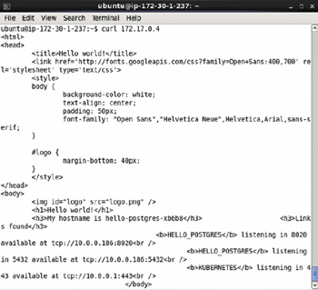

**Figure 13-24:**Invoking another Service Endpoint with curl

#### Deleting the Replication Controller

To delete the hello-postgres replication controller run the following command.

kubectl delete rc hello-postgres

Subsequently list the Pods with the following command.

kubectl get pods

The Pods for the hello-postgres replication controller are not listed as shown in [Figure 13-25](https://viewer.books24x7.com/assetviewer.aspx?bookid=113388&chunkid=879442857&resumebookmarkid=413d1879-81bf-e911-b9b2-00505695593a).

[Larger View](https://viewer.books24x7.com/assetviewer.aspx?bookid=113388&chunkid=879442857&resumebookmarkid=413d1879-81bf-e911-b9b2-00505695593a)

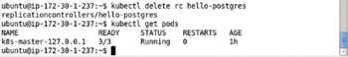

**Figure 13-25:**Deleting the Replication Controller

#### Deleting the Service

To delete the service hello-postgres run the following command.

kubectl delete service hello-postgres

Subsequently run the following command to list the services.

kubectl get services

The hello-postgres service is not listed as shown in [Figure 13-26](https://viewer.books24x7.com/assetviewer.aspx?bookid=113388&chunkid=879442857&resumebookmarkid=413d1879-81bf-e911-b9b2-00505695593a).

[Larger View](https://viewer.books24x7.com/assetviewer.aspx?bookid=113388&chunkid=879442857&resumebookmarkid=413d1879-81bf-e911-b9b2-00505695593a)

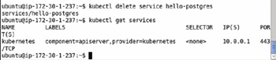

**Figure 13-26:**Deleting the Service

### Summary

In this chapter we discussed using multiple containers in a Pod. We discussed the use case for a multi-container Pod and used the tutum/hello-world and postgres Docker images to create a multi-container Pod. A multi-container pod starts multiple Docker containers for each Pod even though the Pod is the atomic unit. The multiple containers in a Pod share the same IP address and filesystem. When a multi-container Pod is scaled, multiple containers are started for each of the new Pods. In the next chapter we shall discuss installing Kubernetes on a multi-node cluster.

**Kubernetes Microservices with Docker**

Chapter 14 - Installing Kubernetes on a Multi-Node Cluster

Apress © 2016

## Chapter 14: Installing Kubernetes on a Multi-Node Cluster

**© Deepak Vohra 2016  
D. Vohra, *Kubernetes Microservices with Docker*, DOI 10.1007/978-1-4842-1907-2\_14**

### Overview

In all of the preceding chapters in the book we have used a single-node cluster. For most small scale applications a single-node cluster should suffice. But, for relatively large scale, distributed applications a multi-node cluster is a more suitable option. In this chapter we shall install Kubernetes on a multi-node (2 nodes) cluster.

### Components of a Multi-Node Cluster

A multi-node cluster consists of the following main and ancillary components.

* -Kubernetes Master Node
* -Kubernetes Worker Node/s
* -Etcd
* -Flannel
* -Service Proxy
* -Kubectl

etcd, kubernetes master, and service proxy were discussed in [chapter 1](http://viewer.books24x7.com/assetviewer.aspx?bkid=113388&destid=28#28). etcd as introduced in [chapter 1](http://viewer.books24x7.com/assetviewer.aspx?bkid=113388&destid=28#28) is a distributed, key-value store used by the Kubernetes cluster manager. We have installed etcd on the same node as the Kubernetes master but in a production environment etcd would typically be installed as separate cluster installed on nodes different than the Kubernetes master node. A commit to an etcd cluster is based on replication to a majority (quorum) of available nodes with provision for failure of one or more nodes. While the majority of a 1-node cluster is 1, the majority of a 3-node cluster is 2, majority of a 4-node cluster is 3, majority of a 5-node cluster is 3. A etcd cluster would typically have an odd number (>2) of nodes with tolerance for failure. For example, a 5-node etcd cluster could loose up to 2 nodes resulting in a 3-node cluster in which the majority is still determinable. A 3-node cluster has a failure tolerance for one more node. A 2-node etcd cluster does not have any failure tolerance and the majority of a 2-node cluster is considered as 2. The recommended etcd cluster size in production is 3,5, or 7.

Flannel is a network fabric for containers. Flannel provides a subnet to each host that is used by containers at runtime. Actually, Flannel runs an agent called flanneld on each host that allocates subnets. Flannel sets up and manages the network that interconnects all the Docker containers created by Kubernetes. Flannel is etcd backed and uses etcd to store the network configuration, allocated subnets, and auxiliary data such as the IP Address of the host.

**Setting the Environment**

We have used Amazon EC2 instances created from Ubuntu Server 14-04 LTS (HVM), SSD Volume Type - ami-d05e75b8 AMI for this chapter. The following software is required to be installed for this chapter.

* -Docker Engine (latest version)
* -Kubernetes on Master Node (version 1.01)
* -Kubernetes on Worker Node (version 1.01)
* -Kubectl (version 1.01)

Because we are creating a multi-node cluster we need to create multiple Amazon EC2 instances. For a two-node cluster create two Amazon EC2 instances – KubernetesMaster and KubernetesWorker – as shown in [Figure 14-1](https://viewer.books24x7.com/assetviewer.aspx?bookid=113388&chunkid=245918948&resumebookmarkid=413d1879-81bf-e911-b9b2-00505695593a).

[Larger View](https://viewer.books24x7.com/assetviewer.aspx?bookid=113388&chunkid=245918948&resumebookmarkid=413d1879-81bf-e911-b9b2-00505695593a)

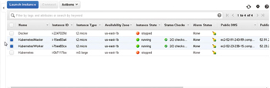

**Figure 14-1:**Creating two Ubuntu Instances for Kubernetes Master and Worker Nodes

SSH Login to each node separately. The Public IP Address for the Master Node may be obtained from the Amazon EC2 console as shown in [Figure 14-2](https://viewer.books24x7.com/assetviewer.aspx?bookid=113388&chunkid=245918948&resumebookmarkid=413d1879-81bf-e911-b9b2-00505695593a).

[Larger View](https://viewer.books24x7.com/assetviewer.aspx?bookid=113388&chunkid=245918948&resumebookmarkid=413d1879-81bf-e911-b9b2-00505695593a)

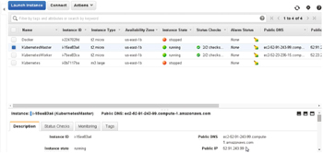

**Figure 14-2:**Obtaining the Public IP Address for a Ubuntu Instance

Log in to the Ubuntu instance for the Master node.

ssh -i "docker.pem" ubuntu@52.91.243.99

Similarly, obtain the Public IP Address for the Ubuntu instance for the Worker node and log in to the Ubuntu instance for the Worker node.

ssh -i "docker.pem" ubuntu@52.23.236.15

Install Docker and Kubectl on each node as discussed in [chapter 1](http://viewer.books24x7.com/assetviewer.aspx?bkid=113388&destid=28#28). Do not install Kubernetes just as [chapter 1](http://viewer.books24x7.com/assetviewer.aspx?bkid=113388&destid=28#28) because a multi-node configuration for Kubernetes is different than a single-node configuration.

Start the Docker Engine and verify its status.

sudo service docker start

sudo service docker status

Docker engine should be listed as "running" as shown in [Figure 14-3](https://viewer.books24x7.com/assetviewer.aspx?bookid=113388&chunkid=245918948&resumebookmarkid=413d1879-81bf-e911-b9b2-00505695593a).

[Larger View](https://viewer.books24x7.com/assetviewer.aspx?bookid=113388&chunkid=245918948&resumebookmarkid=413d1879-81bf-e911-b9b2-00505695593a)

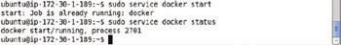

**Figure 14-3:**Starting Docker

**Installing the Master Node**

The Master node hosts the API server and assigns work to worker node/s. We need to run two Docker daemons, a main Docker instance and a bootstrap Docker instance. The main Docker instance is used by the Kubernetes and the bootstrap Docker instance is used by flannel, an etcd. The flannel daemon sets up and manages the network that interconnects all the Docker containers created by Kubernetes.

**Setting Up Flanneld and etcd**

Setting Up Flanneld and etcd involves setting up a bootstrap instance for Docker, starting etcd for flannel and the API server, and setting up flannel on the master node.

**Setting up Bootstrap Instance of Docker**

Flannel, which sets up networking between Docker containers; and etcd on which flannel relies, run inside Docker containers themselves. A separate bootstrap Docker is used because flannel is used for networking between Docker containers created by Kubernetes; and running flannel and Kubernetes in the same Docker engine could be problematic and is not recommended. Create a separate bootstrap instance of Docker for flannel and etcd.

sudo sh -c 'docker daemon -H unix:///var/run/docker-bootstrap.sock -p /var/run/docker-

bootstrap.pid --iptables=false --ip-masq=false --bridge=none --graph=/var/lib/docker-

bootstrap 2> /var/log/docker-bootstrap.log 1> /dev/null &'

The bootstrap Docker daemon gets started and the output from the preceding command is shown in [Figure 14-4](https://viewer.books24x7.com/assetviewer.aspx?bookid=113388&chunkid=887720460&resumebookmarkid=413d1879-81bf-e911-b9b2-00505695593a).

[Larger View](https://viewer.books24x7.com/assetviewer.aspx?bookid=113388&chunkid=887720460&resumebookmarkid=413d1879-81bf-e911-b9b2-00505695593a)

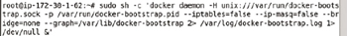

**Figure 14-4:**Starting the Bootstrap Daemon on the Master Node

The '-d' option is completely removed in Docker 1.10 and replaced with 'daemon'. If using the Docker version prior to Docker 1.10, for example Docker 1.9.1, replace 'daemon' with '-d' in the preceding command to run the command as follows:

sudo sh -c 'docker -d -H unix:///var/run/docker-bootstrap.sock -p /var/run/docker-bootstrap.

pid --iptables=false --ip-masq=false --bridge=none --graph=/var/lib/docker-bootstrap 2> /

var/log/docker- bootstrap.log 1> /dev/null &'

**Setting Up etcd**

Set up etcd for the flannel and the API server with the following command.

sudo docker -H unix:///var/run/docker-bootstrap.sock run --net=host -d gcr.io/google\_

containers/etcd:2.0.12 /usr/local/bin/etcd --addr=127.0.0.1:4001 --bind-addr=0.0.0.0:4001

--data-dir=/var/etcd/data

The container for etcd gets downloaded and etcd gets installed as shown in [Figure 14-5](https://viewer.books24x7.com/assetviewer.aspx?bookid=113388&chunkid=887720460&resumebookmarkid=413d1879-81bf-e911-b9b2-00505695593a).

[Larger View](https://viewer.books24x7.com/assetviewer.aspx?bookid=113388&chunkid=887720460&resumebookmarkid=413d1879-81bf-e911-b9b2-00505695593a)

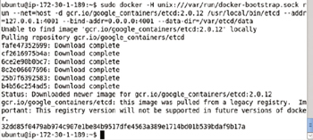

**Figure 14-5:**Setting up etcd on the Master Node

Set up a Classless Inter-Domain Routing (CIDR), which is an IP Addressing scheme that reduces the size of routing tables and makes more addresses available, range for flannel.

sudo docker -H unix:///var/run/docker-bootstrap.sock run --net=host gcr.io/google\_

containers/etcd:2.0.12 etcdctl set /coreos.com/network/config '{ "Network": "10.1.0.0/16" }'

The preceding command does not generate any output as shown in [Figure 14-6](https://viewer.books24x7.com/assetviewer.aspx?bookid=113388&chunkid=887720460&resumebookmarkid=413d1879-81bf-e911-b9b2-00505695593a).

[Larger View](https://viewer.books24x7.com/assetviewer.aspx?bookid=113388&chunkid=887720460&resumebookmarkid=413d1879-81bf-e911-b9b2-00505695593a)

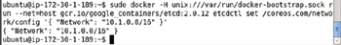

**Figure 14-6:**Setting Up CIDR on the Master Node

**Setting Up Flannel**

By default Docker does provide a networking between containers and Pods but the networking provided by Flannel is much more simplified. We shall be using Flannel for networking. First, we need to stop Docker.

sudo service docker stop

Docker gets stopped as shown in [Figure 14-7](https://viewer.books24x7.com/assetviewer.aspx?bookid=113388&chunkid=887720460&resumebookmarkid=413d1879-81bf-e911-b9b2-00505695593a).

[Larger View](https://viewer.books24x7.com/assetviewer.aspx?bookid=113388&chunkid=887720460&resumebookmarkid=413d1879-81bf-e911-b9b2-00505695593a)

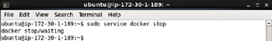

**Figure 14-7:**Stopping Docker Temporarily

Run flannel with the following command.

sudo docker -H unix:///var/run/docker-bootstrap.sock run -d --net=host --privileged -v /dev/

net:/dev/net quay.io/coreos/flannel:0.5.0

Flannel gets installed as shown in [Figure 14-8](https://viewer.books24x7.com/assetviewer.aspx?bookid=113388&chunkid=887720460&resumebookmarkid=413d1879-81bf-e911-b9b2-00505695593a).

[Larger View](https://viewer.books24x7.com/assetviewer.aspx?bookid=113388&chunkid=887720460&resumebookmarkid=413d1879-81bf-e911-b9b2-00505695593a)

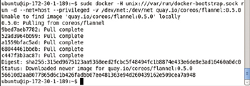

**Figure 14-8:**Installing Flannel

Flannel generates a hash as shown in [Figure 14-9](https://viewer.books24x7.com/assetviewer.aspx?bookid=113388&chunkid=887720460&resumebookmarkid=413d1879-81bf-e911-b9b2-00505695593a). Copy the Hash.

[Larger View](https://viewer.books24x7.com/assetviewer.aspx?bookid=113388&chunkid=887720460&resumebookmarkid=413d1879-81bf-e911-b9b2-00505695593a)

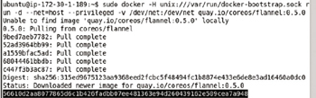

**Figure 14-9:**Obtaining the Hash Generated by Flannel

Copy and paste the hash into the following command, and run the command to obtain the subnet settings.

sudo docker -H unix:///var/run/docker-bootstrap.sock exec <really-long-hash-from-above-here>

cat /run/flannel/subnet.env

The subnet settings get listed as shown in [Figure 14-10](https://viewer.books24x7.com/assetviewer.aspx?bookid=113388&chunkid=887720460&resumebookmarkid=413d1879-81bf-e911-b9b2-00505695593a).

[Larger View](https://viewer.books24x7.com/assetviewer.aspx?bookid=113388&chunkid=887720460&resumebookmarkid=413d1879-81bf-e911-b9b2-00505695593a)

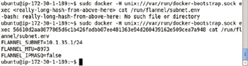

**Figure 14-10:**Listing the Subnet Settings

Make a note of the FLANNEL\_SUBNET and FLANNEL\_MTU values as we shall need these to edit the Docker configuration. Open the Docker configuration file in a vi editor.

sudo vi /etc/default/docker

The default settings in the docker configuration file are shown in [Figure 14-11](https://viewer.books24x7.com/assetviewer.aspx?bookid=113388&chunkid=887720460&resumebookmarkid=413d1879-81bf-e911-b9b2-00505695593a).

[Larger View](https://viewer.books24x7.com/assetviewer.aspx?bookid=113388&chunkid=887720460&resumebookmarkid=413d1879-81bf-e911-b9b2-00505695593a)

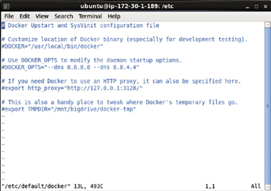

**Figure 14-11:**Docker Configuration File Default Settings

To the DOCKER\_OPTS setting append the following parameters whose values are obtained from the output in [Figure 14-10](https://viewer.books24x7.com/assetviewer.aspx?bookid=113388&chunkid=887720460&resumebookmarkid=413d1879-81bf-e911-b9b2-00505695593a).

--bip=${FLANNEL\_SUBNET} --mtu=${FLANNEL\_MTU}

The modified docker configuration file is shown in [Figure 14-12](https://viewer.books24x7.com/assetviewer.aspx?bookid=113388&chunkid=887720460&resumebookmarkid=413d1879-81bf-e911-b9b2-00505695593a).

[Larger View](https://viewer.books24x7.com/assetviewer.aspx?bookid=113388&chunkid=887720460&resumebookmarkid=413d1879-81bf-e911-b9b2-00505695593a)

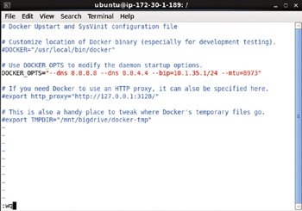

**Figure 14-12:**Modified Docker Configuration File

As mentioned before Docker provides its own networking with a Docker bridge called docker0. As we won't be using the default Docker bridge remove the default Docker bridge. For the brctl binaries first install the bridge-utils package.

sudo /sbin/ifconfig docker0 down

sudo apt-get install bridge-utils

sudo brctl delbr docker0

The output from installing the bridge-utils package and removing the docker0 bridge is shown in [Figure 14-13](https://viewer.books24x7.com/assetviewer.aspx?bookid=113388&chunkid=887720460&resumebookmarkid=413d1879-81bf-e911-b9b2-00505695593a).

[Larger View](https://viewer.books24x7.com/assetviewer.aspx?bookid=113388&chunkid=887720460&resumebookmarkid=413d1879-81bf-e911-b9b2-00505695593a)

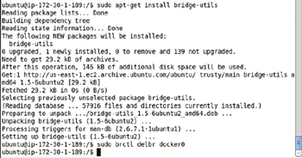

**Figure 14-13:**Removing docker0 bridge

Restart Docker.

sudo service docker start

Docker gets restarted as shown in [Figure 14-14](https://viewer.books24x7.com/assetviewer.aspx?bookid=113388&chunkid=887720460&resumebookmarkid=413d1879-81bf-e911-b9b2-00505695593a).

[Larger View](https://viewer.books24x7.com/assetviewer.aspx?bookid=113388&chunkid=887720460&resumebookmarkid=413d1879-81bf-e911-b9b2-00505695593a)



**Figure 14-14:**Restarting Docker

**Starting the Kubernetes Master**

Setting up flannel networking is the main difference between setting up a single-node cluster and a multi-node cluster. Start the Kubernetes master with the same command as used for a single-node cluster.

sudo docker run \

--volume=/:/rootfs:ro \

--volume=/sys:/sys:ro \

--volume=/dev:/dev \

--volume=/var/lib/docker/:/var/lib/docker:rw \

--volume=/var/lib/kubelet/:/var/lib/kubelet:rw \

--volume=/var/run:/var/run:rw \

--net=host \

--privileged=true \

--pid=host \

-d \

gcr.io/google\_containers/hyperkube:v1.0.1 /hyperkube kubelet --api-servers=

http://localhost:8080 --v=2 --address=0.0.0.0 --enable-server --hostname-override=127.0.0.1 --config=/

etc/kubernetes/manifests-multi --cluster-dns=10.0.0.10 --cluster-domain=cluster.local

The preceding command is run from the Master Node as shown in [Figure 14-15](https://viewer.books24x7.com/assetviewer.aspx?bookid=113388&chunkid=887720460&resumebookmarkid=413d1879-81bf-e911-b9b2-00505695593a).

[Larger View](https://viewer.books24x7.com/assetviewer.aspx?bookid=113388&chunkid=887720460&resumebookmarkid=413d1879-81bf-e911-b9b2-00505695593a)

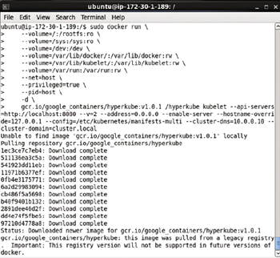

**Figure 14-15:**Starting Kubernetes on the Master Node

Kubernetes gets installed on the master node as shown in [Figure 14-16](https://viewer.books24x7.com/assetviewer.aspx?bookid=113388&chunkid=887720460&resumebookmarkid=413d1879-81bf-e911-b9b2-00505695593a).

[Larger View](https://viewer.books24x7.com/assetviewer.aspx?bookid=113388&chunkid=887720460&resumebookmarkid=413d1879-81bf-e911-b9b2-00505695593a)

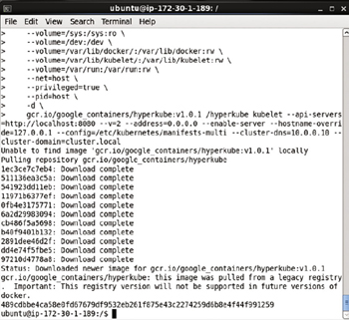

**Figure 14-16:**Kubernetes Started on Master Node

**Running the Service Proxy**

Run the service proxy also using the same command as used for a single-node cluster.

sudo docker run -d --net=host --privileged gcr.io/google\_containers/hyperkube:v1.0.1 /

hyperkube proxy --master=http://127.0.0.1:8080 --v=2

Service proxy gets installed as shown in [Figure 14-17](https://viewer.books24x7.com/assetviewer.aspx?bookid=113388&chunkid=887720460&resumebookmarkid=413d1879-81bf-e911-b9b2-00505695593a).

[Larger View](https://viewer.books24x7.com/assetviewer.aspx?bookid=113388&chunkid=887720460&resumebookmarkid=413d1879-81bf-e911-b9b2-00505695593a)

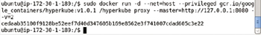

**Figure 14-17:**Starting Service proxy on Master Node

**Testing the One-Node Cluster**

To test the master node run the following command, which lists the nodes in the cluster.

kubectl get nodes

The single node gets listed as shown in [Figure 14-18](https://viewer.books24x7.com/assetviewer.aspx?bookid=113388&chunkid=697598894&resumebookmarkid=413d1879-81bf-e911-b9b2-00505695593a).

[Larger View](https://viewer.books24x7.com/assetviewer.aspx?bookid=113388&chunkid=697598894&resumebookmarkid=413d1879-81bf-e911-b9b2-00505695593a)

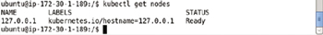

**Figure 14-18:**Listing the Nodes, only the Master Node to start with

### Adding a Worker Node

Setting up a worker node is very similar to setting up the master node. Next, we shall set up a worker node. SSH login to the Ubuntu instance for the worker node.

#### Exporting the Master IP

First, we need to set the environment variable MASTER\_IP. Obtain the Public IP Address for the Ubuntu instance running the master node as shown in [Figure 14-19](https://viewer.books24x7.com/assetviewer.aspx?bookid=113388&chunkid=594652328&resumebookmarkid=6a74a8bf-8ebf-e911-b9b2-00505695593a).

[Larger View](https://viewer.books24x7.com/assetviewer.aspx?bookid=113388&chunkid=594652328&resumebookmarkid=6a74a8bf-8ebf-e911-b9b2-00505695593a)

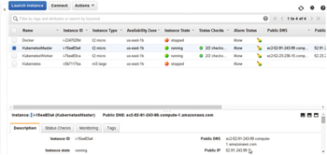

**Figure 14-19:**Obtaining the Master Node's IP Address

Export the environment variable MASTER\_IP using the Public IP Address.

export MASTER\_IP=52.91.243.99

Echo the MASTER\_IP environment variable.

echo $MASTER\_IP

The output from the preceding command is shown in [Figure 14-20](https://viewer.books24x7.com/assetviewer.aspx?bookid=113388&chunkid=594652328&resumebookmarkid=6a74a8bf-8ebf-e911-b9b2-00505695593a).

[Larger View](https://viewer.books24x7.com/assetviewer.aspx?bookid=113388&chunkid=594652328&resumebookmarkid=6a74a8bf-8ebf-e911-b9b2-00505695593a)

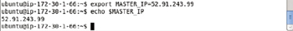

**Figure 14-20:**Exporting the MASTER\_IP Environment Variable on a Worker Node

#### Setting Up Flanneld

Start a bootstrap Docker daemon just for the flannel networking.

sudo sh -c 'docker daemon -H unix:///var/run/docker-bootstrap.sock -p /var/run/docker-

bootstrap.pid --iptables=false --ip-masq=false --bridge=none --graph=/var/lib/docker-

bootstrap 2> /var/log/docker-bootstrap.log 1> /dev/null &'

Bootstrap Docker gets set up as shown in [Figure 14-21](https://viewer.books24x7.com/assetviewer.aspx?bookid=113388&chunkid=594652328&resumebookmarkid=6a74a8bf-8ebf-e911-b9b2-00505695593a).

[Larger View](https://viewer.books24x7.com/assetviewer.aspx?bookid=113388&chunkid=594652328&resumebookmarkid=6a74a8bf-8ebf-e911-b9b2-00505695593a)

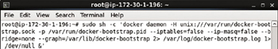

**Figure 14-21:**Starting Bootstrap Docker on the Worker Node

The '-d' option is completely removed in Docker 1.10 and replaced with 'daemon'. If using the Docker version prior to Docker 1.10, for example Docker 1.9.1, replace 'daemon' with '-d' in the preceding command to run the command as follows:

sudo sh -c 'docker -d -H unix:///var/run/docker-bootstrap.sock -p /var/run/docker-bootstrap.

pid --iptables=false --ip-masq=false --bridge=none --graph=/var/lib/docker-bootstrap 2> /

var/log/docker- bootstrap.log 1> /dev/null &'

To install Flannel, first we need to stop the Docker engine.

sudo service docker stop

Docker engine gets stopped as shown in [Figure 14-22](https://viewer.books24x7.com/assetviewer.aspx?bookid=113388&chunkid=594652328&resumebookmarkid=6a74a8bf-8ebf-e911-b9b2-00505695593a).

[Larger View](https://viewer.books24x7.com/assetviewer.aspx?bookid=113388&chunkid=594652328&resumebookmarkid=6a74a8bf-8ebf-e911-b9b2-00505695593a)

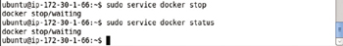

**Figure 14-22:**Stopping Docker Temporarily on the Worker Node

Next, install flannel on the worker node. The same etcd that is running on the master is used for the flanneld on the worker node. The etcd instance includes the Master's Ip using the MASTER\_IP environment variable.

sudo docker -H unix:///var/run/docker-bootstrap.sock run -d --net=host --privileged

-v /dev/net:/dev/net quay.io/coreos/flannel:0.5.0 /opt/bin/flanneld --etcd-

endpoints=http://${MASTER\_IP}:4001

Flannel gets set up on the worker node as shown in [Figure 14-23](https://viewer.books24x7.com/assetviewer.aspx?bookid=113388&chunkid=594652328&resumebookmarkid=6a74a8bf-8ebf-e911-b9b2-00505695593a).

[Larger View](https://viewer.books24x7.com/assetviewer.aspx?bookid=113388&chunkid=594652328&resumebookmarkid=6a74a8bf-8ebf-e911-b9b2-00505695593a)

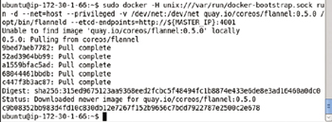

**Figure 14-23:**Installing Flannel on the Worker Node

Copy the hash generated by the preceding command as shown in [Figure 14-24](https://viewer.books24x7.com/assetviewer.aspx?bookid=113388&chunkid=594652328&resumebookmarkid=6a74a8bf-8ebf-e911-b9b2-00505695593a).

[Larger View](https://viewer.books24x7.com/assetviewer.aspx?bookid=113388&chunkid=594652328&resumebookmarkid=6a74a8bf-8ebf-e911-b9b2-00505695593a)

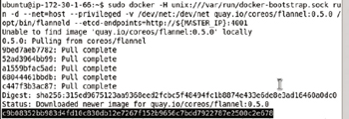

**Figure 14-24:**Obtaining the Hash geenrated by Flannel

Using the hash value in the following command obtain the subnet settings from flannel.

sudo docker -H unix:///var/run/docker-bootstrap.sock exec <really-long-hash-from-above-here>

cat /run/flannel/subnet.env

The subnet settings get output as shown in [Figure 14-25](https://viewer.books24x7.com/assetviewer.aspx?bookid=113388&chunkid=594652328&resumebookmarkid=6a74a8bf-8ebf-e911-b9b2-00505695593a).

[Larger View](https://viewer.books24x7.com/assetviewer.aspx?bookid=113388&chunkid=594652328&resumebookmarkid=6a74a8bf-8ebf-e911-b9b2-00505695593a)

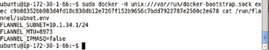

**Figure 14-25:**Listing the Subnet Settings on the Worker Node

Using the subnet settings we need to edit the Docker configuration file. Open the Docker configuration file in the vi editor.

sudo /etc/default/docker

Append the following parameters to the DOCKER\_OPTS setting. Substitute the values for FLANNEL\_SUBNET and FLANNEL\_MTU as obtained from [Figure 14-25](https://viewer.books24x7.com/assetviewer.aspx?bookid=113388&chunkid=594652328&resumebookmarkid=6a74a8bf-8ebf-e911-b9b2-00505695593a).

--bip=${FLANNEL\_SUBNET} --mtu=${FLANNEL\_MTU}

The modified Docker configuration file is shown in [Figure 14-26](https://viewer.books24x7.com/assetviewer.aspx?bookid=113388&chunkid=594652328&resumebookmarkid=6a74a8bf-8ebf-e911-b9b2-00505695593a).

[Larger View](https://viewer.books24x7.com/assetviewer.aspx?bookid=113388&chunkid=594652328&resumebookmarkid=6a74a8bf-8ebf-e911-b9b2-00505695593a)

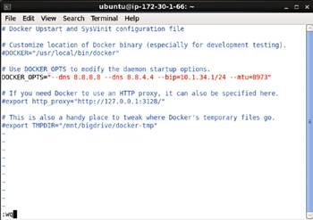

**Figure 14-26:**Modified Docker Configuration File

Shut down and remove the existing Docker bridge docker0, which is used by default by Docker for networking between containers and Pods. The bridge-utils package is needed to be installed as it is not available by default on an Ubuntu instance on Amazon EC2.

sudo /sbin/ifconfig docker0 down

sudo apt-get install bridge-utils

sudo brctl delbr docker0

Restart Docker.

sudo service docker start

The Docker engine gets started as shown in [Figure 14-27](https://viewer.books24x7.com/assetviewer.aspx?bookid=113388&chunkid=594652328&resumebookmarkid=6a74a8bf-8ebf-e911-b9b2-00505695593a).

[Larger View](https://viewer.books24x7.com/assetviewer.aspx?bookid=113388&chunkid=594652328&resumebookmarkid=6a74a8bf-8ebf-e911-b9b2-00505695593a)



**Figure 14-27:**Restarting Docker

#### Starting Up Kubernetes on Worker Node

Start up Kubernetes on the worker node with the same command as used in the Master node with the difference that instead of setting the --api-servers to [http://localhost:8080](http://localhost:8080/)set the --api-servers to the http://${MASTER\_IP}:8080.

sudo docker run \

--volume=/:/rootfs:ro \

--volume=/sys:/sys:ro \

--volume=/dev:/dev \

--volume=/var/lib/docker/:/var/lib/docker:rw \

--volume=/var/lib/kubelet/:/var/lib/kubelet:rw \

--volume=/var/run:/var/run:rw \

--net=host \

--privileged=true \

--pid=host \

-d \

gcr.io/google\_containers/hyperkube:v1.0.1 /hyperkube kubelet --api-

servers=http://${MASTER\_IP}:8080 --v=2 --address=0.0.0.0 --enable-server --hostname-

override=$(hostname -i) --cluster-dns=10.0.0.10 --cluster-domain=cluster.local

The preceding command is to be run on the worker node as shown in [Figure 14-28](https://viewer.books24x7.com/assetviewer.aspx?bookid=113388&chunkid=594652328&resumebookmarkid=6a74a8bf-8ebf-e911-b9b2-00505695593a).

[Larger View](https://viewer.books24x7.com/assetviewer.aspx?bookid=113388&chunkid=594652328&resumebookmarkid=6a74a8bf-8ebf-e911-b9b2-00505695593a)

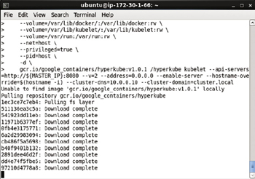

**Figure 14-28:**Starting Kubernetes on the Worker Node

#### Running the Service Proxy

The service proxy on the worker node is also run with the same command as for the master node except that the Master's Ip parameter -- master=http://127.0.0.1:8080 should be replaced with --master=http://${MASTER\_IP}:8080.

sudo docker run -d --net=host --privileged gcr.io/google\_containers/hyperkube:v1.0.1 /

hyperkube proxy --master=http://${MASTER\_IP}:8080 --v=2

The service proxy gets started as shown in [Figure 14-29](https://viewer.books24x7.com/assetviewer.aspx?bookid=113388&chunkid=594652328&resumebookmarkid=6a74a8bf-8ebf-e911-b9b2-00505695593a).

[Larger View](https://viewer.books24x7.com/assetviewer.aspx?bookid=113388&chunkid=594652328&resumebookmarkid=6a74a8bf-8ebf-e911-b9b2-00505695593a)

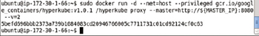

**Figure 14-29:**Starting Service Proxy on the Worker Node

**Testing the Kubernetes Cluster**

From the Master node, not the worker node that was being configured in the preceding commands, list the nodes in the cluster.

kubectl get nodes

Two nodes get listed as shown in [Figure 14-30](https://viewer.books24x7.com/assetviewer.aspx?bookid=113388&chunkid=145550936&resumebookmarkid=6a74a8bf-8ebf-e911-b9b2-00505695593a): the master node and the worker node.

[Larger View](https://viewer.books24x7.com/assetviewer.aspx?bookid=113388&chunkid=145550936&resumebookmarkid=6a74a8bf-8ebf-e911-b9b2-00505695593a)

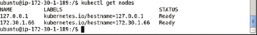

**Figure 14-30:**Listing a Two-Node Cluster

Add more nodes as required using the same procedure as discussed in this section Adding a Worker Node.

**Running an Application on the Cluster**

To test the cluster run an application on the command line using kubectl. As an example, run the Docker image "nginx" with the following command.

kubectl -s http://localhost:8080 run nginx --image=nginx --port=80

Subsequently list the Pods.

kubectl get pods

The nginx application container is created and the nginx replication controller is created with default of 1 replicas as shown in [Figure 14-31](https://viewer.books24x7.com/assetviewer.aspx?bookid=113388&chunkid=872714366&resumebookmarkid=6a74a8bf-8ebf-e911-b9b2-00505695593a). One pod gets listed, also shown in [Figure 14-31](https://viewer.books24x7.com/assetviewer.aspx?bookid=113388&chunkid=872714366&resumebookmarkid=6a74a8bf-8ebf-e911-b9b2-00505695593a). Initially the Pod could be listed as Pending status. Run the preceding command after a few seconds to list the Pod as running and ready. To find on which instance/s (node/s) in the cluster the Pod/s is/are running on, run the command.

kubectl get pods -o wide.

[Larger View](https://viewer.books24x7.com/assetviewer.aspx?bookid=113388&chunkid=872714366&resumebookmarkid=6a74a8bf-8ebf-e911-b9b2-00505695593a)

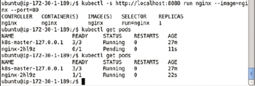

**Figure 14-31:**Installing an Application on the Cluster

**Exposing the Application as a Service**

To expose the replication controller nginx as a service run the following command.

kubectl expose rc nginx --port=80

The nginx service gets created as shown in [Figure 14-32](https://viewer.books24x7.com/assetviewer.aspx?bookid=113388&chunkid=807068121&resumebookmarkid=6a74a8bf-8ebf-e911-b9b2-00505695593a).

[Larger View](https://viewer.books24x7.com/assetviewer.aspx?bookid=113388&chunkid=807068121&resumebookmarkid=6a74a8bf-8ebf-e911-b9b2-00505695593a)



**Figure 14-32:**Creating a Service

List the services with the following command.

kubectl get services

To be able to invoke the service obtain the first cluster Ip with the following command as shown in [Figure 14-33](https://viewer.books24x7.com/assetviewer.aspx?bookid=113388&chunkid=807068121&resumebookmarkid=6a74a8bf-8ebf-e911-b9b2-00505695593a).

kubectl get svc nginx --template={{.spec.clusterIP}}

Invoke the web server using the cluster Ip returned, 10.0.0.99.

curl 10.0.0.99

[Larger View](https://viewer.books24x7.com/assetviewer.aspx?bookid=113388&chunkid=807068121&resumebookmarkid=6a74a8bf-8ebf-e911-b9b2-00505695593a)

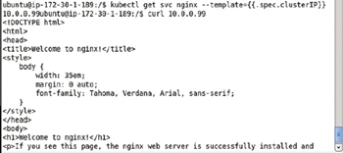

**Figure 14-33:**Invoking a Web Server with Curl

The HTML returned from the nginx application is output as shown in [Figure 14-34](https://viewer.books24x7.com/assetviewer.aspx?bookid=113388&chunkid=807068121&resumebookmarkid=6a74a8bf-8ebf-e911-b9b2-00505695593a).

[Larger View](https://viewer.books24x7.com/assetviewer.aspx?bookid=113388&chunkid=807068121&resumebookmarkid=6a74a8bf-8ebf-e911-b9b2-00505695593a)

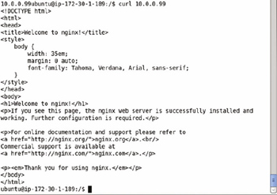

**Figure 14-34:**The HTML generated by the Application

**Testing the Application in a Browser**

To invoke the service endpoint in a browser, set port forwarding from 10.0.0.99:80 endpoint to localhost:80.

ssh -i docker.pem -f -nNT -L 80:10.0.0.99:80 ubuntu@ec2-52-91-243-99.compute-1.amazonaws.com

Port forwarding gets set as shown in [Figure 14-35](https://viewer.books24x7.com/assetviewer.aspx?bookid=113388&chunkid=186352970&resumebookmarkid=6a74a8bf-8ebf-e911-b9b2-00505695593a).

[Larger View](https://viewer.books24x7.com/assetviewer.aspx?bookid=113388&chunkid=186352970&resumebookmarkid=6a74a8bf-8ebf-e911-b9b2-00505695593a)

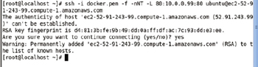

**Figure 14-35:**Setting Port Forwarding

Invoke the nginx application in a local browser with url [http://localhost](http://localhost/) as shown in [Figure 14-36](https://viewer.books24x7.com/assetviewer.aspx?bookid=113388&chunkid=186352970&resumebookmarkid=6a74a8bf-8ebf-e911-b9b2-00505695593a).

[Larger View](https://viewer.books24x7.com/assetviewer.aspx?bookid=113388&chunkid=186352970&resumebookmarkid=6a74a8bf-8ebf-e911-b9b2-00505695593a)

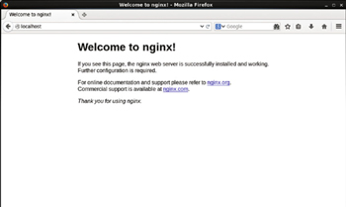

**Figure 14-36:**Invoking a Service Endpoint in a Browser

**Scaling the Application**

Scaling is a common usage pattern of Replication Controller. The nginx replication controller may be scaled with the kubectl scale command. As an example, scale to 3 replicas.

kubectl scale rc nginx --replicas=3

Subsequently list the Pods.

kubectl get pods

An output of "scaled" indicates that the replication controller has been scaled. Three Pods get listed as shown in [Figure 14-37](https://viewer.books24x7.com/assetviewer.aspx?bookid=113388&chunkid=898147455&resumebookmarkid=6a74a8bf-8ebf-e911-b9b2-00505695593a).

[Larger View](https://viewer.books24x7.com/assetviewer.aspx?bookid=113388&chunkid=898147455&resumebookmarkid=6a74a8bf-8ebf-e911-b9b2-00505695593a)

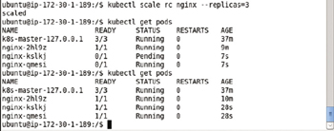

**Figure 14-37:**Listing the Pods

Describe the service with the following command.

kubectl describe svc nginx

Three service endpoints get listed as shown in [Figure 14-38](https://viewer.books24x7.com/assetviewer.aspx?bookid=113388&chunkid=898147455&resumebookmarkid=6a74a8bf-8ebf-e911-b9b2-00505695593a).

[Larger View](https://viewer.books24x7.com/assetviewer.aspx?bookid=113388&chunkid=898147455&resumebookmarkid=6a74a8bf-8ebf-e911-b9b2-00505695593a)

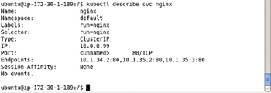

**Figure 14-38:**Describing the Service

To be able to invoke each of the service endpoints in a browser on a local machine, set the port forwarding.

ssh -i docker.pem -f -nNT -L 8081:10.1.34.2:80 ubuntu@ec2-52-91-243-99.compute-1.amazonaws.com

ssh -i docker.pem -f -nNT -L 8082:10.1.35.2:80 ubuntu@ec2-52-91-243-99.compute-1.amazonaws.com

ssh -i docker.pem -f -nNT -L 8083:10.1.35.3:80 ubuntu@ec2-52-91-243-99.compute-1.amazonaws.com

Port forwarding gets set as shown in [Figure 14-39](https://viewer.books24x7.com/assetviewer.aspx?bookid=113388&chunkid=898147455&resumebookmarkid=6a74a8bf-8ebf-e911-b9b2-00505695593a).

[Larger View](https://viewer.books24x7.com/assetviewer.aspx?bookid=113388&chunkid=898147455&resumebookmarkid=6a74a8bf-8ebf-e911-b9b2-00505695593a)

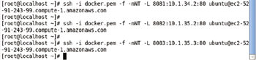

**Figure 14-39:**Setting port Forwarding for the additional Service Endpoints

The service endpoints may be invoked in a local browser. For example the url [http://localhost:8081](http://localhost:8081/) invokes one of the service endpoints as shown in [Figure 14-40](https://viewer.books24x7.com/assetviewer.aspx?bookid=113388&chunkid=898147455&resumebookmarkid=6a74a8bf-8ebf-e911-b9b2-00505695593a).

[Larger View](https://viewer.books24x7.com/assetviewer.aspx?bookid=113388&chunkid=898147455&resumebookmarkid=6a74a8bf-8ebf-e911-b9b2-00505695593a)

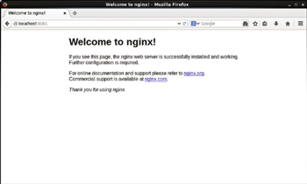

**Figure 14-40:**Invoking a Service Endpoint in a Browser

Similarly, the url [http://localhost:8082](http://localhost:8082/) invokes another service endpoint as shown in [Figure 14-41](https://viewer.books24x7.com/assetviewer.aspx?bookid=113388&chunkid=898147455&resumebookmarkid=6a74a8bf-8ebf-e911-b9b2-00505695593a).

[Larger View](https://viewer.books24x7.com/assetviewer.aspx?bookid=113388&chunkid=898147455&resumebookmarkid=6a74a8bf-8ebf-e911-b9b2-00505695593a)

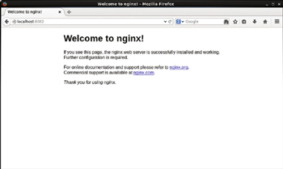

**Figure 14-41:**Invoking another Service Endpoint in a Browser

Similarly, the url [http://localhost:8083](http://localhost:8083/) invokes the third service endpoint as shown in [Figure 14-42](https://viewer.books24x7.com/assetviewer.aspx?bookid=113388&chunkid=898147455&resumebookmarkid=6a74a8bf-8ebf-e911-b9b2-00505695593a).

[Larger View](https://viewer.books24x7.com/assetviewer.aspx?bookid=113388&chunkid=898147455&resumebookmarkid=6a74a8bf-8ebf-e911-b9b2-00505695593a)

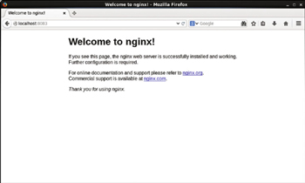

**Figure 14-42:**Invoking a Third Service Endpoint in a Browser

### Summary

In this chapter we installed Kubernetes on a multi-node cluster. The multi-node configuration makes use of flannel for networking instead of the default networking provided by Docker. First, we installed Kubernetes on the master node. Using the Master's Ip Address we installed Kubernetes on a worker node, as a result creating a two-node cluster. As many worker nodes as required may be added using the same procedure. We created an application using the nginx Docker image and invoked the application on the command line using curl, and in a local browser using port forwarding. We also scaled the application. In a single-node cluster an application runs on the master node itself. In a multi-node cluster an application runs on both the worker nodes and the master node. This chapter concludes the book on Kubernetes Microservices with Docker.